1. A balloon is released off of the ground. The following table of values shows the height of a balloon versus time. Make a scatterplot and draw an appropriate line/curve of good fit.
Time(s) | Height (m)
2 | 5
6 | 11
7 | 19
12 | 26
14 | 39
18 | 47

- If we released another identical balloon, how high would you expect it to be after 10 seconds? Mark a point on your line, and state the coordinates.
- After how many seconds would you expect the balloon to be 42 m in the air?

- Determine the rate of change for the height of the balloon. Show your calculation and include units.
- Using your rate of change, how high would you expect the balloon to be after 3 minutes?

- How long would it take for your balloon to reach a height of 1 km? Show your work.
- What does the point (50,125) represent?

2. In each case, make a sketch of what the scatterplot might look like. Include labels on your x- and y- axis, a few sample points, and an appropriate line/curve of best fit. In each case, use proper mathematical language to describe the relationship (ex, positive/negative correlation, strong/medium/weak, linear/non-linear).
a) # golf balls vs mass of golf balls  Sketch  Description of relationship | b)Time I play video games vs. Time I sleep  Sketch  Description of relationship | c)Persons’s age vs # teeth they have  Sketch  Description of relationship

3. The scatter plot below shows the number of push-ups a student does in certain amounts of time.
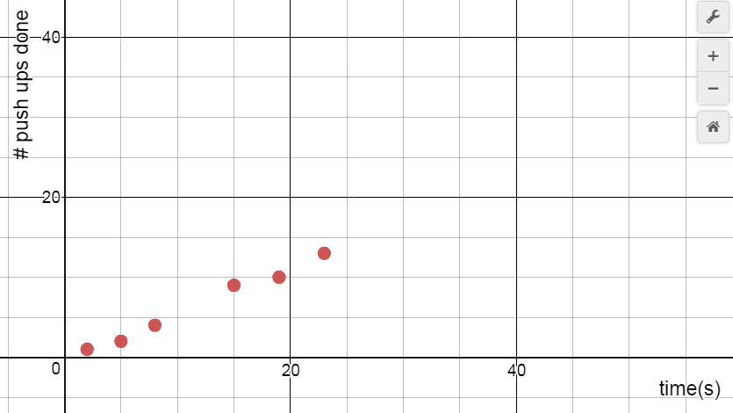
- Draw an appropriate line of good fit for this data
- Another student doesn’t do push-ups as fast. Draw an appropriate line/curve to represent this student.
- Another student starts doing push ups really quickly, but soon gets tired and stops completely. Draw a line/curve to represent this student.
- Using your line, predict how many push-ups the student could do in 50 seconds.

- How confident do you feel in your prediction from part d? Why?
- Determine the rate of change for this relationship.
- What does the rate of change represent?
- The world record for most push-ups in an hour is 2220. If the original person from the graph continues their pace for 40 minutes, how fast do they need to do push-ups in the final 20 minutes in order to beat the record? Show your work.

Multiple Representations Review

4. Consider the following relationships. Create multiple representations of these patterns (table, graph, equation, words).
Input Output  1 11  2 9  3 7  4 5  5 3 | T = 3n + 6
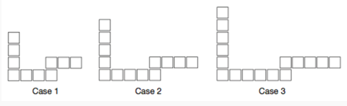 | 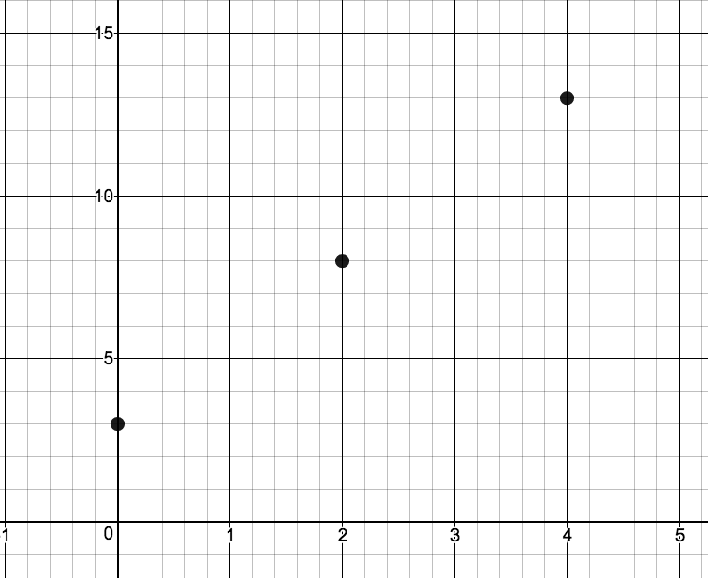

5. Determine if the following relationships are linear or non-linear.
a)  Figure # # squares  1 2  2 7  3 12  4 17 | b)  # weeks gone by $ in account  4 80  5 75  6 65  7 50 | c)  Time(s) Distance (m)  1 1.8  2 2.7  3 3.6  4 4.5
Composite Figures Review
7.

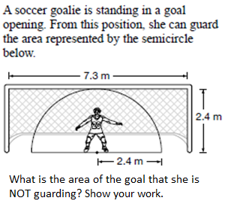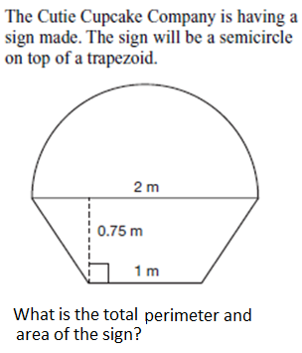
6.
8. Determine the area and perimeter of the following shapes. Show your work.
a) b)
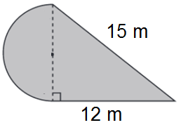 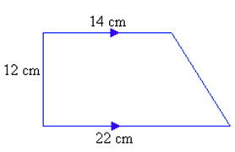

ANSWERS
1. ANSWERS WILL VARY SLIGHTLY
a) about 25 m b) about 17 s c) about 2.4 m/s d) about 432 m
e) about 418 s f) After 50 s, balloon is 125m high
2. a) Strong positive, linear b) medium, negative, linear (although might be non-linear)
c) non-linear (person gets teeth, loses some teeth, gains more, then loses more when old)
3. ANSWERS WILL VARY SLIGHTLY
d) about 27 e) not that confident…person will likely slow down
f) about 0.54 pushups/second g) every second, person does 0.54 pushups
h) 0.77 pushups/second
4. Here are equations (still need to do words, graph, etc.)
a) y = -2x + 13 b) (0,6), (1,9), (2,12), (3,15) c) y = 3x + 7 d) y = 2.5x + 3
5. a) linear b) non-linear c) linear 6. A = 8.5 m² 7. A = 2.7 m² P = 5.9 m
8. a) A = 85.8 m² P = 41.1 m b) A = 216 cm² P = 62.4 cm

