MPM 1D: Representations Activity
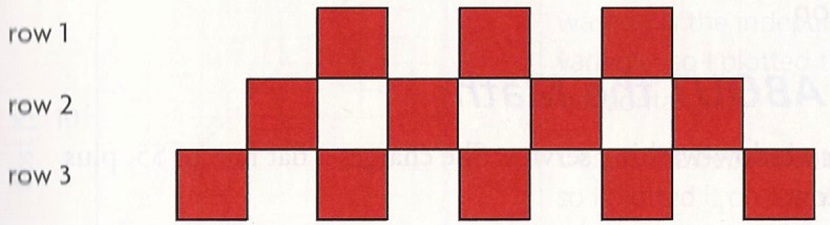
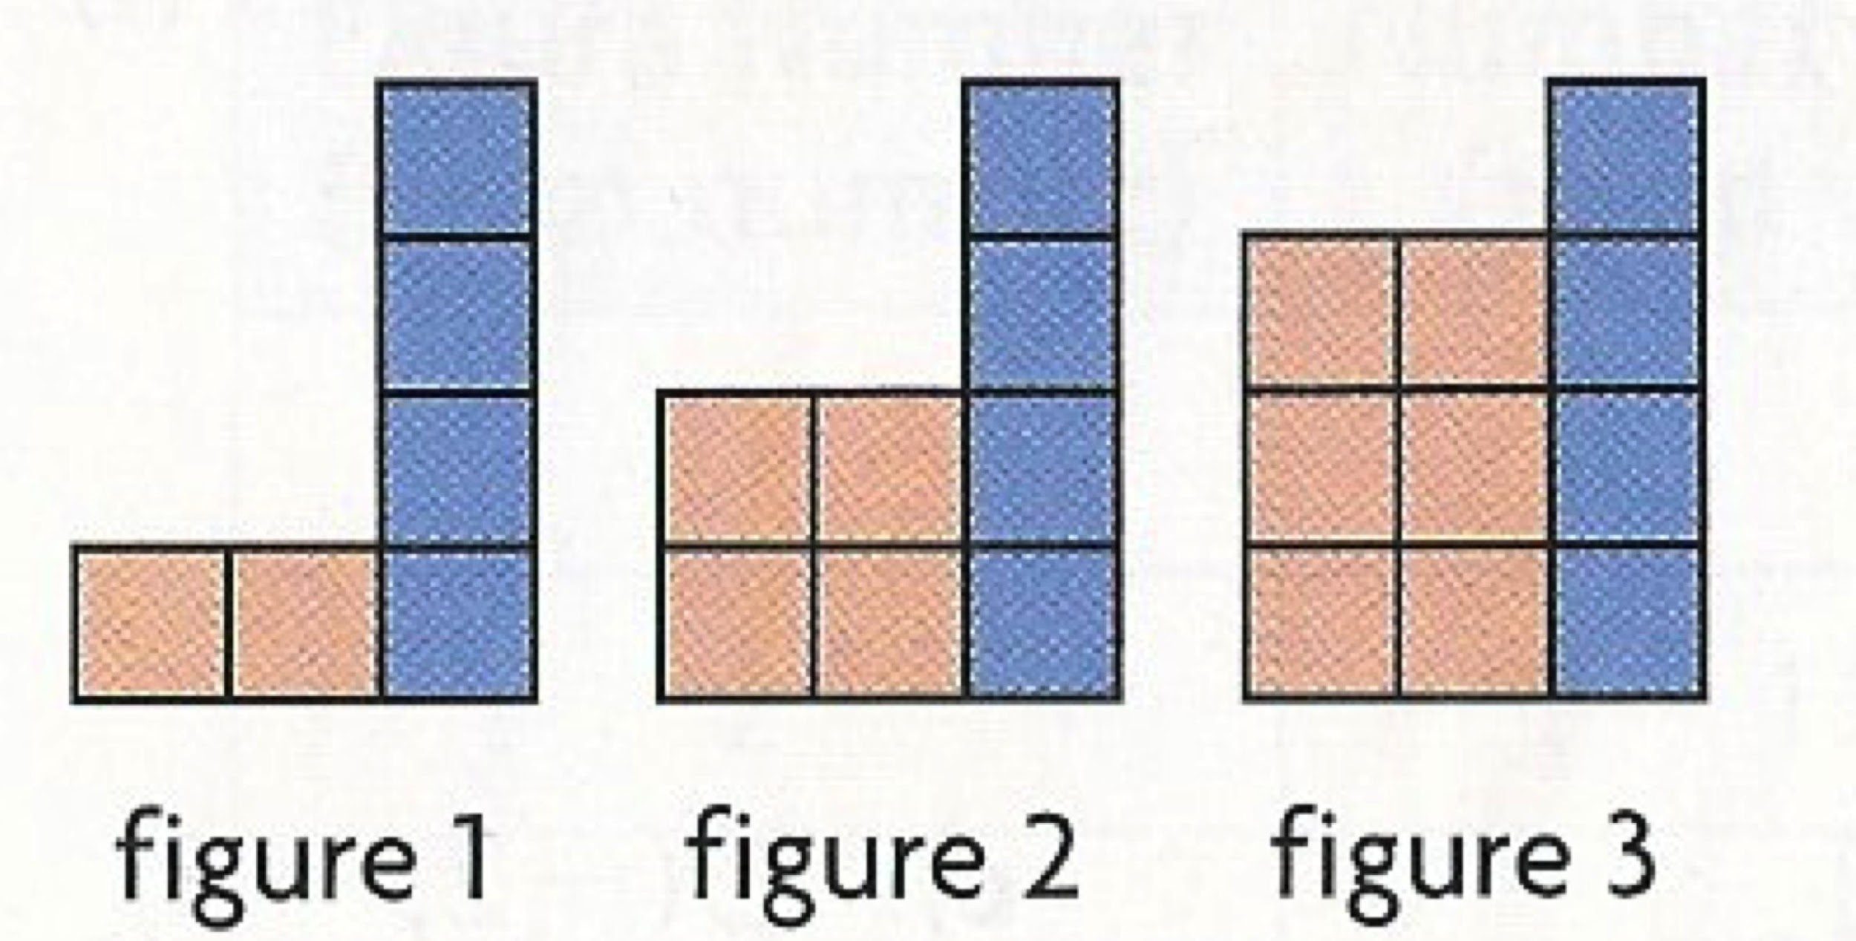
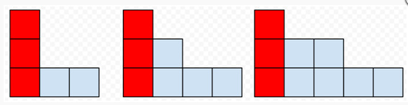
FIGURE 1 FIGURE 2 FIGURE 3

Jo runs a window washing service. She charges a flat rate of $5, plus $3 per window.

Chris starts with $50 in his bank account. He takes out $2.50 at the end of each week to buy hot chocolate from the cafeteria.
3, 7, 11, 15, 19, …
8, 5, 2, -1, …

input | output
1 | 5
2 | 8
3 | 11
4 | 14

Time(s) | # cubes linked
1 | 3
2 | 5
3 | 7
4 | 9

T = 4n + 3
C = 3p + 1

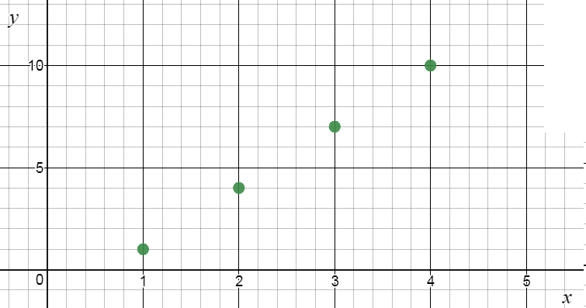

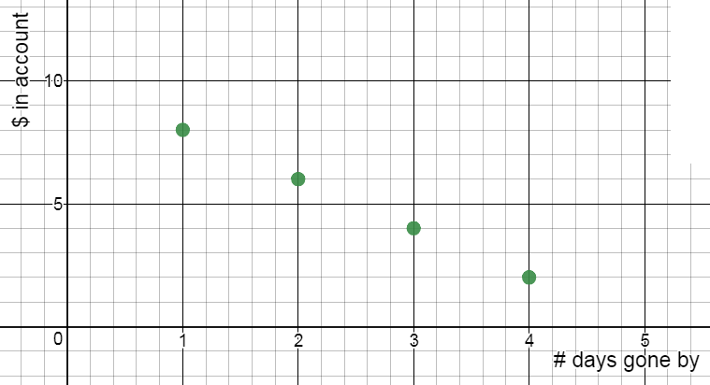

Time(s) | Height of balloon (m)
0 | 10
10 | 12
20 | 14
30 | 16

# visitors | # Timbits left
5 | 50
10 | 40
15 | 30
20 | 20

