SPH3U – Electricity & Magnetism Assignment
Due: Monday Jan 25 via Google Classroom
Your job is to write a multiple choice quiz, similar to the Kahoot quizzes that Mr John made earlier.
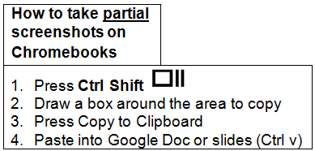
- Aim for between 10-20 questions
- Include a variety of topics related to electricity and magnetism
- Include a variety of levels of difficulty (easy, medium, harder)
- Put thought into your possible answers – try to think of wrong answers that people might reasonably give
- Include both “concept” type questions, as well as “calculation” type questions. Large, complicated circuit analysis questions probably aren’t suitable for a kahoot, but smaller ones would work.
- Here are links to the Kahoots Mr John made if you would like to see some example questions (Kahoot1, Kahoot2)
- Include some pictures in your questions if they can help. You can draw by hand or take from the internet. Consider using a picture for multiple questions. Instructions above.
Here are some possible topics to get you started:
Drawing circuits (symbols, etc.) | Ohm’s Law (V = IR) | Static vs. current electricity
Current, Voltage, Resistance – what are they? | Series circuits – equivalent resistances | Parallel circuits – equivalent resistances
Parallel circuit concepts (ex. what are they? unscrewing one bulb, voltage drop across, how current works | Series circuits concepts (ex what are they? why lightbulbs aren’t bright, current and voltage concepts) | Analogies:  Circuit – Water  Circuit – Jujubes  Circuit – Trucks/Roads/etc
Kirchoff’s voltage law around a loop | Kirchoff’s current law at a node | What are magnets?
Magnetic attraction and repulsion between magnets | Magnetic attraction and repulsion between magnet and non-magnet | Magnetic field lines
The earth’s magnetic field | Oersted’s principle | Faraday’s Law
Left-hand rule (straight conductors) | Left-hand rule (coiled conductors | Motor principle (concepts, directions)

Here’s what I’ll be looking for when marking:
 | R | 1 | 2 | 3 | 4
Variety of questions (topics, difficulties)
Clarity/accuracy of questions (correct vocabulary, wording, understanding)
Overall impression (pictures, # of questions, general quality, etc.

