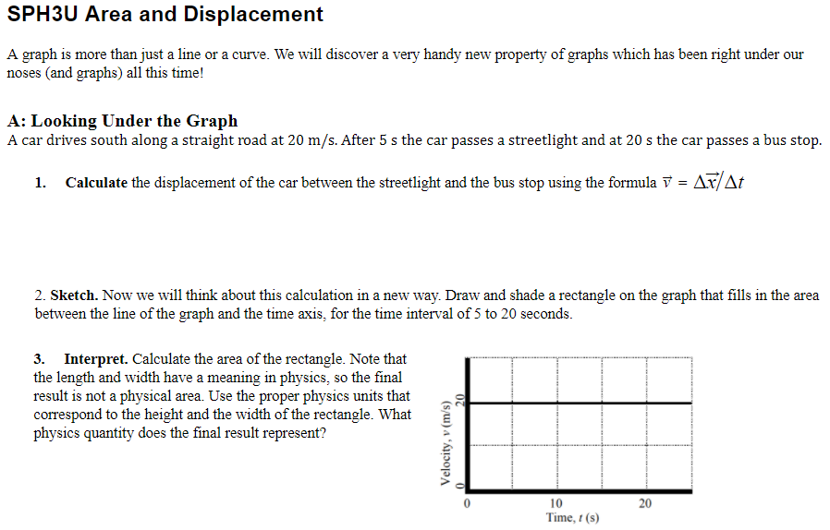

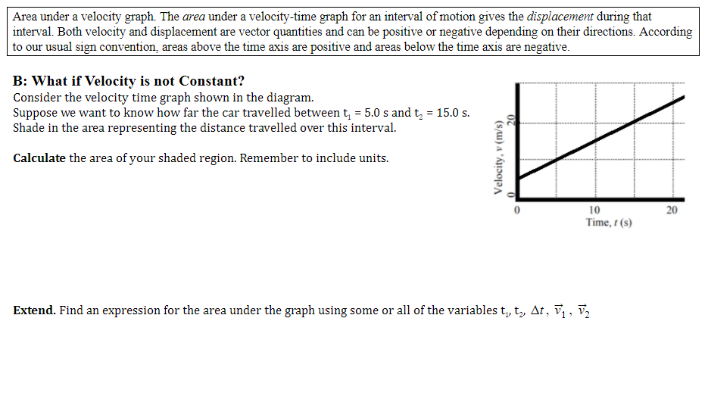

***Convert all x-t graphs into v-t graphs, and vice versa.***

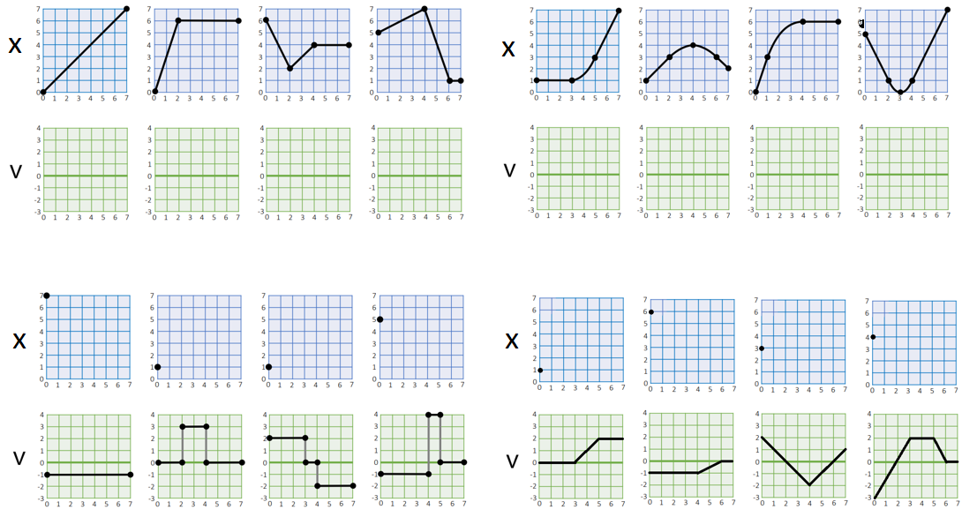

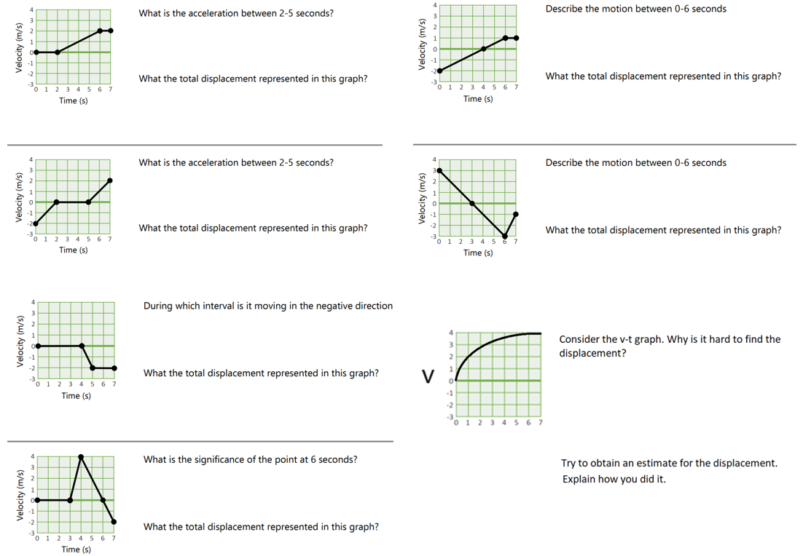

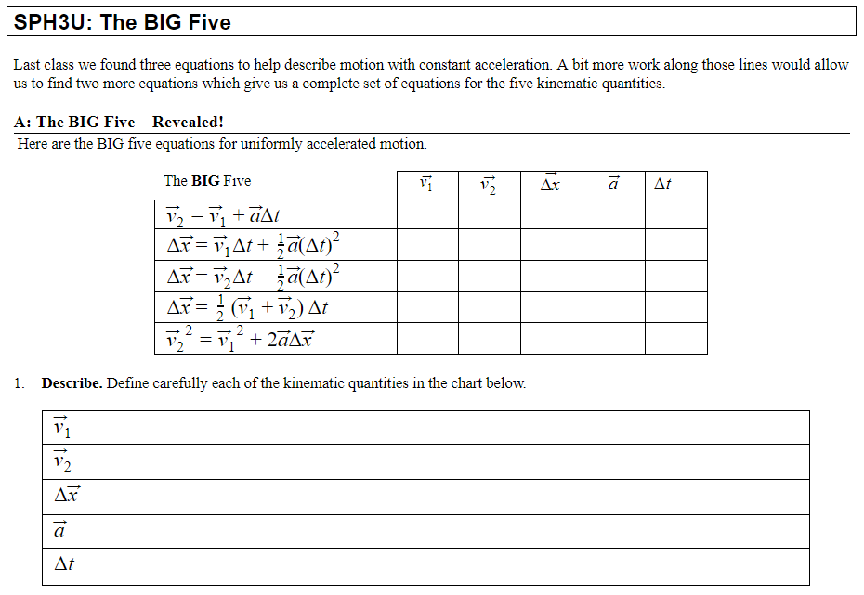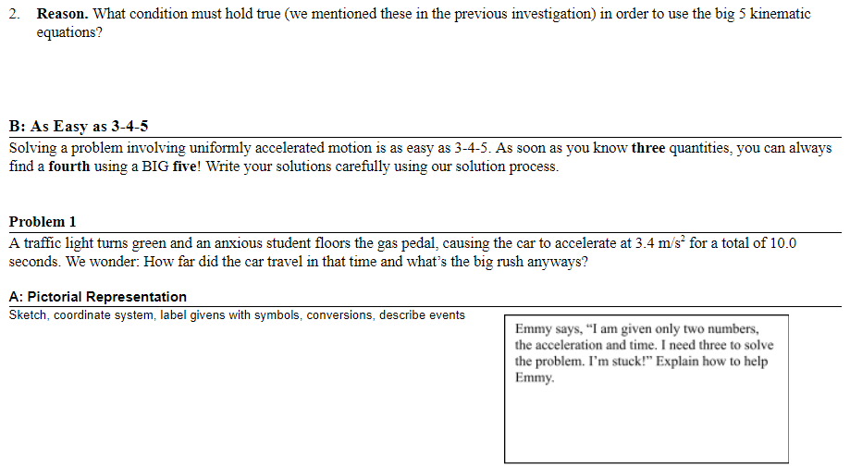

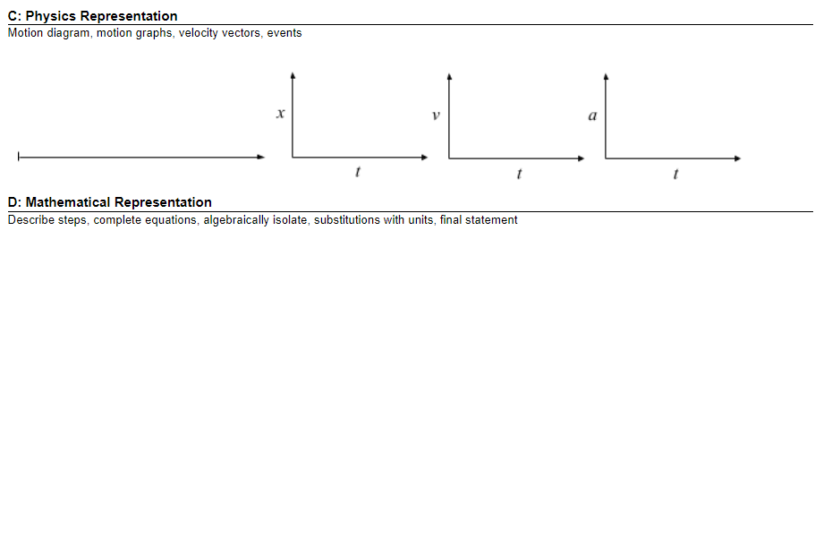

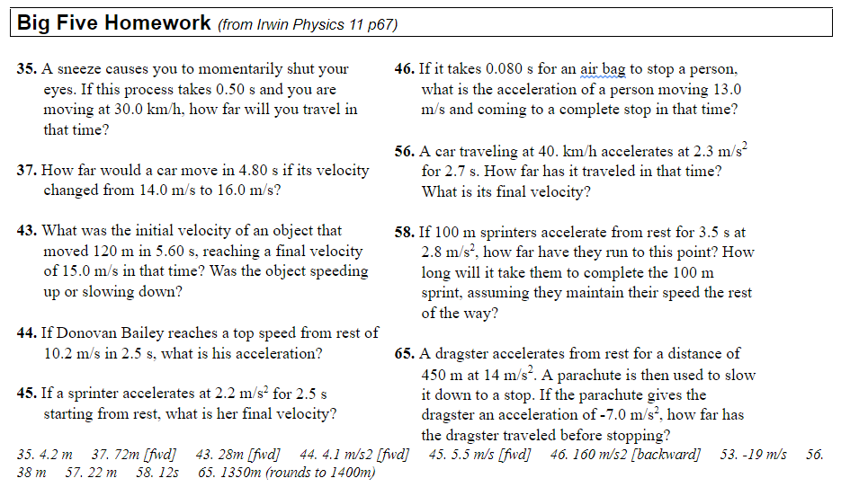

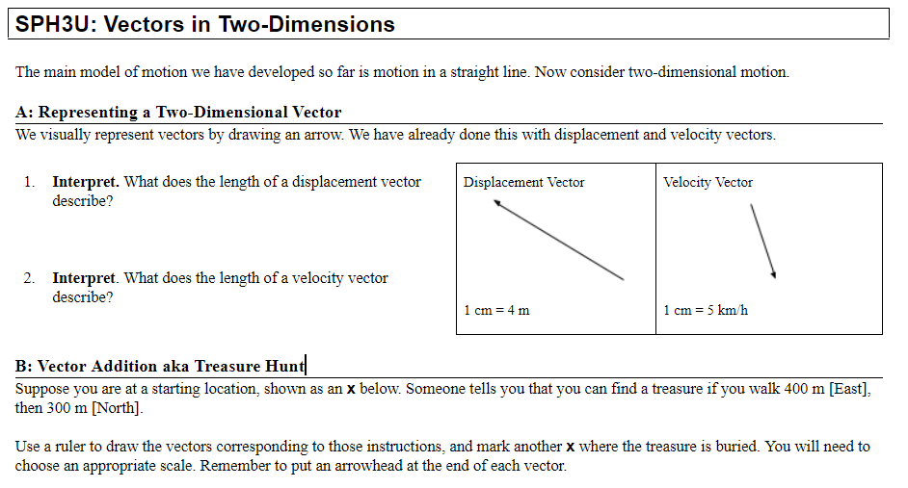

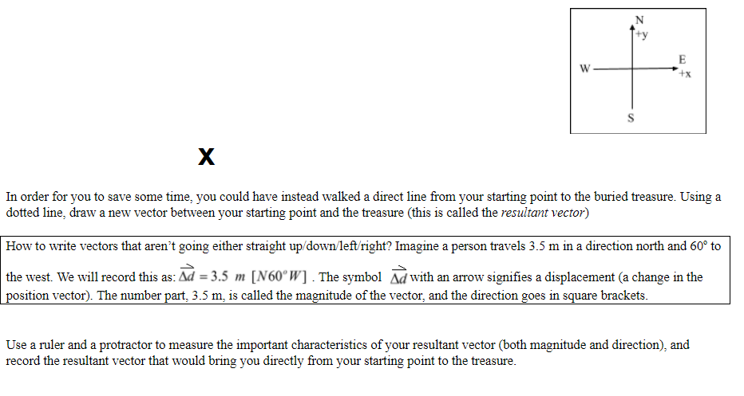

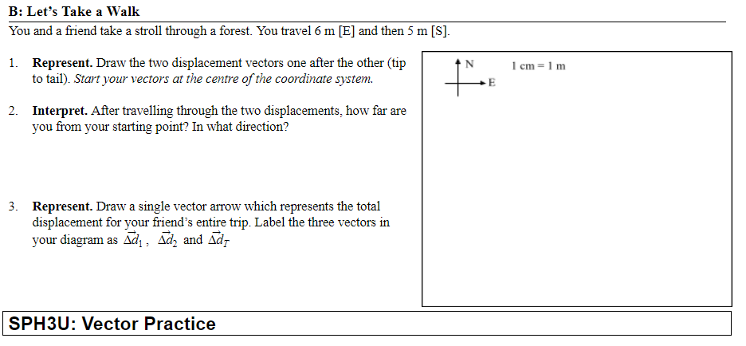

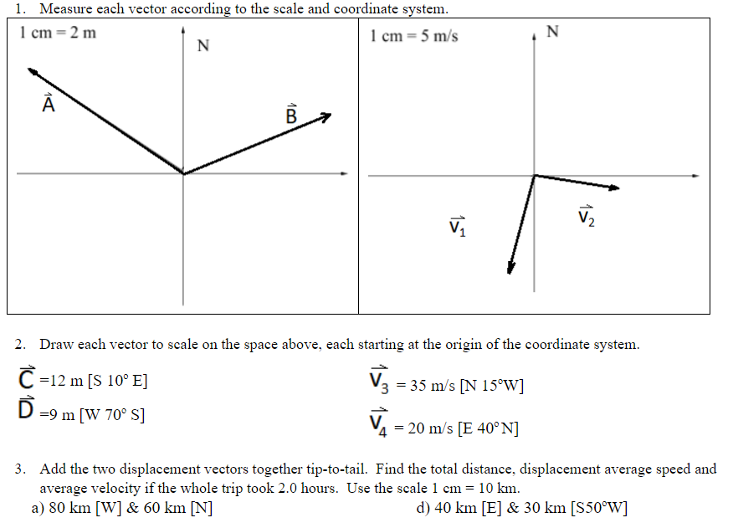

***SPH3U - 2D Projectile Motion Problems***

|  |  |  |
| --- | --- | --- |
|  | |  |
|  |  | FORMULAS $v=\frac{Δd}{Δt}$**(when accel = 0)** |

# SPH3U Homework: Interactions and Forces Name:

## A: Interactions and Forces

There are many different ways in which objects can interact and these different types of interactions can be organized into two large groups. Some common ones are listed below.

**Types of Interactions / Forces**

**Tension** (t) = two objects pulling on each other through a rope or string (no stretching)

interactions

contact

non-contact

tension friction normal

gravitational magnetic

elastic applied

**Elastic** (e) = two objects push/pull on each other due to stretch or compression of material

**Friction** (f) = resistance between two surfaces that are slipping or trying to slip past each other

**Normal** (n) = two surfaces in contact and pressing in to each other

**Applied** (a) = the contact force due to a person – a combination of friction and normal forces

**Gravitational** (g) = the gravitational interaction between two objects

**Magnetic** (m) = the magnetic interaction between two objects

Our contact interactions usually focus on solid objects. It is also possible to have a contact interaction with a fluid. One example of this is **air resistance** (air), and **buoyancy** (b) the interaction responsible for floating.

1. **Represent.** For each situation below complete the missing parts: the description (with the system), the sketch, or the interaction diagram.

|  |  |  |  |
| --- | --- | --- | --- |
| Situation 1 | Situation 2 | Situation 3 | Situation 4 |
| You pull a ball upwards using a string.  system = ball | system = boat | system = nail | system = |
|  | wind | Description: https://encrypted-tbn0.gstatic.com/images?q=tbn:ANd9GcTFyqY9pnwgNEeW08DXwAPBY59p6sRQ7EwNOAXOpD230qftl7RPLg |  |
|  |  |  | wagon  sidewalk  Earth  n  g  hand  f  t |

1. **Represent.** Draw force diagrams (FD) for each situation.

|  |  |  |  |
| --- | --- | --- | --- |
| Situation 1 | Situation 2 | Situation 3 | Situation 4 |
|  |  |  |  |

© C. Meyer, 2017

**SPH3U: Interaction and Force Diagram Review Name:**

Draw an interaction diagram and a force diagram for the system of the rock. Label the forces using:

(force of gravity), (force of tension), (normal force), (force of friction), (force of air resistance). Indicate the direction of motion and the direction of acceleration.



|  |  |  |  |  |  |
| --- | --- | --- | --- | --- | --- |
| Situation | ID | FD | Situation | ID | FD |
| 1) A rock is falling at constant (terminal) velocity due to air resistance. |  |  | 2) A rock tied to a rope is at rest. |  |  |
| 3)A rock is slowing down due to friction. |  |  | 4) A rock is moving upwards and is slowing down. |  |  |
| 5) A rock is tied to a rope and is pulled upward such that it is accelerating up |  |  | 6) The rock is speeding up and experiences friction. |  |  |
| 7) A rock has a book placed on top of it. |  |  | 8) The rock is sliding at constant speed on a frictionless surface. |  |  |
| 9) A rock has been thrown upwards and is slowing down. |  |  | 10) The rock is being held against a wall with a horizontal force. |  |  |

# SPH3U: What is the Effect of a Force?

What happens when a single constant force acts on an object?

## A: The Steady Push or Pull

1. **Prediction**. How will an object move when you exert a constant horizontal force (a steady push or pull) on it?
2. **Observe.** Your teacher will demonstrate the application of a constant(ish) horizontal force to a cart. Record your observations.
3. **Represent.**  Draw an interaction diagram for your system while the force is being exerted. Then draw a motion diagram and a velocity graph and a force diagram (FD). Label the events (1) starts the push / pull (2) stop the push / pull.

+*x*

*t*



**ID**

FD:

**B: Let Go**

After the object is in motion, we will stop exerting the force.

1. **Observe.** Describe the motion of the object **after** it has been released.
2. **Represent.** Complete the motion diagram and velocity-time graph diagrams. Label two events on each: (2) stop the push / pull and (3) the object comes to rest.

*t*



+*x*

1. **Reason and Represent.** Imagine we could reduce friction a bit. How would the motion be different after it is released? Sketch a velocity graph for this imaginary situation and explain how it appears different from the previous velocity graph.



1. **Reason and Represent.** Now imagine we remove **all** sources of friction. After you stop pushing / pulling, what would you observe in this very special situation? Sketch a velocity graph. In this situation what horizontal forces are acting on the cart?

*tt*



**C: Summary**

1. **Reason.** Describe the motion that results from an object experiencing a single constant force.

# SPH3U: The Net Force

A car driving down the road experiences many forces at the same time. What happens in such a case? Use the Forces and Motion Basics (Net Force) simulation with 2 horizontal forces pulling on the cart (<https://phet.colorado.edu/en/simulation/forces-and-motion-basics>). Assume friction is very small (the size of friction is zero).

## 

## A: Two Balanced Forces

Exert two equal-sized forces on the cart, but in opposite directions.

1. **Observe.** Describe the motion of the cart.
2. 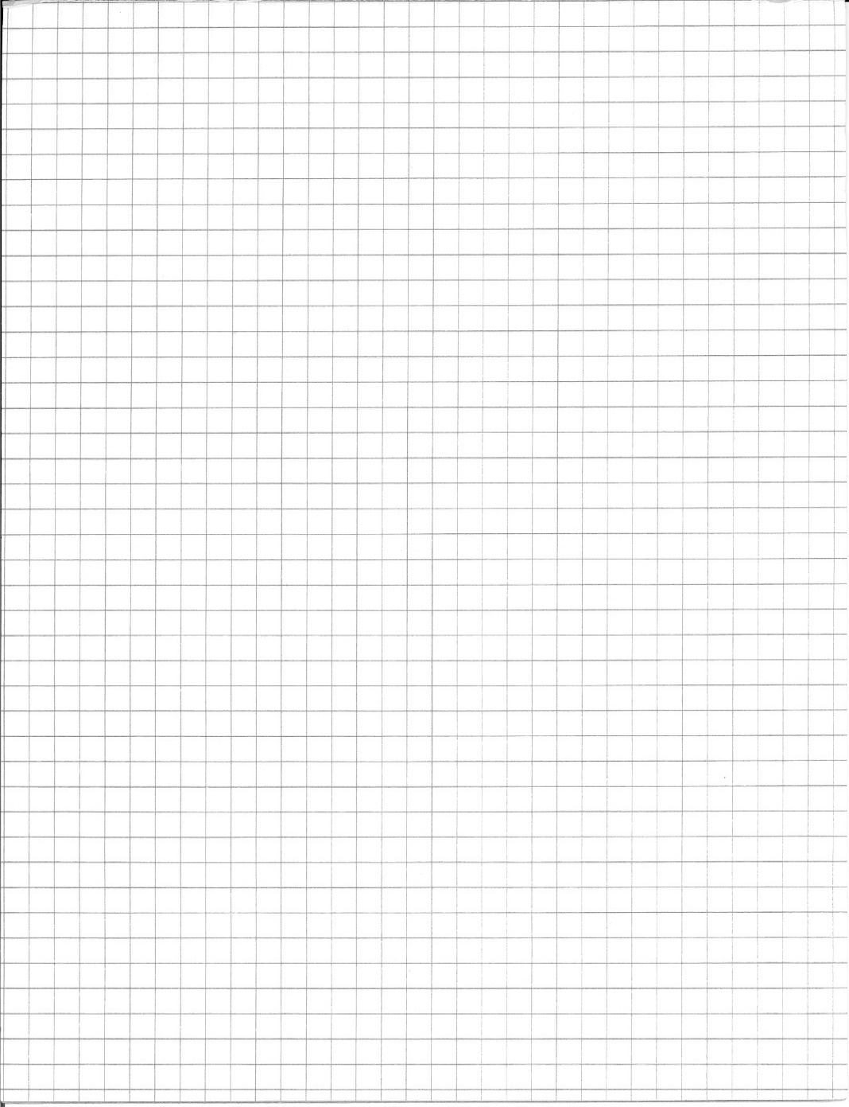**Interpret.** The force diagram (FD) to the right shows a model for the two tension forces exerted on the cart. What do the “tick marks” and the lengths of these vectors tell us about the two forces?

•

**FD ${\vec{F}}_{\text{B}}$ ${\vec{F}}_{\text{A}}$**

Net Force. The *net force (${\vec{F}}_{net}$*) is the combined effect of all the forces acting on an object. Since there may be forces in more than one direction (horizontal & vertical) we will often describe the net force in a particular direction (${\vec{F}}_{net x}$ or ${\vec{F}}_{net y}$).

1. **Explain.** Below are vector and scalar equations for the net force in the *x*-direction experienced by the cart. Why do these make sense? Notice the vector symbols (or lack thereof).

${\vec{F}}_{net x}$*= ${\vec{F}}_{\text{B}}+{\vec{F}}_{\text{A}}$ $F_{net x}$ = ${-F}_{\text{B}}+F_{\text{A}}$*

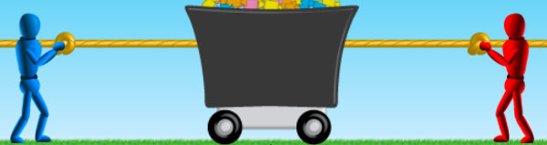

## B: On the Move

What will happen to a cart that is already moving if it experiences balanced forces?

1. **Represent.** Draw a FD for the cart. Label the two forces. Assume *FA* = 50 N and *FB*= 50 N.

**FD**

© C. Meyer 2020

1. **Calculate.** Write a net force equation in the *x*-direction and calculate the result.
2. **Test.** Turn on the speed measurement and add a person to one side of the cart. Once the cart is moving, add a person to the other side of the cart so that the forces balance. Describe your observations and explain.

## C: Net Force is Not Zero

Now increase the size of one of the forces. *FA* = 100 N.

1. 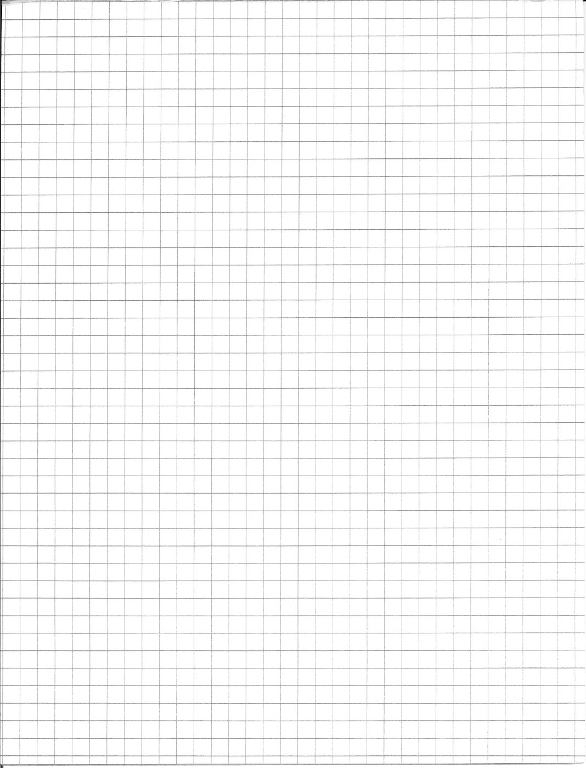**Represent.** Draw a FD and label the two forces. How should you draw the length of the two force vectors?

**FD**

1. **Calculate.** Write a net force equation and calculate the result.

Unbalanced Forces. If the net force is not equal to zero, we say that the forces acting on the object are *unbalanced*.

1. **Test.** Use a timer to determine how long it will take for the tug-of-war to end.

$$\vec{a}$$

Acceleration Vector. If a system accelerates, draw a wiggly acceleration vector ( ) that points in the direction of the acceleration alongside the force diagram. Check your previous force diagrams and add an acceleration vector.

1. 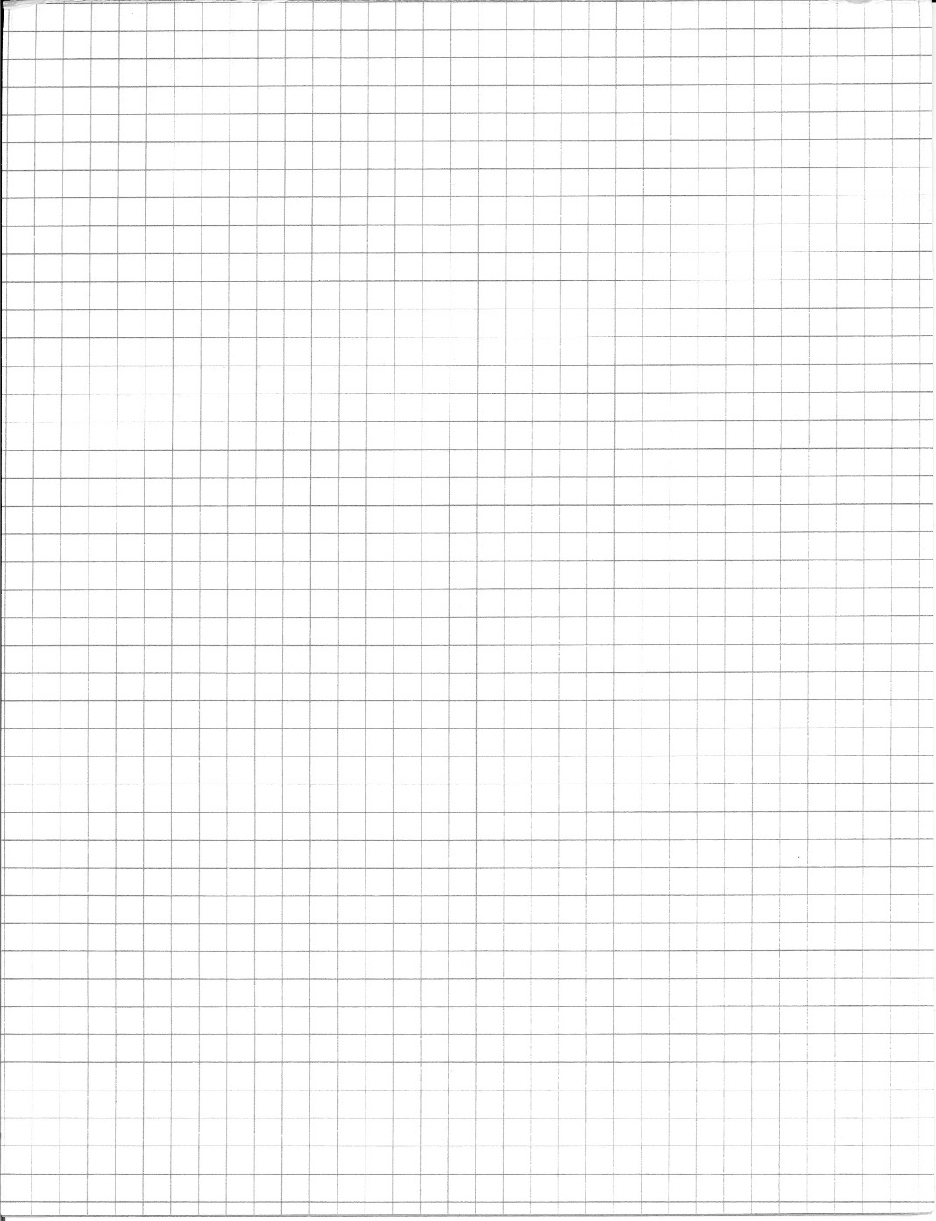**Speculate.** According to your calculation for the net force, what single force could replace the two forces in this situation? Draw a FD for this situation.

**FD**

1. **Test.** The cart now experiences a single force equal to the net force from before. Run the simulation, and again use your timer to determine how long it takes. Compare your result to the time from #3 above.

## D: The Forces-Motion Catalogue

Complete the chart below showing the correspondence between the different states of force and motion we have explored.

|  |  |  |
| --- | --- | --- |
| **State of Force** | **Net Force**  (circle one) | **State of Motion (at rest / constant velocity / accelerating )** |
| No forces at all | zero / non-zero | 1) if starting at rest… |
| 2) if starting in motion… |
| Balanced forces (two or more) | zero / non-zero | 1) if starting at rest… |
| 2) if starting in motion… |
| One single, unbalanced force | zero / non-zero |  |
| Unbalanced forces (two or more) | zero / non-zero |  |

**First Law of Motion:** A body at rest remains at rest or, if in motion, remains in motion at a constant velocity unless acted on by a net external force.

**SPH3U Homework: The Net Force Name:**

1. For each force diagram, decide if the forces appear to be balanced or unbalanced. Write the expression for the net force in the *x- or y*-direction. Use the directions right or up as positive. What type of motion will be the result: acceleration or rest/constant velocity? Look at the sample answers for hints on what to do if you’re stuck.

|  |  |  |  |  |
| --- | --- | --- | --- | --- |
| FD |  |  |  |  |
| Balanced? |  | unbalanced |  |  |
| $${\vec{F}}_{net x}$$ | $${\vec{F}}_{net x}={\vec{F}}_{f}+{\vec{F}}_{a}$$ |  |  |  |
| Motion? |  |  |  | positive acceleration |

|  |  |  |  |  |
| --- | --- | --- | --- | --- |
| FD |  |  |  |  |
| Balanced? | balanced |  |  |  |
| $${\vec{F}}_{net y}$$ |  | $${\vec{F}}_{net y}={\vec{F}}_{n}+{\vec{F}}_{g}$$ |  |  |
| Motion? |  |  |  | negative acceleration |

1. Two forces act in opposite directions on an object, *FR* to the right and *FL* to the left. Indicate the direction of the acceleration with a wiggly acceleration vector. Compare the size of the two forces. Draw a force diagram.

|  |  |  |  |  |
| --- | --- | --- | --- | --- |
| Motion  Diagram | 1 2  ● ● ● ● ● ● | 2 1  ● ● ● ● ● ● | 1 2  ● ● ● ● ● ● | 2 1  ● ● ● ● ● ● |
| Accel. |  |  |  |  |
| Compare |  | FL > FR |  |  |
| Force  Diagram |  |  |  |  |

1. Each situation is described by a force diagram and an initial velocity. Complete the table below. You may assume that the object does not change direction.

|  |  |  |  |  |
| --- | --- | --- | --- | --- |
| FD |  |  |  |  |
| *v1* | 0 | Negative |  | positive |
| Motion Diagram |  |  | 1 2  ● ● ● ● ●● |  |

© C. Meyer 2012

**SPH3U: The Force of Gravity!**

Visit [www.explorelearning.com](http://www.explorelearning.com)  
Enter class code MZTPMM  
Make an account (if needed)

Go to My Classes > SPH3U  
Weight and Mass

How does an object’s mass affect the size of the force of gravity it experiences? Let’s find out. Your teacher will show you a spring scale, but you will collect data using a Gizmos applet. Follow the instructions to the right to find the activity.

1. **Reason.** Is gravity a contact force or a non-contact force? How can we tell?

|  |  |
| --- | --- |
| **graphpaper0001ID** | **FD** |

1. **Represent.** Draw an ID and a FD for the mass. Explain why we can use the scale reading (an upwards force of tension) to determine the size of the force of gravity.

1. **Design & Observe.** We want to know how the mass of the object affects the magnitude of the force of gravity that it experiences. Add a variety of known masses to the spring scale in the activity, and complete the table of values below.

|  |  |
| --- | --- |
| Mass (kg) | Force of Gravity (N) |
| 0 |  |
|  |  |
|  |  |
|  |  |
|  |  |
|  |  |
|  |  |
|  |  |
|  |  |
|  |  |

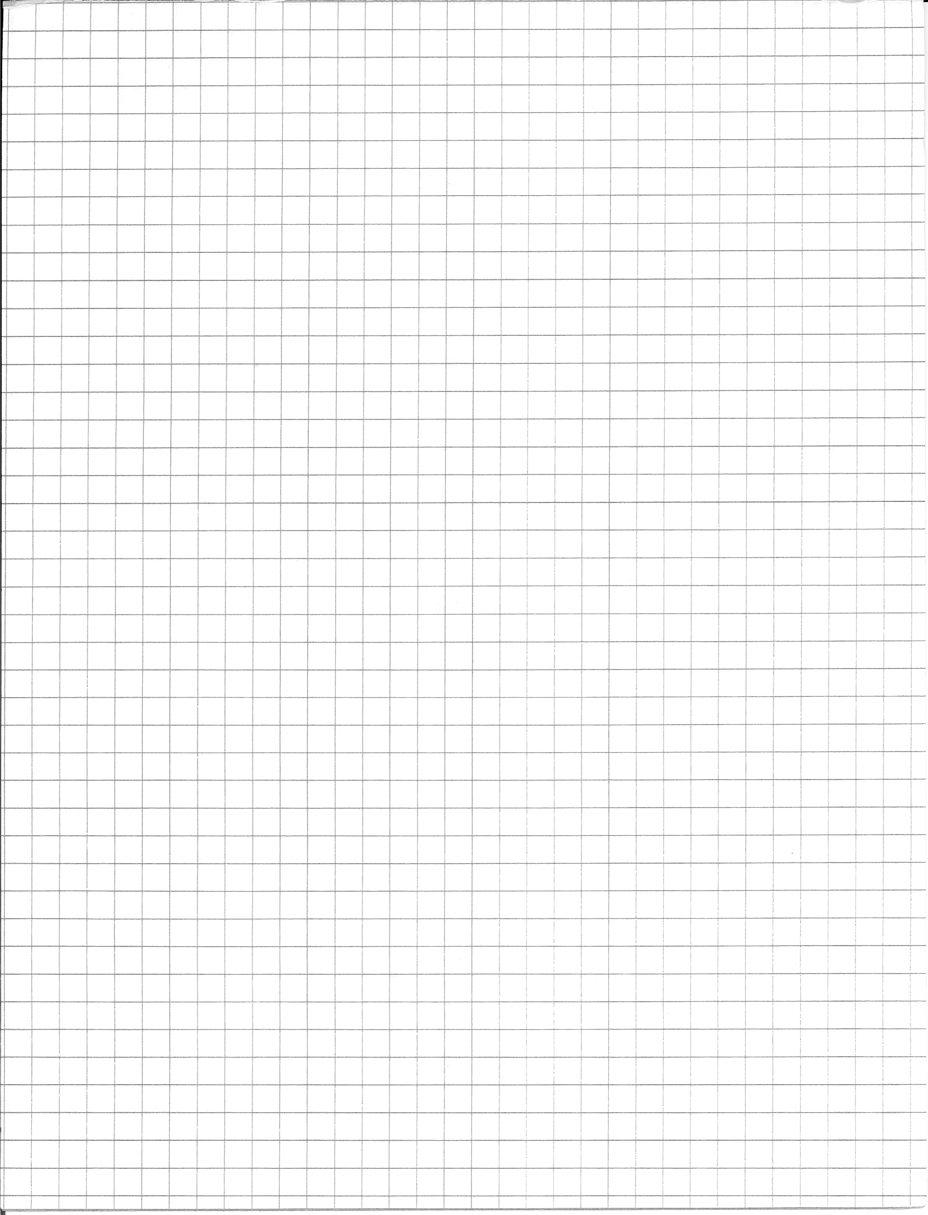

1. **Analyze.** Decide which variable is the dependent one.Plot your data on the graph.

1. **Calculate.** Determine the slope of your graph, including units.

The slope of your graph gives a very important quantity, the gravitational field strength. It tells us how much force the earth’s gravity exerts on each kilogram of matter in an object. The exact value depends on many factors including geographic location, altitude, and planet. The accepted value for your location is: _______ N/kg [down].

1. **Analyze.** Write an equation for your line of best fit – use the symbols *Fg* and *m*.
2. **Apply.** Use your new equation to determine the size of the force of gravity acting on a 1.5x103 kg car.

© C. Meyer 2012

**SPH3U: Force of Gravity Homework**

1. **Represent.** Complete the chart for each situation described.

|  |  |  |  |  |  |
| --- | --- | --- | --- | --- | --- |
|  | **Description** | **Sketch** | **Interaction Diagram** | **Force Diagram** | **Net Force** |
| 1 | A tasty chocolate in your hand is moving upwards with a constant speed.  System = chocolate |  |  |  | $${\vec{F}}_{net x}$$ = ${\vec{F}}_{net y}$ = |
| 2 | You pull upwards on a heavy dumbbell, but it doesn’t move.  System = dumbbell |  |  |  |  |
| 3 | You pull along the horizontal handle of a wagon. It travels along the rough ground and speeds up.  System = wagon |  |  |  |  |
| 4 | You lower a ball using a string. It slows down.  System = ball |  |  |  |  |

1. **Calculate.** The chocolate in question #1 has a mass of 20 g. What is the size of the gravity force it experiences?
2. **Calculate.** The dumbbell in question #2 has a mass of 10 kg and you pull with a force of 10 N. What is the size of the gravity force?
3. **Calculate.** The wagon in question #3 experiences a net force of 30 N and a force of friction of 10 N. What is the size of the pulling force?

**SPH3U: Normal Forces Homework**



|  |
| --- |
| **ID** |

You grab your physics textbook off a shelf and lower it down on to your desk. As the book moves, it lies flat on the palm of your hand. There are four important events that take place: (1) The book begins to speed up as it starts moving downwards, (2) the book reaches a constant velocity, (3) the book begins to slow down as it nears the desk, and (4) the book comes to rest at the bottom.

1. **Represent.**  Draw an interaction diagram for the system of the book during these events.
2. **Represent.** Complete the chart below for each of the three intervals in the book’s downwards motion.
3. **Calculate.** The mass of the book is 1.3 kg. What is the size of the force exerted by your hand between events 2 and 3?

|  |  |  |  |
| --- | --- | --- | --- |
| Interval | 1-2 | 2-3 | 3-4 |
| Motion Diagram | +*y* | +*y* | +*y* |
| graphpaper0001Force Diagram | ● | ● | ● |
| Net Force | = | = | = |

1. **Test and Describe.**  Find a heavy book and place it on the palm of your hand just like in the picture. Lower the book just as we have described above. Try to connect how it feels in your hand when you do this with your understanding of the forces. Describe what you notice.

|  |  |
| --- | --- |
| graphpaper0001FD – no push  ● | FD –push  ● |

1. **Reason.** Your friend places the same book on a table. She then leans on top of it, pushing down with 7 N of force. Draw a FD for book with and without the downwards push. Compare the size of all the forces in the two diagrams.
2. **Calculate:** Calculate the normal force acting on a 2.1 kg book in each scenario:
   1. The book is at rest on the table
   2. The book is still at rest, but you are pushing down on the book with a force of 2.0 N
   3. The book is attached to a string that is being pulled up with a force of 1.5 N
   4. There is a 0.40 kg apple on the book
   5. You pull out the table from below and the book falls through the air

© C. Meyer 2017

**SPH3U: Mass, Weight, Apparent Weight, Inertia**

**Mass**

-quantity of stuff/matter

-fundamental property (like time): impossible to define in terms of other things

-not dependent on gravity...mass constant everywhere (earth, moon, in space, under water, etc.)

**Weight**

-measures force (in Newtons) acting on an object by gravity

-depends on gravity...weight will be different on the moon, or in outer space  
  
-commonly (& incorrectly) used as a substitute for mass, since we spend our time on earth

-in physics we call it the Force of Gravity (Fg)

© G. John 2020

**Normal Force (Fn)**

-the force with which the floor pushes up on an object

Complete the table using symbols like <x, =z, 0, etc

|  |  |  |  |
| --- | --- | --- | --- |
|  | **Mass** | **Weight** | **Apparent Weight** |
| On flat earth | x | y | z |
| On the moon |  |  |  |
| Waist deep in water |  |  |  |
| In outer space |  |  |  |

-When things are on flat surfaces, not accelerating, and acted upon by gravity only, then:

Fn = Fg = mg

Where *m* is the mass of the object and *g* is the acceleration due to gravity (on earth)

**Force of Gravity (Fg)**

-the force of attraction between ANY two objects, but most commonly used for the force between the earth and an object near earth

**Apparent Weight**

-how hard the floor pushes up on you  
  
-the weight you *feel* (consider: in a swimming pool; in an elevator; in outer space)

-this is what a bathroom scale measures

-in physics we call this the Normal Force (Fn)

**Inertia**

-resistance of an object to a change in its state of motion (at rest → at rest; moving → moving)

-from the latin “*iners*” (idle, sluggish)

-is a concept, not a measurement

-the more mass something has, the more inertia it has (consider pushing a small vs. big rock)

# SPH3U: The Change of Force Principle

We have made a great discovery with the First Law of Motion (our catalogue of force-motion relationships). Now we need to figure out what happens when forces change.

## A: Systems and Interactions

Your teacher has a cart set up on a track with a motion detector. We will create a model for the system of the cart including the extra weights. Our experiment has three events: (1) the cart begins moving, (2) the mass hits the ground, and (3) the cart reaches the end of the track.

Objects outside a system are in the *environment*. When objects outside a system interact with a system object, they produce an *external force.* The First Law of Motion involves external forces only. So, we only draw external forces on a force diagram.

1. **Represent.** We will beginby focusing on the system between events 1 and 2. Complete the chart below. Use the interaction diagram to determine the number of force vectors to draw. Use your understanding of the state of motion and force in each direction to determine the size of the force vectors.

|  |  |  |  |
| --- | --- | --- | --- |
| **Interaction Diagram**  cart  weights  earth  track  counter-weight  n  t  g  n | **Vertical Direction**  State of motion:  State of force: | **Horizontal Direction**  State of motion:  State of force: | **graphpaper0001Force Diagram** |

1. **Interpret.** According to the ID above, what have we assumed about the force of friction?

## B: Change of State

|  |  |
| --- | --- |
| Interval 1-2 | Interval 2-3 |
| *v*  *t* | |
| State of Motion: | State of Motion: |
| *t*  *F*t | |
| State of Force: | State of Force: |
| FD graphpaper0001 | FD |

Let’s return to our experiment. We are interested in exploring what happens to the state of motion when forces suddenly change.

1. **Observe and Interpret.** Observe the results from the computer. Complete the velocity and tension force graphs. Label the events. Complete the rest of the chart.
2. **Interpret.** During this experiment the state of motion changes and the state of the force change. What do you notice about the timing of these two changes?
3. **Reason.** Isaac says, “How is it possible in interval 2-3 for the cart to move horizontally with no horizontal force! This doesn’t make sense!” Help Isaac understand.

© C. Meyer 2020

# SPH3U Homework: The Force-Change Principle Name:

**A: The Billiards Game**

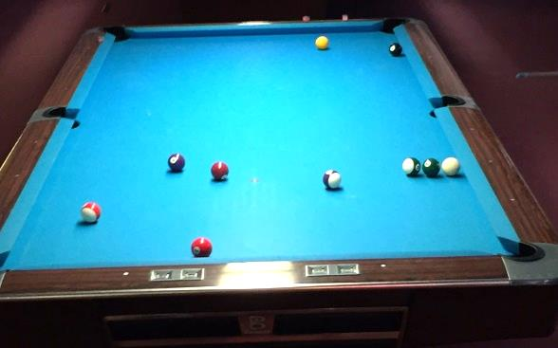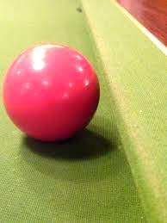In the game of pool, a ball bounces off the cushion at the side of a table. Friction between the ball and the table surface is very small compared with other forces, so we will ignore it. We choose five events to help us explore what happens:

1. The ball is travelling towards the cushion.
2. The ball makes contact with the cushion.
3. The cushion is squished and the ball stops.
4. The ball leaves contact with the cushion.
5. The ball is travelling away from the cushion.
6. **Reason and Represent.** For each interval of time between the pairs of events:
7. Draw an interaction diagram and a force diagram. The possible interacting objects are ball, Earth, table and cushion. Label the normal forces *F*n c-b (normal force of cushion on ball) and *F*n t-b (normal force of table on ball)
8. Describe the state of forces, the state of motion, and what is happening to the speed.
9. Sketch a velocity time graph and label the events (the graph is divided up according to the time intervals).

|  |  |  |  |  |
| --- | --- | --- | --- | --- |
| Interval | 1-2 | 2-3 | 3-4 | 4-5 |
| Description | Ball rolls towards cushion | Cushion becomes squished (compressed) | Cushion expands | Ball rolls away from cushion |
| Sketch | cushion  table  ball! |  |  |  |
| Interaction Diagram |  |  |  |  |
| Force Diagram | **graphpaper0001** |  | **graphpaper0001** |  |
| State of Force (balanced/unbalanced) |  |  |  |  |
| State of Motion (constant/accelerating) |  |  |  |  |
| Speeding Up or Slowing Down? |  |  |  |  |
| Velocity Graph  velocity  time | | | | |

# SPH3U Homework: The Force-Change Principle Practice

**Situation #1**: You are standing still on ice, holding onto the boards. You push off the boards and glide at a constant velocity (no friction) to the other side. When you arrive at the other side you grab the boards and slow down to a stop.

© G. John 2020 17

|  |  |  |  |  |  |  |  |  |  |  |  |
| --- | --- | --- | --- | --- | --- | --- | --- | --- | --- | --- | --- |
| **EVENTS:** | | 1 –start to push off | | 2 – finish pushing | | 3 – arrive at other side | | 4 – come to rest | |  | |
| Interval | | 1-2 | | 2-3 | | 3-4 | |
| Interaction Diagram | |  | |  | |  | |
| Force Diagram | | **graphpaper0001** | | **graphpaper0001** | |  | |
| State of Force (balanced/unbalanced) | |  | |  | |  | |
| State of Motion (constant/accelerating) | |  | |  | |  | |
|  | | | | | | | | | |

**Situation #2**: You drop a tennis ball into water from a height. The ball goes under water, then floats back to the surface.

|  |  |  |  |  |  |
| --- | --- | --- | --- | --- | --- |
| **EVENTS:** | 1 – you drop the ball | 2 ball hits surface | 3 ball reaches lowest point | 4 ball reaches surface | 5? (might not need) |

|  |  |  |  |  |
| --- | --- | --- | --- | --- |
| Interval | 1-2 | 2-3 | 3-4 | 4-5 |
| Interaction Diagram |  |  |  |  |
| Force Diagram | **graphpaper0001** |  | **graphpaper0001** |  |
| State of Force (balanced/unbalanced) |  |  |  |  |
| State of Motion (constant/accelerating) |  |  |  |  |
|  | | | | |

***SPH3U “Well I’m Free……..Freefallin!!”***

|  |  |  |  |  |  |
| --- | --- | --- | --- | --- | --- |
| **Events:** | **1.Start throwing ball upwards** | **2.Let go of ball** | **3.Ball reaches max height** | **4.Ball contacts hand** | **5.Ball comes to rest** |

1. Draw a force diagram of the ball in each interval/moment (use the events above). Ignore air resistance.

|  |  |  |  |  |
| --- | --- | --- | --- | --- |
| 1-2 | 2-3 | At event 3 | 3-4 | 4-5 |

1. Considering the force diagrams above, what can you say about the acceleration of the object while it is going up, at its peak, and coming back down?

1. Predict what the x-t, v-t and a-t graphs would look like if we considered the intervals given.
   1. The interval between events 2 and 4 (ie. the time the ball was in the air). Label the events.
   2. The interval between events 1 and 5 (ie. now including the throw and catch). Label the events.

1. Use the graphs on the next page to estimate the following:

|  |  |  |  |
| --- | --- | --- | --- |
| a) The height of the ball at 5.2 s | b) the velocity of the ball at 5.6 s | c) The time at which the velocity was -3.2 m/s | d) The time at which the ball was at a height of 0.9 m |

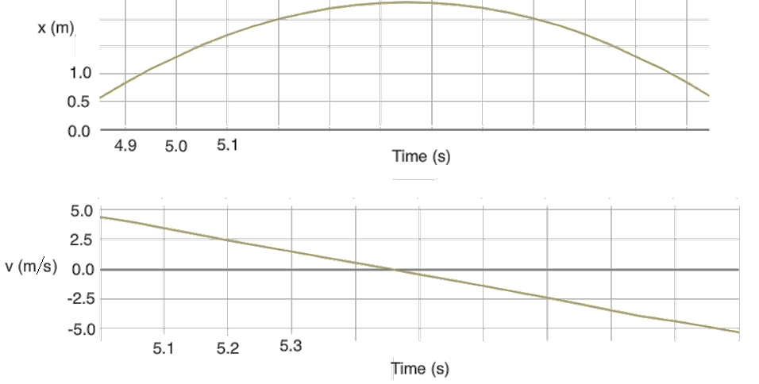

1. Determine the slope of the v-t graph. Show your work, include units, then explain the slope’s meaning.
2. Record the data from our class experiment, then answer the question below.  
   Drop height: Drop time: Initial velocity:

Calculate the acceleration due to gravity using the appropriate equations.

If you’re all done, can you find the equation of the v-t line ( y=mx+b ) and x-t curve ( y=a(x-h)2+k ) above?

