***MPM1D Spiral 3 Test*** Name: __________________________

|  |  |  |
| --- | --- | --- |
|  | **EXPECTATION** | **MARK** |
| PART 1 | determine, through investigation, the optimal values of various measurements |  |
| PART 2 | connect various representations of a linear relation |  |
| PART 3 | Determine the properties of the slope and *y*-intercept of a linear relation; |  |
| PART 4 | Apply geometric properties and relationships the results to solving problems. |  |

***Part 1: Optimization***

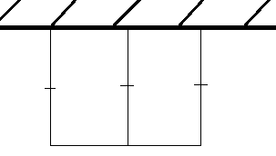

|  |  |  |  |
| --- | --- | --- | --- |
|  |  |  |  |
|  |  |  |  |
|  |  |  |  |
|  |  |  |  |
|  |  |  |  |
|  |  |  |  |
|  |  |  |  |
|  |  |  |  |

1. If 130 m of fencing   
   is available for   
   the shape shown   
   in the diagram,   
   what dimensions   
   will maximize the area?  
   Find the dimensions   
   to the nearest meter   
   (you can use the table,   
   or the graphing calculator)
2. Using **short** bullet point instructions, explain the step-by-step process for minimizing the amount of fence used given a fixed area. You can assume the shape is rectangular in nature.

***Part 2: Distance – Time Graphs***

|  |
| --- |
| 1. Describe the motion of the person that produces the following distance time graph. You do not need to provide numbers for distance/time/speed |
| 1. Describe the motion of the person that produces the following distance time graph. Include details about distance, direction, time and speed for every part of the journey. |

1. a) You start 5 m from the CBR. You walk away from it for 3 seconds, travelling 3m. You stop for 1 second, then walk towards the CBR at 2 m/s for 2 seconds. Carefully draw a distance time graph to represent your motion.  
   ***Part 2: Lines y = mx + b***

b) Suppose someone else started 1 m from the CBR, and walked away from the CBR at 0.5 m/s. Would the two people bump into eachother? If so, where and when?

1. Determine the equation of the following lines.

|  |  |  |
| --- | --- | --- |
|  |  | 1. has a slope of 3, and passes through the point (-3, 1) |

1. Draw a graph of the following lines. Label the lines.

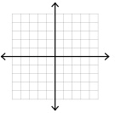

|  |  |
| --- | --- |
| a) y | b) |
| c) x |  |

8. Find the slope between the following pairs of points. You can use: 

a) (6, 9) and (2, 11) b) (-2, 5) and (-5, -1)  
  
  
  
9. Give the equation of a line that…

|  |  |
| --- | --- |
| a) has a slope of 3, and a y-intercept of 5 | b) goes down and to the right |
| c) passes through the point (1, 1) | d) does not have a y-intercept |
| e) is parallel to , and goes through the origin | f) is steeper than y $=-1.5x+5$ but less steep than |

***Part 4: Geometry – Angle Relationships***

Sum = 180(n – 2)

1. a) What is the sum of the interior angles of a 17-sided polygon? Show your work.  
     
     
     
     
     
   b) If the sum of the interior angles of a polygon is 5220◦, how many sides does it have? Show your work.

1. Determine the value of x. Lines *a* and *b* are parallel. Show your work. Diagram not to scale.

(3x + 48)°

5x°

*b*

*a*

1. Find the measure of the interior angle at R. Show your work. Diagram not to scale.  
   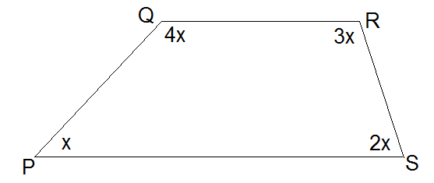
2. Find the value of z. Show your work. Diagram not to scale.  
   