MPM1D Spiral 3 Test Name: __________________________

 | EXPECTATION | MARK
PART 1 – RE2 | demonstrate an understanding of the characteristics of a linear relation;
PART 2 – NU2 | manipulate numerical and polynomial expressions, and solve first-degree equations
PART 3 – NU1 | demonstrate an understanding of the exponent rules of multiplication and division, and apply them to simplify expressions;

Part 1: Cube Toss Questions
- a) Draw a line of good fit and determine the key features (y-intercept, x-intercept, rate of change). Include units. Show how you determined your rate of change, and mark the x-int and y-int on the graph.

b) Write an equation to represent the relationship between the station # and the number of cubes scored in the situation above.
- a) Determine the rate of change of the following cube toss graph. Show your work.
b) The x-intercept is not shown in the graph. What would it be? Explain how you got your answer.

- The cube toss activity is done twice (Trial A and Trial B). Complete the table below.
Representation #1 (don’t need to write anything) | Representation #2  (add for Trial B) | Explanation: why is Trial B like this?

TRIAL A:
$$y=-8.5x+100$$TRIAL B:
$$y=-6.5x+80$$

Part 2: Solving Equations
- Solve for the variable. Show your work.
a) $3x+1=-5$ b) $3t+1=-t-3$
c) d)
- Mr John solves an equation in his head. Do a formal check to see whether his answer is correct. Show your work.
Original Equation | Mr John’s answer
$-4\left(x-3\right)=2x+36$ | $$x=-3$$

- a) Find a simplified algebraic expression for the perimeter of the shape. Diagram not to scale.
b) If the perimeter of the shape is 40 cm, determine the value of x. Show your work.
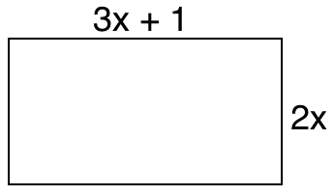

- The perimeter of the rectangle is 3 times as big as the perimeter of the square. What are the side lengths of the two shapes? Show your work. Diagrams not to scale.
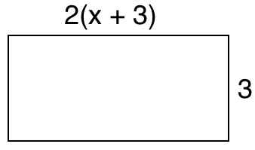 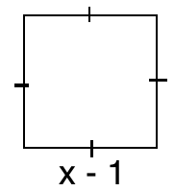

Part 3: Exponents and Exponent Laws
- Write the following as a single power (if possible).
- $6^{2}×6^{5}$ | - $\frac{{\left(-3\right)}^{8}}{{\left(-3\right)}^{3}}$ | - ${\left(x^{4}\right)}^{5}$ | - $2^{5}×3^{4}$

- Evaluate the following. Leave answers as fractions when appropriate.
- –5⁴ | - (–6)³ | - ${\left(\frac{3}{4}\right)}^{2}$ | - ${\left(-\frac{1}{5}\right)}^{3}$

11. Evaluate for $x = 2$ and $y = -3$. Show your work.
a) $5y^{3}$ b) $-2x^{2}y$ c) ${\left(x-y^{2}\right)}^{2}$

12. Use the exponent laws to simplify the following. Show your steps. Leave answers in exponential form.
a) $\frac{5^{4}\left(5^{7}\right)}{5^{2}}$ | b)${\left(3x^{2}\right)}^{3}$ | c) (–2x⁴)(3x²)
d) $\frac{{\left(x^{4}\right)}^{3}}{{(x}^{2})(x^{3})}$ | e)$\frac{{\left(-7\right)}^{3}{\left(-7\right)}^{7}}{{\left[{\left(-7\right)}^{2}\right]}^{3}}$ | f)$\frac{{\left(4t^{2}\right)}^{4}}{\left(-2t^{2}\right)\left(8t^{3}\right)}$

