# eSPH3U Homework: Interactions and Forces Name:

## A: Interactions and Forces

There are many different ways in which objects can interact and these different types of interactions can be organized into two large groups. Some common ones are listed below.

**Types of Interactions / Forces**

**Tension** (t) = two objects pulling on each other through a rope or string (no stretching)

interactions

contact

non-contact

tension friction normal

gravitational magnetic

elastic applied

**Elastic** (e) = two objects push/pull on each other due to stretch or compression of material

**Friction** (f) = resistance between two surfaces that are slipping or trying to slip past each other

**Normal** (n) = two surfaces in contact and pressing in to each other

**Applied** (a) = the contact force due to a person – a combination of friction and normal forces

**Gravitational** (g) = the gravitational interaction between two objects

**Magnetic** (m) = the magnetic interaction between two objects

Our contact interactions usually focus on solid objects. It is also possible to have a contact interaction with a fluid. One example of this is **air resistance** (air), and **buoyancy** (b) the interaction responsible for floating.

1. **Represent.** For each situation below complete the missing parts: the description (with the system), the sketch, or the interaction diagram.

|  |  |  |  |
| --- | --- | --- | --- |
| Situation 1 | Situation 2 | Situation 3 | Situation 4 |
| You pull a ball upwards using a string.  system = ball | system = boat | system = nail | system = |
|  | wind | Description: https://encrypted-tbn0.gstatic.com/images?q=tbn:ANd9GcTFyqY9pnwgNEeW08DXwAPBY59p6sRQ7EwNOAXOpD230qftl7RPLg |  |
|  |  |  | wagon  sidewalk  Earth  n  g  hand  f  t |

1. **Represent.** Draw force diagrams (FD) for each situation.

|  |  |  |  |
| --- | --- | --- | --- |
| Situation 1 | Situation 2 | Situation 3 | Situation 4 |
|  |  |  |  |

© C. Meyer, 2017

**SPH3U: Interaction and Force Diagram Review Name:**

Draw an interaction diagram and a force diagram for the system of the rock. Label the forces using:

(force of gravity), (force of tension), (normal force), (force of friction), (force of air resistance). Indicate the direction of motion and the direction of acceleration.



|  |  |  |  |  |  |
| --- | --- | --- | --- | --- | --- |
| Situation | ID | FD | Situation | ID | FD |
| 1) A rock is falling at constant (terminal) velocity due to air resistance. |  |  | 2) A rock tied to a rope is at rest. |  |  |
| 3)A rock is slowing down due to friction. |  |  | 4) A rock is moving upwards and is slowing down. |  |  |
| 5) A rock is tied to a rope and is pulled upward such that it is accelerating up |  |  | 6) The rock is speeding up and experiences friction. |  |  |
| 7) A rock has a book placed on top of it. |  |  | 8) The rock is sliding at constant speed on a frictionless surface. |  |  |
| 9) A rock has been thrown upwards and is slowing down. |  |  | 10) The rock is being held against a wall with a horizontal force. |  |  |

# SPH3U: What is the Effect of a Force?

What happens when a single constant force acts on an object?

## A: The Steady Push or Pull

1. **Prediction**. How will an object move when you exert a constant horizontal force (a steady push or pull) on it?
2. **Observe.** Your teacher will demonstrate the application of a constant(ish) horizontal force to a cart. Record your observations.
3. **Represent.**  Draw an interaction diagram for your system while the force is being exerted. Then draw a motion diagram and a velocity graph and a force diagram (FD). Label the events (1) starts the push / pull (2) stop the push / pull.

+*x*

*t*



**ID**

FD:

**B: Let Go**

After the object is in motion, we will stop exerting the force.

1. **Observe.** Describe the motion of the object **after** it has been released.
2. **Represent.** Complete the motion diagram and velocity-time graph diagrams. Label two events on each: (2) stop the push / pull and (3) the object comes to rest.

*t*



+*x*

1. **Reason and Represent.** Imagine we could reduce friction a bit. How would the motion be different after it is released? Sketch a velocity graph for this imaginary situation and explain how it appears different from the previous velocity graph.



1. **Reason and Represent.** Now imagine we remove **all** sources of friction. After you stop pushing / pulling, what would you observe in this very special situation? Sketch a velocity graph. In this situation what horizontal forces are acting on the cart?

*tt*



**C: Summary**

1. **Reason.** Describe the motion that results from an object experiencing a single constant force.

# SPH3U: The Net Force

A car driving down the road experiences many forces at the same time. What happens in such a case? Use the Forces and Motion Basics (Net Force) simulation with 2 horizontal forces pulling on the cart (<https://phet.colorado.edu/en/simulation/forces-and-motion-basics>). Assume friction is very small (the size of friction is zero).

## 

## A: Two Balanced Forces

Exert two equal-sized forces on the cart, but in opposite directions.

1. **Observe.** Describe the motion of the cart.
2. **Interpret.** The force diagram (FD) to the right shows a model for the two tension forces exerted on the cart. What do the “tick marks” and the lengths of these vectors tell us about the two forces?

•

**FD ${\vec{F}}_{\text{B}}$ ${\vec{F}}_{\text{A}}$**

Net Force. The *net force (${\vec{F}}_{net}$*) is the combined effect of all the forces acting on an object. Since there may be forces in more than one direction (horizontal & vertical) we will often describe the net force in a particular direction (${\vec{F}}_{net x}$ or ${\vec{F}}_{net y}$).

1. **Explain.** Below are vector and scalar equations for the net force in the *x*-direction experienced by the cart. Why do these make sense? Notice the vector symbols (or lack thereof).

${\vec{F}}_{net x}$*= ${\vec{F}}_{\text{B}}+{\vec{F}}_{\text{A}}$ $F_{net x}$ = ${-F}_{\text{B}}+F_{\text{A}}$*



## B: On the Move

What will happen to a cart that is already moving if it experiences balanced forces?

1. **Represent.** Draw a FD for the cart. Label the two forces. Assume *FA* = 50 N and *FB*= 50 N.

**FD**

© C. Meyer 2020

1. **Calculate.** Write a net force equation in the *x*-direction and calculate the result.
2. **Test.** Turn on the speed measurement and add a person to one side of the cart. Once the cart is moving, add a person to the other side of the cart so that the forces balance. Describe your observations and explain.

## C: Net Force is Not Zero

Now increase the size of one of the forces. *FA* = 100 N.

1. **Represent.** Draw a FD and label the two forces. How should you draw the length of the two force vectors?

**FD**

1. **Calculate.** Write a net force equation and calculate the result.

Unbalanced Forces. If the net force is not equal to zero, we say that the forces acting on the object are *unbalanced*.

1. **Test.** Use a timer to determine how long it will take for the tug-of-war to end.

$$\vec{a}$$

Acceleration Vector. If a system accelerates, draw a wiggly acceleration vector ( ) that points in the direction of the acceleration alongside the force diagram. Check your previous force diagrams and add an acceleration vector.

1. **Speculate.** According to your calculation for the net force, what single force could replace the two forces in this situation? Draw a FD for this situation.

**FD**

1. **Test.** The cart now experiences a single force equal to the net force from before. Run the simulation, and again use your timer to determine how long it takes. Compare your result to the time from #3 above.

## D: The Forces-Motion Catalogue

Complete the chart below showing the correspondence between the different states of force and motion we have explored.

|  |  |  |
| --- | --- | --- |
| **State of Force** | **Net Force**  (circle one) | **State of Motion (at rest / constant velocity / accelerating )** |
| No forces at all | zero / non-zero | 1) if starting at rest… |
| 2) if starting in motion… |
| Balanced forces (two or more) | zero / non-zero | 1) if starting at rest… |
| 2) if starting in motion… |
| One single, unbalanced force | zero / non-zero |  |
| Unbalanced forces (two or more) | zero / non-zero |  |

**First Law of Motion:** A body at rest remains at rest or, if in motion, remains in motion at a constant velocity unless acted on by a net external force.

**SPH3U Homework: The Net Force Name:**

1. For each force diagram, decide if the forces appear to be balanced or unbalanced. Write the expression for the net force in the *x- or y*-direction. Use the directions right or up as positive. What type of motion will be the result: acceleration or rest/constant velocity? Look at the sample answers for hints on what to do if you’re stuck.

|  |  |  |  |  |
| --- | --- | --- | --- | --- |
| FD |  |  |  |  |
| Balanced? |  | unbalanced |  |  |
| $${\vec{F}}_{net x}$$ | $${\vec{F}}_{net x}={\vec{F}}_{f}+{\vec{F}}_{a}$$ |  |  |  |
| Motion? |  |  |  | positive acceleration |

|  |  |  |  |  |
| --- | --- | --- | --- | --- |
| FD |  |  |  |  |
| Balanced? | balanced |  |  |  |
| $${\vec{F}}_{net y}$$ |  | $${\vec{F}}_{net y}={\vec{F}}_{n}+{\vec{F}}_{g}$$ |  |  |
| Motion? |  |  |  | negative acceleration |

1. Two forces act in opposite directions on an object, *FR* to the right and *FL* to the left. Indicate the direction of the acceleration with a wiggly acceleration vector. Compare the size of the two forces. Draw a force diagram.

|  |  |  |  |  |
| --- | --- | --- | --- | --- |
| Motion  Diagram | 1 2  ● ● ● ● ● ● | 2 1  ● ● ● ● ● ● | 1 2  ● ● ● ● ● ● | 2 1  ● ● ● ● ● ● |
| Accel. |  |  |  |  |
| Compare |  | FL > FR |  |  |
| Force  Diagram |  |  |  |  |

1. Each situation is described by a force diagram and an initial velocity. Complete the table below. You may assume that the object does not change direction.

|  |  |  |  |  |
| --- | --- | --- | --- | --- |
| FD |  |  |  |  |
| *v1* | 0 | Negative |  | positive |
| Motion Diagram |  |  | 1 2  ● ● ● ● ●● |  |

© C. Meyer 2012

**SPH3U: The Force of Gravity!**

Visit [www.explorelearning.com](http://www.explorelearning.com)  
Enter class code MZTPMM  
Make an account (if needed)

Go to My Classes > SPH3U  
Weight and Mass

How does an object’s mass affect the size of the force of gravity it experiences? Let’s find out. Your teacher will show you a spring scale, but you will collect data using a Gizmos applet. Follow the instructions to the right to find the activity.

1. **Reason.** Is gravity a contact force or a non-contact force? How can we tell?

|  |  |
| --- | --- |
| **graphpaper0001ID** | **FD** |

1. **Represent.** Draw an ID and a FD for the mass. Explain why we can use the scale reading (an upwards force of tension) to determine the size of the force of gravity.

1. **Design & Observe.** We want to know how the mass of the object affects the magnitude of the force of gravity that it experiences. Add a variety of known masses to the spring scale in the activity, and complete the table of values below.

|  |  |
| --- | --- |
| Mass (kg) | Force of Gravity (N) |
| 0 |  |
|  |  |
|  |  |
|  |  |
|  |  |
|  |  |
|  |  |
|  |  |
|  |  |
|  |  |



1. **Analyze.** Decide which variable is the dependent one.Plot your data on the graph.

1. **Calculate.** Determine the slope of your graph, including units.

The slope of your graph gives a very important quantity, the gravitational field strength. It tells us how much force the earth’s gravity exerts on each kilogram of matter in an object. The exact value depends on many factors including geographic location, altitude, and planet. The accepted value for your location is: _______ N/kg [down].

1. **Analyze.** Write an equation for your line of best fit – use the symbols *Fg* and *m*.
2. **Apply.** Use your new equation to determine the size of the force of gravity acting on a 1.5x103 kg car.

© C. Meyer 2012

**SPH3U: Force of Gravity Homework**

1. **Represent.** Complete the chart for each situation described.

|  |  |  |  |  |  |
| --- | --- | --- | --- | --- | --- |
|  | **Description** | **Sketch** | **Interaction Diagram** | **Force Diagram** | **Net Force** |
| 1 | A tasty chocolate in your hand is moving upwards with a constant speed.  System = chocolate |  |  |  | $${\vec{F}}_{net x}$$ = ${\vec{F}}_{net y}$ = |
| 2 | You pull upwards on a heavy dumbbell, but it doesn’t move.  System = dumbbell |  |  |  |  |
| 3 | You pull along the horizontal handle of a wagon. It travels along the rough ground and speeds up.  System = wagon |  |  |  |  |
| 4 | You lower a ball using a string. It slows down.  System = ball |  |  |  |  |

1. **Calculate.** The chocolate in question #1 has a mass of 20 g. What is the size of the gravity force it experiences?
2. **Calculate.** The dumbbell in question #2 has a mass of 10 kg and you pull with a force of 10 N. What is the size of the gravity force?
3. **Calculate.** The wagon in question #3 experiences a net force of 30 N and a force of friction of 10 N. What is the size of the pulling force?

**SPH3U: Normal Forces Homework**



|  |
| --- |
| **ID** |

You grab your physics textbook off a shelf and lower it down on to your desk. As the book moves, it lies flat on the palm of your hand. There are four important events that take place: (1) The book begins to speed up as it starts moving downwards, (2) the book reaches a constant velocity, (3) the book begins to slow down as it nears the desk, and (4) the book comes to rest at the bottom.

1. **Represent.**  Draw an interaction diagram for the system of the book during these events.
2. **Represent.** Complete the chart below for each of the three intervals in the book’s downwards motion.
3. **Calculate.** The mass of the book is 1.3 kg. What is the size of the force exerted by your hand between events 2 and 3?

|  |  |  |  |
| --- | --- | --- | --- |
| Interval | 1-2 | 2-3 | 3-4 |
| Motion Diagram | +*y* | +*y* | +*y* |
| graphpaper0001Force Diagram | ● | ● | ● |
| Net Force | = | = | = |

1. **Test and Describe.**  Find a heavy book and place it on the palm of your hand just like in the picture. Lower the book just as we have described above. Try to connect how it feels in your hand when you do this with your understanding of the forces. Describe what you notice.

|  |  |
| --- | --- |
| graphpaper0001FD – no push  ● | FD –push  ● |

1. **Reason.** Your friend places the same book on a table. She then leans on top of it, pushing down with 7 N of force. Draw a FD for book with and without the downwards push. Compare the size of all the forces in the two diagrams.
2. **Calculate:** Calculate the normal force acting on a 2.1 kg book in each scenario:
   1. The book is at rest on the table
   2. The book is still at rest, but you are pushing down on the book with a force of 2.0 N
   3. The book is attached to a string that is being pulled up with a force of 1.5 N
   4. There is a 0.40 kg apple on the book
   5. You pull out the table from below and the book falls through the air

© C. Meyer 2017

**SPH3U: Mass, Weight, Apparent Weight, Inertia**

**Mass**

-quantity of stuff/matter

-fundamental property (like time): impossible to define in terms of other things

-not dependent on gravity...mass constant everywhere (earth, moon, in space, under water, etc.)

**Weight**

-measures force (in Newtons) acting on an object by gravity

-depends on gravity...weight will be different on the moon, or in outer space  
  
-commonly (& incorrectly) used as a substitute for mass, since we spend our time on earth

-in physics we call it the Force of Gravity (Fg)

© G. John 2020

**Normal Force (Fn)**

-the force with which the floor pushes up on an object

Complete the table using symbols like <x, =z, 0, etc

|  |  |  |  |
| --- | --- | --- | --- |
|  | **Mass** | **Weight** | **Apparent Weight** |
| On flat earth | x | y | z |
| On the moon |  |  |  |
| Waist deep in water |  |  |  |
| In outer space |  |  |  |

-When things are on flat surfaces, not accelerating, and acted upon by gravity only, then:

Fn = Fg = mg

Where *m* is the mass of the object and *g* is the acceleration due to gravity (on earth)

**Force of Gravity (Fg)**

-the force of attraction between ANY two objects, but most commonly used for the force between the earth and an object near earth

**Apparent Weight**

-how hard the floor pushes up on you  
  
-the weight you *feel* (consider: in a swimming pool; in an elevator; in outer space)

-this is what a bathroom scale measures

-in physics we call this the Normal Force (Fn)

**Inertia**

-resistance of an object to a change in its state of motion (at rest → at rest; moving → moving)

-from the latin “*iners*” (idle, sluggish)

-is a concept, not a measurement

-the more mass something has, the more inertia it has (consider pushing a small vs. big rock)

# SPH3U: The Change of Force Principle

We have made a great discovery with the First Law of Motion (our catalogue of force-motion relationships). Now we need to figure out what happens when forces change.

## A: Systems and Interactions

Your teacher has a cart set up on a track with a motion detector. We will create a model for the system of the cart including the extra weights. Our experiment has three events: (1) the cart begins moving, (2) the mass hits the ground, and (3) the cart reaches the end of the track.

Objects outside a system are in the *environment*. When objects outside a system interact with a system object, they produce an *external force.* The First Law of Motion involves external forces only. So, we only draw external forces on a force diagram.

1. **Represent.** We will beginby focusing on the system between events 1 and 2. Complete the chart below. Use the interaction diagram to determine the number of force vectors to draw. Use your understanding of the state of motion and force in each direction to determine the size of the force vectors.

|  |  |  |  |
| --- | --- | --- | --- |
| **Interaction Diagram**  cart  weights  earth  track  counter-weight  n  t  g  n | **Vertical Direction**  State of motion:  State of force: | **Horizontal Direction**  State of motion:  State of force: | **graphpaper0001Force Diagram** |

1. **Interpret.** According to the ID above, what have we assumed about the force of friction?

## B: Change of State

|  |  |
| --- | --- |
| Interval 1-2 | Interval 2-3 |
| *v*  *t* | |
| State of Motion: | State of Motion: |
| *t*  *F*t | |
| State of Force: | State of Force: |
| FD graphpaper0001 | FD |

Let’s return to our experiment. We are interested in exploring what happens to the state of motion when forces suddenly change.

1. **Observe and Interpret.** Observe the results from the computer. Complete the velocity and tension force graphs. Label the events. Complete the rest of the chart.
2. **Interpret.** During this experiment the state of motion changes and the state of the force change. What do you notice about the timing of these two changes?
3. **Reason.** Isaac says, “How is it possible in interval 2-3 for the cart to move horizontally with no horizontal force! This doesn’t make sense!” Help Isaac understand.

© C. Meyer 2020

## C: Throw in the Towel

Now we will repeat this experiment with just one change – a piece of paper towel is taped underneath the cart such that it rubs on the track as the cart moves.

|  |  |
| --- | --- |
| Interval 1-2 | Interval 2-3 |
| *v*  *t*  **Prediction A** | |
| *v*  *t*  **Prediction B** | |
| *v*  *t*  **Prediction C** | |
| *t*  *F*t | |
| graphpaper0001FD | FD |
| Fnet x = | Fnet x = |
| Fnet y  = | Fnet y  = |

1. **Predict**. There are three common hypotheses to explain what happens in this situation.

**Hypothesis A:** After the force of tension stops, the cart continues for a while with constant velocity, and then the force of friction starts to slow it down.

**Hypothesis B:** When the forceof tension stops, the cart *immediately* stops due to the force of friction.

**Hypothesis C:** When the force of tension stops, the state of motion changes right away to a new acceleration.

Use each hypothesis to predict a velocity graph for the cart. Draw each prediction in the chart.

1. **Test and Evaluate.** Use the results to test the predictions. Evaluate which hypothesis is supported and which is refuted.
2. **Represent.** Complete the chart.Draw a FD for the cart during each interval. Write an expression for the net force in the *x*- and *y*-directions.

**Inertia and Mass.** All matter has an important property: it takes **time** for the velocity of an object to change when it experiences unbalanced forces. In some cases, the time interval can be very small, but it is **never** zero. We will call this property *inertia.* We can measure the amount of inertia a system has, which is called its *mass*. Inertia is **not** an interaction or force: it is a property of matter.

1. **Reason.** Albert says, “I’m pretty sure that when I push a heavy box along the floor and let go, its state of motion changes suddenly from constant velocity to rest.” Do you agree with Albert? Explain why he might have this understanding.

# SPH3U Homework: The Force-Change Principle Name:

**A: The Billiards Game**

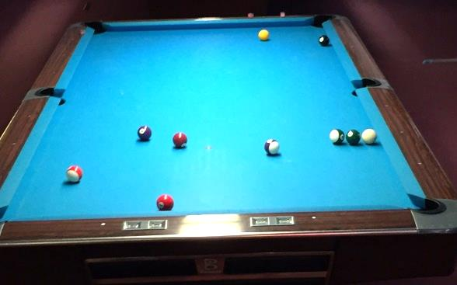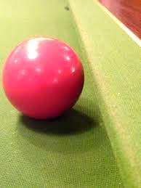In the game of pool, a ball bounces off the cushion at the side of a table. Friction between the ball and the table surface is very small compared with other forces, so we will ignore it. We choose five events to help us explore what happens:

1. The ball is travelling towards the cushion.
2. The ball makes contact with the cushion.
3. The cushion is squished and the ball stops.
4. The ball leaves contact with the cushion.
5. The ball is travelling away from the cushion.
6. **Reason and Represent.** For each interval of time between the pairs of events:
7. Draw an interaction diagram and a force diagram. The possible interacting objects are ball, Earth, table and cushion. Label the normal forces *F*n c-b (normal force of cushion on ball) and *F*n t-b (normal force of table on ball)
8. Describe the state of forces, the state of motion, and what is happening to the speed.
9. Sketch a velocity time graph and label the events (the graph is divided up according to the time intervals).

|  |  |  |  |  |
| --- | --- | --- | --- | --- |
| Interval | 1-2 | 2-3 | 3-4 | 4-5 |
| Description | Ball rolls towards cushion | Cushion becomes squished (compressed) | Cushion expands | Ball rolls away from cushion |
| Sketch | cushion  table  ball! |  |  |  |
| Interaction Diagram |  |  |  |  |
| Force Diagram | **graphpaper0001** |  | **graphpaper0001** |  |
| State of Force (balanced/unbalanced) |  |  |  |  |
| State of Motion (constant/accelerating) |  |  |  |  |
| Speeding Up or Slowing Down? |  |  |  |  |
| Velocity Graph  velocity  time | | | | |

# SPH3U Homework: The Force-Change Principle Practice

**Situation #1**: You are standing still on ice, holding onto the boards. You push off the boards and glide at a constant velocity (no friction) to the other side. When you arrive at the other side you grab the boards and slow down to a stop.

© G. John 2020 17

|  |  |  |  |  |  |  |  |  |  |  |  |
| --- | --- | --- | --- | --- | --- | --- | --- | --- | --- | --- | --- |
| **EVENTS:** | | 1 –start to push off | | 2 – finish pushing | | 3 – arrive at other side | | 4 – come to rest | |  | |
| Interval | | 1-2 | | 2-3 | | 3-4 | |
| Interaction Diagram | |  | |  | |  | |
| Force Diagram | | **graphpaper0001** | | **graphpaper0001** | |  | |
| State of Force (balanced/unbalanced) | |  | |  | |  | |
| State of Motion (constant/accelerating) | |  | |  | |  | |
|  | | | | | | | | | |

**Situation #2**: You drop a tennis ball into water from a height. The ball goes under water, then floats back to the surface.

|  |  |  |  |  |  |
| --- | --- | --- | --- | --- | --- |
| **EVENTS:** | 1 – you drop the ball | 2 | 3 | 4 | 5? (might not need) |

|  |  |  |  |  |
| --- | --- | --- | --- | --- |
| Interval | 1-2 | 2-3 | 3-4 | 4-5 |
| Interaction Diagram |  |  |  |  |
| Force Diagram | **graphpaper0001** |  | **graphpaper0001** |  |
| State of Force (balanced/unbalanced) |  |  |  |  |
| State of Motion (constant/accelerating) |  |  |  |  |
|  | | | | |

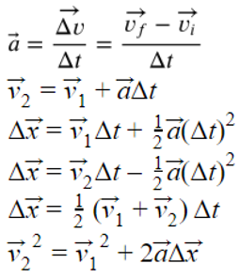

**SPH3U: Force Problem Solving**

To solve problems involving forces and motion you will use Newton’s 2nd Law, $\vec{a}=\frac{\vec{F_{net}}}{m}$ and the BIG 5 equations to the right.

**A: Intro Questions**

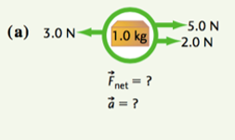 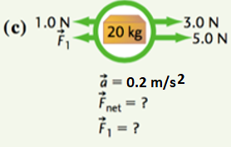

**B: Sample problem**

Include a force diagram, interaction diagram and mathematical solution.

A child pulls their dog in a sled with a force of 205. N, while a friction force of 180. N acts in the opposite direction. The dog and sled weigh a combined 20.0 kg   
a) How fast are the sled and dog travelling after 3.0 s?  
b) The dog jumps off, you continue to pull with the same force, and the sled accelerates at 1.9 m/s2. How heavy is the dog?

|  |  |
| --- | --- |
|  |  |

**C: Practice**

**1.** Find the acceleration of the following FDs

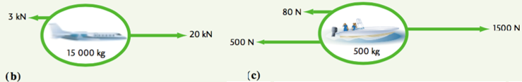

**2.** Find the missing quantity in the following.  
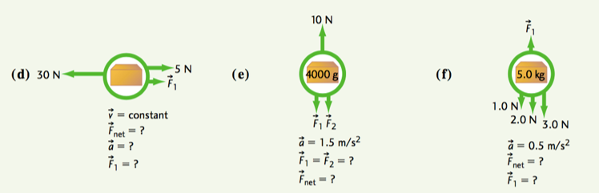

|  |  |
| --- | --- |
| **3.** A bicycle of mass 14.6 kg and a rider of mass 50.0 kg generate a net force of 12N. How fast are they going after 2.0 s?    **4.** A car moving its velocity from 20.0 m/s [N] to 20.0 m/s [S] in 5.5 s. If the mass of the car is 1500. kg, what is the net force acting on it? | **5.** A net force of 200. N is applied to an object, causing its velocity to change from 30.0 km/h to 20 km/h in 2.30 s. What is the object’s acceleration? What is its mass?  **6.** A batter of mass 100. kg uses a bat of mass 2.0 kg to hit a 140g ball. If the impact time is 0.010 s and the ball reaches a speed of 60. km/h from rest, what was the average force applied to the ball? |

**7.** A car of mass 20000 kg has a driving force of 4500 N and experiences an air resistance of 1500 N. What is the car’s acceleration?

**8.** Being the good daughter you are, you are cutting the estate lawn with a push mower of mass 12.6 kg. You exert a force of 117 N horizontally and you experience a frictional force of 45 N due to the mechanism of the machine as well as a resistive force of 58 N due to the grass itself. (a) find the acceleration and (b) the speed reached after 7.0 s of pushing from rest.

***ANSWERS***

*1. (b) 1.13 m/s2 [rt] (c) 1.84 m/s2 [rt] 2. (d) 25N [rt] (e) 6N [up] (f) 2.5N [up] 8.5 N[up] 3. 0.37 m/s [fwd] 4. 11000N [S] 5. 1.21 m/s2 166kg 6. 230 N [fwd]* ***7****. 0.15 m/s2 [fwd]* ***8****. 1.1 m/s2 [fwd] 7.8 m/s [fwd]*

**C: Practice – More Complex Problems Involving Big 5**

**1.** A puck of mass 30.0 g slides across rough ice, experiencing a frictional force of 0.200 N. If it was moving at 10.0 km/h when it hit the ice patch, (a) how long did it take to stop? (b) how long was the ice patch? [ANS: *0.417s 0.577 m*]

**2.** An elevator and its load have a combined mass of 1600 kg. It is initially moving downwards at 3.2 m/s, but a cable slows down the elevator over a distance of 8.7 m before it comes to a stop. What was the tension in the rope as the elevator was slowing down? [2544 N or approx. 2500 N …I think!]

**3.** Two people are having a tug-of-war and pull on a 25 kg sled that starts at rest on frictionless ice. The forces suddenly change as one person tugs harder with a force of 92 N compared with the other person’s force of 90 N. How quickly is the sled moving after 1.5 s? [ANS: 0.12 m/s]

**SPH3U: Exploring Freefall**

How does an object move when it is falling? Let’s find out!

**A: Drop the Ball!**

Someone will hold a motion detector as high as they can. Someone else will hold a large soccer ball underneath the detector and release it (no downwards push). We will focus on what happens as it drops and lands on the ground.

Time

Velocity

1. **Predict.** Predict the shape of the velocity time graph and draw it lightly with a pencil
2. **Observe.** Sketch the results from the computer for the velocity graph of the ball.
3. **Explain.** Using a velocity graph, how can we decide when the acceleration is constant?
4. **Interpret.** We will choose to mark an event when the acceleration of the ball changes or its velocity is zero. On the graph, label the three events:

(1) The ball is released, (2) the ball makes contact with the ground, and (3) the velocity of the ball is zero.

1. **Interpret.** For each interval of time between your events, decide whether the ball is speeding up (SU) or slowing down (SD). Label this on the graph.

|  |  |  |
| --- | --- | --- |
| Interval | 1-2 | 2-3 |
| Interaction Diagram |  |  |
| Force Diagram | **graphpaper0001** |  |

1. **Represent.** There are two intervals of time between the three events we have chosen. For each interval of time, describe the motion and force. Draw an interaction diagram, and draw a force diagram.

*Freefall* occurs whenever an object moves vertically under the influence of gravity alone.

1. **Reason.** Duringwhich interval(s) of time did freefall occur? Explain here and label these regions above your chart and above your graph.
2. **Predict.** Use Newton’s 2nd law to predict the size and direction of the ball’s acceleration during freefall. (you will need the mass of the ball).
3. **Evaluate.** Use the computer data from the velocity graph for the ball drop to determine the acceleration. Does this agree with your prediction?

© C. Meyer 2017

**B: Analyzing the Motion of a Tossed Ball**

We will hold a ball underneath the detector, throw it straight up and down, and catch it. We would like to throw and catch the ball from close to the ground.

Time

Velocity

1. **Predict.** Predict the shape of the velocity time graph and draw it lightly with a pencil
2. **Observe.** Sketch the results from the computer for the velocity graph of the ball.
3. **Interpret.** There are five (!) important events that we would like to focus on. Label these on your velocity graph.

(1) the hand begins to push the ball upwards

(2) the ball leaves contact with the hand

(3) the ball reaches its highest point

(4) the ball makes contact with the hand

(5) the ball stops

1. **Represent.** Complete the chart below.

|  |  |  |  |  |
| --- | --- | --- | --- | --- |
| Interval | 1-2 | 2-3 | 3-4 | 4-5 |
| Direction of Motion |  |  |  |  |
| Interaction Diagram |  |  |  |  |
| **graphpaper0001**Force Diagram |  |  |  |  |

1. **Reason.** Isaac says, “At its highest point, the acceleration of the ball is zero. We know that because it is turning around.” Do you agree or disagree? Explain.

1. **Reason.** Emmy says, “At its highest point, the ball has a velocity of zero.” Marie says, “I agree and at its highest point it remains at rest for a short interval of time.” Who do you agree with? Explain.

1. **Reason.** At which event does freefall begin? At which event does it end? Explain.

1. **Reason.** The BIG 5 equations are valid (they will give reliable results) as long as the acceleration is constant.
2. Could you use a BIG 5 equation to make a calculation between events 3 and 5?

1. What about between events 2 and 4?

**SPH3U: Freefall Acceleration**

**A: The Acceleration Experiment**

We need to find out what the rate of acceleration is and what that rate might depend upon. Your teacher will demonstrate how we can collect measurements and calculate the acceleration of an object under freefall.

In the absence of air resistance, all objects near the surface of the earth that fall freely, will accelerate at:

**B**: **The Freefall Problem**

Xue,is standing on the roof of a building. Emily is standing below and tosses a ball straight upwards to Xue. It travels up past Xue, comes back down and Xue reaches out and catches it. Xue catches the ball 6.0 m above Emily’s hands. The ball was travelling at 12.0 m/s upwards the moment it left Emily’s hand. We would like to know how much time this trip takes.

1. **Represent.** Complete part A below. Indicate the *y*-origin for position measurements and draw a sign convention where upwards is positive. Label the important events.
2. **Represent.** Complete part C below. Make sure the two graphs line-up vertically. Draw a single dotted vertical line through the graphs indicating the moment when the ball is at its highest.

|  |  |
| --- | --- |
| **A: Pictorial Representation**  Sketch, coordinate system, label givens, conversions, describe events  Event 1:  Event 2:  Xue  Event 3:  Emily | **C: Physics Representation**  Motion diagram, motion graphs, key events  +*y*  *y*  *v*  *t*  *t* |

The total length of the path traveled by an object is the *distance*. The change in position, from one event to another is the *displacement*. Distance is a scalar quantity and displacement is a vector quantity.

1. **Reason.** Explain why this in this example it is relatively easy to find the displacement, but harder to find the distance.

1. **Reason.** The BIG 5 equations are valid for any interval of motion where the acceleration is uniform. Does the ball accelerate uniformly during events 1 and 3? Explain.

**D: Mathematical Representation**

There are multiple ways of solving…one will require the use of the quadratic formula. The other way will take additional steps.  


Describe steps, complete equations, substitutions with units, final statement

## Homework: Freefalling

1. Isaac is practicing his volleyball skills by volleying a ball straight up and down, over and over again. His teammate Marie notices that after one volley, the ball rises 3.6 m above Isaac’s hands. What is the speed with which the ball left Isaac’s hand? (8.5 m/s)
2. With a terrific crack and the bases loaded, Albert hits a baseball directly upwards. The ball returns back down 4.1 s after the hit and is easily caught by the catcher. How high did the ball go? (21.0 m)
3. Emmy stands on a bridge and throws a rock at 7.5 m/s upwards. She throws a second identical rock with the same speed downwards. In each case, she releases the rock 10.3 m above a river that passes under the bridge. Which rock makes a bigger splash? (v2=16.2 m/s)

|  |  |
| --- | --- |
| 4.Assuming no air resistance, how long does it take a penny to fall if it was thrown down with an initial velocity of 5.0 m/s from the CN Tower (553 m)? (ANS 10.0 s) | **5.** An object thrown up from a cliff at 10.0 m/s reaches a velocity of 20.0 m/s down as it lands. If the acceleration due to gravity is 10.0 m/s2, what is the object’s displacement? How long did it take for the object to land from the time it was thrown up? (ANS 3.0 s; 15.0 m [down]) |

1. A ball is thrown up at 1.50 m/s from a 25.0 m building.  Calculate (a) the flight time and (b) the final velocity just before the ball hits the ground (c) the final velocity if the ball was thrown down at 1.5 m/s.

*Answers: Δt=2.39s   v2= 22.4 m/s [down]*

1. A ball is thrown from the top of a building.  If it takes 5.0s to fall 200m, find (a) the initial velocity of the ball and (b) the final velocity. *Answers: v1= 15 m/s [down]v2= 65 m/s [down]*
2. An astronaut on the moon throws a wrench straight up at 4.0 m/s.  Three seconds later it falls downwards at a velocity of 0.8 m/s.
   1. What was the acceleration of the wrench after it left the astronaut's hand?
   2. How high above the point from which it was released was the wrench at 3.0 s?
   3. How long would it take the wrench to return to the position from which it was thrown?

*Answers: a=1.6 m/s2 y=8.4m [up] Δt=5.0s*

**SPH3U: Newton’s Third Law**

The idea that the interaction forces between two objects (the carts) are equal in size holds true for all physical objects. This idea is known as *Newton’s 3rd Law*.

When objects interact, a pair of forces is always produced – they are two parts of one interaction. We call these two forces a *third law force pair.*  The two forces that are members of the same third law pair share some important characteristics.

* the same magnitude
* opposite directions
* the same type (gravitational, normal, tension, etc.)
* start and stop acting at the same time
* act on different objects

**A: Exploding Carts!**

Your teacher has two equal-mass dynamics carts on a track. Cart A has a compressed spring attached. Your teacher will release the spring and we will focus on the interval of time when the spring is expanding and affecting the carts.

A

B

|  |  |
| --- | --- |
| graphpaper0001ID | FDs |

1. **Represent.** Draw an ID for the two carts. Draw a FD for each cart.
2. **Predict.** Based on your diagrams, make a prediction comparing the velocity of each cart after the spring is released. Explain.
3. **Test.** Observe the results. Do they agree with your predictions?

|  |
| --- |
| graphpaper0001FDs |

1. **Predict and Test.** An extra mass is added to the cart with the spring. How do you think the FDs and resulting velocities change? Explain. You will test as a class.

**B: The Apple and the Earth**

The story goes that our friend Sir Isaac Newton made a great discovery while he was sitting under an apple tree and an apple happened fall down on him.

|  |  |
| --- | --- |
| ID | graphpaper0001FD |

1. **Represent.** Draw an ID and FD for the apple while it is at rest on the ground. Label each force using the 3rd law notation.

© C. Meyer 2014

|  |  |  |
| --- | --- | --- |
| graphpaper0001ID | FD Apple | FD Earth |

1. **Represent.** Draw an ID and two FDs for the apple and the earth *while the apple is falling*.
2. **Reason.** Marie says, “I think both the apple and the earth should be accelerating.” Do you agree or disagree? Explain.
3. **Reason.** Isaac says, “The earth clearly doesn’t move, so I don’t believe that it experiences an equal force to the apple.” Do you agree or disagree? Explain.
4. **Calculate.** The apple has a mass of 0.2 kg. What is the magnitude of the force of gravity it experiences? ($F_{net}=mg$)
5. **Calculate.** What is the magnitude of the force of gravity the earth experiences? If it has a mass of 6.0 x 1024 kg, what is its acceleration due to its interaction with the apple?

1. **Explain.** The acceleration that the earth experiences due only to the apple is microscopic. What is another reason why things like apples in the air don’t cause the earth any significant acceleration?

**C: The Jumping Child**

|  |  |  |
| --- | --- | --- |
| graphpaper0001ID | FD Child | FD Earth |

1. A 29.0 kg child is standing on the floor. Draw an ID for this situation. Draw a FD for the child and a FD for the earth.

|  |  |  |
| --- | --- | --- |
| graphpaper0001ID | FD Child | FD Earth |

1. The child jumps into the air. Draw an ID while the child is in the air. Draw a FD for the child and a FD for the earth while the child is in the air.

**SPH3U: Newton’s 3rd Law Homework Name:**

**A: Physics on Ice**

You have brought your little cousin out skating for the very first time. Both of you are standing on the ice wearing skates (no friction) and are facing one another. Your little cousin is a bit timid and needs to hold on to your scarf while you pull.

|  |  |  |
| --- | --- | --- |
| ID | FD Cousin | FD You |

1. **Represent.** Draw an ID that includes you and your cousin. Draw a FD for you and a FD for your cousin.
2. **Calculate.** Your cousin holds on while you gently pull the scarf with a 6 N force to start her moving. Her little mass is 17 kg. Determine her speed after pulling for 2.0 s.
3. **Reason.** Albert says, “I understand why the cousin speeds up – you are pulling on the scarf and she holds on. But I don’t predict you will move. Your cousin is only holding on, not pulling. And, in any case, she is much smaller so she couldn’t pull you anyways.” Do you agree or disagree? Explain.

1. **Represent and Calculate.** Use your actual mass to determine your speed after the same 2.0 seconds of pulling.

## B: Practice Problems

1. Two hockey players are standing on the ice. Player A has a mass of 100 kg, and Player B has a mass of 112 kg. One player pushes the other with a force of 50 N. Calculate the acceleration of each player. (ANS: $\vec{a_{A}}=-0.50 \frac{m}{s^{2}}$ $\vec{a_{B}}=0.45 \frac{m}{s^{2}}$)

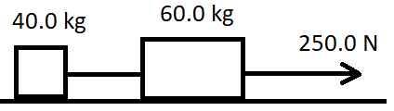2. A 60.0 kg mass and a 40.0 kg mass are connected with a rope, while a second rope pulls on the 60.0 kg mass with a force of 250.0 N. (see diagram). Assuming friction is negligible:

a) find the acceleration of the two-mass system (hint: treat them like a single object)

b) find the tension in the rope connecting the masses (hint: now focus on the 40.0 kg mass)

c) explain why it makes sense that the tension in the two ropes is different

[ANS a) 2.5 m/s2 b) 100. N]

3. Suppose a third mass (m = 25.0 kg) is attached with a rope to the left of the masses from question 2, and the entire system continues to be pulled with a force of 250.0 N. Determine the acceleration of the system, and the tension in all the ropes.  
[ANS *a* = 2.0 m/s2 130. N ; 50.0 N]

© C. Meyer 2015

**SPH3U: Friction**

Pianos are very hard to move. A strong person pushes a piano with a large force and it still doesn’t move. Why not?

**A: The Types of Friction**

At the front of the class your teacher has a fairly heavy object attached to a ***Newton scale***. Watch as your teacher will gradually exert a larger force on the object until it starts to move.

1. **Represent.** For each situation below draw a force diagram for the object. Compare the size of the horizontal forces that may be involved in a particular situation.

|  |  |  |  |  |
| --- | --- | --- | --- | --- |
| (A) Your teacher is not pulling on the object | (B) Your teacher is gently pulling, but it is not yet moving | (C) Your teacher is pulling hard, but it is not yet moving | (D) Your teacher is pulling and it is now moving at a constant velocity | (E) Your teacher is pulling even harder and it is now accelerating |
| FD | FD | FD | FD | FD |
| Compare: | Compare: | Compare: | Compare: | Compare: |

1. **Reason.** In which situations above is the force of friction present? What evidence is there? Explain.

Force of Friction

Time

1. **Describe**. What happens to the size of the friction force when the object begins to move? Draw a graph of force of friction vs time.

Friction is a contact force that occurs when two objects that are pressed together try to slide against one another. If the surfaces are sliding relative to one another we call the force *kinetic friction* (*Ffk*). If the two surfaces are not slipping we call the force *static friction* (*Ffs*).

1. **Describe.** Label the force diagrams above with the appropriate type of friction.
2. **Reason.** What would happen to the size of the force of static friction if we pulled a bit harder and the object still did not move? Explain.

The size of the force of static friction can take a range of values depending on what is happening in the particular situation. 0 < *Ffs* ≤ *Ffs max*. There is a maximum possible value for the force of static friction which occurs just before the objects begin to slip. This maximum value is usually greater than the force of kinetic friction.

**B: Kinetic Friction and the Normal Force**

We will use an online simulation to try to answer the following question:  
**How does the size of the force of kinetic friction depend on how hard the objects are pressing against one another?**

1. **Reason.** Which force represents how hard the two objects are pressing against one another? How could we find the magnitude of this force in the case of a book with a mass of 0.5 kg? Show your calculation.

1. **Design**. Visit the friction simulation at the following link: <https://phet.colorado.edu/sims/html/forces-and-motion-basics/latest/forces-and-motion-basics_en.html>  
   You need to configure a variety of masses, and exert enough force on the masses to make them move. You will need to calculate the normal force on your masses, and the simulation will tell you the force of friction that exists.  
   Note: once you have selected how much friction your surface has (somewhere between None 🡪 Lots), do not change your friction.

FD

1. **Observe and Represent.** Collect data according to your procedure. Plot the data comparing the forces on the graph (FN on the x-axis and Ff on the y-axis).



|  |  |  |
| --- | --- | --- |
| Mass (kg) | Fn (N) | Ff (N) |
|  |  |  |
|  |  |  |
|  |  |  |
|  |  |  |
|  |  |  |
|  |  |  |
|  |  |  |

1. **Analyze.** Construct a line of best-fit for your data.Determine the slope of the line. Show your work below.
2. **Interpret.** The value you foundfor the slope is called the *coefficient of kinetic friction* (*μk*). What characteristics of your experiment do you think affect this value? What would a smaller value for *μk* signify?

The *coefficient of kinetic friction* (*μk*) depends on the physical properties (roughness, chemical composition) of the pair of surfaces and is related to the force of friction by the expression: *Ffk = μkFn*. Since the force of kinetic friction is usually different from the maximum force of static friction, there is a separate *coefficient of static friction* (*μs*). We can find the maximum force of static friction using the expression: *Ffs max = μsFn*.

**C: Examples**

1. It takes a force of 120. N to start moving a box of mass 30.0 kg. What is the coefficient of static friction?
2. If the coefficient of kinetic friction from the box in question 1 is 0.35, what will its acceleration be once it has started moving?

**Force of Friction Homework** *(from Irwin Physics 11 p183)*

1. You push a 35. kg box with a force of 120. N, which is just enough to get it moving.
   1. Determine the coefficient of static friction (ans = 0.34)
   2. Once the box is moving you continue to push it with the same force. If the coefficient of kinetic friction is 0.25, what will its acceleration be? (ans = 0.93 m/s2)
   3. You reduce the force you are pushing with, and the new acceleration is 0.7 m/s2. With what force are you now pushing?  (Fa = 112 N)
2. The coeff. of static friction on a 40.0 kg box is 0.25. The box doesn’t move when pushed with a force of 90. N
   1. How much more force must you give to make it move? (ans: 10 N more needed)
   2. The coefficient of kinetic friction is 0.2. If you are pushing the box with a force of 110 N, what will the acceleration of the box be? (ans: 0.75 m/s2)
   3. You slide the box onto a different surface and you find the box begins travelling at a constant velocity while pushing with the same force (110 N). What is the coefficient of kinetic friction of this new surface? (ans: k=0.275)
   4. CHALLENGE QUESTION!!! (feel free to skip) Your friend places an object on the box, and you find the box is now accelerating at -0.15 m/s2 as you continue pushing with a force of 110 N. What is the mass of the object? (ans: 2.3 kg)

|  |  |
| --- | --- |
|  |  |
|  |  |

**42.** 0.32 **43.** crate can’t move (friction too large) **46.** (a) 19 N [back] (b) 3.4 m/s2 [back] (c) 1.1 m [fwd] (d) 0.82s   
**47**. (a) 5.0 N (b) 101 N *(1.0x102N with 2 sig digs)*

**SPH3U: Universal Gravitation**

*The law of universal gravitation states that two objects of masses M (kg) and m (kg) whose centres are a distance r (m) apart experience a force of attraction given by where rE=6.38x106 m, mE=5.98x1024 kg, G=6.67x10-11N m2/kg2*



1. What is the gravitational force of attraction between   
   a) a 60.0 kg person and a 70.0 kg person whose centers are 1.0 m apart? [2.8 x 10-7 N]  
   b) two 2000.0 kg cars whose centers are 2.5 m apart [4.3 x 10-5 N]
2. Determine the force of gravity at the earth’s surface for someone with a mass of 75.0 kg [735 N]
3. If the force of gravity of a 70.0 kg person on the surface of the earth is 7.00x102 N, what happens to the force of gravity on this person if
   1. The mass of the earth is doubled (double the density)
   2. The mass of the person is doubled
   3. The distance between the person and the center of the earth is doubled

1. Complete the following table. Recall that mass is constant everywhere

|  |  |  |  |
| --- | --- | --- | --- |
| Planet | Mass on planet’s surface  *m* (kg) | Force of gravity on this mass  *Fg*(N) | gravitational field strength at the surface *g* (N/kg) |
| Mercury | 57 | 188 |  |
| Venus |  | 462 |  |
| Jupiter |  |  | 26 |

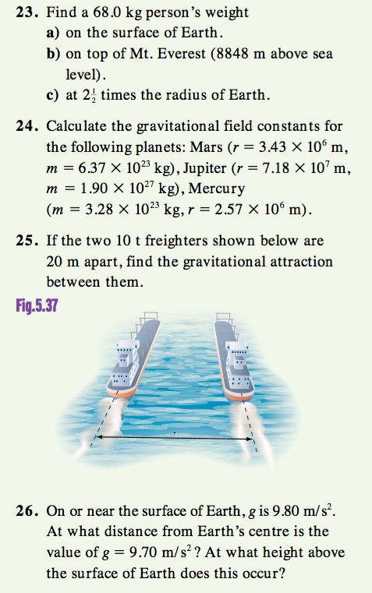



27. A astronaut on the surface of Mars finds that a rock accelerates at 3.6 m/s2 when it is dropped. They also use a Newton scale to find that their weight is 180 N.   
a) What is the mass of the astronaut on Mars? [50 kg]  
b) What is the mass of the astronaut on Earth?   
c) If the astronaut used the same Newton scale on earth, what would their weight be? [490 N]

**23**. (a) 666 N (or 680.N *if g=10.0 N/kg*) (b) 664 N (c) 107 N **24**. gmars= 3.61 N/kg gjupiter=24.6 N/kg gmercury=3.31 N/kg **25.** 1.67x10-5N (with 3 sig digs) **26.** 6.41x106 m 32.5 km

SPH 3U: Dynamics Problem Set Name: _________________

**Freefall motion**

1. A student throws a ball straight up into the air and then catches it after 4.50 seconds. What was the maximum height of the ball? Assume that the ball is thrown from an initial height of 1.50 m. *(26.8m)*
2. A ball is thrown from a 45.0m building with an initial speed of 25 m/s. How longer does it take the ball to hit the ground if it is (a) thrown up (b) thrown down? (6.4 s / 1.4 s)

**Newton’s 2nd Law (horizontal)**

1. A Mazda Miata (m=1080kg) can go from zero to 26.8 m/s (0 to 60 mph) in 7.90 seconds. Find the magnitude of the net force that must act on the car. *(3.66x103 N)*
2. A 4.0x103 kg motor boat experiences a resistance force of 2.5x103 N from the air and a 3.2x103 N force of resistance from the water. If the motor provides a forward force of 6.0 x103 N, calculate the acceleration of the boat. ***(0.075 m/s2 [fwd])***
3. A 15.0 kg object rests on a frictionless horizontal plane and is acted upon by a horizontal force of 30.0 N [E].

(a) What is its acceleration? ***(2.00 m/s2 [E])***

(b) How far will it move in 10.0 s? *(100. m [E])*

(c) What will be its velocity after 10.0 s? *(20.0 m/s [E])*

1. A 300. g croquet ball is thrown with an initial velocity of 6.0 m/s [right]. A force of friction of 0.45N causes the ball to come to a stop. How long did it take the ball to roll to a stop? *(4.0 s)*
2. An 1100 kg car accelerates from rest at 3.4 m/s2 [South].
   1. What is the unbalanced force acting on it? *(3.7 x 103 N [South])*
   2. If the horizontal force exerted on the wheels by the road is 5600 N [South], what force must be resisting the motion of the car? *(1.9 x 103 N [North])*

**Newton’s 2nd Law (vertical)**

1. A model rocket of mass 4.80 x 102 g accelerates vertically upward at 34.0 m/s2 during launch, overcoming both gravity and air resistance. Calculate the thrust force applied by the rocket engine during launch if the air resistance acting on the rocket is 2.40 N**.** *(23.5 N [up])*
2. An elevator and its contents have a combined mass of 6.00x103 kg. It is suspended by a single cable. What force must the cable exert on the elevator
   1. when it is at rest? *(6.00 x 104 N [up])*
   2. when it is moving up at 2.0 m/s2? *(7.20 x104N [up]*
   3. when it is moving down at 2.0 m/s? *(6.00 x 104 N [up])*

**Newton’s 2nd Law and the coefficient of friction**

1. A 5.70 kg box slides across a floor and comes to a complete stop. If its initial velocity was 18.0 km/h [left] and μk = 0.340, find  
   a) the friction acting on the box. *(19.4 N [right])*

b) the acceleration of the box. *(3.4 m/s2 [right])*

c) the total displacement of the box before stopping. ***(3.68 m [left])***

d) the time it took to stop. *(1.47s)*

1. A racing car has a mass of 1500. kg, is accelerating at 5.00 m/s2, is experiencing a lift force of 600. N up (due to its streamlined shape) and ground effects of 1000. N down (due to the spoilers). Find the driving force needed to keep the car going given that μk= 1.00 for the car. *(22900 N [forward])*

**Universal Gravitation**

1. The force of gravity on a 2.50x103 kg spacecraft on the moon is **4080 N.** What is the gravitational field strength there? *(1.63 m/s2)*
2. A 40.0 kg object rests on the surface of a 8.20 x 1022 kg planet with a radius of 3.60 x 105 m.
   1. Calculate the force of gravity acting on the object. *(1.69 x 103 N [down])*
   2. Determine the gravitational field strength  at the planet’s surface. *(42.2 m/s2 [down])*
   3. Calculate the force of gravity acting on the object if it is placed at a position 6.4 x 105 m above the planet’s surface. *(219N N[down])*

**Extras N2L, N3L**

1. A cyclist is travelling at 21 km/h when she sees a stop sign ahead. She applies the brakes and comes to a stop in 15 m. The mass of the cyclist and the bike is 73 kg. Calculate the acceleration of the cyclist.
2. A Saturn V rocket has a mass of 2.92 x 106 kg. Its engines have a thrust of 3.34 x 107 N.
   1. What is the downward force of gravity on the rocket at blast-off? [2.86 x 107 N]
   2. What is the acceleration of the rocket as it leaves the launching platform? [1.6 m/s2]
   3. As the rocket travels upwards, the engine thrust remains constant, but the mass of the rocket decreases. Why?
   4. Does the acceleration of the rocket increase, decrease, or remain the same as the engines continue to fire?
3. Determine the minimum coefficient of static friction that will keep the top box moving along with the bottom box. Assume that the applied force is only applied to the bottom box. Assume the coefficient of kinetic friction between the bottom box and the counter is 0.25. [μS = 0.36]

3.0 kg

7.0 kg

Fapp = 59. 5 N

μK = 0.25

μS = ?



1. Two boxes are side by side on a frictionless surface. A horizontal force of 48.0 N [right] is applied to move both boxes.
   1. Calculate the acceleration of both boxes.
   2. Determine the force that the 40.0 kg box applies to the 20.0 kg box.
   3. Determine the force that the 20.0 kg box applies to the 40.0 kg box.
2. A steel sled is being pulled along the sandy surface of the Planet Z. The sled moves from 12.0 [West] to 24.0 [West] in 0.400 minutes. The magnitude of the net force acting on the sled is 18.5 N and the coefficient of kinetic friction is 0.35 for steel sliding on sand. The mass of planet Z is 9.370 x 1023 kg and the radius of planet Z is 5.00 x 106 m.

(a) Find the acceleration.

(b) How far did the sled travel during the acceleration?

(c) Find the [gravitational field strength] of Planet Z.

(d) The magnitude of all the forces acting on the sled.

(e) What would be the weight of the sled 2.20 x 105 m above planet Z? Draw a fully labeled diagram

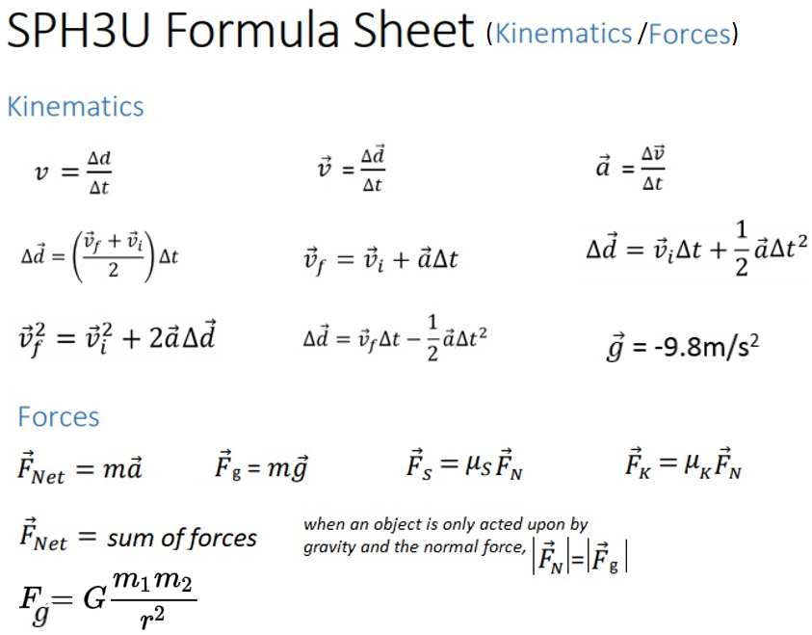

# SPH3U: The Normal Force

**A: A Mysterious Force**

Your friend places her backpack on a table. The backpack is the system.

|  |  |
| --- | --- |
| **graphpaper0001**ID | FD |

1. **Reason.** Your frienddraws a FD for the system and says, “I’m really not sure that there should be an upwards force.” Convince your friend. Cite direct evidence about the system that you can readily observe.
2. **Reason.** Complete her original FD and draw an ID. The backpack has a mass of 5.8 kg (all those textbooks). What is the size of the upwards force?

When two objects press against one another, they interact and exert *normal forces* on one another. A normal force (Fn) is a contact force that is always perpendicular to the surfaces at the point of contact. This force usually prevents objects from deforming by much, from breaking or from merging together. When a person is in contact with another object, we call this special normal force an *applied force*. Note that an applied force can also be a combination of a normal force and a friction force (which we will study later).

**B: Evidence for the Normal Force**

For these activities you need ***two metre sticks***, ***a spring scale*** and ***a 500 g mass***. Make a bridge using the metre stick between two tables. Gently press downwards with your finger in the middle of the metre stick.

1. **Observe.** Describe what you observe happening to the “rigid” metre stick. Why did the shape change?
2. **Reason.** Describe the evidence you feel for the existence of an upwards force acting on your finger.
3. **Observe.** Place the 500 g mass on the metre stick. Describe what happens. What is the size of the upwards normal force?
4. **Observe.** Remove the mass. Place the second metre stick directly on top of the first (the “table” is now twice as thick). Place the 500 g mass on top of the two sticks. What is different about the effect of the mass on our thicker “table”? How has the upwards normal force changed? Explain.

*\*\* Check with your teacher before proceeding. \*\**

© C. Meyer 2014

1. **Reason.** Imagine many, many metre sticks stacked up (a very thick table). What would happen to the metre sticks if we place the 500 g mass on top of them? How has the size of the upwards normal force changed compared to the single metre stick situation? Explain.
2. **Explain.** (*as a class)*How does the normal force work on a microscopic level?

|  |  |  |
| --- | --- | --- |
| **A Physical Model for the Normal Force** | Particles Before Contact | Particles After Contact |

**C: Measuring the Normal Force**

You need a ***0.5-kg mass*** and a ***5 N spring scale***. Rest your hand on the table and place the mass on the flat palm of your hand.

1. **Reason.** What is the size of the upwards normal force on the mass? Explain.

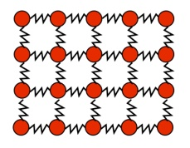



|  |  |
| --- | --- |
| **graphpaper0001ID** | **FD** |

1. **Predict and Calculate.** Another member of your group will pull upwards on the mass with a 3 N force. Draw an ID and a FD for this situation. What do you think will happen? How do you think your hand will feel? What will the size of the normal force be? Explain.
2. **Test.** Attach a spring scale to the mass and exert a 3 N force upwards. How did the sensation in your hand change? What force or forces do you think have changed size when the upwards was added?

The magnitude of the normal force depends on how hard the objects are pressing against one another. Other forces and motion may affect the size of a normal force. As a result, we always have to find the size of the normal force by analyzing what’s happening to the system.

**SPH3U: Force, Mass and Motion**

Recorder: _____________________

Manager: _____________________

Speaker: _____________________

R 1 2 3 4

What factors affect the acceleration of an object? We have already hinted that force and mass are key. Let’s investigate further.

**A: The Atwood Machine**

1. 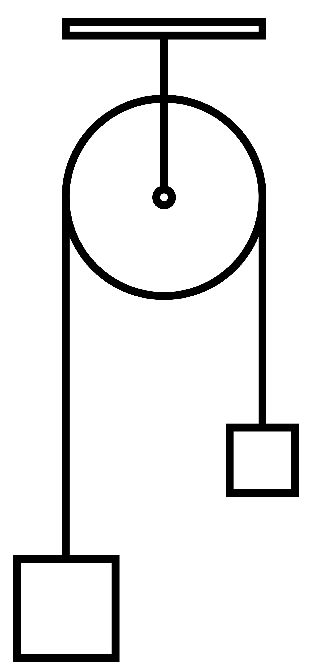**Reason. W**hy does each mass, *mA* and *mB*, move when released. What forces cause the acceleration of each mass?
2. **Reason.** When the mass, *mA*, is released how much mass is moving in total?
3. **Reason.** We can think of the two masses as a single system. What single force is the ultimate cause of the motion of the entire system (*mA* and *mB*together)? This is the force we will vary in our experiment.
4. **Reason.** To conduct a scientific investigation one must always change only one quantity and measure the results while ensuring that everything else remains unchanged. Suppose you want to increase the force moving the system while keeping everything else the same. You add 50 g to *m*B. What else **must** you do?

**B: Investigating the effects of Force and Mass on Acceleration**

Design your own experiment to determine the effect of force or mass on acceleration. In groups complete the Google Slides that your teacher will share with you.

**C: Conclusions**

1. **Summarize.** How does a system’s acceleration depend on the net force?
2. **Summarize.** How does a system’s acceleration depend on the system mass?
3. **Speculate.** Create an equation that shows the relationship between the net force (*Fnet*), the mass (*m*) and the acceleration (*a*) of a system.
4. **Summarize.**  (*as a class)*

**Newton’s Second Law**

**SPH3U: Force, Mass and Motion Homework Name:**

Newton’s Second Law () is the rule for our universe that describes the relation between cause (forces) and effects (acceleration).

**A: The Units of Force**

|  |  |
| --- | --- |
| graphpaper0001ID | FD |

1. **Represent and Explain.** A 3 kg rock is falling to the ground.
2. Draw an ID and FD.
3. Determine the size for the force of gravity acting on the rock.
4. Use Newton’s second law to find the acceleration of the rock while it is falling. Explain why the units of the calculation work out to give an acceleration.

**B: Find the Missing Force**

1. You pull your friend on a wagon using a horizontal, forwards force. There is a small amount of friction. The wagon is gradually speeding up.

|  |  |
| --- | --- |
| graphpaper0001ID | FD |

1. **Represent.** Draw an ID and a FD for the system of wagon + friend.
2. **Reason.** Which horizontal force is larger? Explain.
3. **Represent.** Complete the expressions for the Newton’s second law in the *x-* and *y-*directions. Use the symbols for the forces and a sign convention. If the acceleration in a direction is zero, substitute that in your expression.

*Fnet x = max**Fnet y = may*

= =

1. **Reason.** The mass of your friend is 57 kg. The mass of the wagon is 12 kg. What is the mass of the system? What mass value will you substitute for *m* in your equation? Explain.
2. **Solve**. Your friend speeds up at a rate of 1.1 m/s2. You pull with a force of 97 N. What is the size of the force of friction?

**Dynamics Homework Sheet Name: Problem:**

**A: Pictorial Representation**

Sketch, coordinate system, label givens using symbols, conversions, describe events

**B: Word Representation**

Describe motion (no numbers), explain why, assumptions

**C: Physics Representation**

Motion diagram, motion graphs, velocity vectors, interaction diagram, force diagram, events

**D: Mathematical Representation**

Number and describe steps, complete equations, substitutions with units, final statement with units, direction & significant digits

**Dynamics Homework Sheet Name: Problem:**

**A: Pictorial Representation**

Sketch, coordinate system, label givens using symbols, conversions, describe events

**B: Word Representation**

Describe motion (no numbers), explain why, assumptions

**C: Physics Representation**

Motion diagram, motion graphs, velocity vectors, interaction diagram, force diagram, events

**D: Mathematical Representation**

Number and describe steps, complete equations, substitutions with units, final statement with units, direction & significant digits

# SPH3U: Interactions and Forces

When two objects affect one another in some way we say that they *interact*. We begin exploring the nature of these interactions and what happens as a result.

**A: Thinking About Interactions**

|  |  |
| --- | --- |
| **1** | **2** |
| **3** | **4** |

Watch the [Soccer-Kick-Slow-Motion (Lund)](https://www.youtube.com/watch?v=TKSS3mq18Z4) video of a foot kicking a soccer ball. Refer to the frame numbers in the sketches to help answer the questions.

1. **Observe.** There is an interaction between the foot and the ball.In which frames is the interaction present?
2. **Reason.** What evidence is there (what do we see) that leads us to believe than the ball experiences an interaction? What about the foot?

The ball and foot interaction is an example of a *contact interaction*. Such an interaction is only noticeable when two objects are in contact. When they are not in contact, there is no interaction.

1. **Reason.**  Does the ball participate in any other contact interactions? In which frames and between which objects?

*Non-contact interactions* can take place when the objects are not in contact. Even though the objects are separated by some distance, they still have an effect on one another. Note that an interaction always involves a **pair** of objects.

1. **Reason.** Does the ground participate in a *non-contact* interaction with the ball? Explain.
2. **Reason.** Does Earth participate in a *non-contact* interaction with the ball? Explain.

An *interaction diagram* (ID) represents the interactions present at some moment in time. An ID lists all the objects that are interacting with one another and has lines representing each interaction. The lines are labelled with a single letter describing the type of interaction: a = applied (a person’s contact), g = gravitational, n = normal (surfaces in contact) and many more! Note that we consider the ground and Earth as two separate objects since they often participate in interactions in different ways. We show the system object(s) by drawing a circle around them.

1. **Represent.** In the chart below, complete the interaction diagrams for each of the four frames of the video.

|  |  |  |  |
| --- | --- | --- | --- |
| ball  ground  Earth  n  g  **1** | **2** | **3** | **4**  © C. Meyer, 2014 |

**B: A Model Interaction**

We are going to use an **elastic band** to examine an elastic interaction. **Each member** of your group should try this.

1. **Describe.** Loop one elastic band around your two pointer fingers. Separate your fingers until the elastic band has a good amount of stretch. Describe the effect the elastic has on **each** finger.

|  |  |
| --- | --- |
| LH finger  **ID**  e  RH finger |  |

1. **Represent.** How does the pull of the elastic on each finger compare? Draw an arrow representing the force due to the elastic that each finger experiences. The arrow should **start** from each finger on the diagram. (Don’t draw the elastic.)

Force. Every interaction has two parts called *forces*. Intuitively, a force is a push or a pull of one object on another. In our previous example, we say the two fingers are interacting with one another through the elastic. The fingers pull on each other.

1. **Describe and Represent.** Rest your fingers and try again using the same elastic stretched to a **greater** distance than before. Describe how the sensation of force on your fingers has changed. Draw arrows again and explain how you chose to draw their **length**.



1. **Reason.** What type of quantity best represents a force: a scalar or a vector? Explain.

**C: Representing Forces**

**Force Diagram.** We use a *force diagram* to model a system and represent the forces that the system experiences. In high school physics, we will always use the *point particle* assumption and imagine all the mass of the system objects compressed into a single point. For each interaction the system experiences, we draw a force vectors arrow that begins on the point particle. Label force vectors using a subscript showing the type of interaction (for example ${\vec{F}}_{e}$, an elastic force).

|  |
| --- |
| graphpaper0001**Force Diagram – LH finger $${\vec{F}}_{e}$$** |
| **Force Diagram – RH finger** |

1. **Reason.** Focus on the system of the left finger. According to the interaction diagram above, how many interactions does this finger experience? How many vector arrows should we draw on the force diagram?
2. **Represent.** Now draw a force diagram for the system of the right hand finger. Explain how you choose to draw the length and direction of the force vector.