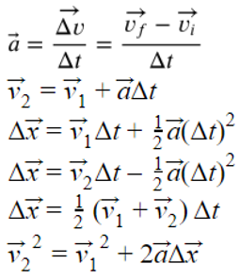

**SPH3U: Force Problem Solving**

To solve problems involving forces and motion you will use Newton’s 2nd Law, $\vec{a}=\frac{\vec{F_{net}}}{m}$ and the BIG 5 equations to the right.

**A: Intro Questions**

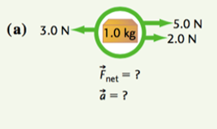 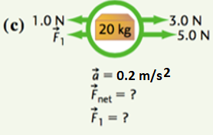

**B: Sample problem**

Include a force diagram, interaction diagram and mathematical solution.

A child pulls their dog in a sled with a force of 205. N, while a friction force of 180. N acts in the opposite direction. The dog and sled weigh a combined 20.0 kg   
a) How fast are the sled and dog travelling after 3.0 s?  
b) The dog jumps off and the sled accelerates at 1.9 m/s2. If the net force remained the same, how heavy is the dog?

|  |  |
| --- | --- |
|  |  |

**C: Practice**

**1.** Find the acceleration of the following FDs

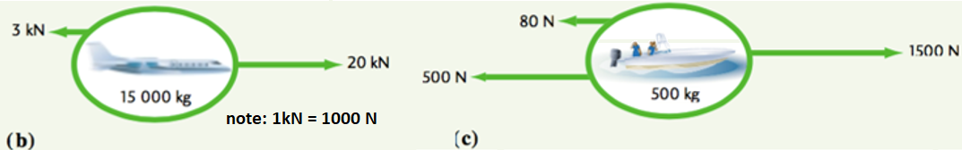

**2.** Find the missing quantity in the following.  
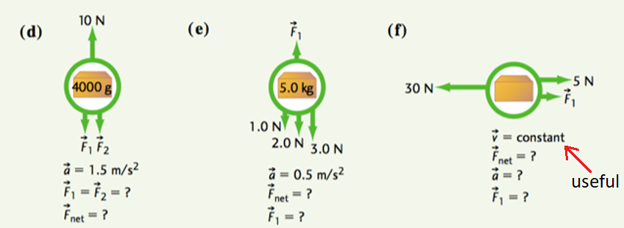

|  |  |
| --- | --- |
| **3.** A bicycle of mass 14.6 kg and a rider of mass 50.0 kg generate a net force of 12N. How fast are they going after 2.0 s?    **4.** A car moving its velocity from 20.0 m/s [N] to 20.0 m/s [S] in 5.5 s. If the mass of the car is 1500. kg, what is the net force acting on it? | **5.** A net force of 200. N is applied to an object, causing its velocity to change from 30.0 km/h to 20 km/h in 2.30 s. What is the object’s acceleration? What is its mass?  **6.** A batter of mass 100. kg uses a bat of mass 2.0 kg to hit a 140g ball. If the impact time is 0.010 s and the ball reaches a speed of 60. km/h from rest, what was the average force applied to the ball? |

**7.** A car of mass 20000 kg has a driving force of 4500 N and experiences an air resistance of 1500 N. What is the car’s acceleration?

**8.** Being the good daughter you are, you are cutting the estate lawn with a push mower of mass 12.6 kg. You exert a force of 117 N horizontally and you experience a frictional force of 45 N due to the mechanism of the machine as well as a resistive force of 58 N due to the grass itself. (a) find the acceleration and (b) the speed reached after 7.0 s of pushing from rest.

***ANSWERS***

*1. (b) 1.13 m/s2 [rt] (c) 1.84 m/s2 [rt] 2. (d) 6N [up]; 2N [down] (e) 2.5N [up] 8.5 N[up] (f) 25N [rt] 3. 0.37 m/s [fwd] 4. 11000N [S] 5. 1.21 m/s2 166kg 6. 230 N [fwd]* ***7****. 0.15 m/s2 [fwd]* ***8****. 1.1 m/s2 [fwd] 7.8 m/s [fwd]*

**C: Practice – More Complex Problems Involving Big 5**

**1.** A puck of mass 30.0 g slides across rough ice, experiencing a frictional force of 0.200 N. If it was moving at 10.0 km/h when it hit the ice patch, (a) how long did it take to stop? (b) how long was the ice patch? [ANS: *0.417s 0.577 m*]

**2.** An elevator and its load have a combined mass of 1600. kg. It is initially moving downwards at 3.20 m/s, but a cable slows down the elevator over a distance of 8.70 m before it comes to a stop. What was the tension in the rope as the elevator was slowing down? [16622 N or approx. 16600 N ]

**3.** Two people are having a tug-of-war and pull on a 25 kg sled that starts at rest on frictionless ice. The forces suddenly change as one person tugs harder with a force of 92 N compared with the other person’s force of 90 N. How quickly is the sled moving after 1.5 s? [ANS: 0.12 m/s]

**SPH3U: Freefall Acceleration**

**A: The Acceleration Experiment**

We need to find out what the rate of acceleration is and what that rate might depend upon. Your teacher will demonstrate how we can collect measurements and calculate the acceleration of an object under freefall.

In the absence of air resistance, all objects near the surface of the earth that fall freely, will accelerate at:

**B**: **The Freefall Problem**

Xue,is standing on the roof of a building. Emily is standing below and tosses a ball straight upwards to Xue. It travels up past Xue, comes back down and Xue reaches out and catches it. Xue catches the ball 6.0 m above Emily’s hands. The ball was travelling at 12.0 m/s upwards the moment it left Emily’s hand. We would like to know how much time this trip takes.

1. **Represent.** Complete part A below. Indicate the *y*-origin for position measurements and draw a sign convention where upwards is positive. Label the important events.
2. **Represent.** Complete part C below. Make sure the two graphs line-up vertically. Draw a single dotted vertical line through the graphs indicating the moment when the ball is at its highest.

|  |  |
| --- | --- |
| **A: Pictorial Representation**  Sketch, coordinate system, label givens, conversions, describe events  Event 1:  Event 2:  Xue  Event 3:  Emily | **C: Physics Representation**  Motion diagram, motion graphs, key events  +*y*  *y*  *v*  *t*  *t* |

The total length of the path traveled by an object is the *distance*. The change in position, from one event to another is the *displacement*. Distance is a scalar quantity and displacement is a vector quantity.

1. **Reason.** Explain why this in this example it is relatively easy to find the displacement, but harder to find the distance.

1. **Reason.** The BIG 5 equations are valid for any interval of motion where the acceleration is uniform. Does the ball accelerate uniformly during events 1 and 3? Explain.

**D: Mathematical Representation**

There are multiple ways of solving…one will require the use of the quadratic formula. The other way will take additional steps.  


Describe steps, complete equations, substitutions with units, final statement

## Homework: Freefalling

1. Isaac is practicing his volleyball skills by volleying a ball straight up and down, over and over again. His teammate Marie notices that after one volley, the ball rises 3.6 m above Isaac’s hands. What is the speed with which the ball left Isaac’s hand? Hint: what is the velocity of the ball at its highest point? (ANS: 8.5 m/s)
2. With a terrific crack and the bases loaded, Albert hits a baseball directly upwards. The ball reaches its maximum height after 2.05 s before dropping and being caught. How high did the ball go? (21.0 m)
3. Emmy stands on a bridge and throws a rock at 7.5 m/s upwards. She throws a second identical rock with the same speed downwards. In each case, she releases the rock 10.3 m above a river that passes under the bridge. Find the velocity with which each rock hits the water. (v2=16.2 m/s)

|  |  |
| --- | --- |
| 4.Assuming no air resistance, how long does it take a penny to fall if it was thrown downwards with an initial speed of 5.0 m/s from the CN Tower (553 m)? (ANS 10.0 s) | **5.** An object thrown up from a cliff at 10.0 m/s reaches a velocity of 20.0 m/s down as it lands. If the acceleration due to gravity is 10.0 m/s2, what is the object’s displacement? How long did it take for the object to land from the time it was thrown up? (ANS 3.0 s; 15.0 m [down]) |

1. A ball is thrown up at 1.50 m/s from a 25.0 m building.  Calculate (a) the flight time and (b) the final velocity just before the ball hits the ground (c) the final velocity if the ball was thrown down at 1.5 m/s.

*Answers: Δt=2.39s   v2= 22.4 m/s [down]*

1. A ball is thrown from the top of a building.  If it takes 5.0s to fall 200m, find (a) the initial velocity of the ball and (b) the final velocity. *Answers: v1= 15 m/s [down]v2= 65 m/s [down]*
2. An astronaut on the moon throws a wrench straight up at 4.0 m/s.  Three seconds later it falls downwards at a velocity of 0.8 m/s.
   1. What was the acceleration of the wrench after it left the astronaut's hand?
   2. How high above the point from which it was released was the wrench at 3.0 s?
   3. How long would it take the wrench to return to the position from which it was thrown?

*Answers: a=1.6 m/s2 y=8.4m [up] Δt=5.0s*

**SPH3U: Newton’s Third Law**

The idea that the interaction forces between two objects (the carts) are equal in size holds true for all physical objects. This idea is known as *Newton’s 3rd Law*.

When objects interact, a pair of forces is always produced – they are two parts of one interaction. We call these two forces a *third law force pair.*  The two forces that are members of the same third law pair share some important characteristics.

* the same magnitude
* opposite directions
* the same type (gravitational, normal, tension, etc.)
* start and stop acting at the same time
* act on different objects

**A: Exploding Carts!**

Your teacher has two equal-mass dynamics carts on a track. Cart A has a compressed spring attached. Your teacher will release the spring and we will focus on the interval of time when the spring is expanding and affecting the carts.

A

B

|  |  |
| --- | --- |
| graphpaper0001ID | FDs |

1. **Represent.** Draw an ID for the two carts. Draw a FD for each cart.
2. **Predict.** Based on your diagrams, make a prediction comparing the velocity of each cart after the spring is released. Explain.
3. **Test.** Observe the results. Do they agree with your predictions?

|  |
| --- |
| graphpaper0001FDs |

1. **Predict and Test.** An extra mass is added to the cart with the spring. How do you think the FDs and resulting velocities change? Explain. You will test as a class.

**B: The Apple and the Earth**

The story goes that our friend Sir Isaac Newton made a great discovery while he was sitting under an apple tree and an apple happened fall down on him.

|  |  |
| --- | --- |
| ID | graphpaper0001FD |

1. **Represent.** Draw an ID and FD for the apple while it is at rest on the ground. Label each force using the 3rd law notation.

© C. Meyer 2014

|  |  |  |
| --- | --- | --- |
| graphpaper0001ID | FD Apple | FD Earth |

1. **Represent.** Draw an ID and two FDs for the apple and the earth *while the apple is falling*.
2. **Reason.** Marie says, “I think both the apple and the earth should be accelerating.” Do you agree or disagree? Explain.
3. **Reason.** Isaac says, “The earth clearly doesn’t move, so I don’t believe that it experiences an equal force to the apple.” Do you agree or disagree? Explain.
4. **Calculate.** The apple has a mass of 0.2 kg. What is the magnitude of the force of gravity it experiences? ($F_{net}=mg$)
5. **Calculate.** What is the magnitude of the force of gravity the earth experiences? If it has a mass of 6.0 x 1024 kg, what is its acceleration due to its interaction with the apple?

1. **Explain.** The acceleration that the earth experiences due only to the apple is microscopic. What is another reason why things like apples in the air don’t cause the earth any significant acceleration?

**C: The Jumping Child**

|  |  |  |
| --- | --- | --- |
| graphpaper0001ID | FD Child | FD Earth |

1. A 29.0 kg child is standing on the floor. Draw an ID for this situation. Draw a FD for the child and a FD for the earth.

|  |  |  |
| --- | --- | --- |
| graphpaper0001ID | FD Child | FD Earth |

1. The child jumps into the air. Draw an ID while the child is in the air. Draw a FD for the child and a FD for the earth while the child is in the air.

**SPH3U: Newton’s 3rd Law Homework Name:**

**A: Physics on Ice**

You have brought your little cousin out skating for the very first time. Both of you are standing on the ice wearing skates (no friction) and are facing one another. Your little cousin is a bit timid and needs to hold on to your scarf while you pull.

|  |  |  |
| --- | --- | --- |
| ID | FD Cousin | FD You |

1. **Represent.** Draw an ID that includes you and your cousin. Draw a FD for you and a FD for your cousin.
2. **Calculate.** Your cousin holds on while you gently pull the scarf with a 6 N force to start her moving. Her little mass is 17 kg. Determine her speed after pulling for 2.0 s.
3. **Reason.** Albert says, “I understand why the cousin speeds up – you are pulling on the scarf and she holds on. But I don’t predict you will move. Your cousin is only holding on, not pulling. And, in any case, she is much smaller so she couldn’t pull you anyways.” Do you agree or disagree? Explain.

1. **Represent and Calculate.** Use your actual mass to determine your speed after the same 2.0 seconds of pulling.

## B: Practice Problems

1. Two hockey players are standing on the ice. Player A has a mass of 100 kg, and Player B has a mass of 112 kg. One player pushes the other with a force of 50 N. Calculate the acceleration of each player. (ANS: $\vec{a_{A}}=-0.50 \frac{m}{s^{2}}$ $\vec{a_{B}}=0.45 \frac{m}{s^{2}}$)

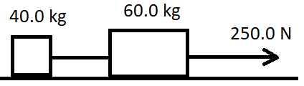2. A 60.0 kg mass and a 40.0 kg mass are connected with a rope, while a second rope pulls on the 60.0 kg mass with a force of 250.0 N. (see diagram). Assuming friction is negligible:

a) find the acceleration of the two-mass system (hint: treat them like a single object)

b) find the tension in the rope connecting the masses (hint: now focus on the 40.0 kg mass)

c) explain why it makes sense that the tension in the two ropes is different

[ANS a) 2.5 m/s2 b) 100. N]

3. Suppose a third mass (m = 25.0 kg) is attached with a rope to the left of the masses from question 2, and the entire system continues to be pulled with a force of 250.0 N. Determine the acceleration of the system, and the tension in all the ropes.  
[ANS *a* = 2.0 m/s2 130. N ; 50.0 N]

© C. Meyer 2015

**SPH3U: Friction**

Pianos are very hard to move. A strong person pushes a piano with a large force and it still doesn’t move. Why not?

**A: The Types of Friction**

At the front of the class your teacher has a fairly heavy object attached to a ***Newton scale***. Watch as your teacher will gradually exert a larger force on the object until it starts to move.

1. **Represent.** For each situation below draw a force diagram for the object. Compare the size of the horizontal forces that may be involved in a particular situation.

|  |  |  |  |  |
| --- | --- | --- | --- | --- |
| (A) Your teacher is not pushing on the object | (B) Your teacher is gently pushing, but it is not yet moving | (C) Your teacher is pushing hard, but it is not yet moving | (D) Your teacher pushes hard enough to cause acceleration | (E) Your teacher is pushing hard enough to keep velocity constant |
| FD | FD | FD | FD | FD |
| Compare: | Compare: | Compare: | Compare: | Compare: |

1. **Reason.** In which situations above is the force of friction present? What evidence is there? Explain.

Force of Friction

Time

1. **Describe**. What happens to the size of the friction force when the object begins to move? Draw a graph of force of friction vs time.

Friction is a contact force that occurs when two objects that are pressed together try to slide against one another. If the surfaces are sliding relative to one another we call the force *kinetic friction* (*Ffk*). If the two surfaces are not slipping we call the force *static friction* (*Ffs*).

1. **Describe.** Label the force diagrams above with the appropriate type of friction.
2. **Reason.** What would happen to the size of the force of static friction if we pulled a bit harder and the object still did not move? Explain.

The size of the force of static friction can take a range of values depending on what is happening in the particular situation. 0 < *Ffs* ≤ *Ffs max*. There is a maximum possible value for the force of static friction which occurs just before the objects begin to slip. This maximum value is usually greater than the force of kinetic friction.

**B: Kinetic Friction and the Normal Force**

We will use an online simulation to try to answer the following question:  
**How does the size of the force of kinetic friction depend on how hard the objects are pressing against one another?**

1. **Reason.** Which force represents how hard the two objects are pressing against one another? How could we find the magnitude of this force in the case of a book with a mass of 0.5 kg? Show your calculation.

1. **Design**. Visit the friction simulation at the following link: <https://phet.colorado.edu/sims/html/forces-and-motion-basics/latest/forces-and-motion-basics_en.html>  
   You need to configure a variety of masses, and exert **just enough force** on the masses to make them move. Record the force required to make the mass move in the Ff column, and calculate and record the normal force on those masses.  
   Note: once you have selected how much friction your surface has (somewhere between None 🡪 Lots), do not change your friction.

FD

1. **Observe and Represent.** Collect data according to your procedure. Plot the data comparing the forces on the graph (FN on the x-axis and Ff on the y-axis).



|  |  |  |
| --- | --- | --- |
| Mass (kg) | Fn (N) | Ff (N) |
|  |  |  |
|  |  |  |
|  |  |  |
|  |  |  |
|  |  |  |
|  |  |  |
|  |  |  |

1. **Analyze.** Construct a line of best-fit for your data.Determine the slope of the line. Show your work below.
2. **Interpret.** The value you foundfor the slope is called the *coefficient of kinetic friction* (*μk*). What characteristics of your experiment do you think affect this value? What would a smaller value for *μk* signify?

The *coefficient of kinetic friction* (*μk*) depends on the physical properties (roughness, chemical composition) of the pair of surfaces and is related to the force of friction by the expression: *Ffk = μkFn*. Since the force of kinetic friction is usually different from the maximum force of static friction, there is a separate *coefficient of static friction* (*μs*). We can find the maximum force of static friction using the expression: *Ffs max = μsFn*.

**C: Examples**

1. It takes a force of 120. N to start moving a box of mass 30.0 kg. What is the coefficient of static friction?
2. If the coefficient of kinetic friction from the box in question 1 is 0.35, what will its acceleration be once it has started moving?

**Force of Friction Homework** *(from Irwin Physics 11 p183)*

1. You push a 35. kg box with a force of 120. N, which is just enough to get it moving.
   1. Determine the coefficient of static friction (ans = 0.35)
   2. Once the box is moving you continue to push it with the same force. If the coefficient of kinetic friction is 0.25, what will its acceleration be? (ans = 0.97 m/s2)
   3. You reduce the force you are pushing with, and the new acceleration is 0.7 m/s2. With what force are you now pushing?  (Fa = 110 or 111 N)
2. The coeff. of static friction on a 40.0 kg box is 0.25. The box doesn’t move when pushed with a force of 90. N
   1. How much more force must you give to make it move? (ans: 8 N more needed)
   2. The coefficient of kinetic friction is 0.20. If you are pushing the box with a force of 110. N, what will the acceleration of the box be? (ans: 0.8 m/s2 or 0.79 m/s2)
   3. You slide the box onto a different surface and you find the box begins travelling at a constant velocity while pushing with the same force (110. N). What is the coefficient of kinetic friction of this new surface? (ans: μk=0.281)
   4. CHALLENGE QUESTION!!! (feel free to skip) Your friend places an object on the box, and you find the box is now accelerating at -0.15 m/s2 as you continue pushing with a force of 110 N. What is the mass of the object? (ans: 2.3 kg)

|  |  |
| --- | --- |
|  |  |
|  |  |

**42.** 0.32 **43.** crate can’t move (friction too large) **46.** (a) 19 N [back] (b) 3.4 m/s2 [back] (c) 1.1 m [fwd] (d) 0.82s   
**47**. (a) 5.0 N (b) 101 N *(1.0x102N with 2 sig digs)*

**SPH3U: Universal Gravitation**

*The law of universal gravitation states that two objects of masses M (kg) and m (kg) whose centres are a distance r (m) apart experience a force of attraction given by where rE=6.38x106 m, mE=5.98x1024 kg, G=6.67x10-11N m2/kg2*

1. What is the gravitational force of attraction between   
   a) a 60.0 kg person and a 70.0 kg person whose centers are 1.0 m apart? [2.8 x 10-7 N]  
   b) two 2000.0 kg cars whose centers are 2.5 m apart [4.3 x 10-5 N]
2. Determine the force of gravity at the earth’s surface for someone with a mass of 75.0 kg [735 N]
3. If the force of gravity of a 70.0 kg person on the surface of the earth is 7.00x102 N, what happens to the force of gravity on this person if
   1. The mass of the earth is doubled (double the density)
   2. The mass of the person is doubled
   3. The distance between the person and the center of the earth is doubled

1. Complete the following table. Recall that mass is constant everywhere

|  |  |  |  |
| --- | --- | --- | --- |
| Planet | Mass on planet’s surface  *m* (kg) | Force of gravity on this mass  *Fg*(N) | gravitational field strength at the surface *g* (N/kg) |
| Mercury | 57 | 188 |  |
| Venus |  | 462 |  |
| Jupiter |  |  | 26 |

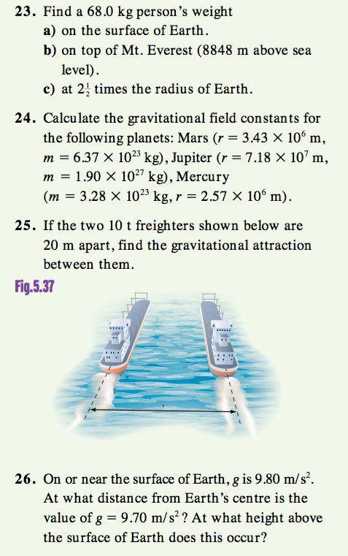



27. A astronaut on the surface of Mars finds that a rock accelerates at 3.6 m/s2 when it is dropped. They also use a Newton scale to find that their weight is 180 N.   
a) What is the mass of the astronaut on Mars? [50 kg]  
b) What is the mass of the astronaut on Earth?   
c) If the astronaut used the same Newton scale on earth, what would their weight be? [490 N]

**23**. (a) 666 N (or 680.N *if g=10.0 N/kg*) (b) 664 N (c) 107 N **24**. gmars= 3.61 N/kg gjupiter=24.6 N/kg gmercury=3.31 N/kg **25.** 1.67x10-5N (with 3 sig digs) **26.** 6.41x106 m 32.5 km

SPH 3U: Dynamics Problem Set Name: _________________

**Freefall motion**

1. A student throws a ball straight up into the air and then catches it after 4.50 seconds. What was the maximum height of the ball? Assume that the ball is thrown from an initial height of 1.50 m. *(26.8m)*
2. A ball is thrown from a 45.0m building with an initial speed of 25 m/s. How longer does it take the ball to hit the ground if it is (a) thrown up (b) thrown down? (6.4 s / 1.4 s)

**Newton’s 2nd Law (horizontal)**

1. A Mazda Miata (m=1080kg) can go from zero to 26.8 m/s (0 to 60 mph) in 7.90 seconds. Find the magnitude of the net force that must act on the car. *(3.66x103 N)*
2. A 4.0x103 kg motor boat experiences a resistance force of 2.5x103 N from the air and a 3.2x103 N force of resistance from the water. If the motor provides a forward force of 6.0 x103 N, calculate the acceleration of the boat. ***(0.075 m/s2 [fwd])***
3. A 15.0 kg object rests on a frictionless horizontal plane and is acted upon by a horizontal force of 30.0 N [E].

(a) What is its acceleration? ***(2.00 m/s2 [E])***

(b) How far will it move in 10.0 s? *(100. m [E])*

(c) What will be its velocity after 10.0 s? *(20.0 m/s [E])*

1. A 300. g croquet ball is thrown with an initial velocity of 6.0 m/s [right]. A force of friction of 0.45N causes the ball to come to a stop. How long did it take the ball to roll to a stop? *(4.0 s)*
2. An 1100 kg car accelerates from rest at 3.4 m/s2 [South].
   1. What is the unbalanced force acting on it? *(3.7 x 103 N [South])*
   2. If the horizontal force exerted on the wheels by the road is 5600 N [South], what force must be resisting the motion of the car? *(1.9 x 103 N [North])*

**Newton’s 2nd Law (vertical)**

1. A model rocket of mass 4.80 x 102 g accelerates vertically upward at 34.0 m/s2 during launch, overcoming both gravity and air resistance. Calculate the thrust force applied by the rocket engine during launch if the air resistance acting on the rocket is 2.40 N**.** *(23.5 N [up])*
2. An elevator and its contents have a combined mass of 6.00x103 kg. It is suspended by a single cable. What force must the cable exert on the elevator
   1. when it is at rest? *(6.00 x 104 N [up])*
   2. when it is moving up at 2.0 m/s2? *(7.20 x104N [up]*
   3. when it is moving down at 2.0 m/s? *(6.00 x 104 N [up])*

**Newton’s 2nd Law and the coefficient of friction**

1. A 5.70 kg box slides across a floor and comes to a complete stop. If its initial velocity was 18.0 km/h [left] and μk = 0.340, find  
   a) the friction acting on the box. *(19.4 N [right])*

b) the acceleration of the box. *(3.4 m/s2 [right])*

c) the total displacement of the box before stopping. ***(3.68 m [left])***

d) the time it took to stop. *(1.47s)*

1. A racing car has a mass of 1500. kg, is accelerating at 5.00 m/s2, is experiencing a lift force of 600. N up (due to its streamlined shape) and ground effects of 1000. N down (due to the spoilers). Find the driving force needed to keep the car going given that μk= 1.00 for the car. *(22900 N [forward])*

**Universal Gravitation**

1. The force of gravity on a 2.50x103 kg spacecraft on the moon is **4080 N.** What is the gravitational field strength there? *(1.63 m/s2)*
2. A 40.0 kg object rests on the surface of a 8.20 x 1022 kg planet with a radius of 3.60 x 105 m.
   1. Calculate the force of gravity acting on the object. *(1.69 x 103 N [down])*
   2. Determine the gravitational field strength  at the planet’s surface. *(42.2 m/s2 [down])*
   3. Calculate the force of gravity acting on the object if it is placed at a position 6.4 x 105 m above the planet’s surface. *(219N N[down])*

**Extras N2L, N3L**

1. A cyclist is travelling at 21 km/h when she sees a stop sign ahead. She applies the brakes and comes to a stop in 15 m. The mass of the cyclist and the bike is 73 kg. Calculate the acceleration of the cyclist.
2. A Saturn V rocket has a mass of 2.92 x 106 kg. Its engines have a thrust of 3.34 x 107 N.
   1. What is the downward force of gravity on the rocket at blast-off? [2.86 x 107 N]
   2. What is the acceleration of the rocket as it leaves the launching platform? [1.6 m/s2]
   3. As the rocket travels upwards, the engine thrust remains constant, but the mass of the rocket decreases. Why?
   4. Does the acceleration of the rocket increase, decrease, or remain the same as the engines continue to fire?
3. Determine the minimum coefficient of static friction that will keep the top box moving along with the bottom box. Assume that the applied force is only applied to the bottom box. Assume the coefficient of kinetic friction between the bottom box and the counter is 0.25. [μS = 0.36]

3.0 kg

7.0 kg

Fapp = 59. 5 N

μK = 0.25

μS = ?



1. Two boxes are side by side on a frictionless surface. A horizontal force of 48.0 N [right] is applied to move both boxes.
   1. Calculate the acceleration of both boxes.
   2. Determine the force that the 40.0 kg box applies to the 20.0 kg box.
   3. Determine the force that the 20.0 kg box applies to the 40.0 kg box.
2. A steel sled is being pulled along the sandy surface of the Planet Z. The sled moves from 12.0 [West] to 24.0 [West] in 0.400 minutes. The magnitude of the net force acting on the sled is 18.5 N and the coefficient of kinetic friction is 0.35 for steel sliding on sand. The mass of planet Z is 9.370 x 1023 kg and the radius of planet Z is 5.00 x 106 m.

(a) Find the acceleration.

(b) How far did the sled travel during the acceleration?

(c) Find the [gravitational field strength] of Planet Z.

(d) The magnitude of all the forces acting on the sled.

(e) What would be the weight of the sled 2.20 x 105 m above planet Z? Draw a fully labeled diagram

# Energy – An introduction

This link (<https://bit.ly/343Lgsp>) can be useful. We group energy into two broad categories:  
  
potential energy: ______________________________________________________________________________________  
  
kinetic energy: ________________________________________________________________________________________  
  
Within these broad categories there are more specific types of energy…

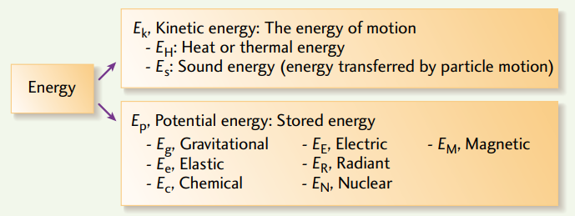  
  
Use the resource linked to above identify one or two examples of each type of energy.

|  |  |
| --- | --- |
| Thermal/heat/sound (K): | Gravitational (P): |
| Elastic (P): | Chemical (P): |
| Electric (P): | Magnetic (P): |
| Radiant (P): | Nuclear (P): |

Using various technologies, we are able to transform energy from one form to another. For example, a hydroelectric damn:

Kinetic energy of water 🡪 electrical energy

For each of the following processes, identify the energy transformations that are taking place. Note that there can be multiple transformations, or multiple types of energy produced.

|  |  |
| --- | --- |
| 1. A match is burning | 1. A gas lawnmower cuts the grass |
| 1. A computer | 1. A hairdryer |
| 1. A battery powered flashlight | 1. A wind turbine |
| 1. A bow and arrow shoots an arrow | 1. A nuclear bomb explodes (far, far away) |
| 1. A wrecking ball demolishes a house | 1. Solar panels power signs on the highway |
| 1. A gas furnace heats your home | 1. Someone jumps on a trampoline |

***Unfortunately, when we transform energy from one form to another the transformation is not perfect. Some of our input energy gets transformed into other unneeded/undesired/unusable forms of energy, and is essentially wasted.***

# Energy in Canada – A snapshot

Where do we get our energy from? Where does it go? How efficient is it? The resource found here provides a good visual of how our energy system works: <https://www.cesarnet.ca/visualization/sankey-diagrams-canadas-energy-systems>

1. ***Start by looking at the energy flow (“All flows”) for all of Canada in the year 2013*** Roughly speaking, how does the amount of energy Canada exports compare to how much it uses domestically?
2. ***Now select “Only Domestic flows” for all of Canada in the year 2013.*** What are the main sources of energy in Canada? Write them in order from greatest to least, and estimate (roughly) what percentage each source produces. Take a minute to reflect on your answer. Does anything surprise/bother/encourage you? (no need to write)
3. Look towards the right of the chart: what main categories is the energy being used for? Rank them roughly from greatest to least. Take a minute to reflect. Is this what you expected? Anything surprising? (no need to write)
4. Summarize what you see when you look all the way to the right of the chart. Any reaction? Where is all the energy going?

1. ***Now compare Canada’s energy flow in 2013 to 1990 (link if desired:*** [***https://bit.ly/3dsrWb0***](https://bit.ly/3dsrWb0)***).*** Any major differences? Similarities?
2. ***Now compare Ontario’s 2013 energy flow to other major provinces (Quebec, BC, Alberta) (link if desired:*** [***https://bit.ly/33ZiFEv***](https://bit.ly/33ZiFEv)***).*** Identify some major differences between the provinces.

The charts are interactive – spend some time clicking the various energy flows for additional learning.

# Tracking Energy

## A: The Pullback Car

Your teacher will demonstrate the motion of ***a pullback car***. We will use the following events:

|  |  |  |  |  |
| --- | --- | --- | --- | --- |
| 1. start pulling car back | 2. finish pulling car back | 3. the instant you release the car | 4. car at max speed | 5. car comes to rest |

1. At which event(s) does the car have primarily potential energy? How do you know?
2. At which event(s) does the car have primarily kinetic energy? How do you know?
3. At which events(s) does the car have neither potential nor kinetic energy? How do you know?
4. What energy transformation is primarily taking place between events 1-2? Explain.
5. What energy transformation is primarily taking place between events 3-4? Explain.
6. What happened to the energy that the car had between events 4 and 5?
7. Complete the energy bar charts for each interval. Events are listed above.

From rest to pullback… From release to max speed… From max speed to rest…  
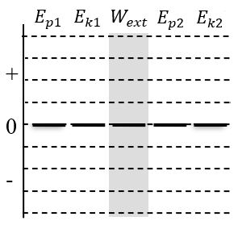 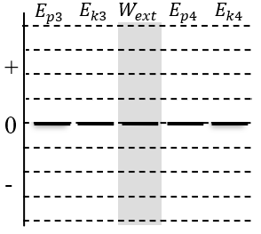 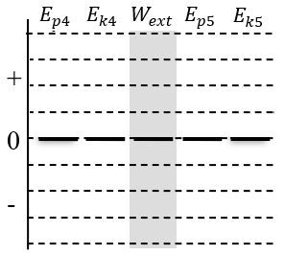

**The Idea of the Conservation of Energy.** Energy cannot be destroyed and energy can’t be created. This powerful idea is called the *conservation of energy*.

**Gravitational Potential Energy** – One specific type of potential energy is gravitational potential energy. When you raise an object up in the air, the object now has more potential energy than when it was lower. A brick held an inch above your foot as compared to a brick held up over your head – which has more potential to do damage? We will often use $E_{G}$ to represent this specific type of potential energy, but in the diagrams below we will continue to use $E_{p}$.

## B: The Pullback Car…on an inclined plane

Your teacher has a car set up at the bottom end of an inclined track. The car has already been pulled back, and we will call the car’s initial height zero. We will use the following events:

|  |  |  |  |  |
| --- | --- | --- | --- | --- |
| 1. car being held, already pulled back | 2. car part way up ramp | 3. car at max height | 4. car part way down ramp | 5. car reaches initial position while moving |

1. At which event(s) does the have:

|  |  |  |  |  |
| --- | --- | --- | --- | --- |
| a) at least some potential energy | b) at least some kinetic energy | c) only potential energy | d) only kinetic energy | e) some kinetic and some potential |

1. What is the difference between the potential energy at event 1 and the potential energy at event 3?
2. Suppose friction did not exist, and all the energy that the car had at event 1 is conserved by the system throughout the process. Draw energy bar diagrams for each interval.

Interval 1-2 Interval 2-3 Interval 3-4 Interval 4-5

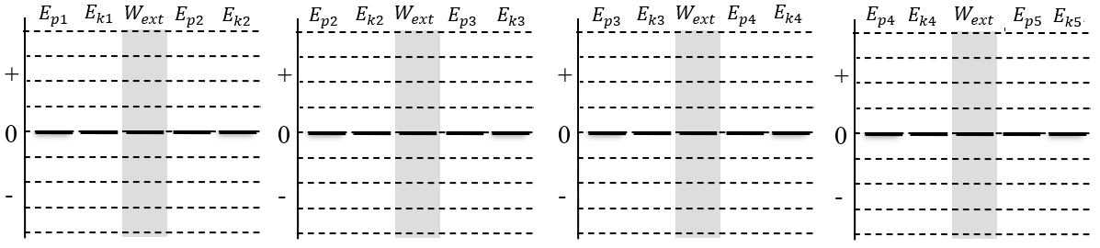

1. Now, let’s consider friction. Suppose the rubbing of the tires on the ramp cause the car to lose a half bar of energy during every interval. Draw energy bar diagrams for this situation.

Interval 1-2 Interval 2-3 Interval 3-4 Interval 4-5



1. How can we tell that the diagrams in #4 are a better representation of the situation than #3?

# Homework: Tracking Energy Name:

**Energy Thinking Process:** To track energy, we must answer two important questions:

1. **Which characteristics of the system are changing?** Start by deciding whether characteristics like the object’s *speed* or vertical position is changing. This helps you decide which energies increase, decrease, or stay the same and draw the bar chart. Double check the bar chart math!
2. **Is energy flowing in or out of the system?** Are there any objects in the environment that are adding energy to or removing energy from the system?

**Represent and Explain.** You are moving a book with your hand. Three different situations are shown below. For each, complete a bar chart. For each situation, describe the characteristics that are changing and any energy flows. Complete the bar chart double-check; after you count the number of block in each section, the equation at the top should make sense.



*y*1

*y*2

*v*2

*v*1

Ek1 + Eg1+Wext = Ek2 +Eg2

+

0

-

•

•

•

•

•

•

•

•

2

1

**Describe changes:**

* The velocity is constant, so Ek stays the same
* The book is going up, so Eg increases

**Energy flow:**

* Energy flows in because of the hand

**Double check**: + =



*y*2

*y*1

*v*1

*v*2

Ek1 + Eg1+Wext = Ek2 +Eg2

+

0

-

•

•

•

•

•

•

1

2

**Describe changes:**

**Energy flows:**

**Double check**: + =

© 2020 C. Meyer



*y*1

*y*2

*v*2

*v*1

Ek1 + Eg1+Wext = Ek2 +Eg2

+

0

-

•

•

•

•

2

1

**Describe changes:**

**Energy flows:**

**Double check**: + =

# Tracking Energy Homework

For each description, complete the energy bar chart and motion diagram, then identify the energy transformations that occur.

|  |  |
| --- | --- |
| 1. A car starts from rest at the top of a hill, and the driver accelerates going down the hill | 1. A parachute glides smoothly to the ground at constant velocity. |
| 1. A race car accelerates quickly along a flat race track | 1. A cannonball is shot upwards and smashes through a castle wall, coming to rest on the 3rd floor of the castle |

# Doing Work!

How do we track the transfer energy into or out of a system?

## A: The Energetic Cart

We will be using a cart in this investigation, and we will assume the force of friction between the cart and table is zero.

FD

1. **Describe and Represent.** We want some energy to flow from your hand to the cart. Describe how you can do this. Draw a motion diagram and a force diagram during this process (while it gains kinetic energy)

+*x*

1. **Describe and Represent.** The cart is initially moving quickly and we want energy to flow from the cart to your hand. Describe how you can do this. Draw an MD and FD during this process. **System = cart**

+*x*

FD

1. **Demonstrate**. Use the cart and show these two situations to your teacher. Move on to the next questions while you wait.

Mechanical Work. Energy can be transferred into or out of a system by an external force. We say that the external force does work on the system. If the system loses energy, we say the force does negative work. If the system gains energy, we say the force does positive work. Energy is a scalar quantity; positive or negative work does not indicate a direction, it only indicates a gain or loss of energy for the system.

1. **Explain.**  In which case above was the work positive or negative. Explain.
2. **Reason.** Think about the first situation above. What do you think would happen to the amount of energy that flows into the system if your hand exerted the same force for twice the distance? Explain.
3. **Reason.** Think about the second situation above. Suppose the cart was moving at the same speed, but now the force you exerted was twice as large. What would happen to the stopping distance? Explain.

**The Definition of Work**. The work done by a force on a system (*W*)depends on three quantities: the size of the force (*F*), the displacement of the system (Δ*d*) and the angle between the force vector and the displacement vector (θ). These are related by the expression, *W =|F||*Δ*d|*cosθ. The units of work may be expressed as N⋅m, but this is equivalent to the unit joules (J) for energy.

© 2015 C. Meyer

**B: Working the Angles**

**Reason and Calculate.** A cart with a mass of 0.70 kg is initially at rest. Then it is pushed horizontally by a hand with a force of 10 N. Friction is negligible.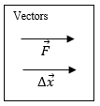 Vector arrows showing the direction of the force from the hand and the displacement of the cart are drawn for you.

* 1. What is the angle between the two vectors? (The angle represents the *difference* in direction of the two vectors)
  2. After it moves a distance of 0.40 m, how much work (in joules) has been done by the force?

1. **Reason and Calculate.** The same cart is rolling along a table and is released. It collides with a block that exerts a 12 N stopping force on the cart. It rolls 0.35 m while stopping.

Vectors

* 1. Draw vector arrows for the block’s force and the displacement of the cart.
  2. What is the angle between the two vectors? What is the work done by the block’s force while bringing the cart to rest?
  3. Interpret the sign of the value for the work that you calculated. What energy flow took place?

1. **Reason and Calculate.** Nowyou push on the cart for 0.50 m while the cart pushes against the block. The block’s force is still 12 N and you push horizontally with a force of 15 N.

FD

* 1. Draw a force diagrams for the system of the cart.
  2. What energy flows are present in this situation?

* 1. Calculate the work done by each force acting on the system.

* 1. What is the total work done on the system? How much kinetic energy did the system gain during this process?

**Net Work – Kinetic Energy Theorem.** The *net work* is the sum of all the work done on the particle. If the net work is positive, the particle *gains* kinetic energy. If the net work is negative, the particle *loses* kinetic energy. This idea is called the *net work - kinetic energy theorem* and is represented by the expression: *Wnet =Ek2 – Ek1 = ΔEk .* Note that this is the same as finding the work done on the particle by the net force vector: *Wnet = |Fnet||Δd| cosθ*.

# Homework: Doing Work! Name:

You are pulling a wagon. It is a bit tiring, but everything is going well until you try to pull it through a patch of mud. The wagon slows and stops. We will focus on the interval while the wagon is slowing in the mud. We will model the effect of the mud on the wagon like a friction force.

1. **Represent**. Draw a force diagram for the system of the wagon.

FD

1. **Describe.** Which forces cause energy to flow in or out of the system?

|  |  |  |  |
| --- | --- | --- | --- |
| Force | θ | Sign of work?  (+, - or 0) | Flow of energy? (in, out or none) |
| *Ft* |  |  |  |
| *Ff* |  |  |  |
| *Fn* |  |  |  |
| *Fg* |  |  |  |

1. **Reason.** Use the new expression for work (*W* = *|F||*Δ*d|*cosθ) to help complete the chart for each force acting on the car.
2. **Reason.** Overall, is the system gaining or losing energy? Explain how you know.
3. **Reason.** Do forces acting perpendicular to the displacement of an object transfer energy in or out of a system? Explain.
4. **Reason.** Did the sign of the work depend on our choice of our positive/negative direction choice? Explain.
5. **Calculate.** The size of your pulling force was 59 N. The friction force from the mud was 75 N. The wagon initially had 8.3 J of kinetic energy. How far did it travel through the mud before stopping?
6. Now you pull the wagon really hard and it starts to speed up.
7. **Reason.** Is this situation accurately described by the FD and energy flow diagram above? Explain what changes you would need to make.
8. **Reason.**  Is the wagon gaining or losing kinetic energy? What would the sign (+/-) of the net work be?
9. **Reason.** How does the amount of energy transferred by each force compare in this situation?

© 2020 C. Meyer

**Doing Work Homework** *(from Irwin Physics 11 p241)*

|  |  |
| --- | --- |
|  |  |
|  |  |
|  |  |

*Answers:* ***12****. 62.5J* ***13****. 0 J* ***14****. 0J* ***15****. 1200 N* ***18a****. 11 000J* ***18b****. 11000J* ***19****. 60000 J*

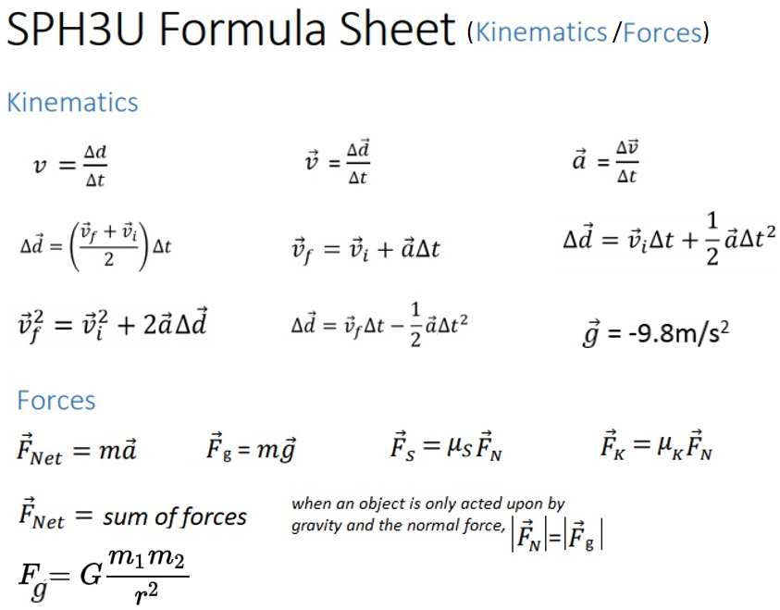

**Energy Research & Artifact Project DUE MARCH 19th**

***Artifact: an object made by humans with cultural, social or historical significance***

In this independent project you need to create some kind of artifact connected to an energy-related topic or issue of your choice. You will be given a great deal of freedom to choose the type of artifact you create, and you will have one full day to work on it. Some examples include:

|  |  |  |  |  |  |
| --- | --- | --- | --- | --- | --- |
| A poster | A video | A song/rap | An essay/written analysis | | A story |
| A diorama | A piece of art | A poem | An interpretive dance | | A pamphlet/brochure |
| A dramatic production | | A summarized interview | | Feel free to suggest other options… | |

Your artifact can be either informative or persuasive.

Trying to convince people about the merit of an idea (or lack thereof). Can be one-sided/biased.

Trying to educate people about the issue. Can include both sides of the argument (pros/cons).

Some other comments & considerations…

* Yes, you are expected to do some research into your topic
* Artifacts that are primarily visual in nature (ex. a painting) should be accompanied by a brief written explanation describing what the artifact is intending to demonstrate/communicate.
* You will be given one full day at home this week to complete your project
* Artifact to be submitted by the end of our next Physics week (March 19th)
* Although you can use any resources you wish, your artifact must contact value added by you. For example, simply making a slideshow of pictures from the internet would not be ok…but assembling those pictures in a creative/artistic/impactful way would be ok
* This is intended to be complete in a day, not over the full upcoming week. **I will keep my expectations reasonable!!**

I will be marking this project according to the following criteria:

|  |  |  |
| --- | --- | --- |
| ***Evidence/quality of research & learning*** | ***Effectiveness to inform/persuade*** | ***Overall impression*** |

Learn

Have funf

Be creative

Some possible topic ideas: (more ideas to come)

|  |  |  |
| --- | --- | --- |
| Pipelines – are they really that bad? Electric cars - the way of the future? | First Nations – are they benefitting enough from the energy industry? | Energy in developing countries – how does it work? |
| Hydroelectricity - what impact do dams have on people & environment? | Buying local – is it really energy efficient? | Air conditioners – comfortable yes, but what’s the impact? |
| Geothermal energy – why isn’t there more of it? | Solar panels – can they be improved? Energy cost to build? | Emails – what’s the energy/environmental cost? |
| Why are renewable energy sources still way behind non-renewable | Incandescent vs. fluorescent vs. LED lights – what’s it all about? | Wind turbines – ugly eyesore or energy source of the future? |
| Biomass, tidal energy – what’s it all about? | Energy storage – is it a good idea? | Living “off the grid” – how does it work from an energy point of view? |
| Household heating & cooling - | Vegetarianism – the energy efficient way to live? | COVID – what’s been its impact on the energy sector? |
| Oil & gas – shutting it down would put many out of work | Energy use in other countries – what can we learn from them? | Canada’s energy attitudes – regional differences/conflict |