***MPM1D Cube Toss — Moving back*** Name: ____________________________

1. Make a scatterplot and draw a line of best fit for the cube toss data shown in the table.

|  |  |
| --- | --- |
| station # | # scored |
| 1 | 90 |
| 2 | 77 |
| 3 | 65 |
| 4 | 49 |
| 5 | 39 |
| 6 | 24 |



1. How many cubes would the class score from station 7? Mark a point and state the coordinates.
2. What is the y-intercept of your line? What does the y-intercept mean/represent?
3. 4. From what station number would the class need to throw from in order to score 30 cubes?   
   Mark a point and state the coordinates.
4. 5. What is the x-intercept of your line? What does the x-intercept mean/represent?

6. Determine the rate of change for your line, using either rise/run, or the slope formula. What does the rate of change mean/represent?  
  
   
  
  
  
7. Write an equation for your line using the rate of change and the y-intercept.

8. What would the cube toss equation be for a class that:

|  |  |  |
| --- | --- | --- |
| a) Scores 80 cubes from “station 0”, and decreases by 15 cubes every station? | b) Scores 65 cubes from “station 0” and decreases by 8 cubes every station? | c) Scores 50 cubes from **station 3**, and decreases by 5 cubes every station |

9. Why does it make sense in this situation for the rate of change to be negative?

10. Write your “cube toss equation” from #7 (previous page) here: ______________________________

|  |  |
| --- | --- |
| a) Use your equation to predict how many cubes will be scored from station 7. You will need to substitute something into your equation. | b) Use your equation to predict from which station we would expect to score 8 cubes. You’ll need to substitute something into your equation. |

11. The cube toss equation for a particular class is given by: $y=-7.5x+82$  
In each case remember: *x* is the station number; *y* is the number of cubes scored

|  |  |
| --- | --- |
| a) What does the number –7.5 represent? | b) What does the number 82 represent? |
| c) How many cubes will be scored from station 5? Use your equation and show your work. | d) From which station would you expect to score 20 cubes? Use your equation and show your work. |

We call the x-intercept, the y-intercept and the slope/rate of change the ***key features***. Determine the key features for each line below, then write an equation for the line.

|  |  |
| --- | --- |
| a) | KEY FEATURES (y-int, x-int, rate of change) and EQUATION |
| b) |  |

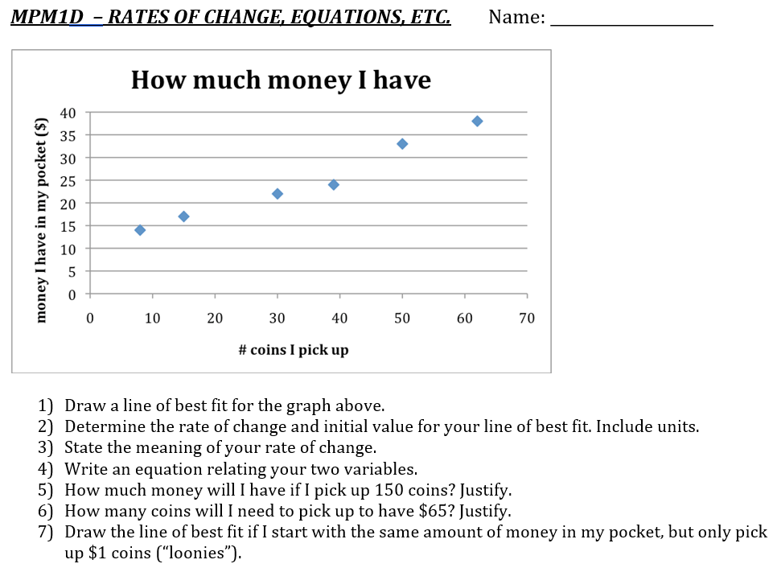

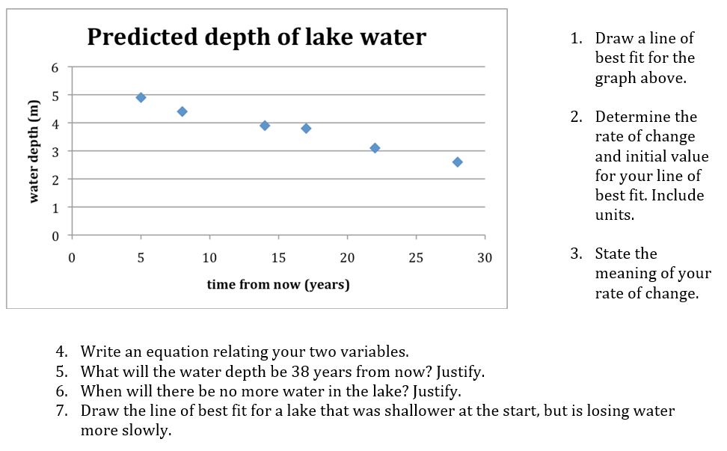

***MPM1D – Finding and Interpreting Key Features***

In each case, determine an equation for the line. Identify the key features and explain what each one means. In your explanation, make sure to use some of the words from the graph labels.

1.

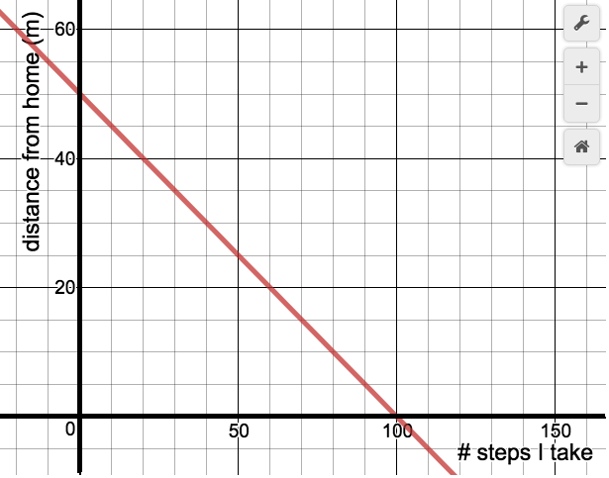

2.

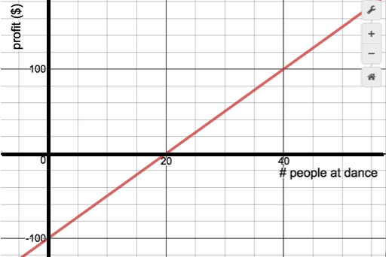

3.

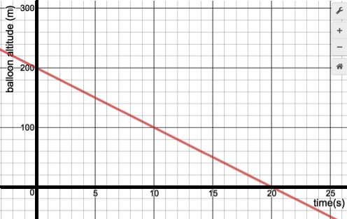

4.

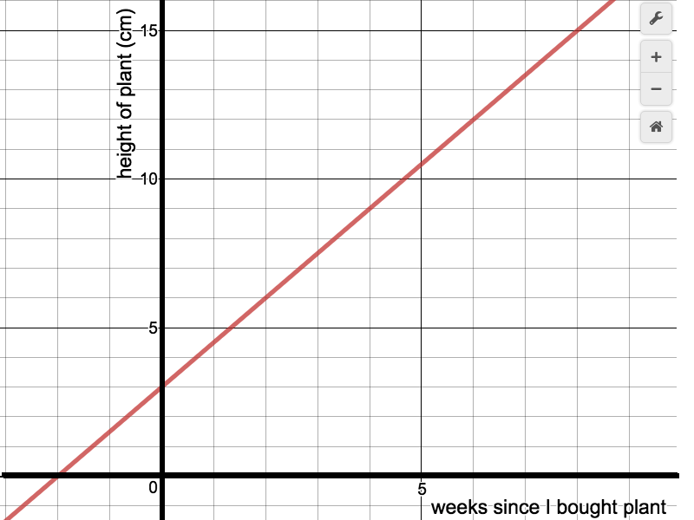

**Jerseys for Sale!**

Carolyn gets a job at the Redblacks selling football jerseys. She is paid a $10 flat fee plus $7.50 for every jersey she sells. Let her total pay be *p* ($) and the number of jerseys she sells *n.*

|  |  |
| --- | --- |
| *n* | *p* |
| 0 |  |
| 5 |  |
| 10 |  |
| 15 |  |
| 20 |  |
| 25 |  |

1. Complete the table of values to the right.
2. What is an equation for Carolyn’s total pay?
3. What is Carolyn’s pay if she sells 0 jerseys?
4. Use your equation to find her pay if she sold 17 jerseys.
5. Use your equation to find how many jerseys she would need to sell to earn $182.50 for a game.
6. At the end of the season inventory is limited and Carolyn can only sell a maximum of 17 jerseys. What are the possible values that your two variables (*n* and *p*) can be?
7. What would the equation be if Carolyn were paid:
   1. $15 flat fee, plus $7.50 per jersey sold? b. $10 flat fee, plus $9 per jersey?
8. $15 flat fee, plus $5 per jersey? d. $20 flat fee only? e. $8 per jersey only?

**Lemonade Stand**

Suzie spends $25.00 on supplies to run a lemonade stand. By the end the week Suzie sold 110 glasses of lemonade and made a total profit of $8.00 (in other words, she sold 110 glasses for $33). Suzie is interested in the relationship between her ***total profit*** and the ***number of glasses of lemonade*** she sells.

1. What is the “fixed” cost of Suzie’s business?

2. If she spent $25 and had a profit of $8, how much revenue did the 110 glasses generate?

3. How much money does Suzie receive ***per glass*** of lemonade she sells?

4. Write an equation relating your two variables.

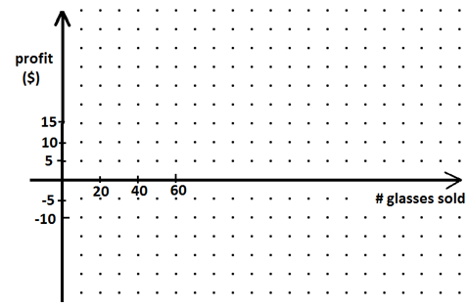5. Suzie wonders how much money she will earn in other weeks when she sells a different number of glasses of lemonade. Draw a graph showing Suzie’s profit if she sells anywhere from 0 to 200 glasses of lemonade. Use increments of 40 glasses of lemonade.

|  |  |
| --- | --- |
|  |  |
| 0 | -25 |
| 40 |  |
| 80 |  |
|  |  |
|  |  |
|  |  |

7. Find Suzie’s profit if she sells 62 glasses of lemonade

a) using your graph

b) using your equation

8. Find the # of glasses Suzie needs to sell to break even a) with your graph

b) using your equation

10. How would your graph be different if Suzie’s cost for supplies went up to $30? What about down to $20?

11. How would your graph be different if Suzie charged 50 cents/glass? What about 20 cents/glass?

***More partial variation situations***…remember: think y = mx + b

Rate of change initial value

***Do these questions on a separate sheet of paper.***

1. A mobile phone company charges a flat fee of $20 and a cost per minute. When your phone bill comes, you discover that you talked for 150 minutes, and your total bill was $72.50 including the flat fee. Determine  
   a) the cost per minute of talk time  
   b) an equation showing the relationship (you will need to introduce variables)  
   c) how much it will cost (including the flat fee) to talk for 275 minutes (use your equation)  
   d) how long you talked for if you total bill came to $51.15 (use your equation)
2. An airplane traveling at an altitude of 5000 m begins descending (going downwards) at a constant rate. After 15 seconds, the airplane has descended 72 m. Determine  
   a) the rate of change for this situation b) an equation showing the relationship  
   c) the altitude of the plane after 75 seconds d) how long it will take the plane to land.
3. You plant a small tree which begins growing at a constant rate. You measure the height of the tree after 3 weeks, and its height is 33 cm. You measure the height of the tree again after 7 weeks and its height is 38.2 cm. Determine  
   a) the rate of change for this situation  
   b) how tall the tree was when you planted it (the “initial value”)  
   c) an equation showing the relationship  
   d) how tall the plant will be after 18 weeks   
   e) how much time has gone by when the plant is 51.3 cm tall

ANSWERS (this page)   
1a) $0.35/minute b) C = 0.35t + 20 c) $116.25  
d) 89 mins

2. a) -4.8 m/s b) a = -4.8t + 5000  
c) 4640 m d) ~1041.7 s

3. a) 1.3 cm/week b) 29.1 cm  
c) h = 1.3w + 29.1 d) 52.5 cm   
e) 17.1 weeks

JERSEYS FOR SALE  
3. p = 7.5n+10 4. $10   
6. $137.50 8. 23 jerseys   
9. n = 0, 1, 2, …, 17 and p = 10, 17.5, …, 130, 137.5 10./11.   
a) p = 7.5n+15 (higher y-intercept) b) p = 9n + 10 (steeper)   
c) p = 5n + 15 (less steep, higher y-int)   
d) p = 20 (horizontal) e) p = 8n (steeper, through origin)   
  
LEMONADE STAND  
2. -25$ 3. $0.3 $/glass 4. p = 0.3c – 25 7. –$6.40   
8. 83.3, or 84 glasses  
10. Lower y-intercept (down to –30); higher y-intercept (up to –20)  
11. Steeper if 50 cents per glass; less steep if 20 cents per glass

***MPM 1D – Linear Systems***

Mr John wants his students to write a math contest. The Sunlife Math Contest costs $30.00 to register plus $2.45 per student. The Waterloo Math Contest costs $4.00 per student with no flat fee.

1. write an equation for the total cost, *C* in $, based on the number of students, *n*, for each contest

Sunlife: _____________________________ Waterloo: _______________________________

1. create a table of values and draw a graph for each math contest. Careful – table goes up by 2 people.

|  |  |
| --- | --- |
| Sunlife | |
| *n* | *C* ($) |
| 0 |  |
| 2 |  |
| 4 |  |
| 6 |  |
| 8 |  |
| 10 |  |

|  |  |
| --- | --- |
| Waterloo | |
| *n* | *C* ($) |
| 0 |  |
| 2 |  |
| 4 |  |
| 6 |  |
| 8 |  |
| 10 |  |



|  |  |  |  |
| --- | --- | --- | --- |
| c) If 8 students register, which contest is cheaper? | d) If 16 students register, which contest is cheaper? | | e) If 24 students register, which contest is cheaper? |
| f) Under which circumstances/conditions will it be cheaper to register for each of the contests? | | g) The minimum number of students that Mr John will register is 10, and the most he is allowed to spend is $90. What are the possible values for *n* and *C* for the $4 Waterloo contest? | |

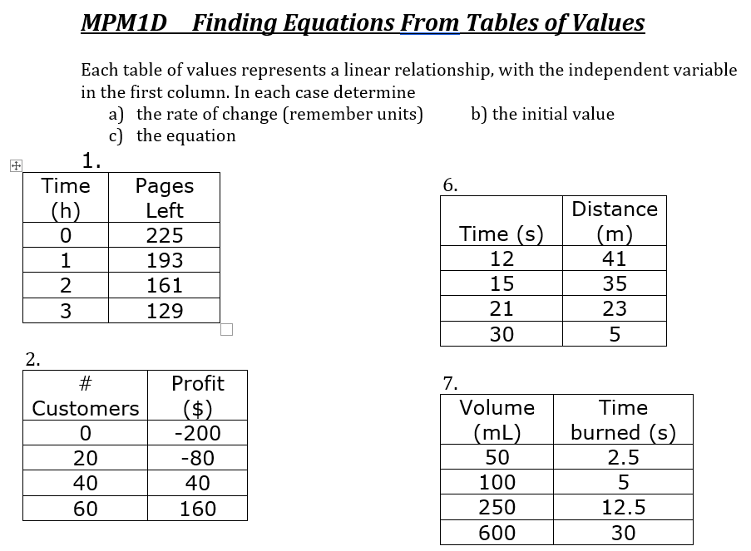

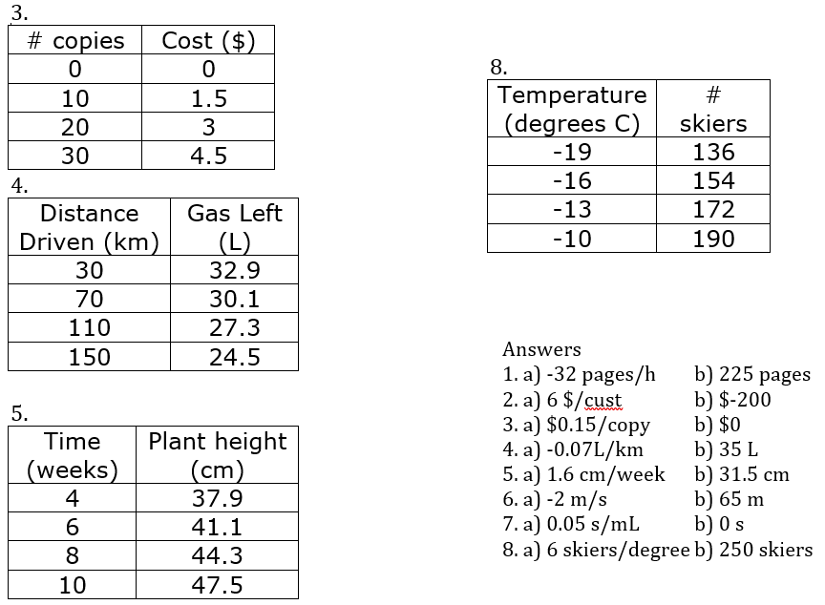

***Standard Form: Ax + By + C = 0***

* Sometimes the equation of a line does not look like y = mx + b. It can also be in Standard Form:

**Ax + By + C = 0** where A, B and C are constants (numbers)

* We can convert from Ax + By + C = 0 to y = mx + b by re-arranging the equation. I**solate y.**

EX/ Change each equation to y = mx + b form, then draw a graph.

1. x + y – 2 = 0 b) x + 2y = 4

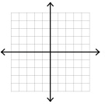 

1. 2y – 6 = 0 d) 6x – 3y – 15 = 0

 

***MPM1D - Practice Graphing Standard Form by Rearranging***

In each case, rearrange the equation to be in the form y = mx + b. Then graph.

|  |  |
| --- | --- |
| $2x+5y+10=0$ | $3x+2y=-8$ |
| $10x-5y=20$ | $x+3y+3=0$ |
| $4y-16=0$ | $24x-18y-38=-2$ |

***Graphing Using Intercepts***

Sketch a graph for each. Focus on two "extreme" cases (all of one, none of the other).

Pictures (x) cost $6 and books (y) cost $8. You spend $24 total.

T-shirts (x) cost $10 and pants (y) cost $20. You spend $40 total.

Hamburgers (x) cost $5 and hot dogs (y) cost $4. You spend $20 total

  

We can graph lines in Standard Form (Ax + By + C = 0) by finding the ***x-intercept*** and ***y-intercept***.   
What is the value of *x* at the *y*-intercept? What is the value of *y* at the *x*-intercept?

EX/ Determine the x- and y-intercepts for the following lines, then graph them.   
a) 2x + y = 4 b) 3x – 4y + 12 = 0

 

***MPM1D - Practice Graphing Using Intercepts***

In each case, graph the line by first finding the x- and y-intercept. What is the slope of each line?

|  |  |
| --- | --- |
| $3x+4y+12=0$ | $2x+3y=-6$ |
| $-3y+x+3=0$ | $-10x+5y=20$ |
| $4y-16=0$ | $-12x-18y+36=0$ |

***Linear Systems***

* Which points are on which line? Recall: points that are ON a line make an equation true (ex. 2 = 2). Points that are NOT ON a line will make an equation false (ex. 3 = 4)

|  |  |  |  |
| --- | --- | --- | --- |
| Points | Line 1 | Line 2 | Line 3 |
| (-4, -1) |  |  |  |
| (-2, 3) |  |  |  |

* 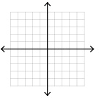Graph line 1 () and line 2 ().   
  What is special about point (-2, 3)?

EX/ Solve each linear system by graphing each line, then identify the point where the lines cross.

Double check your answers if you can.

1.  and  2. and  3.  and 

  

***MPM 1D – Finding a line given conditions   
(including standard form, parallel and perpendicular lines)***

|  |
| --- |
| ***ANSWERS*** |
| a) y = 3x + 5 |
| b) y = –2.5x + 14 |
| c) |
| d) |
| e) |
| f) |
| g) |
| h) |
| i) |
| j) |
| k) |
| l) |
| m) |
| n) |
| o) |
| p) |
| q) |

*Find the equation of a line in the form y = mx + b that   
meets the following conditions. Answers on the right.*

1. Has a slope of 3, and passes through the point (4, 17)
2. Passes through the point (2, 9) and (6, –1)
3. is parallel to y = 2x + 3 and has the same y-intercept as 
4. is perpendicular to and has the same y-intercept as 
5. is parallel to  and passes through the point (–2, 5)
6. is perpendicular to and passes through the point (–15, 6)
7. is perpendicular to and passes through the point (–1, 3)
8. is perpendicular to and passes through the point (3, 4)
9. is perpendicular to and passes through the point (0, –6)
10. is parallel to and has the same y-intercept as 
11. is perpendicular to and with same y-intercept as 
12. is parallel to  and passes through the origin
13. is parallel to  and has the same y-intercept as 
14. is parallel to  and has the same x-intercept as 
15. is perpendicular to  and has the same x-intercept as 
16. passes through the point (1, 4) and has the same y-intercept as 
17. passes through the point (4, –1) and has the same x-intercept as 

**We will be taking up all examples from this page. They can serve as useful examples for the types of questions we will see in the next few pages.**

***MPM1D – Geometry Problems Part 1***

1. What is the sum of the interior angles of an 18-sided figure?

2. What is the measure of each interior angle of a regular 14-sided figure?

3. What is the measure of each exterior angle of a regular 12-sided figure?

4. How many sides does a polygon have if the sum of its interior angles is 3780˚?

5. How many sides does a regular polygon have if each interior angle is 160˚?

***MPM1D – Geometry Problems Part 2***

|  |  |
| --- | --- |
| 1. Find the value of x, and then find the biggest angle. Show your work. | 1. Find the value of the smallest angle. Show your work. |
| 1. Find the values of x and y. Show your work. | 1. Find the value of x. Show your work. |

**MPM1D - Solving Equations in Geometry**

In each of the following questions, show your work. Use a separate piece of paper.

1. What is the sum of the interior angles of a 15-sided figure?

2. What is the measure of each interior angle of a regular 20-sided figure?

3. What is the measure of each exterior angle of a regular 16-sided figure?

4. How many sides does a polygon have if the sum of its interior angles is 3420˚?

5. How many sides does a regular polygon have if each interior angle is 168˚?

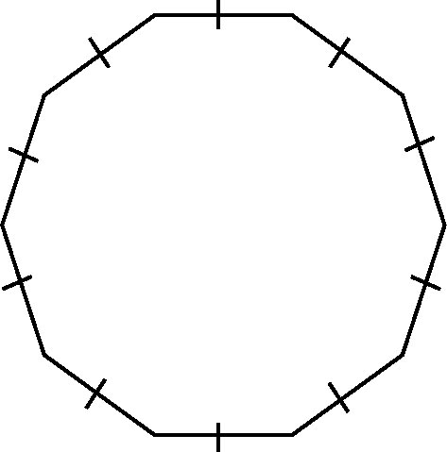7. What is the measure of each internal and external angle?

1. Find the value of x  
   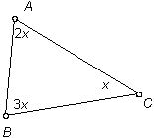
2. What is the value of x?  
   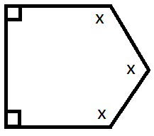
3. One exterior angle of a regular polygon is shown. How many sides does it have?  
   
4. Find the value of x  
   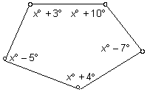
5. What is the value of a if AB is parallel to CD? Hint: Focus on angles A and D first  
   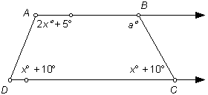

Answers

*1. 2340*° *2. 162*° *3. 22.5*°   
*4. 21 sides 5. 30 sides   
7.* 144˚, 36˚ 8. 115˚ 9. 120˚   
10. 12 11. 107˚ 12. 30˚

***MPM1D - Grade 9: Geometry Properties*** Name:_________________________

|  |  |
| --- | --- |
|  |  |
|  | **4.** Interior angles of a triangle |
|  |  |
| **7.** Exterior Angle Theorem |  |
|  |  |

1. 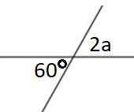Write an equation and solve for the variable in each of the following  
   a) b)   
    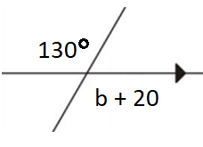  
     
   c) d)   
   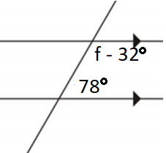 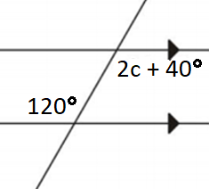  
     
   e) f)   
   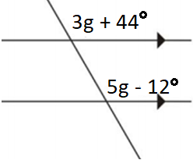 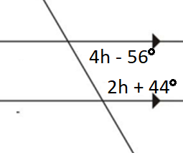
2. Solve for the variable(s)

a) b) c)

$$(x+ 30)$$

$$(x –10)$$

$$x$$

$$x$$

$$(x+7)$$

$$(x-5)$$

$$(x-10)°$$

$$(x+4)$$

$$95$$

$$130$$

$$100$$

$$x$$

1. Find the value of the variable. Use equations when needed. Show your work.  
   a) b) c)  
   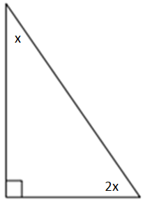 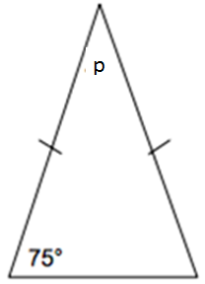 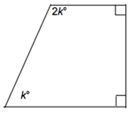  
   d) e) f)   
   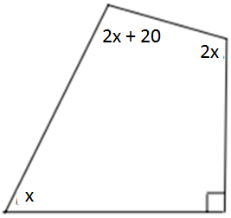 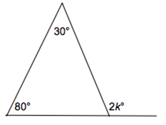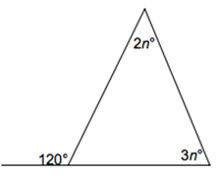

ANSWERS

1. a) a = 30°

b) b = 110° c) f = 134°

d) c = 40° e) g = 28°

f) h = 32°

2. a) x = 35°

b) x = 85° c) c = 91°

3. a) x = 30 °

b) p = 30°  
c) k = 60° d) x = 50°

e) k = 55° f) n = 24°

4. x = 21°  
W = 46°  
Y = 102°  
Z = 32°

5. x = 15°  
y = 14°

<PBC = 30°  
<ABQ = 47°  
<CBQ = 137°

1. Solve for x, then determine angles W, Y and Z.   
   Show your work  
   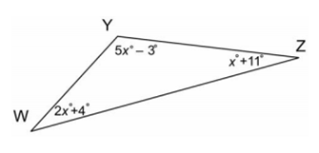
2. Solve for x and y, then determine the following angles:  
   a) <PBC b) <ABQ c) <CBQ  
     
   