***MPM1D – Solving Equations* Name: ____________________**

SOLVE EACH OF THE FOLLOWING. SHOW YOUR STEPS.

PART 1

1. 
2. 
3. 
4. 
5. 
6. 
7. 
8. 
9. 
10. 

PART 2

1. 
2. 
3. 
4. 
5. 
6. 
7. 
8. 
9. 
10. 

PART 3 – Try these. You can use algebra tiles if you want, but…

1. 
2. 
3. 
4. 
5. 
6. 
7. 
8. 
9. 
10. 

PART 4 – Expand (get rid of brackets) and simplify, then solve. Show your steps.

1. 
2. 
3. 
4. 
5. 
6. 
7. 
8. 

***Solving Equations – Perimeter and Area models***

Determine the value of *x* in each case. Show your work.

|  |  |
| --- | --- |
|  |  |
|  |  |

***Solving Equations – Perimeter and Area (practice)*** Name: _____________  
  
Determine the value of *x* in each case. Show your work. Use a separate paper.

|  |  |
| --- | --- |
|  |  |
|  |  |
|  |  |
|  |  |

***Supplemental Problems - Solving Equations With Perimeter and Area***

The TOTAL area of the shapes is given. Find the value of x in each case.

|  |  |
| --- | --- |
|  |  |
|  |  |
|  |  |
|  |  |

***MPM1D: y = mx + b Examples*** Name: ______________________________

|  |  |
| --- | --- |
| Determine the equation of each line shown below.  a) y-intercept: slope = $\frac{rise}{run}=$   equation:    b) y-intercept: slope = $\frac{rise}{run}=$   equation:    c) y-intercept: slope = $\frac{rise}{run}=$   equation:    d) equation: |  |
| Graph and label the following lines on the grid.   a) $y=\frac{2}{3}x-5$ b) $y=-\frac{1}{2}x+4$         c) $y=3x-1$ d) $y=6$ |  |

***MPM 1D – Graphs and Equations of Lines*** Name: ______________________

Find the equation of each line in either the form or .

In both cases, you will need the slope and y-intercept.

|  |  |
| --- | --- |
|  |  |
|  |  |
|  |  |
|  |  |
|  |  |
|  |  |

Graph each line. Start with the y-intercept, then use the slope to find other points.

|  |  |
| --- | --- |
|  |  |
|  |  |
|  |  |
|  |  |
| 1. x = –2 |  |
|  |  |

Find the equation of a line that:



|  |  |
| --- | --- |
| 1. Has a y-intercept of 2, and passes through the point (2,3) | 1. Has a y-intercept of 3, and passes through the point (1, 1) |
| 1. Has a slope of , and passes through the point (–4, 1) | 1. Has a slope of , and passes through the point (3, –2) |
| 1. Has a slope of , and passes through the point (2, 5) | 1. Passes through points (–2, 1) and (2, 3) |
| 1. Passes through the points (1, 2) and (3, –4) | 1. Passes through the points (1, 4) and (8, 18) |

***Understanding Checkpoint – Analytic Geometry*** Name: ____________________  
  
Give the equation of a line that…

1. has a slope of  ____________________
2. has a y-intercept of 6 ____________________
3. is increasing ____________________
4. is decreasing ____________________
5. is a vertical line ____________________
6. is a horizontal line ____________________
7. is steeper than  ____________________
8. is less steep than  ____________________
9. goes in the opposite direction to  ____________________
10. is steeper than  but less steep than  ____________________
11. crosses the y axis between and  ____________________
12. goes through the origin ____________________
13. is horizontal and does not go through the origin ____________________
14. is steep, is increasing, and has a small y-intercept ____________________
15. is not steep, crosses high on the y axis and goes in the opposite ____________________  
    direction of 
16. is a horizontal line with the same y-intercept as  ____________________
17. is a vertical line that passes through the point (1, 4) ____________________
18. is steeper than and passes through the origin ____________________
19. has the same slope as and a y-intercept of 6 ____________________
20. is perpendicular to  ____________________
21. passes through the points (2, 4) and (4, 5) ____________________

***MPM1D – Calculating Volume and Surface Area*** Name: _________

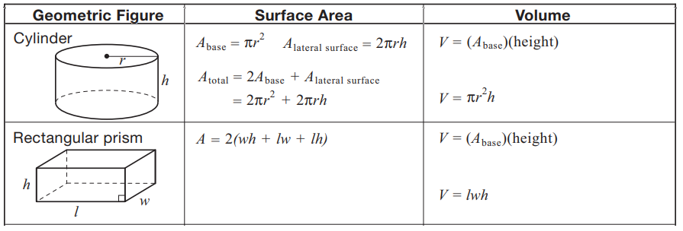

Calculate the surface area and volume of the following shapes. Show your work.  
a) b)   
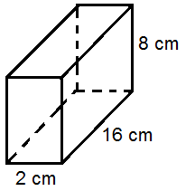 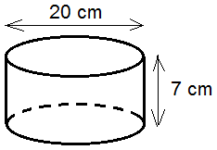

*EXERCISES TAKEN FROM CENTRE FOR INNOVATION IN MATHEMATICS TEACHING:* [*https://www.cimt.org.uk/*](https://www.cimt.org.uk/)

***Work on a separate piece of paper.***

|  |  |
| --- | --- |
|  |  |
|  |  |
|  |  |
|  |  |
|  |  |

***MPM1D – Pyramids Practice***

$$V=\frac{b^{2}h}{3} \\ SA=b^{2}+4\frac{bs}{2}$$ 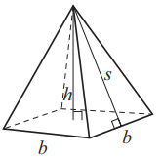

1. Calculate the surface area and volume of the pyramid.  
    Use the formulas to the right. Show your work.  
   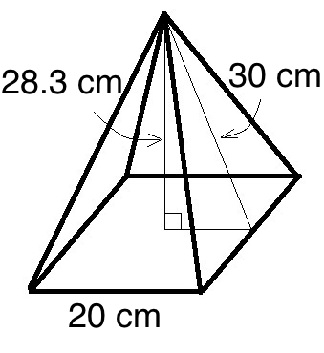
2. a) Use the base and height of the pyramid to find the slant height. Show your work.  
   b) Calculate the surface area of the pyramid. Show your work.  
   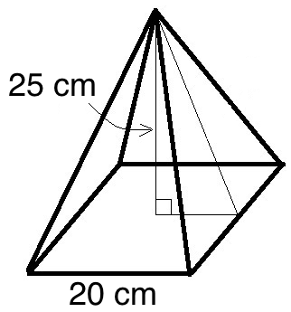
3. a) Use the slant height and base to find the height of the square-based pyramid. Show your work  
   b) Calculate volume of the pyramid. Show your work.  
   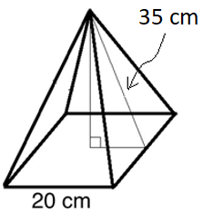
4. CHALLENGE QUESTION… A square-based pyramid has a volume of 2000 cm3, and the length of its base is 20 cm. What is the surface area of this pyramid?  
     
   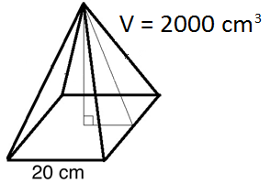

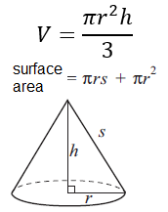

***MPM1D – Cones Practice***

1. a) Calculate the volume of the cone. Show your work  
   b) Use the radius and height to find the slant height of the cone  
   c) Calculate the surface area of the cone. Show your work.  
   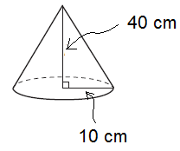
2. Use the slant height and radius to calculate the height of the cone. Show your work.  
   b) Calculate the volume of the cone.  
   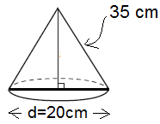

***MPM1D – Spheres Practice***

$$V=\frac{4πr^{3}}{3}$$

$$SA=4πr^{2}$$ 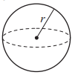

1. a) Calculate the surface area and volume of the sphere. Show your work.  
     
   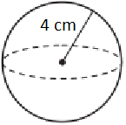
2. a) A sphere fits tightly into a box. What is the volume of the sphere?  
   b) How much air is in the box? Show your work.  
     
   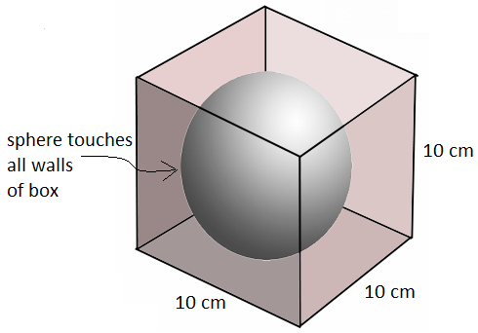

# ***MPM1D – Surface Area & Volume Problems* N**ame:_________________

|  |  |
| --- | --- |
| 1. Calculate the surface area and volume of the cone in the diagram. | 1. A container is made up of a cone and a cylinder. The cone and cylinder in the diagram below have the same height. What is the volume of the container? |
| 1. The diagram shows a greenhouse that is built in the shape of a half-cylinder. Material to cover the roof costs $3/m2. The shaded ends are not covered. What is the cost to cover the roof? |
| 1. An ice cream store makes an ice cream cone as shown in the diagram. The cone is open topped, and the entire outside is coated in chocolate. Find the surface area that is coated in chocolate. | 1. Paper is used to make a popcorn container in the shape of an open-topped cylinder. Calculate the amount of paper needed to make the container. |
| 1. Calculate the volume of the figure shown in the diagram. | 1. How many times bigger is the volume of the bigger sphere? |

***Measurement – Problem Solving***

1. The diameter of a tennis ball is 6.7 cm. Assuming the 3 balls shown in the picture fit tightly in the canister, determine  
   a) the amount of empty space in the container  
   b) the surface area of the container

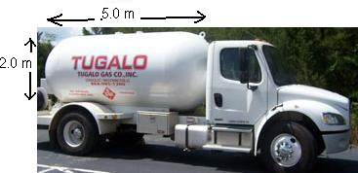

1. The tank of a truck is in the shape of a cylinder, with a half sphere on both ends. The entire tank (including the half spheres) is 5.0 m long.   
    1m3 = 1000L  
   a) Draw a diagram showing the shapes you will use to calculate the volume (with dimensions)  
   b) How many m3 of propane can the tank hold?  
   c) How many square meters of metal is needed to make the tank?  
   d) If a BBQ tank holds 20 L of propane, how many BBQ tanks can this truck fill?

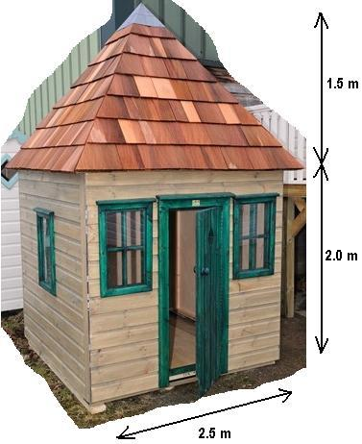

1. a) A child’s playhouse is made up of a square-based prism with a pyramid-shaped roof. Assuming there is a floor but no other interior walls or ceilings, how many pieces of cardboard (each measuring 1.4m x 1.4m) are required to make the house?  
   b) Suppose you have a maximum of 34 square meters of cardboard to work with. You wish to keep the floor area and height of the walls the same as the diagram, but you are willing to alter the height of the roof pyramid. What is the maximum height of the roof pyramid that you can construct out of your available cardboard.

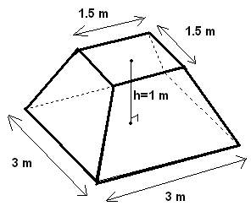4. A frustum is a pyramid that has had its top chopped off; the large concrete frustum in the diagram is now half of its original height (ie. the original pyramid had a height of 2m). As the manufacturer of the frustum you need to determine   
a) the volume of concrete required  
b) the total surface area of the frustum (including the underside)  
c) the total cost if concrete costs $40/m3   
d) how many cans of paint you need if one can of paint covers 5 m2 and you wish to apply 3 coats of paint  
e) the total cost of all the materials (paint and concrete) for this project if a can of paint costs $6.50.

|  |  |  |  |  |  |  |  |  |  |  |  |  |  |  |  |  |  |
| --- | --- | --- | --- | --- | --- | --- | --- | --- | --- | --- | --- | --- | --- | --- | --- | --- | --- |
| ANSWERS SOLVING EQUATION P. 1, 2, 3, 4 | ANSWERS PERIMETER AREA PRACTICE p. 6   |  |  | | --- | --- | | 1. $x=10.66 units$ | 2. | | 3. $x=6 units$ | 4. | | 5. $x=8 units$ | 6. | |  |  |   ANSWERS PERIMETER AREA SUPPLEMENTAL p. 7   |  |  |  |  | | --- | --- | --- | --- | | 1.X = 4.5 | 2.X = 3.9 | 3.X = 7.6 | 4.X = 20.4 | | 5.X = 5.3 | 6.X = 3.0 | 7.X = 5 | 8.X = 13.2 | |
| ANSWER TO GRAPHING LINES (p. 9-12) Can be found at [this link](https://static1.squarespace.com/static/588e089dbe6594f32856d61d/t/5bfc07936d2a73887b9ab7e1/1543243672000/11711+practice+graphing+solns.pdf) or in weekly planner | p. 14 Prisms will follow via weekly planner |
| Prisms p. 15, 16, 17 | Pyramids, Cones, Spheres p. 18, 19, 20, 21  will follow via weekly planner |
| SURFACE AREA VOLUME PROBLEMS p. 22  **ANSWERS TO WORKSHEET**   |  |  | | --- | --- | | **1. V=314.2 cm3 SA = 282.7cm2** | **2. V=3015.9cm3** | | **3. $7539.82** | **4. SA=219.8cm2** | | **5. SA=1498.5cm2** | **6. V=76 ft2** | | **7. 8 times** |  | | MEASUREMENT PROBLEM SOLVING p. 23  Answers  1. a) 236.2 cm3 b) 493.6 cm2  2. b) 13.6 m3 c) 31.4 m2  d) 680 tanks 3. a) 19 pieces b) 0.9 m 4. a) 5.3 m3 b) 22.5 m2  c) $210 d) 14 cans  e) $301.00 |