MPM1D Adding and Subtracting Integers

Never write two signs (+, -, x, ÷) side by side: add brackets around the second one as required.
$-3 + - 4$ Bad Form! $-3 +(- 4)$ Proper!
That being said, it is often helpful to reduce the number of signs and brackets in an expression. When doing this, we need to follow certain rules:
a) $3-(+1) =$ 3 b) $3+(-1) =$
c) $3+(+1) =$ d) $3-(-1) =$

1. Evaluate.
a) $114-120$ b) $-60-35$ c) $2-6-8+6+10$ d)$-5+4+3-1-8$

2. Evaluate. Show any steps you use to simplify, especially when you have two signs in a row.
a) $-2- (-4)$ b) $3+8+(-5)$
c) $-20-\left(-10\right)+\left(-35\right)-(-20)$ d) $-6+\left(-3\right)-\left(-3\right)-(+10)$

- List four possible values to make each statement true. If not possible, write “not possible”
 | - An integer greater than $-2$ and greater than –8 | - An integer greater than $-12$ and less than –2 |  | - An integer greater than $-2$ and less than –12
4a) If you subtract a positive integer from a negative one, is the result positive or negative?  Example: |  |  | b) If you subtract a negative integer from a positive one, is the result positive or negative?  Example:
c) If you subtract a negative integer from a negative one, how can the result be negative?  Example: |  |  | d) If you subtract a positive integer from a positive one, how can the result be negative?  Example:
MPM1D Multiplying and Dividing Integers
- Multiply or divide the numbers
- Then determine their signs:

$$\left(+\right)\left(+\right)= \\ \left(-\right)\left(-\right)= \\ \left(+\right)\left(-\right)= \\ \left(-\right)\left(+\right)=$$ | $$\frac{(+)}{(+)}=$$  $$\frac{\left(-\right)}{\left(-\right)}=$$ | $$\frac{(+)}{(-)}=$$  $$\frac{\left(-\right)}{\left(+\right)}=$$
When there are two signs in a row, sometimes we can reduce them down to one (and sometimes we can’t)
Simplifying two signs to one sign:
If we have $×(+)$ we can just write it as $×$ eg. $3×(+7)=$3
If we have $÷(+)$, we can write it as $÷$ eg. $-8÷(+4)= -$8 ÷
When we have two signs next to each other that cannot be rewritten as one sign, we write the second one in brackets.
Good Form: $6÷(-3)$ or $2×(-4)$ Bad Form! $6÷-3$ or $2×-4$
1. Evaluate.
- $\left(6\right)\left(3\right)$ | - $\left(-4\right)\left(-3\right)$ | - $\left(-2\right)\left(-3\right)\left(-6\right)$

- $-2\left(6\right)$ | - $4\left(-10\right)$ | - $(3)(-2)(10)(-5)$

- $-8÷2= -$ h) $\frac{10}{-2}$ i) $-44÷(-11)$

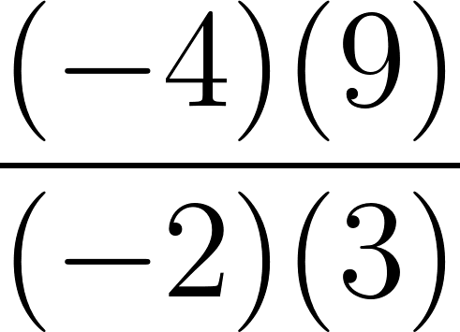
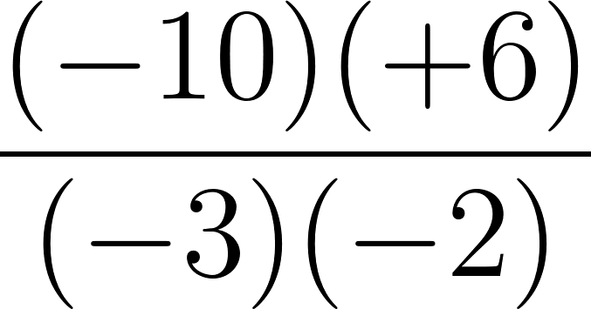
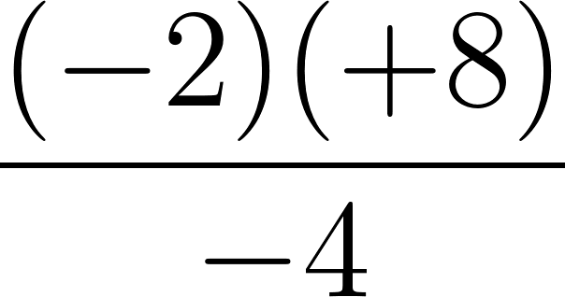
2. Evaluate. Show your steps.
a)
b) c) d) $\frac{\left(-2\right)\left(-100\right)}{{\left(-5\right)}^{2}}$

MPM1D Order of Operations
Recall: First we need to evaluate things in brackets. Second we evaluate any exponents and roots.
Third we do any multiplication or division. Fourth, we do addition and subtraction.
1. Evaluate. Show your steps.
a) $2(15 – 18)$ b) $7 – 3(4^{2} + 10)$ c) $15-2×3^{2}÷6$
d) $120-4\left[3\left(-2+3\right)+5\right]$ e) $-6+\left(-3\right)-(-4+8)×4÷(-2)$

f) g)
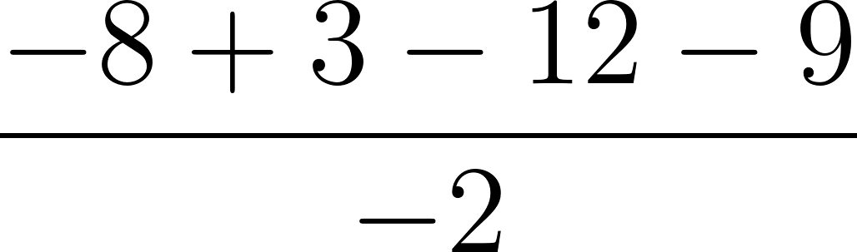 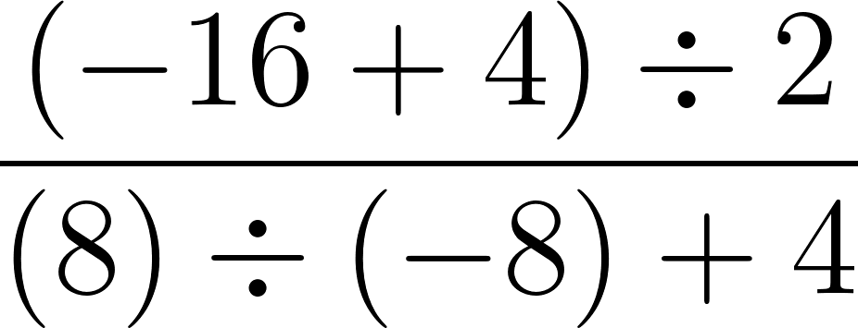 i) $\frac{120÷\left(25-30\right)}{8×\left(-2+3\right)}$
- Adam has $450. He spends $210 on food. Later he divides all the money into four parts out of which three parts were distributed and one part he keeps for himself. Then he found $50 on the road. Write a mathematical expression for the amount of money he has, and find his final amount.

- Mel had $35 and withdrew $200 from her bank account. She bought a pair of pants for $34.00, 2 shirts for $16.00 each, and 2 pairs of shoes for $24.00 each. Write a mathematical expression to represent the amount of money she has, and determine her final amount.

MPM1D Ratios and Rates Name: ___________________
A ratio is a comparison of quantities. For example, if there are 8 apples and 6 oranges in a bowl, the ratio of apples to oranges is 8:6. In this case, there are a total of 8 + 6 = 14 pieces of fruit.

Ratios can be simplified by finding a number that divides evenly into all numbers in the ratio. For example, a ratio of 8:6 can be reduced to 4:3 by dividing each number by 2.

Example 1 Simplify each:
a) 20 : 24 b) 21 : 15 c) 10 : 25 : 45

Example 2 A 350 mL can of red paint is mixed with 1050 mL of yellow paint to make orange paint
a) Write a ratio in simplest form to compare the amount of yellow paint to red paint.

b) Write a ratio in simplest form to compare the amount of yellow paint to the amount of orange paint.

c) How much yellow paint is needed to make 1200 mL of orange paint? (hint…your ratio from b could be useful!)

Example 3 You have 300 candies. Some are red, some white, and some pink. The ratio of the red to white to pink is 5:2:3. How many of each colour is there?
Example 4 - Calculate the unit rate for each:
A rate compares quantities that are measured in different units.
A unit rate or rate of change describes how many units of the first type of quantity correspond to one unit of the second type of quantity.
Examples:
Rate | Unit Rate
I drive 160 km per 2 hours | $\frac{160km}{2h}=$80 km/h
I earn $480 every 4 days | $$\frac{\$480}{4 days}=\$120/day$$

a)You travel 360 km in 4.5 hours. b) You type 500 words in 12 minutes. c) You made $170 in 20 hours.

Example 5 The table below shows the price per case of water at different stores. Evelyn is buying 120 bottles of water. At which store should Evelyn buy her water to pay the least? How much would it cost? (EQAO)
Store | Price per case | # of 500 mL bottles per case
Cheapies | $1.75 | 8
Food smart | $2.25 | 12
Variety Foods | $4.59 | 20
Super Grocers | $4.99 | 24

Grade 9 Assessment of Mathematics, February 2014 Open-Response

Guzzling Gas
David and Shaunese each take a 450 km trip.
- David drives a car and uses 7 L of gas per 100 km
- Shaunese drives a truck and uses 12 L of gas per 100 km.
If gas costs $1.23/L, how much more will it cost Shaunese than David to drive 450 km? Show your work.

MPM1D Review – Percents Name: ______________________

A percent is a number expressed as a fraction of 100. For example, if I say 32% of the animals are cows, it means that for every 100 animals, 32 of them are cows. If there are 200 animals, there are 64 cows.
Percents can be expressed using decimals or fractions: $32\%=0.32=\frac{32}{100}$
In fact, when doing calculations it is often more convenient to use decimals.
25% of 60 is 15
$$0.25×60=15$$
1. BASIC PRACTICE
30 is what percent of 80?  $\frac{30}{80}=0.375$So 37.5% | What is 40% of 60?  $$0.4×60=24$$ | 20% of a number is 50. What is the number?  ? $×0.2=50$  $$\frac{50}{0.2}=250$$
15 is what percent of 70? | What is 30% of 120? | 70% of a number 42. What is the number?
40 is what percent of 28? | What is 18% of 80? | 32% of a number 10. What is the number?

2. Your friend gives you a box of 150 apples. Unfortunately, some of the apples have gone bad!
If 4% of the apples have gone bad how many apples is this? | If 10 of the apples have gone bad, what percentage is this? | If 12% of the apples have gone bad, how many apples are still good?
3. More mixed examples…show your work!
a) Ben has read 75 pages of a 200-page book. What percentage of the book has he read? | b) Gail has $1000 in the bank. She took out $50 to buy school supplies. What percentage of her savings did she take out?
c) Your friend sells you a skateboard for 75% of the original price. Your friend paid $120. What do you pay? | d) You eat 40 g of chocolate, which is 30% of the entire chocolate bar. How much did the full chocolate bar weigh?
e) Charlie and Lena buy a present for their mother. Charlie spends $10 and Lena spends $15. What percentage of the total did Lena spend? | f) You travel 6 km, which is 80% of the distance to school. What is the full distance to school?
5. Start with the number 100. Increase it by 20%. Then take the answer, and increase it again by 20%. Is this the same as increasing the number 100 by 40%? Explain!

Cube Link Follow Up Questions Name: _______________________
Time (s) | # cubes linked
0 | 0
5 | 15
10 | 38
15 | 47
20 | 65
25 | 79
- Make a scatterplot and draw a line of best fit for the following cube link data.

- If the group linked for 30 seconds, how many cubes would you expect it to link? State the Coordinates and mark a point.
- If the group linked 55 cubes together, how many seconds did it link for?
State the Coordinates and mark a point.

- Approximately how many cubes are linked every second? Show your calculations or explain. Note: this number is called the rate of change, or unit rate. | - If you linked cubes for 200 seconds, how many cubes would you link? Show calculation.
- If you linked 750 cubes, how many seconds were you linking for? Show your calculation. | - The group links cubes, and links 110 cubes in 60 seconds. Is it going faster or slower than before?
The cubes link scatterplot for GROUP A is shown below. Draw a line of best fit for this scatterplot.
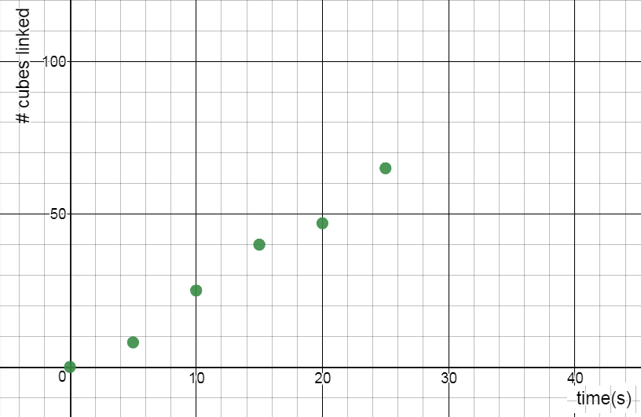
8. Determine the rate of change for this group. In other words, how many cubes does it link per second? Show your calculation.

9. If this group linked cubes for an hour, how many cubes could it link? Show calculations or explain your thinking.

10. a) GROUP B links with one hand only. Draw a line on the graph above for this group. Use a ruler.
b) GROUP C works about the same speed as GROUP A, but they start with some cubes already linked together. Draw a line that could represent this group.
c) We let GROUP D start with 50 cubes already linked, but they really don’t like this activity. Instead of adding new cubes to their chain, they slowly remove cubes from their chain. Draw a line for this group.
11. A group links cubes at a rate of 2.5 cubes per second, and decide they want to make a stack that goes all the way to Parliament Hill (3.8 km away). If we pay the group $5/hour for their work, how much will they earn? Show your work.

Scatterplots, Lines of Good Fit, Predictions, Rates of Change Name: __________________
USE YOUR LINE OF BEST FIT TO MAKE PREDICTIONS.
 | 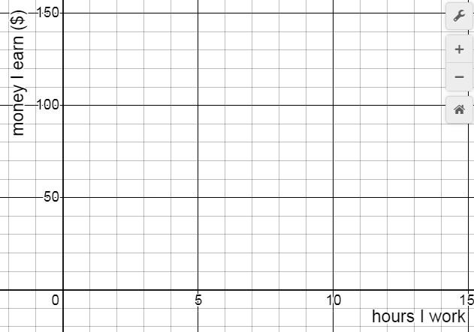
- Make a scatterplot using the data from the table of value. |  | - Draw a line of best fit for the points in your scatterplot.
- How much money will you earn if you work for 7 hours? State the coordinates and mark a point on the graph. |  | - If you earned $90, how long did you work for? State the coordinates and mark a point on the graph.
- Use a point on your line to determine the rate of change. Show your calculation and include units. |  | - Explain the meaning of the rate of change.
- How much money will you earn in one year if you work for 3 hours every day?
 | 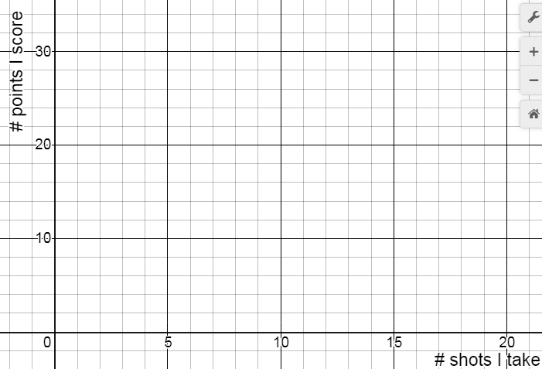
- Make a scatterplot using the data from the table of value. |  | - Draw a line of best fit for the points in your scatterplot.
- How many points will you score if you take 7 shots? State the coordinates and mark a point on the graph. |  | - Predict how many shots you took if you scored 26 points. State the coordinates and mark a point on the graph.
- Use a point on your line to determine the rate of change. Show your calculation and include units. |  | - Explain the meaning of the rate of change.
- You took 24 shots and scored 40 points. Is this more or fewer points than you would expect to score? Explain how you know.
MPM1D – Scatterplots, Rates of Change, Making Predictions
1. Make a scatterplot to represent the data, and draw a line of good fit. Then answer the questions.
 |  | Calculate the rate of change. Show calculation and units.
How much would you expect to earn in tips if you served 45 customers? | If you earned $85 in tips, how many customers did you probably serve? Use your rate of change.
2. The amount of money in two bank accounts is shown in the graph below. How much more will you expect there to be in Account A after one year? Justify.
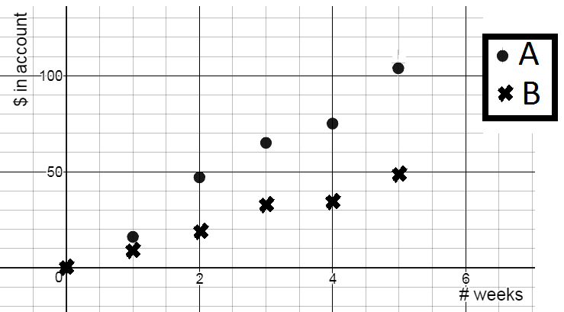
MPM 1D – Direct Variation Examples – do on a separate sheet!
1. You leave home, and then travel 70 km in 4 hours. Let d represent your distance from home (in km), and t the number of hours your drive.
a) Find the rate of change and write an equation relating distance and time. Include units.
b) Make a table of values showing values of t between 1 and 5.
c) Find the distance travelled in 13.2 hours (use your equation).
d) How long it would take to travel 170 km (use your equation)?
2. The income at a music concert (I in $) depends on the number of people (n) that attend. The table of values below shows the relationship between I and n.
- Find the rate of change. Include units. What does the rate of change represent in this case?
- Write an equation relating your variables
- Use your equation to determine how much money was earned when 530 people attended.
- Use your equation to determine how many people attended when the income was $13598.
N (people) | i ($)
0 | 0
50 | 1300
100 | 2600
150 | 3900
200 | 5200

3. The depth of a submarine relative to sea level (d in m) vs. time (t in s) is shown in the graph below.
a) Find the rate of change. Include units.
b) Find an equation relating depth &time
c) Use your equation to determine the depth of the submarine after 21.5 s
d) The Mariana Trench is the deepest point in the Pacific Ocean with a depth of 10 911m. How long would it take the submarine to reach the bottom (if it could)?
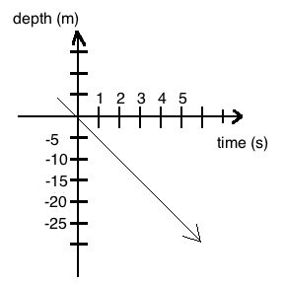
4. The equation h = 0.4d relates the height of a plant, h in cm, to the number of days, d, since it was planted.
a) What is the rate of change? Include units.
b) What does the rate of change represent/mean?
c) Use your equation to determine the height of the plant in 3 weeks time.
d) Use your equation to determine how many days it will take for the plant to be a meter tall.
Answers: 1a) 17.5 km/h c) 231 km d) 9.7 h or 9 h 42 m
2. a) $26/person b) i = 26n c) $13870 d) 523 people
3. a) -5 m/s b) d = -5t c) -107.5 m d) 2182.2 s or 36 m 22 s
4. a) 0.4 cm/day b) how many cm is grows in a day c) 8.4 cm d) 250 days

MPM1D – Multiple Representations Practice
Try to represent each relationship:
-as a table -in words -as an equation -as a graph
1. | 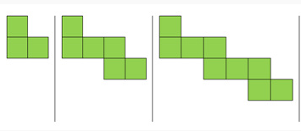  Figure 1 Figure 2 Figure 3
2. | A taxi driver charges a flat fee of $2.50 plus $0.50 per kilometre.
3. | 4, 10, 16, 22, 28, …
4. | T = 7n + 2
5. | Time (minutes) Candies remaining  1 7  2 5  3 3  4 1
6. | 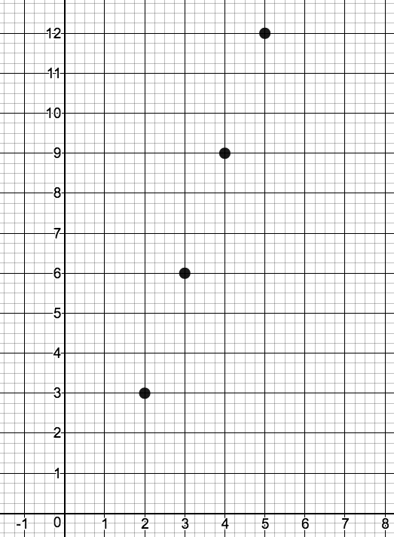
7.

Name:________________________ FINDING MISSING SIDES OF RIGHT TRIANGLES
Find the unknown side using sum of squares/Pythagorean theorem.
a)  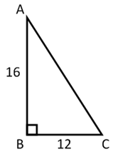 | b)  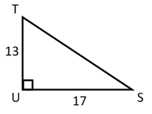
c)  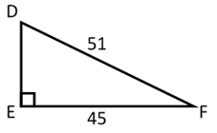 | d)  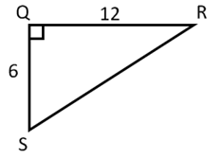
e)  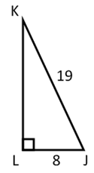 | f)  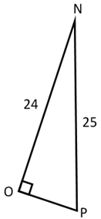
g)  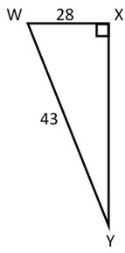 | h)  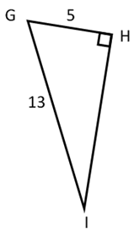
MPM1D Areas and Perimeters of Composite Figures Name: __________________

Find the area and perimeter of the following shapes. Show all important calculations.

Example 1

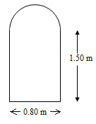

Example 2
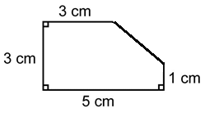

Areas of Composite Figures
1. Calculate the perimeter and area of each shape.
- b)
3 cm
10 cm
4 cm
12 cm
5 cm

c)
64 m
100 m

2. Calculate the area of the shaded region.
a) b)
6.8 m
6.2 cm
9.8 cm

c) d)
4.8 cm
5 cm

Application

3. The field inside a 400 m running track is to be seeded. Each straight portion of the track is 100 m. Each curved part of the track is a semicircle. One 1.5 kg bag of grass seed will seed an area of 80 m².
- What is the length of each curved part of the track?
- Calculate the width of the field.
- Calculate the area of the field.
- Determine the number of bags of seed required.
- One 1.5 kg bag of grass seed costs $12.64. How much does it cost to seed the field?

Trickier…
4. A dog is tied to a 2-m leash at ground level on the side of a building. The leash is attached 1 m from the corner of the building.
- Sketch the region within the dog’s reach and label dimensions.
- Determine the area of this region, to the nearest square metre.
- Calculate the area of the shaded region
4.8 m
- Find an expression for the area of the shaded part of each figure.
- b)
r
R

2r

2r

Answers
 |  | Perimeter (cm) | Area (cm²)
 | a | 30 | 30
 | b | 30 | 40
 | c | 401 | 9617
2. a) 181 cm²  b) 9.9 m²  c) 36 cm²  d) 258 cm²  3. a) 100 m  b) 64 m  c) 9617 m²  d) 121 bags  e) $1529.44 | 4. b) 7 m²  5. 6.5 m²  6. a) A = πR² - πr²  b) A = 4r² - πr²
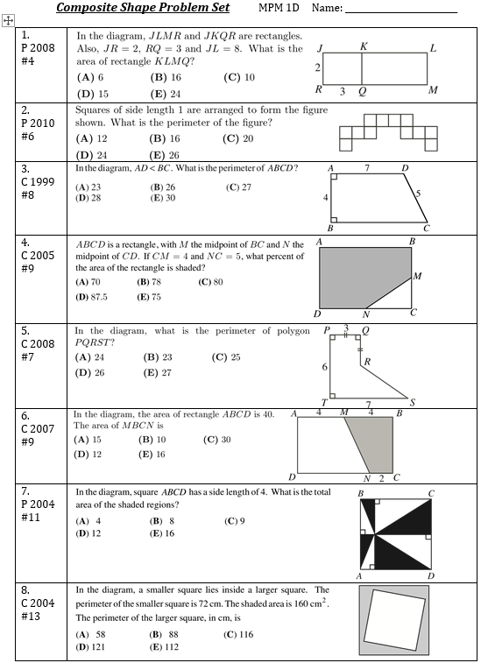
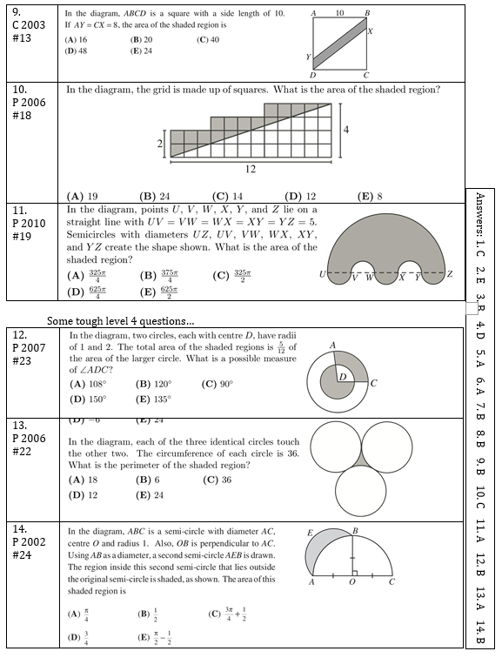
CHALLENGE – CAN YOU FIND AN EQUATION THAT CONNECTS THE FIGURE NUMBER TO THE NUMBER OF OBJECTS IN THAT FIGURE? Note: This is BEYOND the grade 9 curriculum
