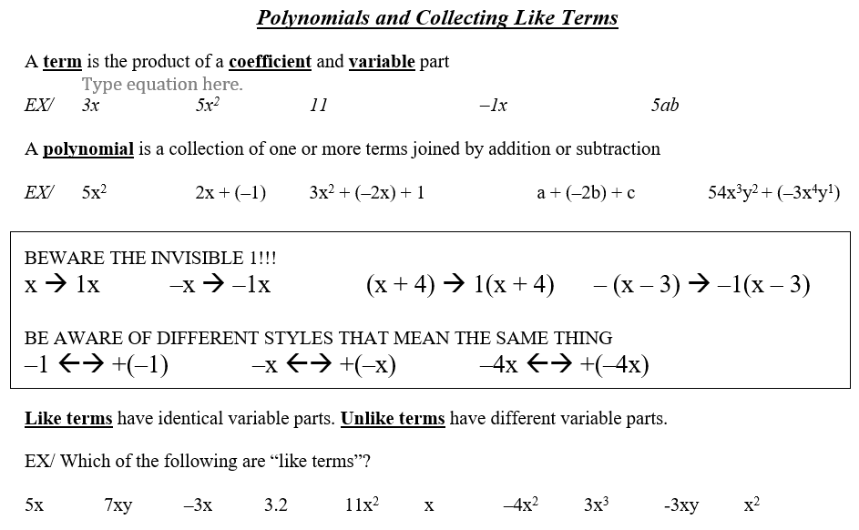 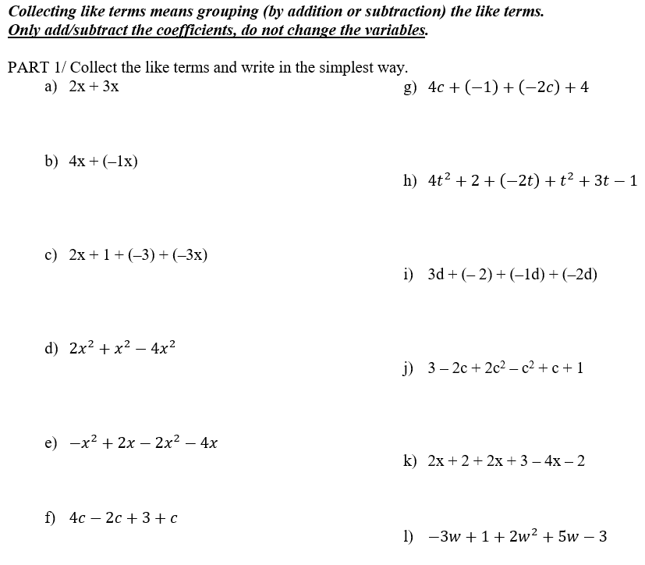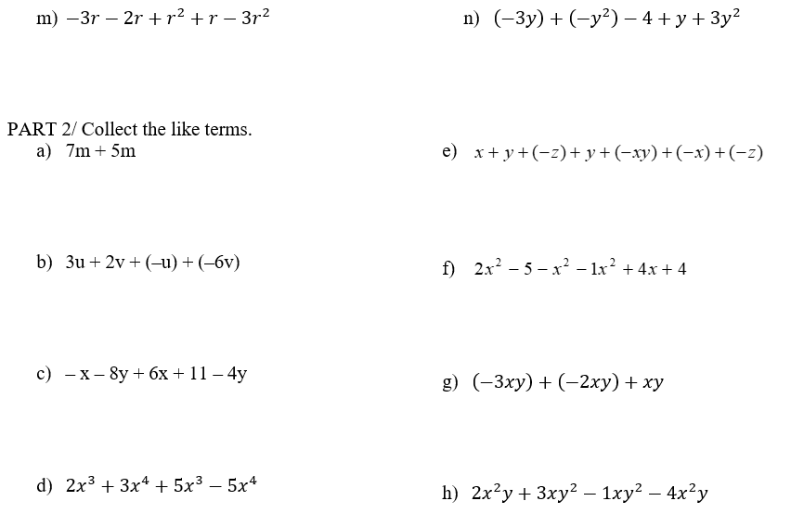

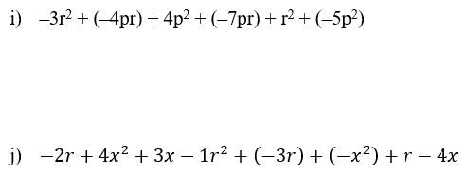

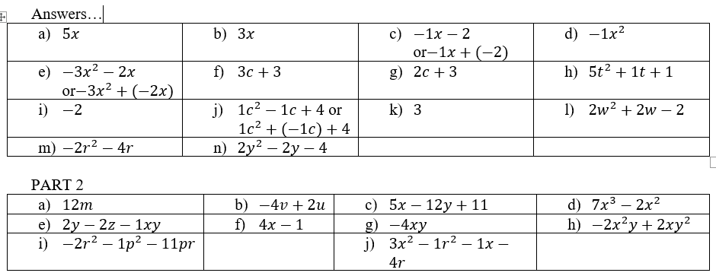

***MPM1D – Distributive Property Name: ________________________***

The distributive property states that: Example: $3\left(x+4\right)$

a(x + y) = ax + ay $=3x+12$

Expand each of the following. Your final answer should have no brackets.  
  
1.  2.  3)  4) 

5)  6)  7)  8)   
  
  
  
  
  
  
9)  10)  11)  12) 

13)  14)  15)  16)   
  
  
  
  
  
  
17)  18)  19)  20) 

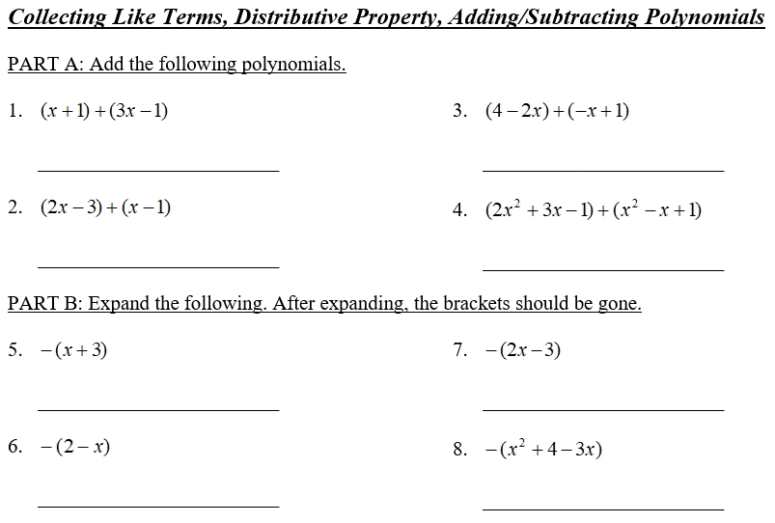 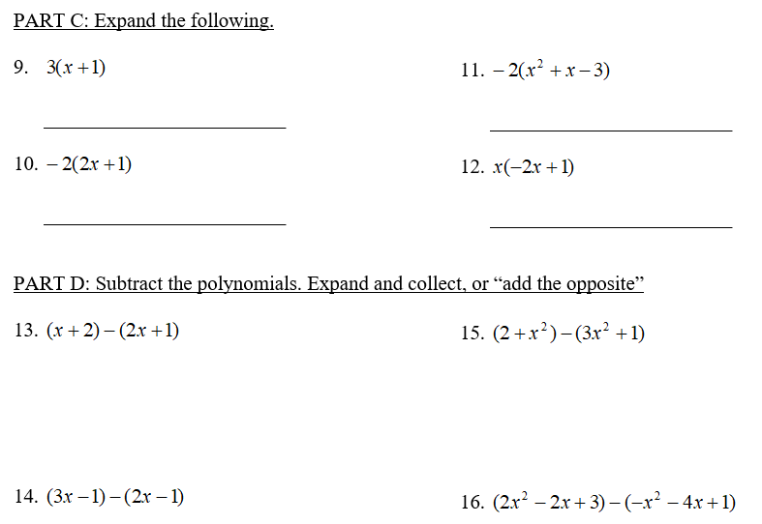

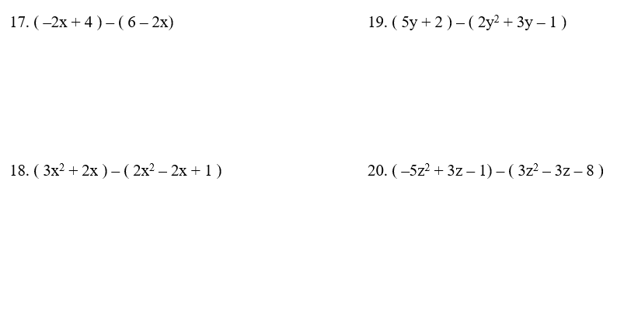 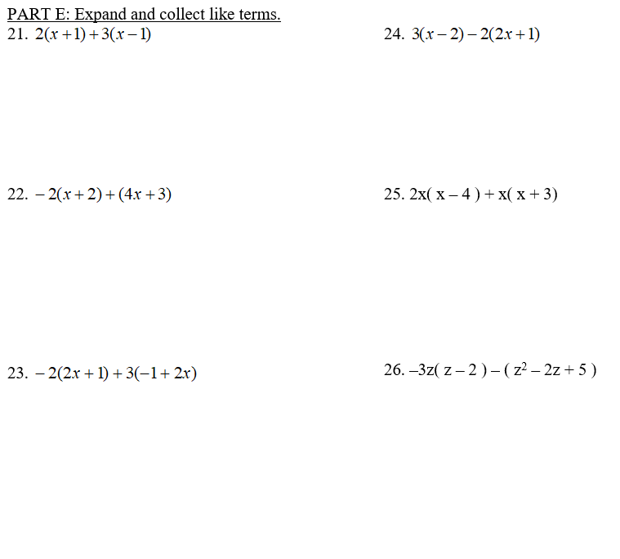 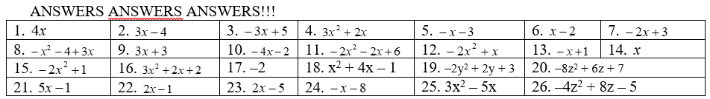

***MPM1D – Polynomials Summary Work*** Name: ___________________________  
  
Simplify each of the following. Use a different sheet of paper to show any steps.

|  |  |
| --- | --- |
|  |  |
|  |  |
|  |  |
|  |  |
|  |  |
|  |  |
|  |  |
|  |  |
|  |  |
|  |  |
|  |  |
|  |  |
|  |  |

ANSWERS

|  |  |  |  |
| --- | --- | --- | --- |
|  |  |  |  |
|  |  |  |  |
|  |  |  |  |
| 1. 1 |  |  |  |
|  |  |  |  |
|  |  |  |  |
|  |  |  |  |

***Coordinates/Ordered Pairs - Introduction*** Name: ________________________________

The imaginary lines we call the x-axis (which is horizontal) and y-axis (which is vertical), chop the Cartesian plane into 4 quadrants. We use ordered pairs to locate points on the plane

|  |  |
| --- | --- |
|  |  |

1. Mark the following points on the Cartesian plane.

|  |
| --- |
| 1. (1, 3) |
| 1. (4, 5)   Join the following points using straight lines: b), c), d), e), b)  Now join: g), h), i)  Surprise! |
| 1. (4, –3) |
| 1. (–6, –3) |
| 1. (–6, 5) |
| 1. (–3, 3) |
| 1. (–4, 0) |
| 1. (–1, –2) |
| 1. (2, 0) |

1. State the coordinates of the points on the Cartesian plane.

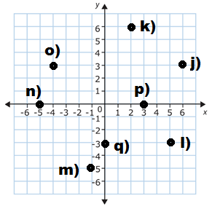

|  |
| --- |
|  |
|  |
|  |
|  |
|  |
|  |
|  |
|  |

***MPM1D – My Line Polygraph*** Name: _____________________

|  |  |  |  |  |  |  |  |
| --- | --- | --- | --- | --- | --- | --- | --- |
| A |  | B |  | C |  | D |  |
| E |  | F |  | G |  | H |  |

For each question and answer, identify the lines that could be eliminated. Use the lines above.

|  |  |  |  |
| --- | --- | --- | --- |
| **#** | **Question** | **Answer** | **Eliminated** |
| 1. | Is the line increasing? | Yes |  |
| 2. | Does the line pass through the origin? | No |  |
| 3. | Is the line steep? | No |  |
| 4. | Is the line decreasing? | Yes |  |
| 5. | Is the line either horizontal or vertical? | Yes |  |
| 6. | Is the line increasing and steep? | Yes |  |
| 7. | Does the line have a positive y-intercept? | No |  |
| 8. | Can you see the x-intercept in the picture? | Yes |  |

In each case, I will give you two lines that remain. Write a question that would let you win the game.

|  |  |  |
| --- | --- | --- |
| **Line 1** | **Line 2** | **Question** |
|  |  |  |
|  |  |  |
|  |  |  |
|  |  |  |
|  |  |  |

For each question, draw three lines (one for yes, two for no). Use a ruler.

|  |  |  |  |
| --- | --- | --- | --- |
| **Line 1 (Yes!)** | **Line 2 (No!)** | **Line 3 (No!)** | **Question** |
|  |  |  | Is the line steep and decreasing? |
|  |  |  | Does the line have a positive x-intercept and a positive y-intercept? |
|  |  |  | Does the line pass through 3 quadrants? |

|  |  |  |  |
| --- | --- | --- | --- |
| Steep | Not steep | Increasing | Decreasing |
| Vertical | Horizontal | x-intercept | y-intercept |
| Positive | Negative | Origin | Quadrant (1/2/3/4) |
| x-axis | y-axis |  |  |

***MPM1D – Draw A Line That…*** Name: _________________________

|  |  |  |  |
| --- | --- | --- | --- |
| a. is increasing  b. is steep and decreasing  c. passes through the point (3,1)   d. passes through the origin and is not steep  e. has a positive x-intercept   f. has a negative y-intercept and passes through (2,–5)   g. passes through three quadrants  h. is vertical, with a negative x-intercept  i. is horizontal, with a positive y-intercept  j. is not steep, is decreasing, and has a negative y-intercept  k. passes through 2 quadrants and has no y-intercept   l. has a positive x-intercept and a positive y-intercept  m. is horizontal, and passes through (–2, 4)  n. passes through  (–4,–1) and (2, 3)  o. passes through the origin and the point (40, 40) | a. | b. | c. |
| d. | e. | f. |
| g. | h. | i. |
| j. | k. | l. |
| m. | n. | o. |

***Slope - Introduction***

In math, we have a way to determine/measure/represent the steepness of a line that connects two points. It is called “Slope”, and it is can be found by finding the ratio of the vertical distance between two points to the horizontal distance between two points:



|  |  |
| --- | --- |
| For the vertical distance (“rise”) | For the horizontal distance (“run”) |
| 🡪 Moving upwards is positive | 🡪 Moving from left to right is positive |
| 🡪 Moving downwards is negative | 🡪 Moving from right to left is negative |

1. Find the slope between points A and B. Leave answers as reduced fractions ( instead of ).

|  |  |  |  |
| --- | --- | --- | --- |
| a. | b. | c. | d. |
| e. | f. | g. | h. |

2. For each pair of graphs, find the slope from Point A to Point B. Compare your answers for each pair, then reflect. Remember to reduce your slopes to simplest form.

|  |  |
| --- | --- |
| a. | b. |
| c. | d. |

***Zukei Puzzles*** Name: __________________________________

Zukei Puzzles are logic puzzles originally created by a Japanese person named Naoki Inaba, and I have added a few of my own. In each case, you need to connect 3 or 4 of the dots to create the indicated shape. Note – there will be some MPM1D-related follow-up!

|  |  |  |
| --- | --- | --- |
| 1. | 2. | 3. |
| 4. | 5. | 6. |
| 7. | 8. | 9. |
| 10. | 11. | 12. |
| 13. | 14. | 15. |
| 16. | 17. | 18. |
| 19. | 20. | 21. |

***Zukei Puzzles - Follow up***

Recall: 

1. Consider Zukei puzzles #7, 11 and 21, which are all either parallelograms or rhombuses. Determine the slope of each side of each shape.

|  |  |  |
| --- | --- | --- |
| Puzzle #7 | Puzzle #11 | Puzzle #21 |

2. How many pairs of parallel sides does a parallelogram and rhombus have? How do your slopes from question #1 support this?

3. Consider Zukei puzzles #8, 18 and 19, which are all trapezoids. Determine the slope of each side of each shape. Remember to reduce each fraction.

|  |  |  |
| --- | --- | --- |
| Puzzle #8 | Puzzle #18 | Puzzle #19 |

4. How many pairs of parallel sides does a trapezoid have? How do your slopes from question #3 support this?

5. Consider Zukei puzzles #4, 15 and 17, which are all squares or rectangles. Determine the slope of each side of each shape. Remember to reduce each fraction.

|  |  |  |
| --- | --- | --- |
| Puzzle #4 | Puzzle #15 | Puzzle #17 |

6. How many pairs of parallel sides do squares and rectangles have? How do your slopes from question #5 support this?

7. Squares and rectangles have sides that meet at 90°. We say the lines are _____________________________. Examine the slopes you determined in question #5. Suggest how we might be able to tell whether lines are perpendicular from their slopes.

8. Determine the slopes for the rectangle in puzzle #3 below. Do these slopes make sense given your response in question #7? Why/why not?  
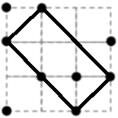  
9. Two students say they’ve found a right angle triangle in #6. Use slopes to determine which is correct.  
 Solution #1 Solution #2

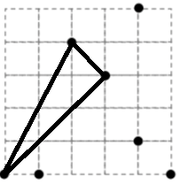 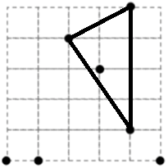

***MPM 1D – Shapes and Slopes***  Name: _____________________________

|  |  |  |  |  |  |  |  |  |
| --- | --- | --- | --- | --- | --- | --- | --- | --- |
| EXAMPLE 1 | | | EXAMPLE 2 | | | EXAMPLE 3 | | |
| Slope of A | Slope of B | Slope of C | Slope of A | Slope of B | Slope of C | Slope of A | Slope of B | Slope of C |

How can we tell if lines are parallel?

|  |  |  |  |  |  |  |  |  |
| --- | --- | --- | --- | --- | --- | --- | --- | --- |
| EXAMPLE 4 | | | EXAMPLE 5 | | | EXAMPLE 6 | | |
| Slope of A | Slope of B |  | Slope of A | Slope of B |  | Slope of A | Slope of B |  |

How can we tell if two lines are perpendicular?

***Working with Slopes – Parallel and Perpendicular***

1. Write whether these slopes are parallel, perpendicular, or neither

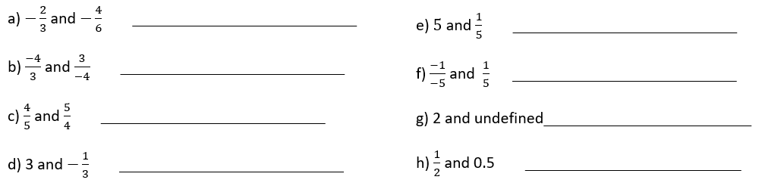

1. Here are the slopes of some lines.

|  |  |  |  |  |  |  |  |  |  |
| --- | --- | --- | --- | --- | --- | --- | --- | --- | --- |
| $$\frac{2}{3}$$ | $$\frac{1}{3}$$ | $$3$$ | $$-\frac{3}{2}$$ | $$\frac{4}{6}$$ | | $$\frac{6}{2}$$ | $$-\frac{1}{3}$$ | $$\frac{12}{4}$$ | 2 |
| a) Write all the slopes that are parallel | | | | | b) Write all the slopes that are perpendicular | | | | |

1. Give a slope that is perpendicular to each of the following slopes:

|  |  |  |  |
| --- | --- | --- | --- |
| 1. m = | 1. m = | 1. m = 2 | 1. m = 0 |

1. Use slopes to determine if the following sets of points form a parallelogram.

|  |  |  |  |
| --- | --- | --- | --- |
| a) |  | b) |  |

1. Use slopes to determine if the following points form a trapezoid.

|  |  |  |  |
| --- | --- | --- | --- |
| a) |  | b) |  |

***Making Shapes*** Name: __________________________________  
**ON THIS PAGE, ONLY IDENTIFY POINTS FOR WHICH THE COORDINATES ARE INTEGERS, AND ONLY IDENTIFY POINTS THAT ARE ON THE GRID (THERE ARE MANY OTHERS OFF THE GRID)**

1. a) What are the coordinates of the points?  
  
  
  
  
  
  
b) Identify all possible locations for a 4th point that would result in a parallelogram

c) How many points will result in a trapezoid (not including the 3 points from part b)?

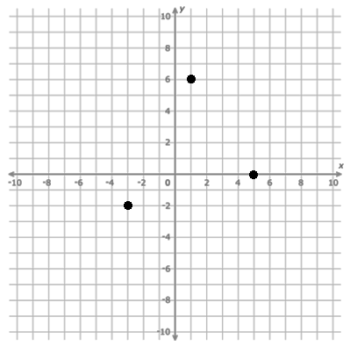

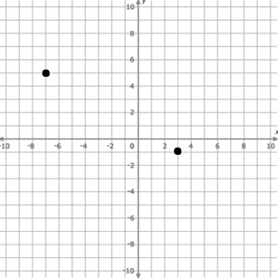

2. a) Determine the slope between the two points.  
  
  
b) Identify all possible locations (on the grid) for a third point that would result in a straight line.

c) Identify all possible locations for a third point that would result in a right angle triangle (there are 5 that are on the grid).

***Calculating Slope from Points or Graphs***

ANSWERS (I think!)

1. a) (5, 0), (1,6), (–3, –2) b) (–7,4), (9,8), (1, –8) c) 12 points (not including 3 from b)
2. a) m= $\frac{3}{5}$ b) (–2,2) or (8, –4) c) (6,4), (9,9), (0, –6), (–4,10), (–10, 0)

* The slope of a line is how steep it is
* We can find the slope of a line connecting two points (*x*1 , *y*1) and (*x*2, *y*2) by this formula:



Determine the slope.   
a)  
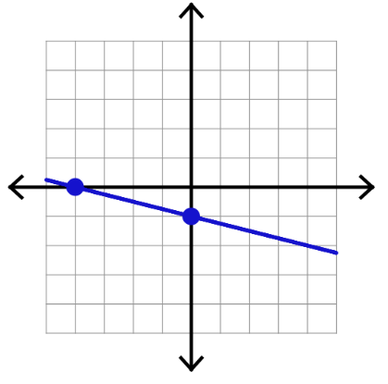  
  
  
  
  
  
  
  
  
  
  
b)  
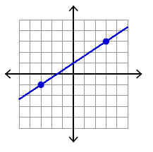

1. (5, 6); (8, 2)
2. (–1, 3); (5, 7)
3. (–5, 0); (–1; 2)
4. (4, –2); (–5, –11)

Calculate the slope between each pair of points. 

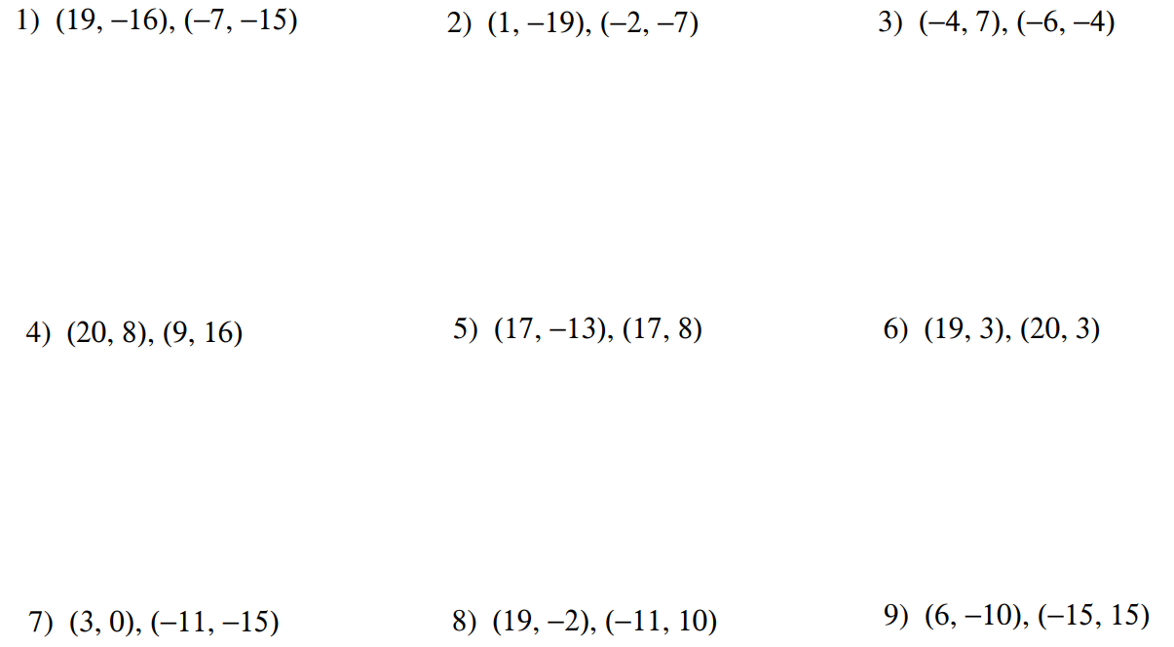

Examples: Given a point on a line and the slope of the line, find another point on the line.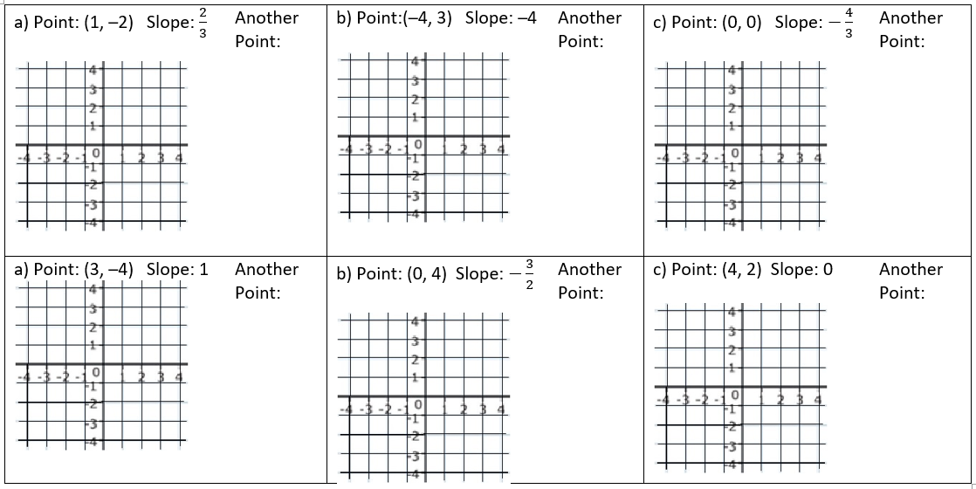

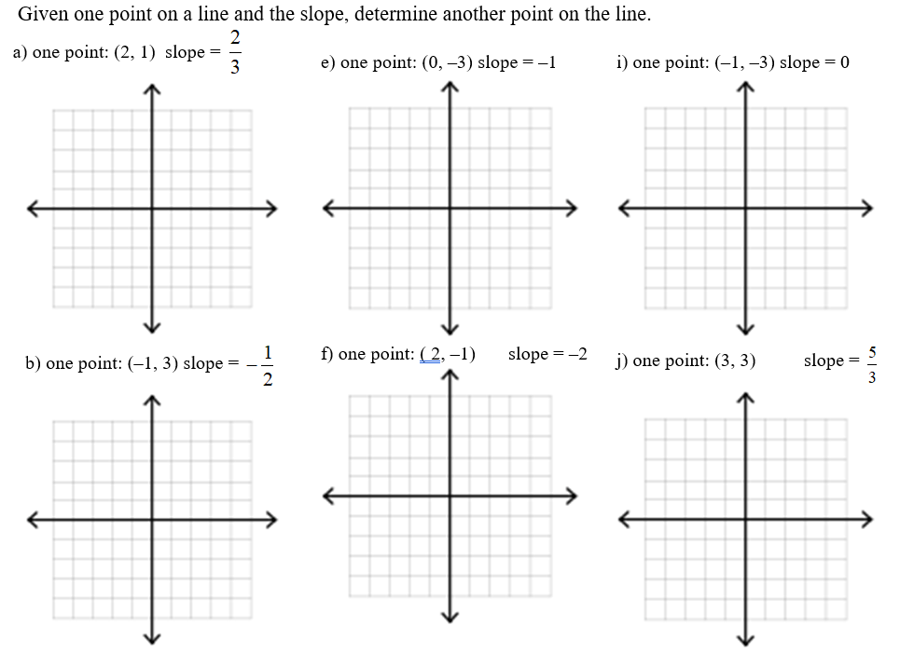

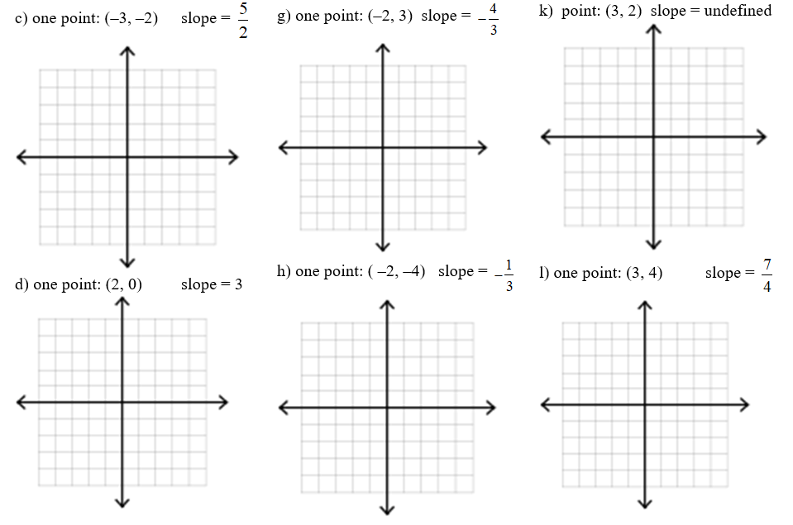

***Slope – Mixed Problems…***

1. Calculate the slope between each pair of points. State whether the slope are parallel, perpendicular, or neither.

|  |
| --- |
| 1. ( 4, 5 ) and (2, 1) ( 6, 2 ) and (10, 10) |
| 1. (5, 1) and (2, 2) ( 6, 7) and (8, 2) |
| 1. ( 2, 3 ) and (5, 1) ( 6, 2) and ( 0, –2 ) |
| 1. ( 3, 2 ) and (8, 2) (–4, 2) and (–4, 8 ) |

1. A line with a slope of $-\frac{15}{13}$ passes through the point ( –15, 6). What is another point on the line? Explain.
2. Use slopes to determine if the following three points form a right angle.

|  |  |  |  |
| --- | --- | --- | --- |
| a) | L( –4, 3 ) M( –2, –3 ) N( 7, 0 ) | b) | P( –1, –3 ) Q( 3, 5 ) R( –5, 0) |

1. Do the following three points form a straight line? Justify using slopes.  
   A( 13, 18 ) B( –5, 9 ) C( 19, 21 )
2. Point L lies on line segment KM as shown. What is the value of *w*? Show your work/thinking.  
   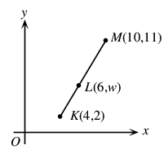
3. If the line that passes through the point (2, 7) and (*a*, *3a*) has a slope of 2, what is the value of *a*? Show your work/thinking.

***CARDBOARD PRISMS – CALCULATING COSTS***

1. You need the following amounts of material. Determine the cost of the cardboard prism. Show your work. You only need to pay for what you use.

|  |  |  |  |
| --- | --- | --- | --- |
| ITEM: Cardboard | ITEM: Noodles | ITEM: Glue | ITEM: Labour |
| YOU NEED: 900 cm2 | YOU NEED: 1400 mL | YOU NEED: 80 cm for edges 20 dabs (enough for 10 wall braces) | YOU NEED: 1.5 hours |
| COST: 5000 cm2 costs $10 | COST: 2L costs $5 | COST: A glue stick costs $0.25 and can do 15 cm of edge or 4 dabs | COST: Worker makes $620 for her 40 hour week |

1. You need the following amounts of material. Determine the cost of the cardboard prism. Show your work. You only need to pay for what you use.

|  |  |  |  |
| --- | --- | --- | --- |
| ITEM: Cardboard | ITEM: Noodles | ITEM: Glue | ITEM: Labour |
| YOU NEED: 900 cm2 | YOU NEED: 1400 mL | YOU NEED: 80 cm for edges 20 dabs (enough for 10 wall braces) | YOU NEED: 1.5 hours |
| COST: A 50 cm x 80 cm piece normally costs $16, but it is on sale for 25% off | COST: A box measuring  12 in x 12 in x 12 in costs $7 | COST: A pound of glue sticks costs $15. Each glue stick weighs 25 g. A glue stick can do 20 cm of edge or 8 dabs | COST: Builder is paid 40% more than Ontario’s minimum wage |

*Some common conversions. You can look up others as needed, but state any conversion rates you use.*1 inch = 2.5 cm (approx.) 1 cm3 = 1 mL 1 foot = 12 inches 1 kg = 1000 g 1 dozen = 12 items  
1 m = 100 cm 1 m = 3.3 feet (approx.) $1 = 100 cents 1L = 1000 mL 1 pound = 454 g

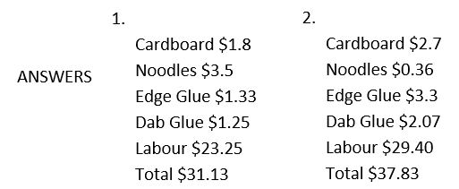

***MPM1D CARDBOARD PRISMS – CALCULATING COST*** Name: __________________________

The cardboard prism you need to build requires the following materials:

|  |  |  |  |  |
| --- | --- | --- | --- | --- |
| Cardboard | Noodles | Edge Glue | Dab Glue | Labour |
| 1200 cm2 | 1450 mL | 85 cm | 6 wall braces (each brace has 2 dabs) | Will take an hour and a quarter |

Calculate the cost to build the prism for each of the 4 countries below. In all cases, you only need to pay for the materials you use (eg. If you only need half a stick of glue, you don’t need to pay for the entire stick).

|  |  |  |  |  |  |  |  |
| --- | --- | --- | --- | --- | --- | --- | --- |
| **TANZANIA** | | | | | | | |
| 1. Cardboard   🡪 Cardboard costs $0.0025 per square cm | 1. Noodles   🡪 Noodles cost $0.75 per L | | 1. Glue   🡪 For edges: it costs 2 cents per cm of edge  🡪 For dabs: each dab costs 5 cents | | | 1. Labour   🡪The builder is paid $5/hour | |
| **MONGOLIA** | | | | | | |
| 1. Cardboard   🡪 Cardboard costs $1.50 for a piece measuring 500 square cm | | 1. Noodles   🡪2 L of noodles cost $3.50 | | 1. Glue   🡪 a glue stick costs $1.25 🡪 each glue stick can do 50 cm of edge, or 10 dabs | 1. Labour 🡪 The builder is paid $275 for their 40 hour work week | |
| **NICARAGUA** | | | | | | |
| 1. Cardboard   🡪 A piece of cardboard measuring 50 cm x 80 cm costs $6.25, but is on sale for 20% off. | | 1. Noodles   🡪 The first half litre of noodles costs $1.40.  🡪 After that, noodles cost $1.80 per litre | | 1. Glue   🡪A dozen glue sticks costs $5.50 🡪 2 glue sticks are needed to join 1 foot of edges 🡪 One glue stick can be used for 25 dabs | 1. Labour   🡪The builder insists on getting paid 20% more than the Ontario minimum wage | |
| **FIJI** | | | | | | |
| 1. Cardboard   🡪 A cardboard sheet measuring 2 feet by 3 feet costs $25 🡪 Add 15% of the required cardboard amount for wastage | | 1. Noodles   🡪 Noodles cost $5 per kg 🡪 One scoop of noodles weighs 40 g and has a volume of 74 mL | | 1. Glue   🡪 Glue costs $6.60 per pound 🡪 a 7 g stick of glue is enough for 25 cm of edge, or 12 dabs | 1. Labour   🡪 The builder demands US$500 for a 40 hour work week 🡪 you still need to pay in Canadian $ | |

*Some common conversions. You can look up others as needed, but state any conversion rates you use.*1 inch = 2.5 cm (approx.) 1 cm3 = 1 mL 1 foot = 12 inches 1 kg = 1000 g 1 dozen = 12 items  
1 m = 100 cm 1 m = 3.3 feet (approx.) $1 = 100 cents 1L = 1000 mL 1 pound = 454 g

