***MFM2P – Final Evaluation 1*** Name: _____________________

|  |  |
| --- | --- |
| **Expectation:** | **Mark** |
| use their knowledge of ratio and proportion to investigate similar triangles and solve problems related to similarity and the Pythagorean Theorem |  |

1. The height of a person is shown, together with the length of their shadow and the length of the shadow of a flagpole. Find the height of the flagpole. Show your work.  
     
   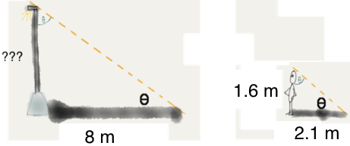
2. You place a mirror on the ground and position yourself to see the top of a tree. How far are you from the mirror? Show your work.  
   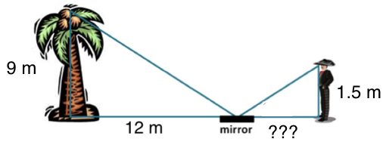
3. The measurements of the school are shown. What is the distance from one corner of the school to the opposite corner? Show your work.  
   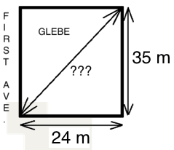
4. The measurements of the school are shown. What is the perimeter of the school? Show your work.  
   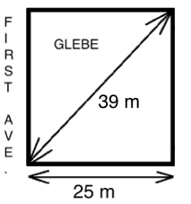
5. The three triangles below are similar. Find the value of x and y. Show your work.  
   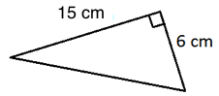 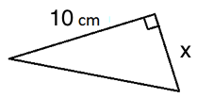

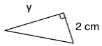

1. What is the length of the line from R to S? Show your work.  
   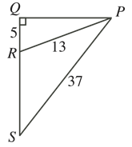

***MFM2P – Final Evaluation 2*** Name: _____________________

|  |  |
| --- | --- |
| **Expectation:** | **Mark** |
| solve problems involving right triangles, using the primary trigonometric ratios |  |

All of the questions on this page relate to getting from Point A to Point B as shown in the diagram.  
**\*\*\* FOR ALL QUESTIONS, DRAW A DIAGRAM AND SHOW YOUR WORK \*\*\***

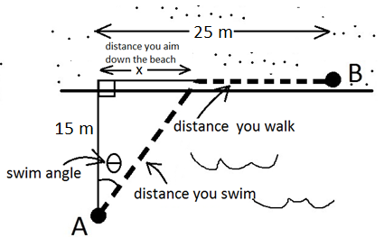

|  |  |
| --- | --- |
| 1. If you swim 20 m, what was your swim angle? | 1. If you walk 7 m what was your swim angle? |
| 1. If your swim angle was 20°, how far did you walk? | 1. If your swim angle was 32°, how far did you swim? |

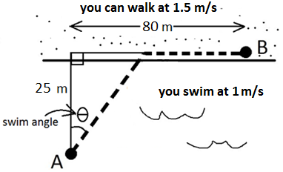

1. Refer to the diagram above. If your swim angle is 30°, how long does the total journey take? Show your work.
2. Refer to the diagram above. If you spent 20 seconds walking, what was your swim angle? Show your work.

***MFM2P – Final Evaluation 3*** Name: _____________________

|  |  |
| --- | --- |
| **Expectation:** | **Mark** |
| solve problems involving the surface areas and volumes of three-dimensional figures, and use the imperial and metric systems of measurement. |  |

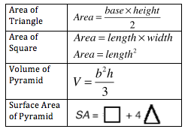

1. a) Calculate the surface are and volume of the pyramid shown in the diagram. Show your work.  
   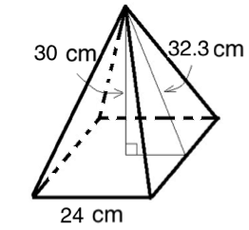  
     
     
     
     
     
     
     
   b) We will make the pyramid above out of cardboard and fill it with noodles.   
   Cardboard costs $0.002 per cm2. Noodles cost $2.50 per Litre. How much will it cost to build and fill the pyramid? Show your work.

Note: 1 L = 1000 mL  
 1 cm3 = 1 mL

*Some common conversions.*

1 inch = 2.5 cm (approx.) 1 cm3 = 1 mL 1 foot = 12 inches 1 kg = 1000 g 1 dozen = 12 items  
1 m = 100 cm 1 m = 3.3 feet (approx.) $1 = 100 cents 1L = 1000 mL 1 pound = 454 g

1. a) Calculate the surface area and volume of the pyramid shown in the diagram. Show your work.  
   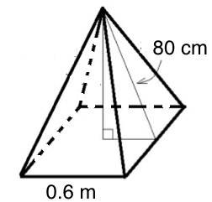  
     
     
     
     
     
     
     
     
     
   b) We will make the pyramid above out of cardboard and fill it with noodles.   
   Noodles cost $0.45 for 2 Litres. Cardboard costs $3.50 for a piece measuring 2 feet by 3 feet.  
   How much will it cost to build the pyramid? You only need to pay for the material you use.   
   Show your work.  
     
     
     
     
     
     
     
     
   .***MFM2P – Final Evaluation 4*** Name: _____________________



|  |  |
| --- | --- |
| **Expectation:** | **Mark** |
| Manipulate and solve algebraic equations, as needed to solve problems; |  |

|  |  |  |
| --- | --- | --- |
| FIGURE 1 | FIGURE 2 | FIGURE 3 |

1. Consider the figures above. The number of circles is given by the equation , where *x* represents the figure number, and *y* represents the number of circles.

a) How many circles will be in the 43rd figure? Use the equation above, and show your work.  
  
  
  
  
  
  
b) What figure number will have 612 circles? Show your work.

2. The height of a cup stack is given by the equation , where *c* represents the number of cups, and *h* represents the height of the stack.

a) How tall will the stack be if there are 87 cups? Show your work.  
  
  
  
  
b) If the stack is 164 cm tall, how many cups are in the stack? Show your work.

3. Solve the following equations. In other words, find the value of *x*. You can use algebra tiles if you wish. Show your work. If you use algebra tiles, draw pictures to represent your solution.  
a)  b)  
  
  
  
  
  
  
  
  
  
  
  
  
  
  
  
c)  d)

***MFM2P – Final Evaluation 5*** Name: _____________________

|  |  |
| --- | --- |
| **Expectation:** | **Mark** |
| graph a line and write the equation of a line from given information; |  |

1. For each of the following tables of values, determine:

* the rate of change (include units)
* the initial value (include units)
* an equation

a) b) c)

|  |  |
| --- | --- |
| # cups | height of stack (cm) |
| 4 | 22.0 |
| 6 | 26.4 |
| 8 | 30.8 |
| 10 | 35.2 |

|  |  |
| --- | --- |
| time (s) | # cards |
| 0 | 10 |
| 5 | 13 |
| 10 | 16 |
| 15 | 19 |

|  |  |
| --- | --- |
| # weeks gone by | money ($) in my account |
| 0 | 50 |
| 1 | 45 |
| 2 | 40 |
| 3 | 35 |

2. For the following graph, determine  
a) the rate of change (include units) b) the initial value (include units) c) an equation  
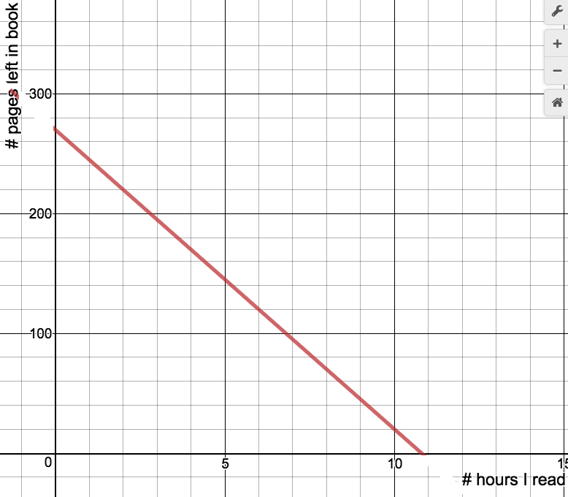  
  
3. You toss cards into a box. The number of cards in the box is given by the equation , where *t* represents in the time in seconds, and *n* represents the number of cards in the box.  
a) What does the number 15 represent in this situation?  
  
  
  
  
b) What does the number 0.8 represent in this situation?  
  
  
  
  
c) If someone started with more cards in their box, but threw cards in more slowly, what might their equation be? Explain your equation.

1. You throw cards in the box at a constant rate. After 8 seconds, you have 21 cards in the box. After 18 seconds you have 26 cards in the box. How many cards did you start with in your box? Show your work.

***MFM2P – Final Evaluation 6*** Name: _____________________

|  |  |
| --- | --- |
| **Expectation:** | **Mark** |
| solve systems of two linear equations, and solve related problems that arise from realistic situations. |  |

1. In each case, determine the cost of a red and the cost of a yellow. An algebraic solution is preferred. Show your work.

|  |  |
| --- | --- |
| A: 4 reds and 2 yellows cost 16 cents | B: 2 reds and 2 yellows cost 10 cents |
|  | |

RED COSTS ________________ YELLOW COSTS __________________

|  |  |
| --- | --- |
| A: 6 reds and 2 yellows cost 22 cents | B: 2 reds and 4 yellow cost 24 cents |
|  | |

RED COSTS ________________ YELLOW COSTS __________________

|  |  |
| --- | --- |
| A: 4 red and 3 yellows cost 22 cents | B: 6 reds and 2 yellows cost 23 cents |
|  | |

RED COSTS ________________ YELLOW COSTS __________________

2. You stack red cups on the desk, and white cups on the floor. The stack of white cups grows faster than the stack of red cups. The equation for the height of the red stack (plus the desk) and white stack are as follows:  
RED CUPS (WITH DESK): $h=0.4c+56$  
WHITE CUPS: $h=1.1c+9.1$  
In both cases, *c* represents the number of cups in the stack, and *h* represents the height of the stack, in cm.

After how many cups will the two stacks be equal in height? What will the height be?  
Solve the problem in more than one way if you can (using equation, graph or table)

***MFM2P – Final Evaluation 7*** Name: _____________________

|  |  |
| --- | --- |
| **Expectation:** | **Mark** |
| manipulate algebraic expressions, as needed to understand quadratic relations; |  |

1. Expand. You can use algebra tiles if you wish. Show your work. If you used algebra tiles, draw a picture.  
   a)  b) $x\left(x-2\right)$  
     
     
     
     
     
     
     
     
     
     
   c) $\left(x+3\right)\left(x+2\right)$ d) $\left(2x-1\right)\left(x-2\right)$
2. Factor. In other words, change from $x^{2}+3x+2$ to $\left(x+1\right)\left(x+2\right)$. You can use algebra tiles if you wish.   
   a) $x^{2}+5x+6$ b) $x-3x-4$ c) $x^{2}-13x+40$
3. Sketch the following parabolas.

Length/width form means: $y=\left(x+1\right)\left(x+2\right)$

Area form means: $y=x^{2}+3x+2$

|  |  |
| --- | --- |
| Length/width form:   x-intercepts: ____________       area form: ____________________________  y-intercept: ______________       vertex: __________________ | Sketch |

|  |  |
| --- | --- |
| Area form:   y-intercept: ____________        length/width form:   ____________________________  x-intercepts: ______________        vertex: __________________ | Sketch |

***MFM2P – Final Evaluation 8*** Name: _____________________

|  |  |
| --- | --- |
| time (s) | distance from CBR (m) |
| 0.2 | 1.0 |
| 0.6 | 1.7 |
| 1.0 | 1.9 |
| 1.4 | 1.8 |
| 1.8 | 1.6 |
| 2.2 | 0.6 |

|  |  |
| --- | --- |
| **Expectation:** | **Mark** |
| identify characteristics of quadratic relations; |  |

*Scenario – You roll a can up a ramp away from a CBR,  
 and the CBR records the following data.*

|  |  |
| --- | --- |
| Sketch (put key features in approximate place!) | Regression Equation/Information  x represents: ____________________________  y represents: ___________________________  Regression equation/information: |
| Key features (include coordinates of key features) | Meaning of key features |
| How far was the can from the CBR after 0.8 s? (use your graphing calculator TABLE, or your regression equation) | When the can was 1.3 m from the CBR, how much time had passed? (use TABLE) |

*Scenario: You place a CBR at the top of a ramp, and roll a can up towards it. You collect data, do a regression, and obtain the following equation:  
*  
*where x represents the time since you pushed the can (in seconds), and  
 y represents the distance the can is from the CBR (in m)*

|  |  |
| --- | --- |
| 1. How far will the can be from the CBR after  0.3 s? Use your equation (only) if you can. Otherwise, use your graphing calculator. | 1. How far will the can be from the CBR after  2.3 s? Use your equation (only) if you can. Otherwise, use your graphing calculator. |
| 1. How far was the can when you pushed it? Explain how you got your answer. | 1. When is the can the closest to the CBR, and how close does it get? Explain how you got your answer. |
| 1. How many meters did the can travel in the first second after it was pushed? Show your work or explain. | |

***MFM2P – Final Evaluation 9*** Name: _____________________

|  |  |
| --- | --- |
| **Expectation:** | **Mark** |
| solve problems by interpreting graphs of quadratic relations. |  |

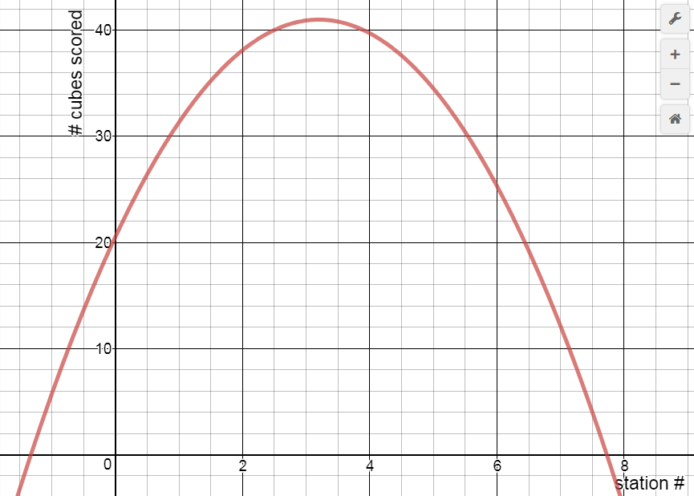

A class of students tosses cubes into a container from 6 different stations as shown above. They record their class score from every station, then do a regression for their data. The graph is shown to the left.

|  |  |
| --- | --- |
| 1. If the class threw from station 7, how many cubes would you expect it to score? State the coordinates and mark a point (SCAMP) | 1. If the class threw from halfway between stations 5 and 6, how many cubes would you expect it to score? SCAMP |
| 1. If the class scores 35 cubes, from what station(s) is it probably throwing from? SCAMP | 1. What does the point (2, 38) mean? |
| 1. What do the x-intercepts represent? | 1. If each student threw 5 cubes, how many students do you think are in the class? Explain your thinking. |

***Changes to the situation***

Here is what the cube toss set up looked like:  
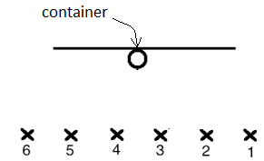

Below, a sketch shows the shape of the graph for the number of cubes a class scores. In each case, a change is made to the situation. Draw a new curve to represent the new situation, clearly showing the new location of the key features. Explain your changes.

|  |  |
| --- | --- |
| **Change to the situation: The yogourt container is smaller** | |
| Graph: draw a new line to reflect the change | Why have the key features moved to their new location? |
| **Change to the situation: The stations stay the same distance from the wall, but more closer together. (In other words, the distance between the throwing stations is reduced)** | |
| Graph: draw a new line to reflect the change | Why have the key features moved to their new location? |