**SPH3U: Scientific notation**

Scientific notation is used to express very large or very small measurements.

The general form for scientific notation is: **M x 10n** where **M** is a number that has only 1 digit placed to the left of the decimal (1<=M<10) and **n** is the integer exponent of 10

**A: Scientific notation**

1. Observe the following examples of numbers in standard form and in scientific notation. Then make a set of rules to convert to standard form and a set of rules to convert into scientific notation.

98 700 000 = 9.87 x 107

0.000 307 = 3.07 x 10-4

2000 = 2x103

205 = 2.05x102

0.001430 = 1.430 x10-3

**B: Scientific notation - practice**

1. Express each of the following in scientific notation:

524 000 000 000 = ____________________ 904 510 = ____________________________

0.000 000 043 = ______________________ 0.76 = _______________________________

894 x 102 = __________________________ 0.004 x 1011 = ________________________

0.35 x 10-6 = _________________________ 333 x 10-6 = ________________________

speed of light in a vacuum, 299 792 458 m/s number of seconds in a day, 86 400 s

mean radius of Earth, 6 378 000 m

1. Convert into standard form:

2.62 x 105 = ___________________________ 1.365 x 102 = __________________________

7.04 x 10-5 = ___________________________ 1.2x10 = _____________________________

3.105 x 10-4 = __________________________ 6.701x102= ____________________________

4. Use a calculator to calculate the following:

a) ( $3.2×{10}^{3})(5.8×{10}^{2})$ b) ( $6×{10}^{-4})(8×{10}^{-2})$ c) ($-4.5×{10}^{-7})(3×{10}^{9})$

**SPH3U: Measurement, Numbers, Significant Digits**

|  |  |
| --- | --- |
| **Measure**.Students in the classroom will measure the length of their desk, in m. Here are some sample measurements: | Someone walks in the room and asks “How long is a desk in meters?”. What number can we confidently tell them? |
| When recording measurements in science we want to include all the digits we are confident in, plus one estimated digit. We call these ***significant digits***. Including all significant digits, how long is a desk? | Now measure and record the width of your desk in units of hands (using the **width** of the 4-fingers in your hand), considering the appropriate number of significant digits. |

The term *significant digits* describes the digits in a number or measurement that are physically meaningful or reliable. In order to determine the number of significant digits, follow the 4-rules:

Rule #1: Non-zero digits are always significant

Rule #2: Any zeros between two significant digits are significant

Rule #3: A final zero or trailing zeros in the decimal portion ONLY are significant

Rule #4: If scientific notation is used, all digits shown are significant

|  |  |  |  |  |  |
| --- | --- | --- | --- | --- | --- |
| How many significant digits do these numbers have? | | | Round to 3 significant digits | | |
| a) 52400 | b) 0.00504 | c) 123.750x105 | a) 466810 | b) 0.0805372 | c) 123.750x105 |

1. Determine the number of significant digits in the following numbers:

a) 1570 b) 3072 c) 0.0325 d) 10.4 e) 15 000

f) 15001 g) 0.0205 h) 100 i) 3.05x103 j) 2.10x10-2

**When performing calculations, your answer should have no more significant digits than the least number of significant digits given in the question. (this is a simplified version of significant digits rules)**

1. Perform the following calculations and answer using the correct number of significant digits

a) 88 + 24.25 b) 47.5 x 52 c) 5.3 x 3.9 d) 31.7 x 2.5

d) 2.32 + 1.2 e) 120 + 8.2 f) 9.42 - 3.22 g) 2300 + 125

**SPH3U: Conversions**

Some useful conversions:  
1 kg = 2.2 lbs 1 min = 60 s  
1 hour = 60 mins 1 hour = 3600 s  
1 inch = 2.54 cm 1 foot = 12 inches

**“Hey Dad! Drive the car as fast as Usain Bolt!”**  
When we multiply something by 1, that something is not changed. We use this idea when converting between units.  
  
Convert:

|  |  |  |
| --- | --- | --- |
| 9 hours into minutes | 30 lbs into kg | 3.5 feet into cm |
| 720 cm into feet | 10 m/s into km/h | |

**Practice**

1. Convert the following quantities. Carefully show your conversion ratios and how the units divide out.

|  |  |
| --- | --- |
| Convert to seconds  12.5 minutes= | Convert to kilometres  4.5 m = |

|  |  |
| --- | --- |
| Convert to kilograms  m=138 lbs= | Convert to seconds  ∆*t* =3.0 days = |

|  |  |
| --- | --- |
| Convert to m/s  v=105 = | Convert to km/h  v=87 = |

|  |  |
| --- | --- |
| Convert to days  ∆*t* =5.0x105 minutes= | Convert to seconds  ∆*t* =1.0 hour = |

1. Your teacher is about 5’9” (5 foot 9). How tall is he in m? (There are 12 inches in a foot and 2.54 cm in an inch)
2. Ussain Bolt ran 100 m in Berlin with a time of 9.58 s. How fast was he running on average in km/h?
3. Which quantity is larger? Circle the larger quantity. Perform a conversion to justify your answer.
   1. 27 feet or 10 meters b.     250 seconds or 4 minutes

c.     170 lb or 75 kg d.     22 km/h or 6 m/s

1. You are driving in the United States where the speed limits are marked in strange, foreign units. One sign reads 65 mph which should technically be written as 65 mi/h. You look at the speedometer of your Canadian car which reads 107 km/h. Are you breaking the speed limit? (1 mi = 1.60934 km)

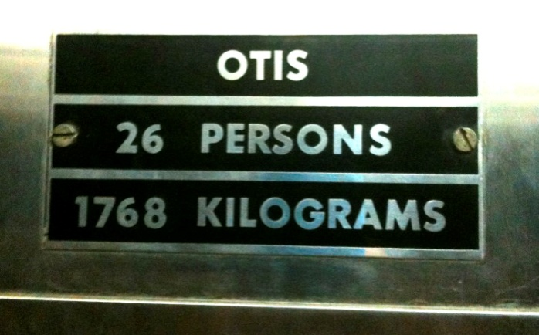

1. You step into an elevator and notice the sign describing the weight limit for the device. What is the typical weight of a person in pounds according to the elevator engineers?

**SPH3U: Vectors**

**Scalars & Vectors**

Scalar: A physical quantity with size (magnitude) but no direction. Examples:

Vector: A physical quantity with magnitude and direction. Examples:

Reference Point: A point from which position is measured

**Representations of vectors**

(1) Using arrows (2) Using symbols (3) Using numbers

**Direction of Vectors**

**SPH3U: Algebra Review/Practice**

**A: Finding Unknown Quantities**

In physics we will be dealing with various equations, and we will need to use algebra to find missing values.   
There are two main methods that can be employed:

|  |  |
| --- | --- |
| **Method 1**: Rearrange the equation to isolate the variable we want to find, then substitute and evaluate | **Method 2**: Substitute the values of known variables, then rearrange and solve for the unknown |

Given the equation 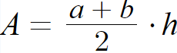, find *a* if *A* = 20 cm2, *b* = 6 cm, *h* = 4 cm

|  |  |
| --- | --- |
| **Method 1** | **Method 2** |

**B: Practice**

Find the missing value. In general you can use either method, although it’s desirable to be able to use either. Consider significant digits when giving final answer. We’ll ignore units…for now. Show your work.

|  |  |  |
| --- | --- | --- |
| 1. Given *P* = 20.0, *l* = 8.0  EQN: $P=2l+2w$    Find *w* | 2. Given *y* = 5, *m* = 10, *b* = 3        EQN: $y=mx+b$    Find *x* | 3. Given $\vec{v_{2}}=30.0$, $\vec{v_{1}}=0.50$, $\vec{a}=6.0$ EQN: $\vec{v_{2}}=\vec{v_{1}}+\vec{a}∆t$  Find $∆t$ |
| 4. Given $\vec{v_{2}}=15$ ${\vec{v}}_{avg}=26$       Find $\vec{v_{1}}$  EQN: | 5. Given $\vec{a}=0.50$, $\vec{v_{f}}=30.0$, $∆t=6.0$ Find $\vec{v_{i}}$    EQN: | 6. Given $\vec{v_{2}}=8.0$ $\vec{v_{1}}=5.0$ $\vec{a}=2.8$ Find $∆\vec{x}$    EQN: ${{\vec{v}}_{2}}^{2}={{\vec{v}}_{1}}^{2}+2\vec{a}∆\vec{x}$ |

Answers (I think!)  
1. 2. 3. 4. 5. 6.

# SPH3U: Introduction to Motion

**A: The Gold Medal Race**

A 16 year-old swimmer from Toronto, Penny Oleksiak, won a gold medal in the women’s 100-m freestyle swimming competition at the 2016 Rio Summer Olympics.

1. **Describe.** Watch the video [www.youtube.com/watch?v=Yej6QDEoZzk](http://www.youtube.com/watch?v=Yej6QDEoZzk) . For each interval, describe how she swims (or moves) and if she moving at a steady rate?

|  |  |
| --- | --- |
| **Interval** | **Description** |
| 1-2 in air  2-3 Underwater  3-4 Front Crawl  4-5 Turn Around  5-6 Underwater    6-7 Front Crawl |  |

**B: Constant Speed?**

Together we will watch a video of a motorized physics buggy [Toy Car Lab Video #1](https://youtu.be/4PkZpbeLA1I) or [Toy Car Lab Video #2](https://youtu.be/jJbACVnt7VE)

1. **Observe.** Describe the motion of your object. Explain why you think it is moving at a steady rate.

1. **Reason.** Excitedly, you show the buggy to a friend and mention how its motion is very steady or uniform. Your friend, for some reason, is unsure. Describe how you could use some simple distance and time measurements (don’t do them!) which would convince your friend that the motion of the buggy is indeed very steady.

1. **Define.** The buggy moves with *constant speed*. Write a definition for constant speed. (Do not use the words *speed* or *velocity* in your definition!) When you’re done, write this on your whiteboard – you will share this later.

**Definition: Constant Speed**

**C: Testing a Claim – Constant Speed**

You have a hunch that your object / person moves with a constant speed. Now it is time to test this hypothesis.

To describe the *position* of an object along a line we need to know the distance of the object from a reference point, or origin, on that line and which direction it is in.

+ *x*

positive *x*-direction

origin

1. **Measure.** Record your data below for the motion of the buggy

|  |  |  |  |  |  |  |  |  |  |
| --- | --- | --- | --- | --- | --- | --- | --- | --- | --- |
| Position ( m) |  |  |  |  |  |  |  |  |  |
| Time (s) |  |  |  |  |  |  |  |  |  |



Position, *x* (m)

Time, *t* (s)

1. **Represent.** Plot your data on a graph with position on the vertical axis and time on the horizontal axis. Choose scales that will use most of the graph area.
2. **Represent**. Draw a straight line of best fit for your points. It does not need to directly pass through the dots.
3. **Calculate and Interpret.** Calculate the slope of the graph (using the line of best fit, don’t forget the units). Interpret the meaning of the slope of a position-time graph. (What does this quantity tell us about the object?)

*Reminder: slope = rise / run.*

1. **Predict.** Predict (without using a graph) where would the buggy would be found 2.0 s after your last measurement.

1. Draw motion diagrams that match the following descriptions

|  |  |
| --- | --- |
| 1. The buggy in the video | 1. A buggy travelling slowly |
| 1. A buggy travelling faster | 1. A buggy speeding up |

**SPH3U: Interpreting Position Graphs**

Today you will relate position-time graphs to the motion they represent. We will do this using a motion sensor (***CBR***). The origin is at the sensor and the direction away from the sensor is the positive direction

**A: Interpreting Position Graphs**

1. For each description of a person’s motion, sketch your prediction for the position-time graph. Note that in a sketch of a graph we don’t worry about exact values, just the correct general shape.

|  |  |  |
| --- | --- | --- |
| (a) Walking slowly away from the sensor at a steady rate. | (c) Walking quickly towards the sensor at a steady rate. | (e) Walking slowly towards, then quickly away |
| (b) Standing still, far from the sensor | (d) Walking slowly away, stopping, then quickly towards | (f) Walking away and getting faster |

**B: The Position Prediction Challenge**

Now for a challenge! From the description of a set of motions, can you predict a more complicated graph?

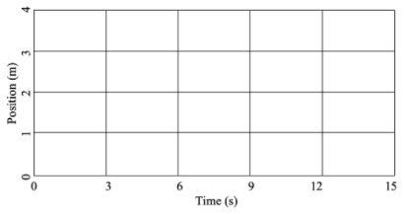

*A person starts 1.0 m in front of the sensor and walks away from the sensor slowly and steadily for 6 seconds, stops for 3 seconds, and then walks towards the sensor quickly for 6 seconds.*

1. Sketch your prediction for the position-time graph for this set of motions.
2. Describe the motion of the student.

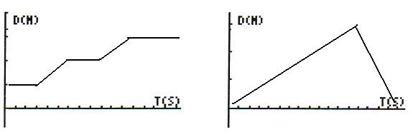 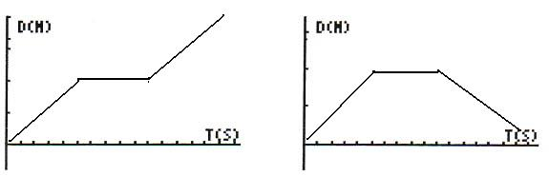 

**SPH3U Homework: Position Graphs Name:**

|  |  |
| --- | --- |
| 1. Emmy walks along an aisle in our physics classroom. A motion diagram records her position once every second. Two events, her starting position (1) and her final position (2) are labeled. Use the motion diagram to construct a position time graph – you may use the same scale for the motion diagram as the position axis. Draw a line of best-fit.   ● ● ● ● ● ● ● ●  1  2  position (m)  time (s) | 1. Use the position-time graph to construct a motion diagram for Isaac’s trip along the hallway from the washroom towards our class. We will set **the classroom door as the origin**. Label the start (1) and end of the trip (2).   position (m)  time (s) |

1. Albert and Marie both go for a stroll from the classroom to the cafeteria as shown in the position-time graph to the right. Draw a motion diagram for both Albert and Marie. Draw the dots for Marie above the line and the dots for Albert below. Label their starting position (1) and their final position (2 or 3).



Position, *x* (m)

Time, *t* (s)

Marie

Albert

Marie

Albert

+

1 ●

●

**3**

●

**2**

.

* 1. Who leaves the starting point first?
  2. Who travels faster?
  3. Who reaches the cafeteria first?

1. Albert and Marie return from the cafeteria as shown in the graph to the right. **Explain** your answer the following questions according to this graph.



position (m)

time (s)

Marie

Albert

Marie

Albert

+

* 1. Who leaves the cafeteria first?
  2. Who is travelling faster?
  3. What happens at the moment the lines cross?
  4. Who returns to the classroom?
  5. Draw a motion diagram for both Albert and Marie. Label their starting position (1 or 2) and their final position (3).