Analyzing Distance Time Graphs
EXAMPLE (an actual EQAO question from past exam)
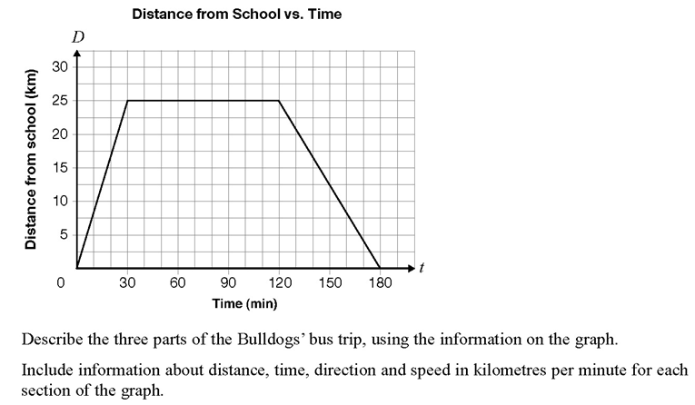
Q1: The Corner Store  At 11 o’clock, Micha’s mother sends him to the corner store for milk and tells him to be back in 30 minutes. Examine the graph and answer the questions  1. How long did it take Micha to reach the store?  2. How long did Micha stay at the store?  3. How long did it take Micha to get home from the store?  4. How can you use the graph to tell which direction Micha is travelling?  5. How far did Micha travel in the segment BC?  6. How long did it take Micha to travel segment BC?  7. What was Micha’s speed (in m/min) during segment BC?  8. Calculate Micha’s speed during segment EF.  9. How could you tell (without calculations) that Micha was travelling faster during BC than EF?  10. When is Micha travelling the fastest? Explain.  11. When is Micha travelling the slowest? Explain.  12. Did Micha make it home in 30 minutes? How do you know? | 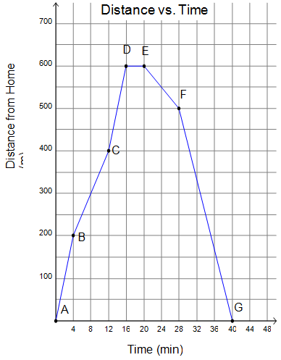

Q2: A Walker’s Walk
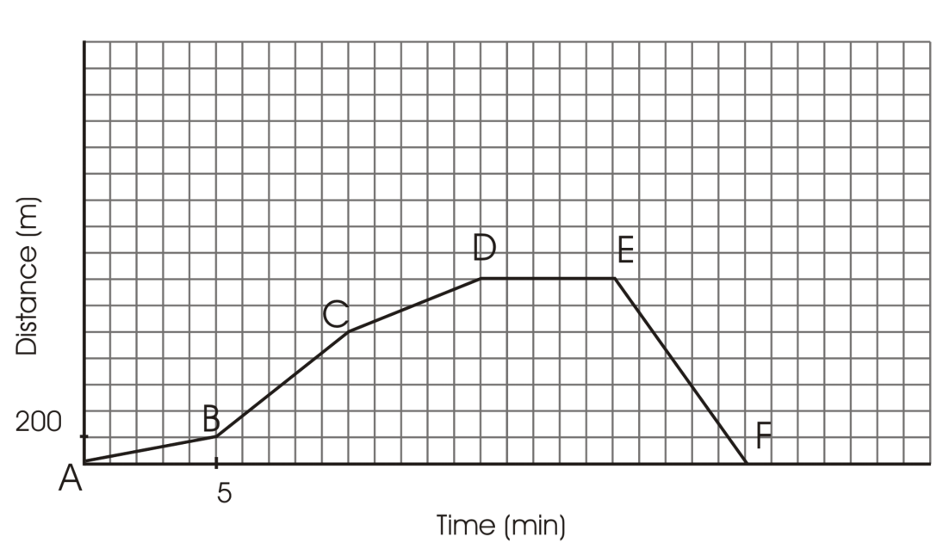
Chris walks each day as part of his daily exercise. The graph shows his distance from home as he walks his route.
200

Using the graph, give an explanation of what is occurring over Chris’ walk.
Include information about time, distance, direction and speed during each segment

Q4: Drawing Graphs:
Draw a distance-time graph to match the following story:
Terri has been playing soccer all afternoon at the recreation centre 3 km from her home. It’s supper time and she wants to get home quickly so she jumps onto her bike and starts peddling very hard, changing gears and increasing her speed. After 10 minutes she is 2 km from her home but she is also tired and decides to rest for a short while. After resting for 3 minutes she starts riding again but at a constant speed. 15 minutes later she is 1 km from her home and at the top of the long hill that leads right to her driveway. Very tired from all her activity she just lets the bike roll down the hill to her home and only applies the brakes 6 minutes later when she reaches her driveway.

Q5. More sketching practice
Sketch the graph of a journey that includes a quick walk, slow walk, some time standing still, moving towards a point, moving away from a point and accelerating. Make sure to label each of the components.
ANSWERS (I think!)

Corner Store
- 16 mins
- 4 mins
- 20 mins
- Line going up and to right away
Line going down and to right towards
- 200 m
- 8 mins
- 200/8 = 25 m/min
- 12.5 m/min
- Line BC is steeper: up 4 over 2, vs EF down 2 over 2
- AB – steepest line
- EF
- No – point G is when they get home, it is after 40 minutes

Q2 – Walker’s Walk
 | Distance (m) | Direction | Time (min) | Speed (m/min)
AB | 200 | Away | 5 | 40
BC | 800 | Away | 5 | 160
CD | 400 | Away | 5 | 80
DE | 0 | N/A | 5 | 0
EF | 1400 | towards | 5 | 280

Drawing Graphs
