ANALYTIC GEOMETRY PROBLEM SET #5 DEC 2019

1  P2007 #8 | 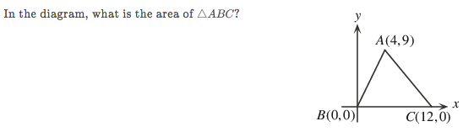
2
C2018 #8
3  C2005 #7 | 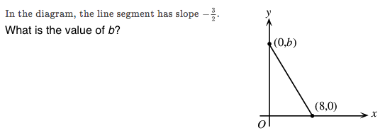
4  Galois 2015 #1 | 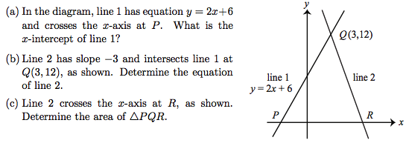
5  Galois 2012 #3 | 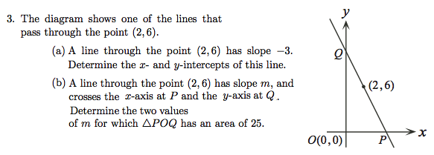
6  Euclid 2009 #1 | 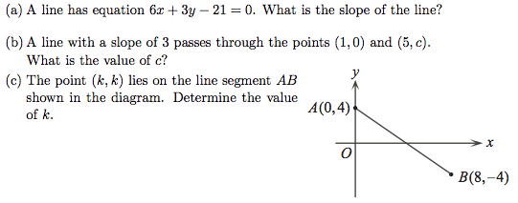
7  Galois 2019 #2 | 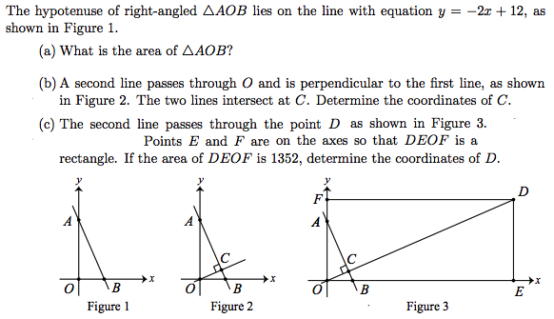
8  Euclid 2006 #1 | 