MAP4C – Using Data to Make Predictions
Data from the past can help us make predictions about the future. Here’s the process:
(Graph ) Data Scatterplot Regression Equation Prediction Conclusion
For each of the graphs, use the process to make required predictions. Use Desmos to help make your predictions.
GRAPH:
DATA (INCLUDE UNITS):

REGRESSION TYPE:  REGRESSION RESULTS: | REGRESSION EQUATION:
PREDICTION FOR DEPENDENT VARIABLE:  Predict how much wind energy was produced in 2017. | PREDICTION FOR INDEPENDENT VARIABLE:  Predict when there will be 700 thousand megawatts produced.
CONCLUSION: | CONCLUSION:
GRAPH:
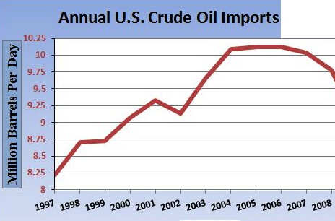
DATA (INCLUDE UNITS):

REGRESSION TYPE:  REGRESSION RESULTS: | REGRESSION EQUATION:
PREDICTION FOR DEPENDENT VARIABLE:  Predict how many barrels per day were imported in 2013. | PREDICTION FOR INDEPENDENT VARIABLE:  Predict when there were 4 million barrels per day imported.
CONCLUSION: | CONCLUSION:
GRAPH:
DATA (INCLUDE UNITS):

REGRESSION TYPE:  REGRESSION RESULTS: | REGRESSION EQUATION:
PREDICTION FOR DEPENDENT VARIABLE:  Predict the suicide rate if a state has 80% gun ownership. | PREDICTION FOR INDEPENDENT VARIABLE:  Predict the gun ownership if the suicide rate is 18%.
CONCLUSION: | CONCLUSION:
GRAPH:
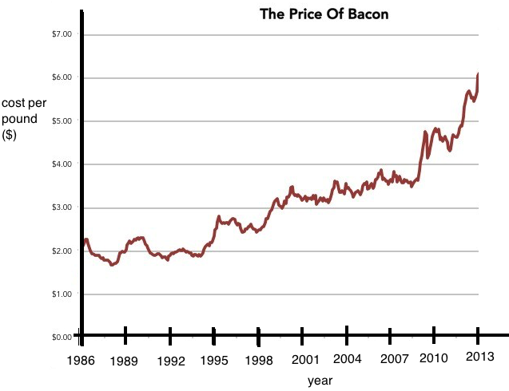
DATA (INCLUDE UNITS):

REGRESSION TYPE:  REGRESSION RESULTS: | REGRESSION EQUATION:
PREDICTION FOR DEPENDENT VARIABLE:  Predict the cost of bacon in 2016. | PREDICTION FOR INDEPENDENT VARIABLE:  Predict when the cost of bacon will reach $15/pound.
CONCLUSION: | CONCLUSION:

