MAP4C – Optimization Skills Practice Name: _____________________
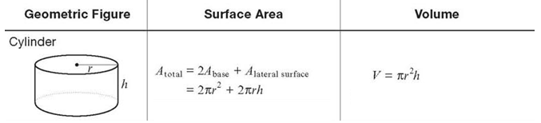
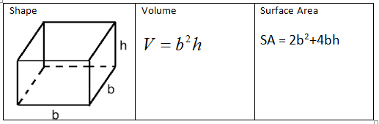
- Calculate the volume of a cylinder with a radius of 6 cm and a height of 11 cm. | - Calculate the surface area of a box with base (b) of 7 cm and a height of 4 cm
- If a box has a base (b) of 9 cm and a volume of 760 cm³, what is its height? | - If a box has a base (b) of 6.5 cm and a surface area of 250 cm², what is its height?
- If a cylinder has a radius of 3 cm and a surface area of 400 cm², what is its height? | - ***If a box has a height of 8 cm and a surface area of 500 cm², what is its radius?

MAP4C – Optimization Skills Practice Name: _____________________
- Calculate the volume of a cylinder with a radius of 6 cm and a height of 11 cm. | - Calculate the surface area of a box with base (b) of 7 cm and a height of 4 cm
- If a box has a base (b) of 9 cm and a volume of 760 cm³, what is its height? | - If a box has a base (b) of 6.5 cm and a surface area of 250 cm², what is its height?
- If a cylinder has a radius of 3 cm and a surface area of 400 cm², what is its height? | - ***If a box has a height of 8 cm and a surface area of 500 cm², what is its radius?

