MAP4C – Problem Solving Name: __________________________
In each case:
a) draw a diagram of any relevant shapes/objects, and label any relevant dimensions
b) state clear, step-by-step instructions for how this problem can be solved.
c) Execute your steps, in order, to solve the problem.

- You have a piece of playdoh in the shape of a cylinder with radius 3 cm and height 5 cm. If you double the height of the cylinder, how many times bigger is the new volume?
- A playdoh cube has side lengths of 7 cm. If you double the length of each side, how many times bigger is the volume?
- A container of water in the shape of a cube has side lengths 12 cm. It is poured into an empty cylinder with a radius of 6 cm. How high will the water level rise?
- Your teacher gives you a cube with side lengths 5 cm. You break it into two pieces, then build new cubes with them. You measure the new side lengths to be 3.5 cm. What was your percent error from what the side length was supposed to be?
- You have a piece of playdoh in the shape of a cylinder with radius 4 cm and height 6 cm. If you double the volume of the cylinder and keep the height the same, what will the new radius be?
- A cylinder with a radius of 6 cm has water up to a height of 10 cm. A ball with a radius of 4 cm is placed in. What will the new height of the water in the cylinder be?
- You try to build two playdoh spheres: one with a radius of 4 cm, the other with a radius of 5 cm. Using a measuring scale, you find that the big sphere weighs 2.5 times as much as the small sphere. What is your percent error compared to what you would expect?
- You pour water from one cylinder into another. The first cylinder is full of water, and has a radius of 3 cm and a height of 15 cm. The second cylinder is empty, and has a radius of 6 cm. If the water rises to a height of 4 cm, what was the percent error from what you would have expected?
- A single piece of paper is big enough to build a cube that has side lengths
10 cm x 10 cm x 10 cm. How many pieces of paper you would need to build a cube that has side lengths that are twice as big?
- A container in the shape of a square-based prism with base dimensions 8 cm x 8 cm has walls that are 20 cm tall. Water is poured in to a height of 12 cm. How many golf balls (circumference = 13.4 cm) will it take to make the water level rise by 5 cm?
- First you build a cube using a square piece of paper that has an area of 1800 cm². Then you use a square piece of paper whose length and width are both 25% bigger than the first one. How many times bigger is the volume of the second cube, compared to the first?
- A playdoh sphere has a surface area of 1000 cm². How many small spheres with a radius of 2 cm could this playdoh make?
- You have a ball of playdoh that has a diameter of 8 cm. If the volume of the ball is doubled, by what percent will the diameter increase?
- A ball is dropped into a cylinder of water with a diameter of 10 cm, and it makes the water level rise by 1.5 cm. If you then drop a ball with half the diameter of the first ball into the water, how much will the water level rise?
- You have a sphere of playdoh with a surface area of 500 cm². You form it into a cylinder with r = 4 cm. Then you break it in half and form two new cylinders with r = 4. How many times smaller is the height of the two smaller cylinders compared to the height of the bigger cylinder?
- A container in the shape of a cylinder has a radius of 6 cm. 8 golf balls are placed in it (circumference = 13.4 cm). If you pour 600 mL of water into the container, what will the height of the water level be (in cm)?
- You have a bunch of small playdoh spheres, each with a diameter of 1cm. How many of these small playdoh spheres will it take to form a large playdoh sphere with a diameter of 10 cm?
- A marble factory needs to fabricate marbles that have a volume of 1.8 cm³, with a volume tolerance of +/– 5%. What range is possible for the radius of the marbles?
- A cylinder with a radius of 6 cm has water up to a height of 10 cm. Three balls are dropped in, and the height of the water rises to 12 cm. What was the radius of each ball?
- A factory is producing ball bearings (like metal marbles) that have a radius of 1.5 cm. The material to produce the inside of the ball bearings costs $0.50 per cm³, and the silver coating that is painted on the outside costs $0.75 per cm². If the radius is increased by 20%, by what percent does the total cost of production increase?
- You have a hunk of playdoh. You form it into a cube, and measure the side lengths to be 5 cm. You then break the cube into two equal pieces and form new cubes. By what percent has the side length decreased?
- A single piece of paper is big enough to build a cube that has side lengths
10 cm x 10 cm x 10 cm. If you use two pieces of paper instead of one, by what percent could you increase the side length? What about the volume?
- A square piece of paper with an area of 1000 cm² is used to build a cylinder whose diameter and height are equal. If the length and width of the piece of paper were both 50% bigger, how many times bigger would the volume of the cylinder be (assume diameter and height remain equal to each other)?
- Student #1 says: “When I double the radius of a cylinder, the volume is 6 times as big.”
Student #2 says: “When I double the radius of a cylinder, the volume is 8 times as big”
Is this possible? Use formulas, examples or explanations to demonstrate why/why not.
- Student #1 says: “When I double the radius of a cylinder, the surface area is twice as big.”
Student #2 says: “When I double the radius of a cylinder, the surface area is three times as big”
Is this possible? Use formulas, examples or explanations to demonstrate why/why not.
- A factory is producing two types of ball bearings: small and large. The material to produce the inside of the ball bearings costs $0.50 per cm³, and the silver coating that is painted on the outside costs $0.75 per cm². The small ones have a radius of 1.5 cm. If the cost to produce the large ball bearing is 50% more than the small, what is the radius of the larger ball bearing? (tip: you might need to use Desmos)
- SUPPLEMENTAL CHALLENGE PROBLEMS
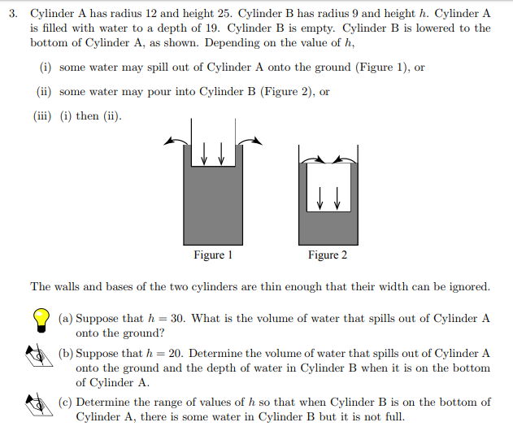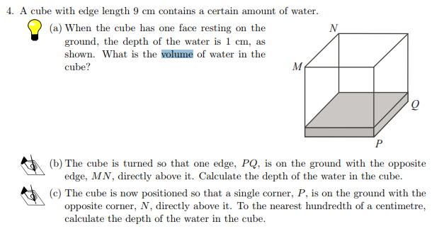

- Alveoli are located in human lungs. They resemble in some ways broccoli, with many small spheres forming bunches. These small spheres are responsible for absorbing oxygen from the atmosphere. The bigger the total surface area of all these spheres, the easier it is for the lungs to absorb oxygen into the blood supply.
When you smoke the walls of the alveoli are broken down, and many small spherical alveoli become one bigger spherical alveoli.
The radius of one alveolus (singular of alveoli) is approximately 0.03 cm. If 10 alveoli of a smoker merge into one single larger alveoli, how many times less surface area does the smoker have for inhalation? The total volume of the small alveoli before smoking remains the same as the big alveoli after smoking, but the surface area changes.
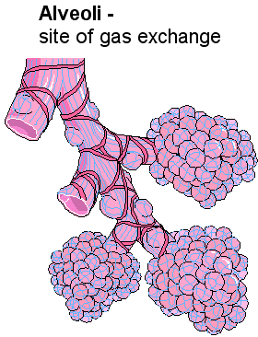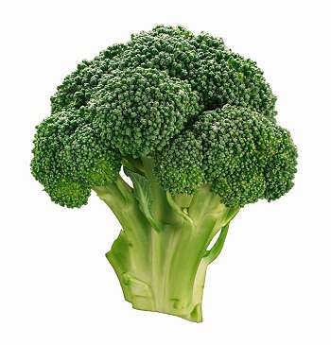

MORE IDEAS
You place a cylinder upright into a wider cylinder with water. Water won’t reach top of second cylinder. How high will it rise?

