MAP4C – Problem Solving Planning
For each situation, write step by step instructions for how this problem can be solved. Write things like: “calculate the volume of the cylinder”, “calculate the radius of the ball”, “multiply the volume by 2”, etc.
Situation #1: A cylinder has a radius of 3 cm and a height of 25 cm. We fill the cylinder with water to a height of 15 cm. Then we add 5 golf balls to the water. Each golf ball has a radius of 2.2 cm. What will the new height of the water be?
Situation #2: You are given some playdoh in the shape of a cylinder. The cylinder has a circumference of 30 cm and a height of 6 cm. If we double the volume of playdoh, by what percent will the radius increase?
Situation #3: You are given a cube made out of paper. The surface area of the cube (all 6 identical faces added together) is 1200 cm². If we double each dimension (length, width height) of the cube, how many times bigger is the new surface area?

All done? Try this…
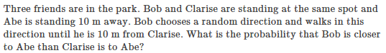(2014 Cayley #23)

