MAP4C – Algebra Practice for Playdoh/Water/Paper Problems
SHAPE | SURFACE AREA | VOLUME | SHAPE | PERIMETER | AREA
Sphere | 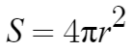 | 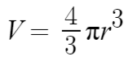 | Circle | 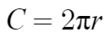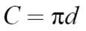 | 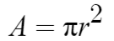
Cylinder | 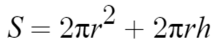 | 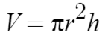 | Square | 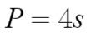  (s=side length) | 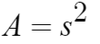
Cube | 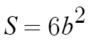(b=side length) | 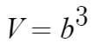
In each case, use the appropriate formula to solve for the missing dimension.
Shape: Circle | Given: C = 30 cm | Find: r | Shape: Circle | Given:  Area = 50 cm² | Find: r
Shape: Square | Given:  Perimeter = 30cm | Find: side length | Shape: Square | Given:  Area = 60 cm² | Find: side length
Shape: Cylinder | Given: r = 6 cm  V = 2000 cm³ | Find: h | Shape: Cylinder | Given: h = 20 cm  V = 1500 cm³ | Find: r
Shape: Cube | Given  V = 4000 cm³ | Find: side length | Shape: Cube | Given: surface area = 700 cm² | Find: side length
Shape: Sphere | Given: V = 200 cm³ | Find: radius | Shape: Sphere | Given: surface area = 1000 cm³ | Find: radius
Shape: Cylinder | Given: r = 7 cm,  S.A. = 500 cm² | Find: height | Shape: Cylinder | Given: h = 10 cm  S.A. = 2000 cm² | Find: radius
All done? Try these…
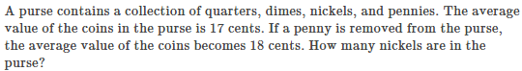
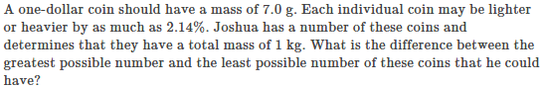

ANSWERS (I think)
- R=4.8cm
- R=4.0cm
- S=7.5cm
- B=7.7cm
- H=17.7cm
- R=4.9cm
- B=15.9cm
- B=10.8cm
- R=3.6cm
- R=8.9cm
- H=4.4cm
- R=?

