MAP4C – FORMULA SHEET FOR PLAYDOH, WATER AND PAPER QUESTIONS
Checklist of Things to try to Include:
-Sphere
-Cylinder
-Cube
-Playdoh
-Water
-Paper
-Working with %
-How many times
-Square roots
-Cube roots
-Volumes
-Surface Areas
SHAPE | PERIMETER | AREA
Circle | 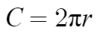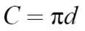 | 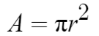
Square | 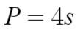  (s is side length of square) | 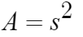

SHAPE | SURFACE AREA | VOLUME
Sphere | 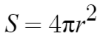 | 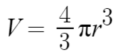
Cylinder | 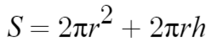 | 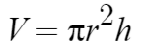
Cube | 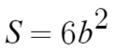  (b is side length of cube) | 