MAP4C – Optimizing Dimensions (Method 2a) Name: _______________
DAYCARE FENCE
A daycare is putting up a fence to enclose the children. It has budgeted enough for 72m of fence. What length and width will give it the biggest area? Find your dimensions to the nearest meter. If you can, find it to one decimal.
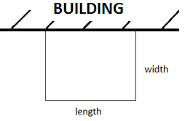
Fence Used (m) | Length | Width | Area = length x width
Daycare follow up questions…
Optimal Dimensions and Max Area:
For this particular fence configuration, what is the ratio of length to width that gives the maximum area?
A daycare is allowed to have a maximum of 3 children for every 24m² of enclosed play area. Each child at the daycare pays $850/month in fees.

- What is the maximum amount of money that the daycare could earn per month? Use your findings from the front side, and show your work.
- The daycare decides to build their yard with a width of 24m and a length of 24m. How much less money are they earning than what they could be? Show your work.
- If the daycare had 120m of fence instead of 72m, what is the maximum number of students they could enclose? Show your work.
- If the most that another daycare can earn is $22 100 per month, what were the dimensions of the yard, and how much fence did they build with? Show your work.

PIGS AND CHICKENS
A farmer needs to put up some fencing to hold her pigs and chickens. If the total area needs to be 576 feet², what is the smallest amount of fence that the farmer needs? Find your answer to the nearest foot.
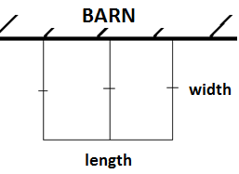
Area | Length | Width | Fence used (feet)
 | 10
 | 20

For this particular fence configuration, what is the ratio of length to width that gives the smallest amount of fence?
Optimal Dimensions and Minimum Fence Used?
Farmer follow up questions…
The farmer calls the fencing company, and they can install it for $75/meter. Pig food costs $20 for a 50 kg bag.

- What is the smallest amount of money that the farmer can spend on his animal fencing? (Remember, it must have an area of 576 feet²). Show your work.
- Farmer 1 builds her fence using the optimal dimensions, but Farmer 2 builds his fence in the shape of a square (with one side still against the barn). Both farmers still have an area of 576 feet². How many extra kg of pig food will Farmer 1 be able to afford due to her superior fence design? Show your work.
- If the farmer needed to enclose 2000 feet² instead of 576 feet², what is the minimum cost of the fence? Show your work.
- If a farmer’s fence cost $6000, what were the fence dimensions? Assume it was built to minimize the amount of fence used.
SKATING RINK
The city off Ottawa is building two ice skating rinks, side by side, as shown in the diagram. It can afford to build boards with a total length of 500 feet. What is the biggest total skating rink area that it can enclose? Find your answer to the nearest foot.
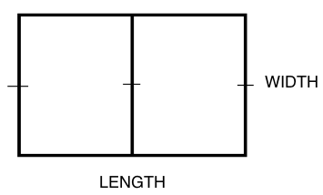
Fence Used | Length | Width | Area
 | 20
 | 40

EX3 Skating rink follow up questions…
For this particular fence configuration, what is the ratio of length to width that gives the maximum area?
Optimal Dimensions and Maximum Area?
The city is allowed 4 skaters for every 100 square feet of skating area. Each skater pays $2.50 to skate.

- What is the greatest amount of money that the city can earn at its skating rink? Show your work.
- The city decides to build a skating rink with a length of 100 feet. How much less money will it earn by building its rink in this way? Show your work.
- If the city doubled its budget so it could afford twice as many boards, how many times more skaters would it be able to accommodate? Show your work.
- A different skating rink in the city is able to earn a maximum of $750. What are the dimensions of this rink? (Note: it is the same basic shape as the rink in our example, and built with the optimal dimensions).

CAMPGROUND BEACH
A campground wants to make a roped off swimming area. They want the area of the swimming area to be 3000 m². What dimensions (length and width) will minimize the length of rope used? Find your dimensions to the nearest meter.
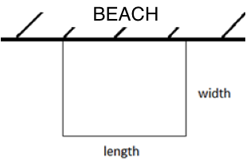
Area | Length | Width | Fence Used
 | 20
 | 40
EX4 Beach follow up questions…
Optimal Dimensions and Min Fence Used:
For this particular fence configuration, what is the ratio of length to width that gives the minimum amount of fence?
A 100 foot rope costs $40. The maximum number of swimmers for this 3000m² swimming area is 200.

- What is the least amount of money that could be spent on the rope for the swimming area? (Use your optimal shape from the front of the page)
- A new regulation states that swimming areas should go no further than 25 m away from the beach. How much more money will the campground need to spend on rope?
- A different campground spends $336 on rope, and builds a rectangular swimming area. What is the maximum number of swimmers it will be able to accommodate? (assume it is allowed the same number of swimmers per square meter as the original).
- Let’s say the beach didn’t have to make its swimming area a rectangle. Can you find another way to rope off a 3000 m² swimming area that uses even less rope? Show your work.

