MAP4C – Trigonometry Quiz

In each case, determine the value of x.

a)  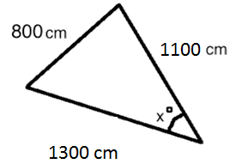 | b)  