MAP4C – Final Evaluation Introduction Name: _______________
For this entire 6-part final evaluation, we are considering the construction of two 3-D sculptures. Each of the sculptures will be built using two different building materials.
The Building Materials
Building Material | Use | Related to…
Super Special Clay | -Used as main building material to form the 3D object | Volume
Super Special Paint | -Used to coat/paint the outside of the object | Surface Area
The Sculptures
Sculpture A – Cylinder | Sculpture B – Square based-prism
-lies on its side, but entire surface area must be covered with super special paint | -lies on its side, and so bottom face does not need to be covered with super special paint
Other Notes
- There are 6 individual tasks that relate to these objects (see checklist below)
- You may use any of your own notes or assignments from the semester
- Tasks can be completed using a combination of “by hand” (paper/pencil/calculator) or using Chromebooks (Desmos/Google Sheets)
- Any “by hand” work can be submitted directly to Mr John. Any Chromebook work can be submitted in Google Classroom.
- When completing tasks using Chromebooks or Desmos, remember that all your work must be documented (consider either using multiple tabs in Google Sheets, or taking screenshots/pictures of your work and pasting into a Google Doc or Slides presentation)
- Some trickier questions are marked with asterisks (***). Give them your best shot, and don’t get discouraged if you can’t solve them completely.
Checklist
Predicting the Future | Calculating Costs | Optimization | Annuities | Surface Area and Volume | Exponential Functions

SHAPE | PERIMETER | AREA
Circle | 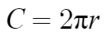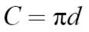 | 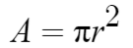
Square | 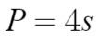  (s is side length of square) | 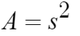

SHAPE | SURFACE AREA | VOLUME
Sphere | 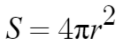 | 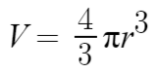
Cylinder | 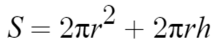 | 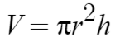
Cube | 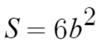  (b is side length of cube) | 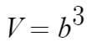
Square-based prism | $$SA=2b^{2}+4bh$$(note: includes all 6 faces) | $$V=b^{2}h$$
Rectangular Prism | $$SA=2lw+2lh+2lw$$ | $$V=lwh$$

Linear Regression | Quadratic Regression | Exponential Regression
$$y_{1}\sim ax_{1}+b$$ | $$y_{1}\sim ax_{1}^{2}+bx_{1}+c$$ | $$y_{1}\sim ab^{x_{1}}$$

How to take partial screenshots on Chromebooks | - Press Ctrl Shift  - Draw a box around the area to copy  - Press Copy to Clipboard  - Paste into Google Doc or slides (Ctrl v)
How to take full screenshots on Chromebooks | - Press  - Press Copy to Clipboard  - Paste into Google Doc or slides (Ctrl v)
MAP4C Final Evaluation – Predicting the Future Name: __________________
Some common conversions. If you need others, ask Mr John.
1 inch = 2.5 cm (approx.) 1 cm³ = 1 mL 1 foot = 12 inches 1 kg = 1000 g 1 kg = 2.2 pounds
1 m = 100 cm 1 m = 3.3 feet (approx.) $1 Canadian = $0.8 US 1L = 1000 mL 1 pound = 454 g
You research the historical cost of the two building materials. The cost of clay is summarize on this side of the page, and the cost of paint on the back. Please provide clear visual evidence of how your predictions are made/calculated.
Cost of Clay per m³ ($), since 1992 | - Draw a line of best fit for the cost of clay, and determine an equation for the line. Do this by hand if you can. If not, do a regression with Desmos.  - Explain the meaning of the rate of change and initial value in this situation.  - Use your equation from question #1 to predict the cost of clay in the year 2022. Show your work.  - Use your equation from question #1 to predict in what year the cost of clay per m³ will be $20000. Show your work.
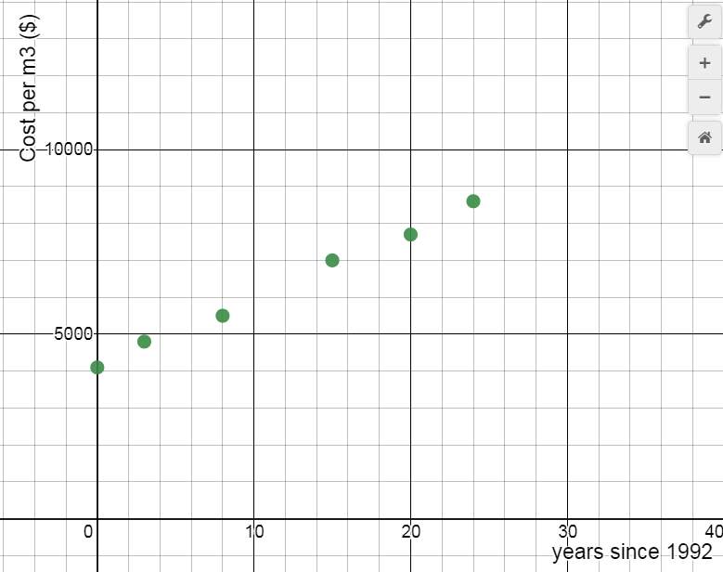

Cost of Paint per m² ($), since 1992 | - Use Desmos to obtain a regression equation to represent the cost of paint since 1992. What is your equation? (write it below the questions)  - Use Desmos to predict the cost of paint in the year 2022. Include a sketch or save a screenshot from Desmos  - You are hoping to build the sculpture when the cost of paint falls below 4500 $/m². Predict in what year you will be able to build. Include a sketch or save a screenshot of Desmos.  - Suppose you need 20 m³ of clay (front side of page) and 38 m² of paint. If the project is delayed until 2025, how much will you expect to pay for the entire sculpture? Show your work.
Years since 1992 | Cost per m² ($)
0 | 4000
5 | 5200
7 | 5500
14 | 6000
18 | 5900
23 | 5600
26 | 5300

MAP4C Final Evaluation – Calculating Costs Name: _______________________
You obtain two different price quotes for each of the two materials (clay, paint) required. Calculate the total cost of each material from each supplier, and decide which supplier to buy from.
Since you are trying to secure a large amount of funding for this project, make your calculations as clear as possible – many small calculations are better than a few big ones. Include units, and any short pieces of information that will help the reader understand the calculations.
- Clay - Required amount: 20 m³
Quote from Claytabulous Incorporated:  A barrel with a volume of 6 m³ normally costs $63000. It is currently on sale for 15% off the normal price. | Quote from SupaClay:  A 25 pound bag costs $150  1 m³ of clay weighs 1500 pounds

2. Paint – Required coverage: 38 m²
Price quote from Dainty Painty:  Paint is sold in 4-litre containers, and a litre of paint can cover 0.75 m².  Each container costs US$24 000. (Dainty Painty provides quotes in American dollars…we need the price in Canadian dollars) | **** Price quote from Paint ‘o’ Rama:  Concentrated paint is sold in 1.2L buckets for $52 000. Before being used, the concentrated paint must be diluted with water in the ratio 3 parts water to 2 parts paint. A litre of the diluted solution can cover 20 feet². ****

MAP4C Final Evaluation – Optimization Name: __________________
These investigations can be done using a table, Google Sheets, or with equations/Desmos. In whichever case, you must provide clear visual evidence of the process and results.
Consider Sculpture A (cylinder)
1. You are very concerned that the price of paint is going to rise in the future, and so you decide you want to minimize the amount of paint you use. If the volume of the sculpture is 20 m³, what is the smallest surface area that the shape could have? Get your answer to one decimal place. Note: Use of grid below optional.
Volume (m³) | Radius (m) | Height (m) | Surface Area (m²)
20 | 0.2
20 | 0.4

Consider Sculpture B (square-based prism)
2. The supply of paint is limited, and you only have enough to cover 35 m² of surface area. You still want the sculpture to be as big as possible, and therefore you would like to maximize the total volume of the object.
Determine the dimensions of the object, to the nearest tenth of a meter, that will result in the maximum volume. Since the shape is lying on its side, the surface area should not include the face that is on the ground. Use of grid below is optional.
S.A. (m²) | Base dimension b (in meters) | Height (m) | Volume (m³)
35 | 0.5
35 | 1.0

MAP4C Final Evaluation – Annuities Name: ____________________
Your investors are open to loaning you money, but you have to pay them back over time. Use your Debting and Investing spreadsheets to answer the following questions. Screenshot any pictures to demonstrate your answers (they can be pasted into a Google Doc or Slideshow).
Suppose you need to borrow $400 000 to pay for the sculpture…
- a) If the interest rate is 5% per year and you pay back $5000 per month, how long will it take to pay back the entire amount?
b) How much is the final payment?
c) How much do you pay back in total?
d) What percentage of all the money you pay back is interest? (show calculation)
- If you pay them $4500 per month and want to repay the loan in 10 years, what must the interest rate be as a percent? Answer to 1 decimal.

Your investors had some financial problems and they pull out of the project. That means that you need to save $400 000 to fund it yourself.
- If your investments can earn an interest rate of 4% per year and you save $3400 per month for 8 years, will you be able to afford the sculpture?
- a) If you can get an interest rate of 5.5% per year and save monthly for 10 years, what must your monthly payment be in order to fund the project?
**** b) Suppose, after 7 years, the interest rate went from 5.5% down to 3.5%. By how much must you increase your monthly payment during the final 3 years to meet your savings goal? ****

MAP4C Final Evaluation – Surface Areas and Volumes Name: _____________
You are considering a variety of sizes and dimensions for the sculptures. Answer the questions below, using clear mathematical communication. Formulas can be found on the main information sheet. Show all your work.
Consider Sculpture A (cylinder)
- If the diameter is 1.2 m and the height is 4.5 m, what will the volume be?
- If the volume of the object is 22 m³ and the circumference is 10 m, what will the height and surface area be?
- The object has a volume of 16 m³ and a height of 4 m. If you increase the radius by 20% but keep the height the same, by what percentage will the volume increase?
- **** You want the sculpture to have a volume of 25 m³, and you want the height and the diameter of the shape to be equal. What should the dimensions be? ****
Consider Sculpture B (square-based prism)
For questions 1-3, assume the square-based prism is actually a cube.
- You are planning for the cube to have a side length of 3m, and you will build it using a bunch of smaller cubes that have a side length of 0.15 m. Approximately how many of the small cubes will be needed?
- If the total surface area of the sculpture is 55 m², what is its volume? (Recall: the face on the ground does not count in the surface area)
- You would like the cube to have a side length of 3 m, but your budget will only allow for 24 m³ of clay. By what percentage will you be forced to reduce the side length of your cube?
- **** You decide against building a cube, and decide you want a square-based prism with a height that is 3 times the base dimension. If the sculpture has a surface area of 35 m², what must the dimensions be? (Recall: bottom face does not count in surface area) ****

MAP4C Final Evaluation – Exponential Functions Name: __________
Answer the following questions about the future costs of clay and paint. Provide either clear mathematical evidence on this page, or clear visual evidence using Desmos (paste screenshots into a Google Doc or Slides.)
The basic form of an exponential function is: or
- Complete the table of values showing the cost of clay since 1992.
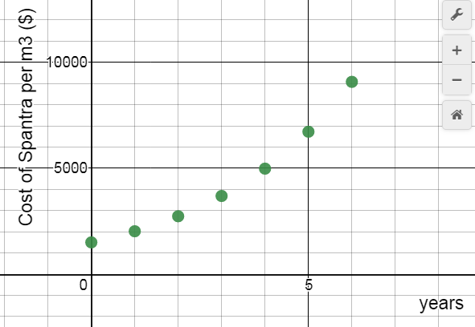 | Years since 1992 Cost  0  1  2  3  4  5  6

- By how many dollars did the price of clay increase between years 1 and 2? Show your calculation  - By what percent did the price of clay increase between years 1 and 2? Show your calculation. | - By what percent did the price of clay increase between years 2 and 6? Show your calculation  - What do expect the cost of clay to be in year 7? Show your calculation.
- Write an exponential equation for the cost of clay in the above example. No regression required.
- If the cost of clay increases by 10% per year, and after 4 years it cost $10 200, what was the initial cost? Show your work. | - If the initial cost per m³ was $9200, and after 5 years the cost per m³ is $11 500, by what percent was the price increasing every year? Show your work.

- Suppose the cost of clay increases by 10% every single year. A student says that the cost of the same clay will increase by about 61% over a 5 year period. Does this make sense? Explain why or why not.
- The cost of paint will decrease exponentially over time according to , where t represents the number of years from now, and C represents the cost per m² of paint.
  - By what percent is the cost of the paint decreasing every year?
  - What will the cost of paint be 10 years from now? Show your work.
  - How many years will it take for the cost of paint to fall below $2600? Show your work (on this paper or electronically).

ANSWERS

PREDICTING NOTE PAGE 2 ANSWERS WILL NEED UPDATING
1. y = 190x + 4100 | 2. | 3. y = 9800 | 4. x = 83.7 year=2075
5. y=-8.37x2 + 258.7x + 4137.23 | 6. (30, 4361.1) | 7. (1.476, 4500) or (29.43, 4500) | 8. Paint cost/m2 = $3558.1  clay cost = $10370  Cost = $342 607.80

CALCULATING COSTS
Claytabulous | SupaClay | Dainty Painty | Paint ‘O’ Rama
$178 500 | $180 000 | $380 000 | $358 644 (maybe 844)

OPTIMIZATION
Front | r=1.47m | h=2.94m | SA=40.8m2
Back | b=2.415m | h=3.22m | V=18.79m3

ANNUITIES
1. a) 98 months | b) $2573.69 | c) $487 573.09 (?) | d) 17.96%
2. 6.2% | 3. No: $383923.02 | 4. a) $2508 | b) 3049 – 2507 = $542

SA AND VOL
1. 5.09m3 | 2. r=1.5915m  h=2.76m  SA=43.5m2 | 3. 44% increase | 4. r=1.58m  h=3.17m
5. 8000 | 6. 3.317m | 7. reduce by 3.9% | 8. b=1.78m  h=5.35m

EXPONENTIALS
2. $800 | 3. 40% | 4. 225% | 5. $12218
6. C=1500(1.34)x | 7. a=6966.7 | 8. 4.56% | 9. yes
10. a) 3% | b) $3687 | c) 21.5 years

