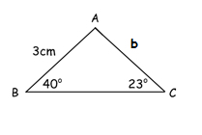MCR3U – Trigonometry Review
1. Determine if the following have 0, 1, or 2 triangles
a) , a = 8, c = 7
b) , d = 2, f = 5
c) , g = 4, i = 6
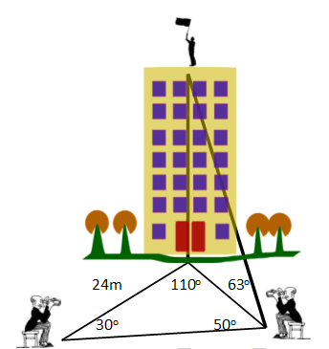

2. Determine , given , j = 3, k = 6
3. Determine the length of b to the nearest centimeter.
4. Determine the height of the building.

Quadratics Review
1. Simplify
2. Find the equation of the quadratic function in standard form with zeros at and and goes through the point (0, -15.5)
3. a) Sketch the graph of and its inverse
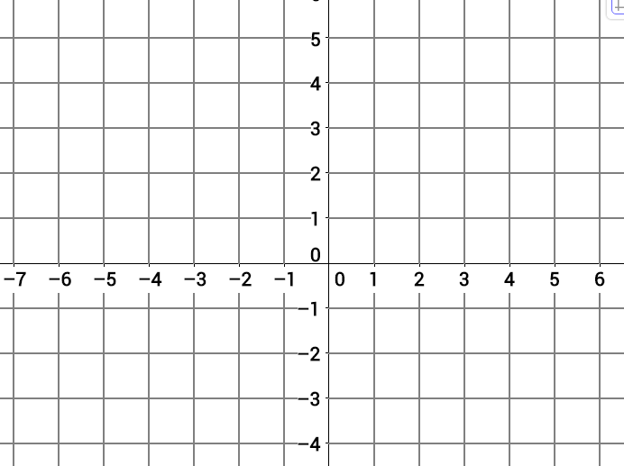
b) Determine the equation of
