Applying Transformations to Sinusoidal Functions

Carefully graph 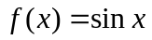 and 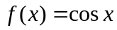. Identify key features and state the key points.
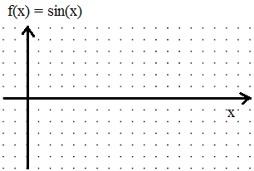 |  | 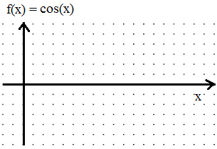
“Key” Key features (axis, amplitude, period, phase shift, reflection)  Axis:  Amplitude:  Period:  Phase shift:  Reflection over axis? | Key Points | “Key” Key features (axis, amplitude, period, phase shift, reflection)  Axis:  Amplitude:  Period:  Phase shift:  Reflection over axis? | Key Points
  x | f(x)
  x | f(x)

Now carefully draw the following.
A function based on , but with:  Axis: 3  Amplitude: 2  Period: 180  Phase shift: 90 degrees to the right  No reflection | A function based on 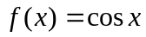 , but with:  Axis: -1  Amplitude: 3  Period: 720  Phase shift: 180 degrees to the left  Reflection over the axis
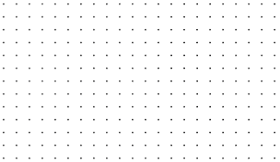

Now we will transform and . The goal is to be able to sketch something like 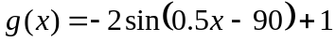 without too much difficulty.
Pay attention to connections between the equations and the key features.
Parent Function
Transformed function g(x) | 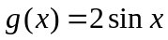
g(x)in terms of f(x) |  |  | 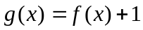
Input Output Diagram
Description of transformations (in the correct order)
Graph | 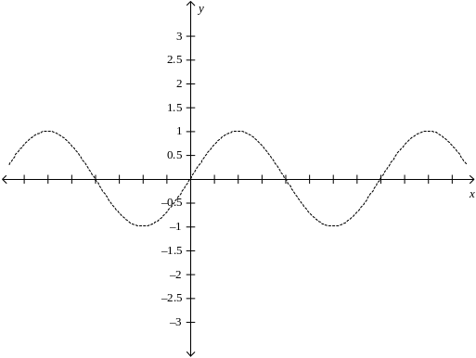
Key Features | Axis:  Amplitude:  Period: | Phase shift:  Reflection over axis? | Axis:  Amplitude:  Period: | Phase shift:  Reflection over axis?

Now try to draw a clear, accurate graph of 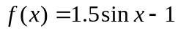 . Use the tools above as necessary. And a ruler. Use that, too.
Parent Function
Transformed function g(x) |  |  | 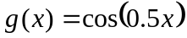
g(x)in terms of f(x) | 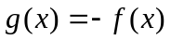
Input Output Diagram
Description of transformations (in the correct order)
Graph | 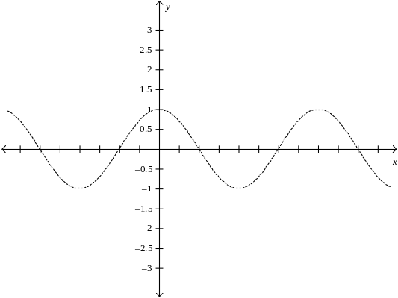
Key Features | Axis:  Amplitude:  Period: | Phase shift:  Reflection over axis? | Axis:  Amplitude:  Period: | Phase shift:  Reflection over axis?

Now try to draw a clear, accurate graph of 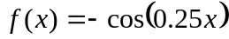 . Use the tools above as necessary.
Parent Function
Transformed function g(x) | 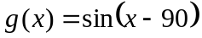
g(x)in terms of f(x) |  |  | 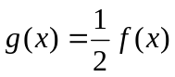
Input Output Diagram
Description of transformations (in the correct order)
Graph
Key Features | Axis:  Amplitude:  Period: | Phase shift:  Reflection over axis? | Axis:  Amplitude:  Period: | Phase shift:  Reflection over axis?

Now try to draw a clear, accurate graph of 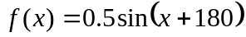 . Use the tools above as necessary.
Parent Function
Transformed function g(x) | 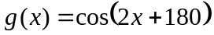 |  | 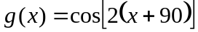
g(x)in terms of f(x)
Input Output Diagram
Description of transformations (in the correct order)
Graph
Key Features | Axis:  Amplitude:  Period: | Phase shift:  Reflection over axis? | Axis:  Amplitude:  Period: | Phase shift:  Reflection over axis?
ALRIGHT STOP!! THE TWO GRAPHS ABOVE SHOULD BE IDENTICAL. IF THEY ARE NOT, THERE’S A MISTAKE. NOTE THE TWO FORMATS:
vs

BOTH CAN BE USED TO SKETCH A GRAPH, BUT ONE FORMAT IS MOST USEFUL IN IDENTIFYING THE PHASE SHIFT OF THE GRAPH (ie. 90º LEFT).

Change the following into a form that is more useful in identifying the phase shift.
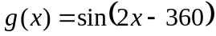 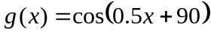

Parent Function
Transformed function g(x) | 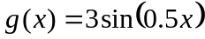 |  | 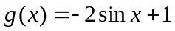
g(x)in terms of f(x)
Input Output Diagram
Description of transformations (in the correct order)
Graph
Key Features | Axis:  Amplitude:  Period: | Phase shift:  Reflection over axis? | Axis:  Amplitude:  Period: | Phase shift:  Reflection over axis?

Now try to draw a clear, accurate graph of 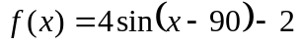 . Use the tools above as necessary.
Draw a clear, accurate graph of each of the following:
a) 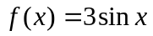 | b) 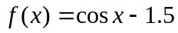
c) 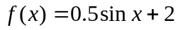 | d) 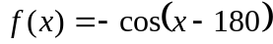
e) 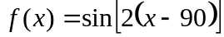 | f) 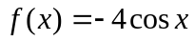
g) 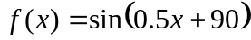 | h) 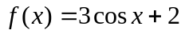

i) 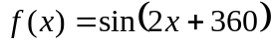 | j) 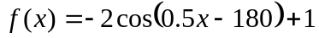
Now determine two equations for each of the following curves: one using 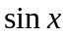as a parent function, the other using
k)  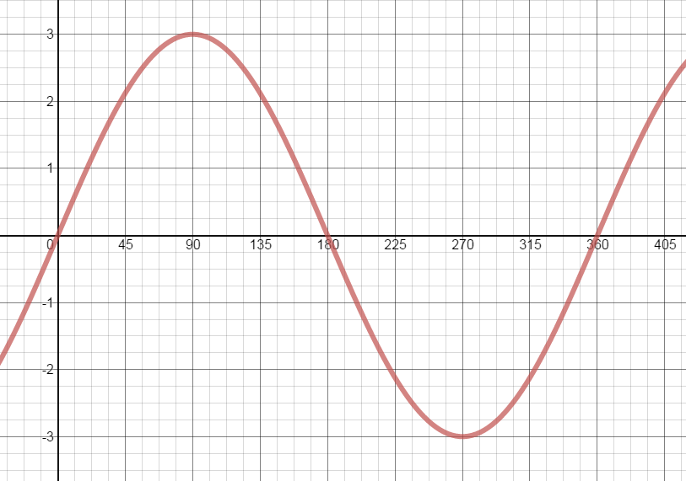 |  | l)  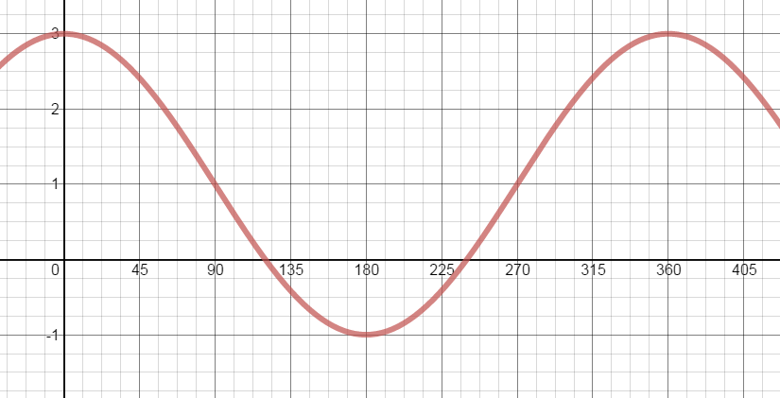
m)  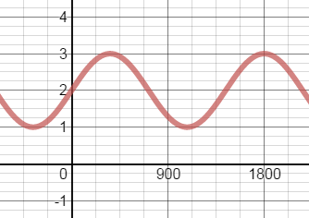 |  | n)  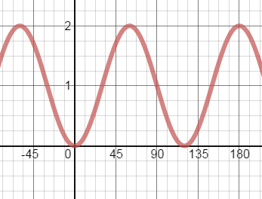
o)  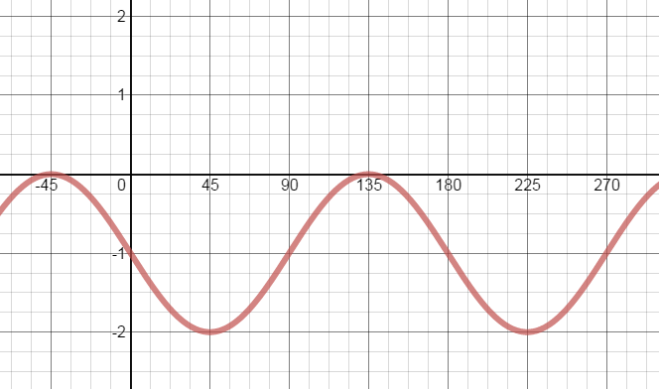 |  | p)  

