MCR3U - Fish out of Water!
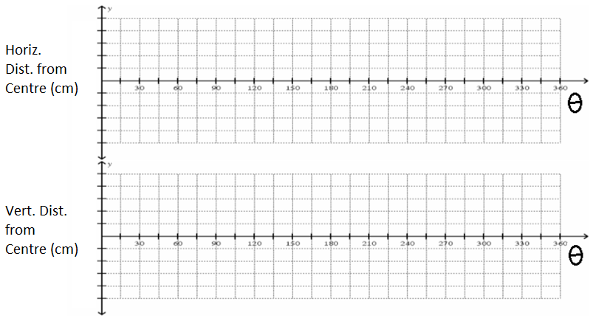
What are the key features, and what do they represent?

