MCR 3U – Changing Conditions

Consider the Battery Roll Activity, where we varied the height of the ramp and measured the distance the battery traveled. If we had changed the experiment, it would change the shape of the graph.

Provide specific examples to demonstrate the previous statement. For each example, provide a sketch of what the graph would look like, and provide a reasonable domain and range..

If, in the experiment,…

The new graph would look like this:  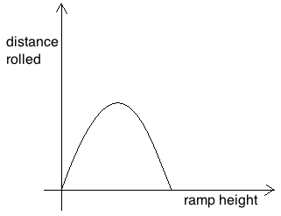 | New Domain and Range:
If, in the experiment,…

The new graph would look like this: | New Domain and Range:
If, in the experiment,…

The new graph would look like this: | New Domain and Range:

Consider the Ball Bounce Activity, where we varied the number of bounces and measured the rebound height. If we had changed the experiment, it would change the shape of the graph.

Provide specific examples to demonstrate the previous statement. For each example, provide a sketch of what the graph would look like, and briefly explain why it would look this way. Use point form.

If, in the experiment,…

The new graph would look like this:  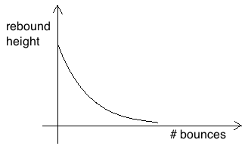 | New Domain and Range:
If, in the experiment,…

The new graph would look like this: | New Domain and Range:
If, in the experiment,…

The new graph would look like this: | New Domain and Range:

Consider…how could we have changed the asymptote, so it would not be at y = 0?

