MFM2P – POINT A TO POINT B Name: ___________________________
You are swimming in the ocean at Point A. Point B is located on the beach a ways down from where you are swimming.
You want to get from Point A to Point B as fast as possible.
You can walk on the beach faster than you can swim in the water.
What route should you choose? How far down the beach should we aim?
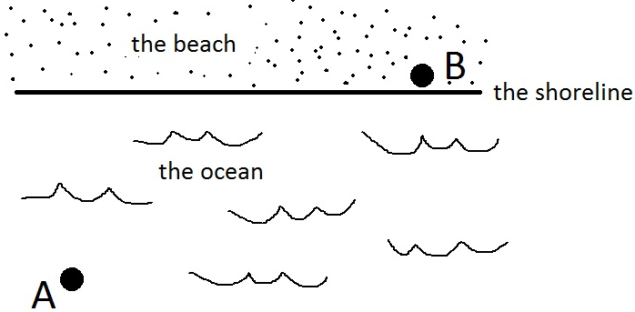

Here are some routes you could choose…
Why might this route be the fastest?
Why might this route NOT be the fastest?

Why might this route be the fastest?
Why might this route NOT be the fastest?

Why might this route be the fastest?
Why might this route NOT be the fastest?

We want to find out how far down the beach we should aim. So let’s introduce a variable (x) for how far down the beach we should aim. Here’s a diagram:
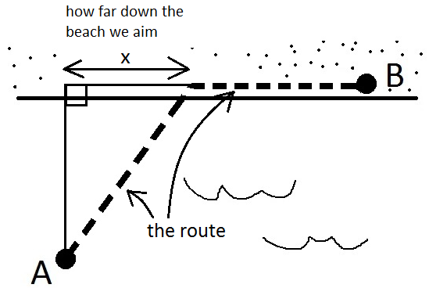
Now we add some numbers to the situation:
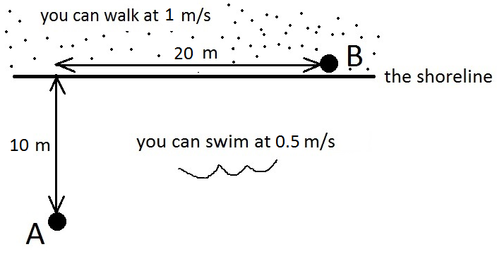
What route do you think you should take to get from A to B as fast as possible? Make a guess, and draw your route on the diagram below.
For your chosen route, how far down the beach are you aiming (in other words, what is x?)
How many meters will you walk along the beach?
We can model the situation using measuring tapes, objects for Points A and B, and blocks.
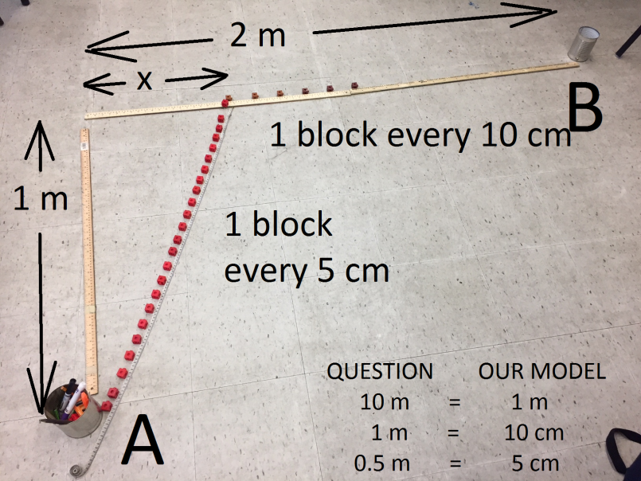
In order to find the fastest route, we are going to test some different routes. We will choose various points along the beach at which to aim, and find how long that route would take.
Complete the table of values for various choices of x, then make a scatterplot of your data.
x |  |  |  | y
Distance along beach we aim (m) | Distance along beach we aim in model (cm) | Time (# blocks) spent swimming | Time (# blocks) spent walking | Total time (# blocks swim + walk)
0 | 0
4 | 40
8 | 80
12 | 120
16 | 160
20 | 200
Back to the question: how far down the beach should we aim, in order to get from Point A to Point B the fastest?

Are we SURE that route is the very fastest? If yes, how do you know? If not, what route(s) might be faster?

Let’s try to find the very fastest route.
Make a scatterplot using the data
from the previous page.
On the horizontal (x) axis, put the
distance we aim along the beach
On the vertical (y) axis, put the total time
You can copy the data into this table to help make your scatterplot.
Then draw a curve of best fit.

x | y
Distance along beach we aim (m) | Total time (swim + walk)
0
4
8
12
16
20

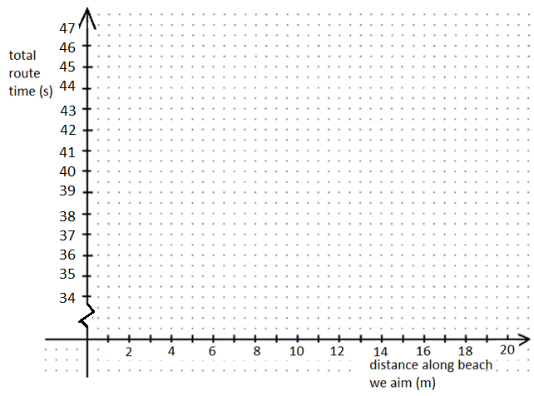
Use your scatterplot on the previous page to answer the following questions.

- How far along the beach should we aim in order to get from Point A to Point B the fastest?
- If we use the best route from question #1, how long will it take to reach point B?
- If we aim 18m along the beach, how long will that route take us? SCAMP (State Coordinates And Mark Point)
- If a route took 41 seconds, how far along the beach did we aim? SCAMP

- What is the y-intercept of this graph? What does it mean? SCAMP
- What is the vertex of this graph? What does it mean? SCAMP
Use your graphing calculator to perform a regression for your table of values. What is your regression information? What is the equation for this curve?
Copy your regression equation here: ____________________________________
In this equation what does x represent? What does y represent?

- Use your graphing calculator: If we aim 18 m along the beach, how long will the route take us?
- How does your prediction from question 7 compare to the prediction you made using the graph (see question #3 on previous page)?

Use the following equation to answer the following questions. Show your work.
Note: x represents the distance we aim down the beach, and y represents the journey time
$y=0.04x^{2}-0.55x+39.8$

- If we aim 5 m along the beach, how long will the route take?
- If we aim 25 m along the beach, how long will the route take?

- Why would it be strange to aim 25 m along the beach?

Remember the original situation and
answer the questions below. In each case,
include a diagram and show your work.
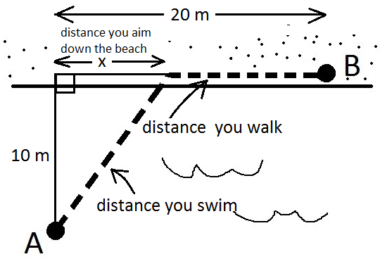

- If you aim 5 m down the beach (x = 5), how far do you swim? | - If you aim 12 m down the beach, how far do you swim?
- If you swim 15 m, how far down the beach did you aim? | - If you swim 20 m, how far down the beach did you aim?
- If you walked 9 m, how far did you swim?
Instead of choosing how far down
the beach we aim, we could instead
talk about the angle we swim at.
What we mean is this
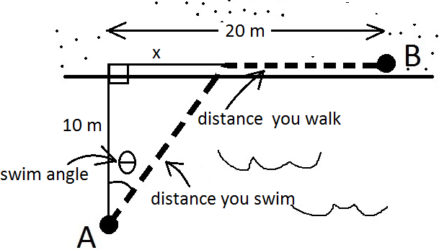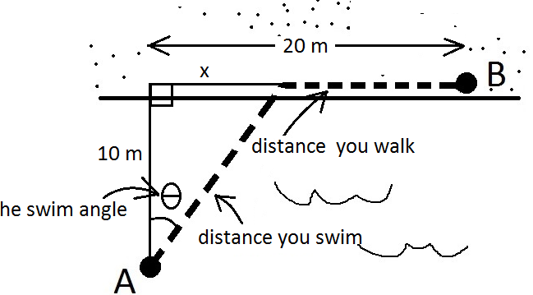
Now answer the following. Draw
a diagram and show your work.

- If your swim angle is 20°, how far down the beach did you aim? | - If your swim angle is 35°, how far down the beach did you aim?
- If your swim angle is 42°, how far did you swim? | - If you swim angle is 70°, how far did you swim?
- Recall: you walk at 1m/s and swim at 0.5m/s. If your swim angle is 50°, how long does the entire journey take? Show your work.

Now we don’t know the swim angle.
Can you find the swim angle from
the following information?
In each case, draw a simple, clear
diagram to represent the situation.

- If you aimed 5m down the beach  (x = 5), what was the swim angle? | - If you aimed 9m down the beach, what was the swim angle?
- If you swim 15m, what was your swim angle? | - If you you swim 18m, what was your swim angle?
- If you swim 12m, how far do you walk? | - If you walk 5m, how far do you swim?
Recall: you walk at 1 m/s and swim at 0.5 m/s for each of the following questions.
- If you aim 7 m down the beach, how long does the total journey take? Show your work.
- If your swim angle is 22°, how long does the total journey take? Show your work.

The following summarizes some of our findings so far.
This was the situation | This was the graph that went with the situation
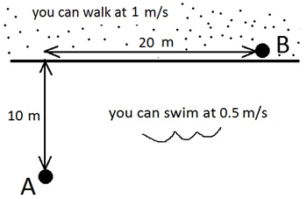 | 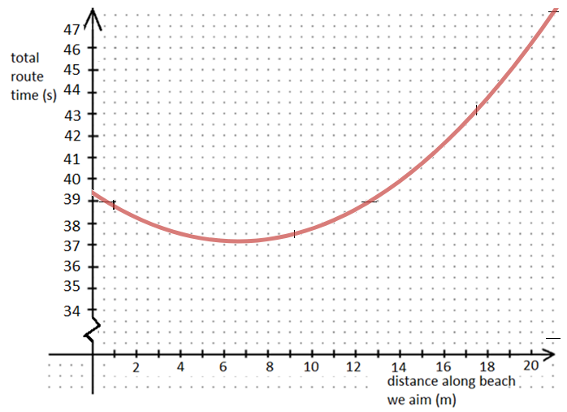
Now we are going to change the situation. For example, if you were a very slow swimmer (much slower than 0.5 m/s), it might change where you want to aim in order to have the fastest journey.
In each case, a change is made to the original situation (above). Sketch what the new graph might look like. Explain the changes you made to the location of the y-intercept and the vertex.
Change to the situation | Draw what the new graph would look like. Clearly show the new vertex and y-intercept
- You still walk at 1 m/s, but now you are a much slower swimmer than before
Explain the changes you made to the vertex and y-intercept. Why do they move to their new locations?

Change to the situation | Draw what the new graph would look like. Clearly show the new vertex and y-intercept
- You still swim at 0.5 m/s, but now you are a much faster walker than before
Explain the changes you made to the vertex and y-intercept. Why do they move to their new locations?

Change to the situation | Draw what the new graph would look like. Clearly show the new vertex and y-intercept
- Your swimming speed and walking speed are the exact same: 1 m/s
Explain the changes you made to the vertex and y-intercept. Why do they move to their new locations?

Consider the following situation. Note that the distances and speeds have changed.
How far down the beach should beach should you aim to have the smallest journey time? Justify your answer.
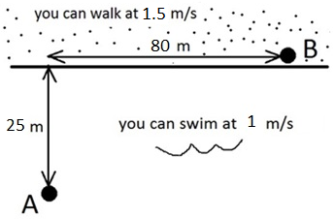

Consider the following: you are in a boat at Point A, and need to get the shipment to Point B. On land, you have the option to load the shipment onto trucks. There are some costs involved:
BOATS | TRUCKS
Gas costs $0.50 per km  It costs $50 per hour to rent the boat | Gas costs $1.20 per km
How far down the beach should beach should you aim to spend the least on the journey?
