MFM2P – The Painted Square Name: ____________________________________

Consider shape below, which is a 5x5 square made out of cubes.
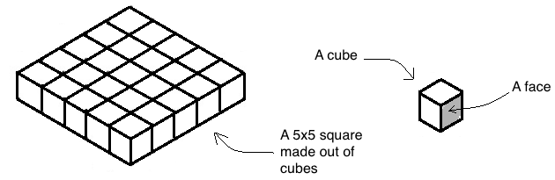
Imagine you completely paint the 5x5 square, including the top, bottom and all the sides
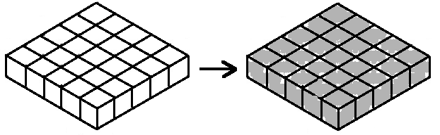.
After painting the square, imagine we completely took it apart into cubes. The cubes won’t be all covered in paint – some of their faces will have paint on them, and others won’t.
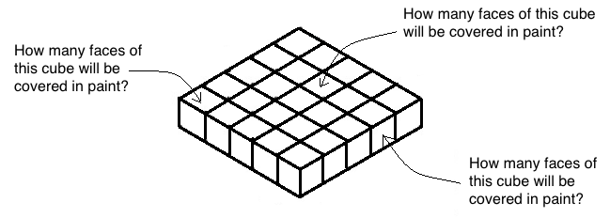

a) What is the total number of cubes that make up this square?
b) How many cubes will have 4 faces covered in paint?
c) How many cubes will have 3 faces covered in paint?
d) How many cubes will have 2 faces covered in paint?
Complete all the tables of values on page 3. Then make a scatterplot for each of them on the grid below. Yes, you will have 3 different lines on the same grid (you should label them)

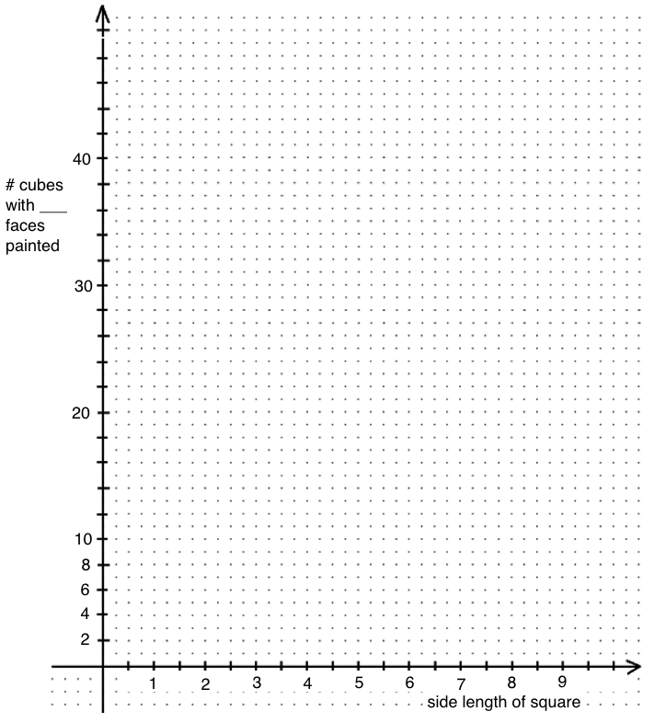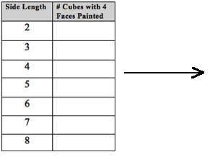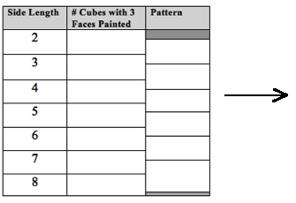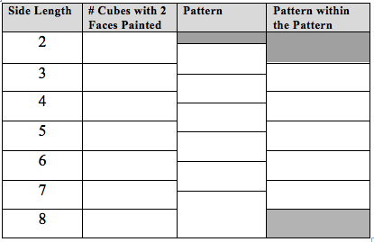
Regression Info and Equation
(side length vs. # cubes)
Regression Info and Equation
(side length vs. # cubes)
Regression Info and Equation
(side length vs. # cubes)

- Imagine we built a square with side lengths of 12x12.
a) How many total cubes will be needed to make the square? | b) How many of the cubes will have 4 faces painted? How do you know?
c) How many of the cubes will have 3 faces painted? Show calculations or explain your answer. | d) How many of the cubes will have 2 faces painted? Show calculations or explain your answer.

- a) Can you come up with a general rule for finding how many cubes will have 4 faces painted? Use math symbols or words.
b) Can you come up with a general rule for finding how many cubes will have 3 faces painted? Use math symbols or words.
c) Can you come up with a general rule for finding how many cubes will have 2 faces painted? Use math symbols or words.

a) Imagine a painted square had 76 cubes with 3 faces painted. How big was the square? Show your calculations. | b) Imagine a painted square had 120 cubes with 3 faces painted. How many cubes in that same square have only 2 faces painted? Show your work.

a) If a painted square has 196 cubes with 2 faces painted, how big was the square? Show your calculations. | b) If a painted square has 441 cubes with 2 faces painted, how many cubes in that same square have 3 faces painted? Show your work.

- Imagine we made a square, and when we painted it there were 4 cubes that had 4 faces painted. How big was the square? Show your work.

Here is the regression equation (from page 3) for the number of cubes with 2 faces painted:
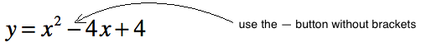
What does x represent? What does y represent?
(If you don’t know, look back to the table of values on page 3 that made the equation in the first place)
- x represents:
- y represents:
1. Enter this equation into your graphing calculator (see “ENTER AN EQUATION”). Use the TABLE button to predict the following:
a) How many cubes will have 2 faces painted if the side length of the square is 17? | b) How many cubes will have 2 faces painted if the side length of the square is 24?
c) If there were 324 cubes that had 2 faces painted, what was the side length of the square? | d) If there were 729 cubes that had 2 faces painted, what was the side length of the square?
2. Now try to use the equation above to determine:
a) how many cubes will have 2 faces painted if the side length of the square is 19 | b) how many cubes will have 2 faces painted if the side length of the square is 22
Check your answers for #2a) and b) using the table in your graphing calculator. Do they match?
Here is the regression equation (from page 3) for the number of cubes with 3 faces painted
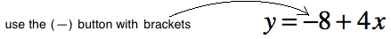
What does x represent? What does y represent?
(If you don’t know, look back to the table of values on page 3 that made the equation in the first place)
- x represents:
- y represents:
1. Enter this equation into your graphing calculator (see “ENTER AN EQUATION”). Use the TABLE button to predict the following:
a) How many cubes will have 3 faces painted if the side length of the square is 17? | b) How many cubes will have 3 faces painted if the side length of the square is 24?
c) If there were 64 cubes that had 3 faces painted, what was the side length of the square? | d) If there were 140 cubes that had 3 faces painted, what was the side length of the square?
2. Now try to use the equation above to determine:
a) how many cubes will have 3 faces painted if the side length of the square is 19 | b) how many cubes will have 3 faces painted if the side length of the square is 22
Check your answers for #2a) and b) using the table in your graphing calculator. Do they match?
Continue working with the equation
3. Now try to use the equation above to determine:
a) if a square had 96 cubes with 3 faces painted, how big was the square? | b) if a square had 152 cubes with 3 faces painted, how big was the square?
Check your answers for #3a) and b) using the table in your graphing calculator. Do they match?
Last thing…something for a little later. Within this package we have discovered the following:
 | By doing a regression on graphing calculator… | By using our own brains…
# cubes with 3 faces painted |  | 2 less than the side length of the square, then multiply by 4. As an equation this would be:
# cubes with 2 faces painted |  | 2 less than the side length of the square, then square that number (multiply it by itself). As an equation, this would be:

In the above table, we are writing an equation for the number of cubes with 3 faces painted in two different ways. Same goes for the number of cubes with 2 faces.

Shouldn’t those two equations give the same result, and therefore be equivalent? To be continued….
Note: could get into surface area, cost to paint, etc. as well as painted cube or other shapes.

