MFM2P – Similar Pyramids and Pyramid Ratios Name: _________________________________
- Each pair of pyramids is built with the same wall angle. Find the missing side lengths
a)  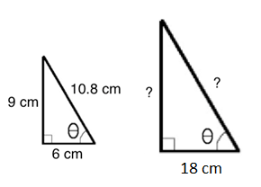 | b) 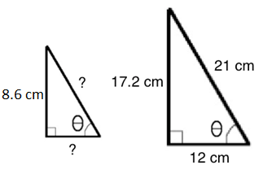

2. The half cross-section of some pyramids are shown in the diagrams below. In each case determine the height of the pyramid, the slant height, or the base half length.
a)  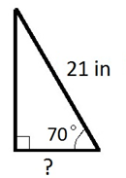 | b)  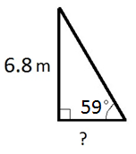

- The half-cross section of some pyramids are shown in the diagrams below. In each case determine the wall angle.
a)  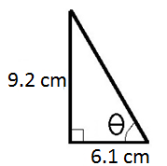 | b)  