***MFM2P – Pyramids, Pyramids and More Pyramids***

A pyramid can be visually represented in 3 ways:  
  
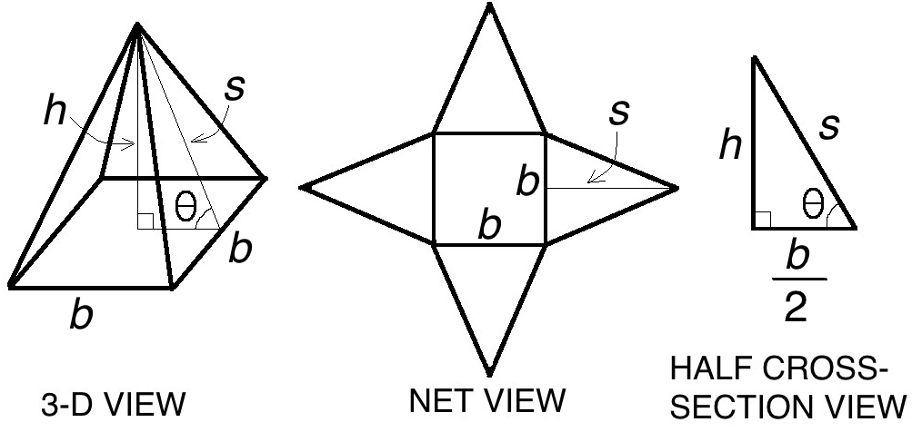

|  |  |  |
| --- | --- | --- |
| Letter | Meaning | Notes |
| *b* | Base length of pyramid | -also base length of triangle pyramid face -need to divide by 2 when working with cross-section |
| *h* | Height of pyramid |  |
| *s* | Slant height of pyramid | -slant height of pyramid is same as height of triangle pyramid face…careful!!! |
|  | Wall angle of pyramid |  |

Pay attention to your units. Here are some examples of units you will be using

|  |  |
| --- | --- |
| Lengths | cm, in, m, feet, km, etc. |
| Areas | cm2, in2, m2, feet2, km2, etc. |
| Volumes | cm3, in3, m3, feet3, km3, L |

Here are some formulas that will be useful:

|  |  |
| --- | --- |
| Area of Triangle |  |
| Area of Square |  |
| Volume of Pyramid |  |
| Surface Area of Pyramid |  |

1. The measurements of a pyramid are shown in the table. Add the measurements to the representations below everywhere you can.

|  |  |  |  |
| --- | --- | --- | --- |
| pyramid height = 20 cm | base length = 30 cm | slant height = 25 cm | wall angle = 53° |

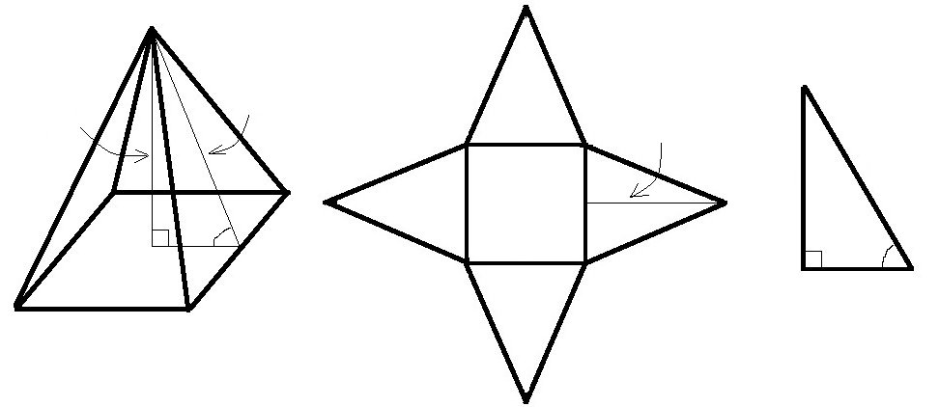

1. The three representations of a pyramid are shown below, along with some measurements. Add all applicable measurements to the other representations

|  |  |
| --- | --- |
| a) |  |
| b) |  |

1. a) Calculate the surface area and volume of the pyramid shown in the diagram. Show your work.  
   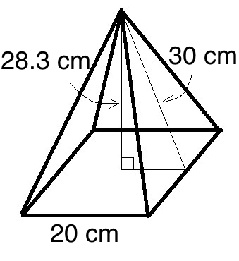  
     
     
     
     
   b) The cardboard to make the pyramid costs $0.002 per cm2. How much will the pyramid cost?
2. a) Calculate the surface area of the pyramid represented in the half cross-section view below. Show your work.  
     
   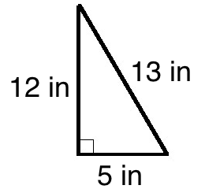  
     
     
     
   b) The cardboard used to build the pyramid from question 4 a) is sold in sheets that measure 40 in by 50 in. Each sheet costs $4.50. Find the cost of the cardboard to build the pyramid. Note: you are allowed to use part of a sheet – you only pay for the portion you use.

1. The half-cross section of some pyramids are shown in the diagrams. In each case determine the height of the pyramid, the slant height, or the base half length.

|  |  |  |
| --- | --- | --- |
| a) | b) | c) |

1. Calculate the surface area of the pyramid shown in the diagram. Show your work.  
   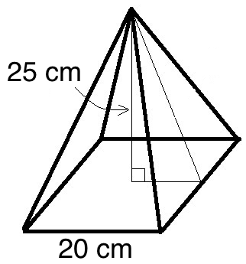
2. Calculate the volume of the pyramid shown in the diagram. Show your work.  
     
   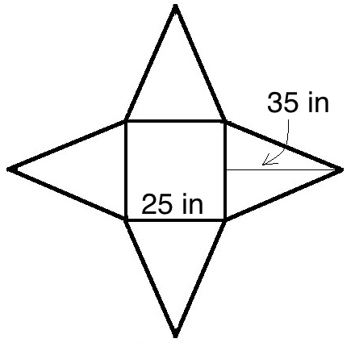
3. The volume of the pyramid shown in the diagram is 6.875 m3. What is the height of the pyramid? Show your work.  
   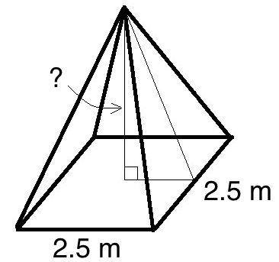
4. The volume of the pyramid shown in the diagram is 3 feet3. What is the length of the base of the pyramid?  
   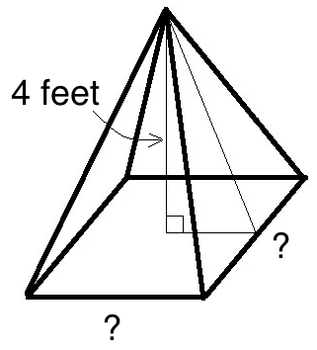
5. The surface area of the pyramid in the diagram is 50 m2. What is the slant height of the pyramid?  
   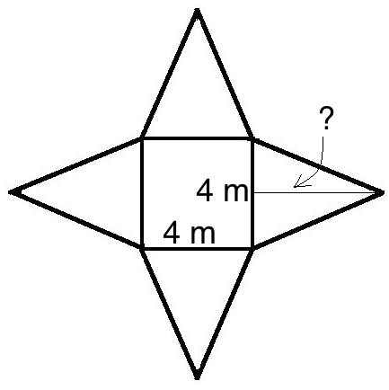
6. The surface area of the pyramid in the diagram is 500 cm2, and the area of each triangular face is 75 cm2. What is the length of the base of the pyramid? What is the slant height?  
   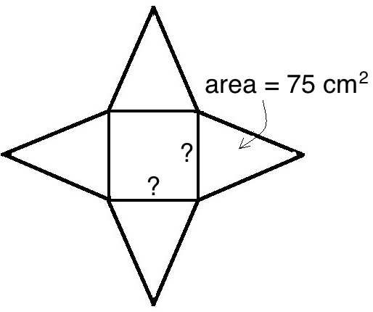
7. Each pair of pyramids is built with the same wall angle. Find the missing side lengths

|  |  |
| --- | --- |
| a) | b) |
| c) | |

1. For each pair of pyramids shown below, determine if they have the same wall angle

|  |  |
| --- | --- |
| a) | b) |

1. The half cross-section of some pyramids are shown in the diagrams below. In each case determine the height of the pyramid, the slant height, or the base half length.

|  |  |
| --- | --- |
| a) | b) |
| c) | d) |
| e) | f) |

1. a) Calculate the surface area of the pyramid shown in the diagram. Show your work.

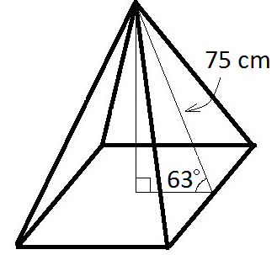  
  
  
  
  
  
  
  
b) The cardboard used to build the pyramid from question 15 a) is sold in sheets that measure 2 feet by 3 feet. Each sheet costs $3.75. Find the cost of the cardboard to build the pyramid. Note: you are allowed to use part of a sheet – you only pay for the portion you use. Show your work.

1. The half-cross section of some pyramids are shown in the diagrams below. In each case determine the wall angle.

|  |  |
| --- | --- |
| a) | b) |
| c) | d) |
| e) | f) |

MORE FOLLOW UP QUESTIONS…NOT DONE YET

1. To be safe, the walls of a pyramid must be less than 50°. Which of the following pyramids are safe? (give three different representations)
2. The cardboard to make the pyramid in #16 is sold in sheets that measure 2 feet by 3 feet, and each sheet costs $2.50. How much is the cardboard from the pyramid in #16 worth?
3. We are going to build the following pyramid out of YY, then paint it with XX. The cost of YY and XX are shown in the table. What will be the total cost for the pyramid? Show your calculations.
4. We have been working with the wall angle. What would the edge angle be?