MFM2P – White Cups vs Red Cups Name: _________________________________
Stack white cups on the ground, and red cups on 3 textbooks. How many cups will it take for the two stack heights to be equal? (note: same # red and white cups)
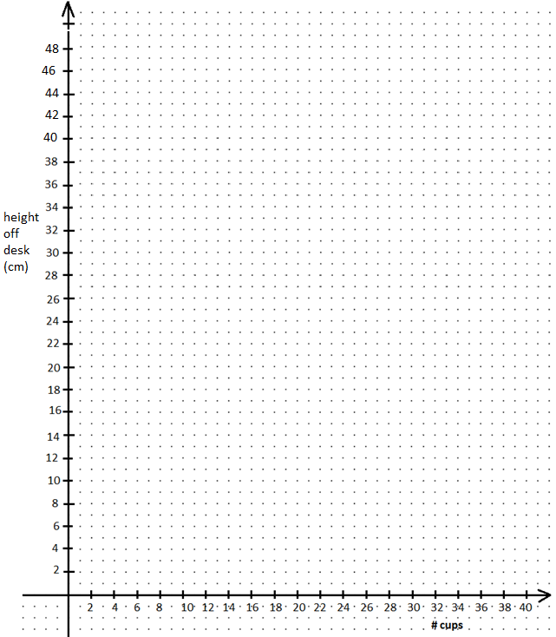
HOW MANY CUPS UNTIL THE STACKS ARE EQUAL HEIGHT? WHAT IS THE STACK HEIGHT?
White cups
# cups | Height off desk (cm)
2
4
6
8
10
12
Red cups (+textbooks)
# cups | Height off desk (cm)
2
4
6
8
10
12

