MFM2P – Cup Stacking Name: _________________________
- A group collects the following data for its stacked cups. Make a scatterplot and draw a line of best fit. Remember to label your axes.
# cups | Height (cm)
1 | 14.0
2 | 16.4
3 | 18.7
4 | 21.0
5 | 23.5
6 | 25.9
7 | 28.4

- Determine the rate of change (“slope”) and y-intercept of your line of best fit, then build an equation connecting the number of cups to the stack height.

- Use a graphing calculator to find the equation for the table of values above. How does it compare to your equation in #2?
- Draw a diagram showing a cup that might have made the table of values above. Show any important heights.

- The cup stack graph for a different group is shown below. Use the graph to make some predictions. Each time you make a prediction, add the point (x,y) to the graph.
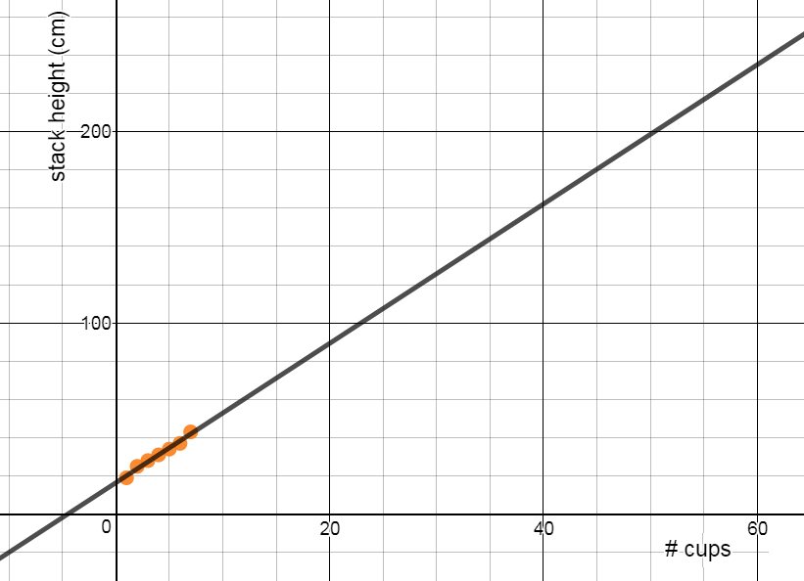
e) Determine the rate of change/slope and the y-intercept for the line above. What is the equation for this relationship?
- How tall will 15 cups be?
- How tall will 42 cups be?
- How many cups will make a stack that is 120 cm tall?
- How many cups will make a stack that is 230 cm tall?

f) Use your equation from e) to predict how tall 42 cups will be. Show your work. How does it compare to your prediction from the graph?
g) Use your equation in e) to predict how many cups will make a stack that is 230 cm tall. Show your work. How does it compare to your prediction from the graph?

- The cup stack equation for a different cup is as follows:
Use the equation from question #6 to predict the following. Show your work.
- How tall will a stack of 50 cups be? | - How tall will a stack of 167 cups be?
- How many cups will be needed to make a stack that is 263 cm tall? | - How many cups will be needed to make a stack that is 95 cm tall?

- Below are pictures of 3 different cups. The cup stack graph of Cup A is shown. What would the graphs of Cup B and Cup C look like? Draw lines for Cup B and Cup C on the same graph as Cup A. Use a ruler.
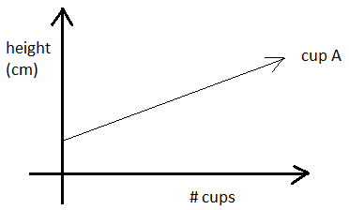
Cup A  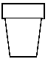 | Cup B  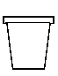 | Cup C  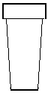

- Three different types of cups are used to make stacks. Their cup stack graphs are all shown. A picture of Cup D is also shown. Draw pictures for Cup E and Cup F that match their graph
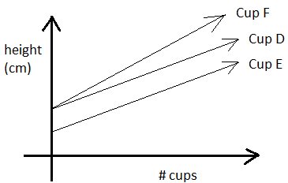
Cup D | Cup E | Cup F

- Cup A is stacked on the ground, and Cup B is stacked on a stool. The height above the ground for the stacks of Cup A and Cup B are shown in the table. Make a scatterplot for each of the cups (on the same grid), and determine after how many cups their stack height will be the same. What will that height stack be?
CUP A
# cups | Height (cm)
1 | 15
2 | 22
3 | 29
4 | 36
5 | 43

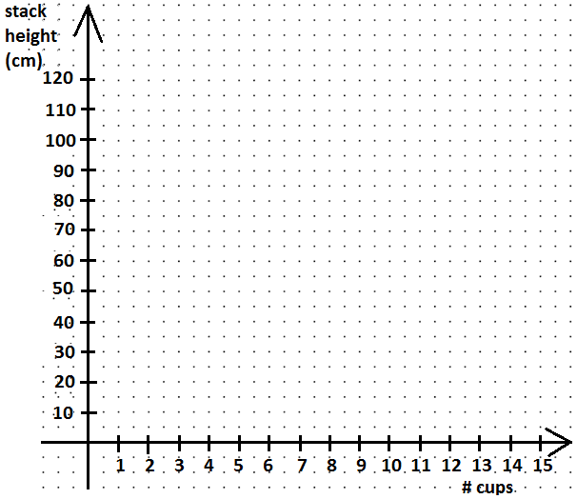
CUP B
# cups | Height (cm)
1 | 51
2 | 55
3 | 59
4 | 63
5 | 67

