**MPM1D – Test #3 Review**



***Part 1: Slope***

|  |  |
| --- | --- |
| 1. State the coordinates of A, B and C | 1. Find the slope between each pair of points. Reduce your answer.   A & B E & A A & C     B & C A & D C & D |

1. Calculate the slope between each pair of points. Simplify your answer.  
   a) ( 6, 3 ) and ( 2, 5 ) b) (–3, –8 ) and ( 3, 4 ) c) (–6, 2 ) and (–2, 8 )
2. Given a point on a line and the slope, find another point on the line.

|  |  |  |  |  |  |
| --- | --- | --- | --- | --- | --- |
| a) Point: (1, –2) Slope: $\frac{2}{3}$ | Another Point: | b) Point:(–4, 3) Slope: –4 | Another Point: | c) Point: (0, 0) Slope: $-\frac{4}{3}$ | Another Point: |
| a) Point: (3, –4) Slope: 1 | Another Point: | b) Point: (0, 4) Slope: $-\frac{3}{2}$ | Another Point: | c) Point: (4, 2) Slope: 0 | Another Point: |

1. State whether the two slopes gives are parallel, perpendicular or neither

a) $-\frac{2}{3}$ and $-\frac{4}{6}$\_\_\_\_\_\_\_\_\_\_\_\_\_\_\_\_\_\_\_\_\_\_\_\_\_\_\_ b) $\frac{-4}{3}$ and $\frac{3}{-4}$\_\_\_\_\_\_\_\_\_\_\_\_\_\_\_\_\_\_\_\_\_\_\_\_\_\_\_  
  
c) $\frac{4}{5}$ and $\frac{5}{4}$\_\_\_\_\_\_\_\_\_\_\_\_\_\_\_\_\_\_\_\_\_\_\_\_\_\_\_ d) 3 and $-\frac{1}{3}$\_\_\_\_\_\_\_\_\_\_\_\_\_\_\_\_\_\_\_\_\_\_\_\_\_\_\_  
  
e) $5$ and $\frac{1}{5}$\_\_\_\_\_\_\_\_\_\_\_\_\_\_\_\_\_\_\_\_\_\_\_\_\_\_\_ f) $\frac{-1}{-5}$ and $\frac{1}{5}$\_\_\_\_\_\_\_\_\_\_\_\_\_\_\_\_\_\_\_\_\_\_\_\_\_\_\_  
  
g) 0 and undefined\_\_\_\_\_\_\_\_\_\_\_\_\_\_\_\_\_\_\_\_\_\_\_\_\_ h) $\frac{1}{2}$ and 0.5 \_\_\_\_\_\_\_\_\_\_\_\_\_\_\_\_\_\_\_\_\_\_\_\_\_\_

1. A line joins point A to point B, and another line joins point C to point D. Use slopes to determine the line AB is parallel or perpendicular to line CD (or neither).

|  |  |
| --- | --- |
|  | A( –1, 0 ) B( –5, –6 ) C( 4, –3 ) D( 1, –1 ) |

***Part 2: Solving Equations***

1. Solve for the variable. Show your work.a) 5m – 3 = 22 b) $4x+5=21$ c) $-2x+6=18$  
   d) $5x+3=2x+15$ e) $-3x-4=2x+21$ f) $12-2x=6x-20$  
   g) 4*a* + 9 = 44 – a h) $2\left(x+1\right)=-14$ i) $-3\left(x+1\right)=2(x-5)$  
   j) (*h* + 2) + 6 = 5(*h* – 1) k)  l) 8 – 2(*x* – 3) = 6 – (*x* + 3)
2. The perimeter of each shape below is 32 cm. Find the value of x in each case. Diagrams not to scale.  
   a) b) c)   
   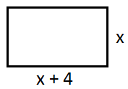 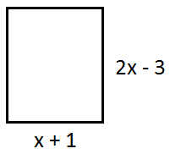 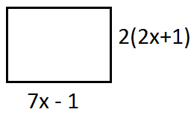

|  |  |
| --- | --- |
| 1. 9B_4-2-4A square and a rectangle have the same perimeter. Find the side lengths of each figure. |  |

***Part 3: Distance-Time Graphs***

10. Describe the motion of the person that produces each of the following distance time graphs. You do not need to provide numbers for the distance/time/speed; use descriptions like “walking towards”, “walking slowly”, etc.  
a) b) c)   
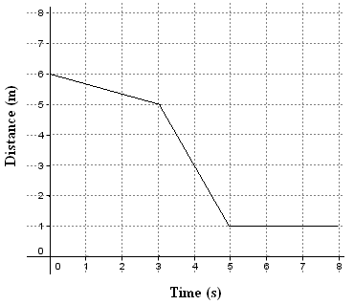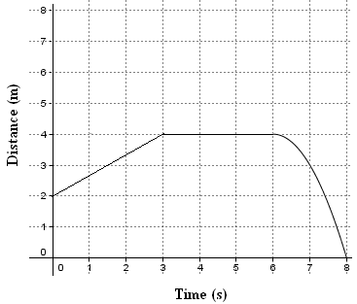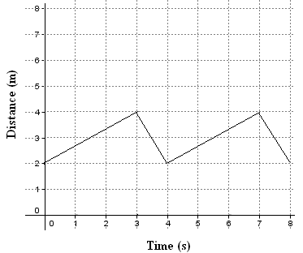

11. For graph a) in question 4, describe the motion in more detail. Include details about direction, time, speed and distance travelled for each part of the journey**.**

12. Draw a distance time graph that matches each description

|  |  |  |
| --- | --- | --- |
| a) Walking slowly away, then quickly towards | b) Standing still, then walking quickly away, then standing still | c) walking away slowly, speeding up, then stopping |

13. a) You begin 8 m from the CBR. You walk towards the CBR at a constant speed for 3 seconds and travel 6 m. You stop for 4 seconds. You then walk away from CBR for 2 seconds at 1.5 m/s. Draw and label a distance time graph for your walk on the grid provided.

***ANSWERS (I think…)***

PART 1

1. a) $4x+8$ b) $6x-4$ c) $5x-22$
2. a) $x=6$ so sides are 6 cm, 10 cm b) $x=6$ so sides are 7 cm, 9 cm   
   c) $x=10.8$ so sides are 11.8 cm, 8.4 cm
3. a) $m=5$ b) $x=2$ c) $a=7$ d) $h=\frac{13}{4}=3.25$ e) $x=-6$ f) $x=11$
4. NOTE: DON’T SOLVE THE EQUATION. CHECK MINE USING LEFT SIDE/RIGHT SIDE   
   a) LS not equal to RS, so answer not correct b) LS equals RS, so answer is correct
5. $x=6$; square is 7 x 7, rectangle is 9 x 5
6. $x=8$; $P=96 units$

PART 2

1. $y-$ intercept: 96 cubes (approx. x-intercept: ~station 9   
   rate of change = –11.4 cubes per station (approx.)
2. $y-$ intercept: how many cubes we would score from imaginary station 0  
   x–intercept: from what station number we would expect to score 0 cubes  
   rate of change: how many cubes we decrease with every station we move back
3. a) $-$ 11 cubes per station b) –8.6 cubes per station (approx.)
4. a) Stations should start at same place (station 0). Trial B has stations that are spaced further apart  
   b) y = –8.5x + 70 Various answers possible: 70 could be 60, 80, 75, etc  
   c) you need to think deeply about this one. Note that there is no negative sign on the rate of change.

PART 3

11. a) walk slowly towards CBR, walk quickly towards CBR, stop

b) walk away from CBR, stop, walk towards CBR speeding up along the way

c) walk away slowly, walk towards quickly, walk away slowly, walk towards quickly

12. a) start 6 m form CBR, walk slowly towards CBR at 0.33 m/s for 3 s, walk quickly towards CBR at 2 m/s for 2 s, stop for 3 s

b) start 2 m away from CBR, walk away from CBR at 0.67 m/s, stop for 3 s, walk all the way towards the CBR speeding up along the way

c) start 2 m away from CBR, walk away at 0.67 m/s for 3 s, walk towards at 2 m/s for 1 s, walk away at 0.67 m/s for 3 s, walk towards at 2 m/s for 1 s

13. a) Draw a straight line from (0,8) to (3,2). Draw another line from (3,2) to (7,2). Draw another line from (7,2) to (9,5)

b) 4 m per 8 s, or approx. 0.5 m/s