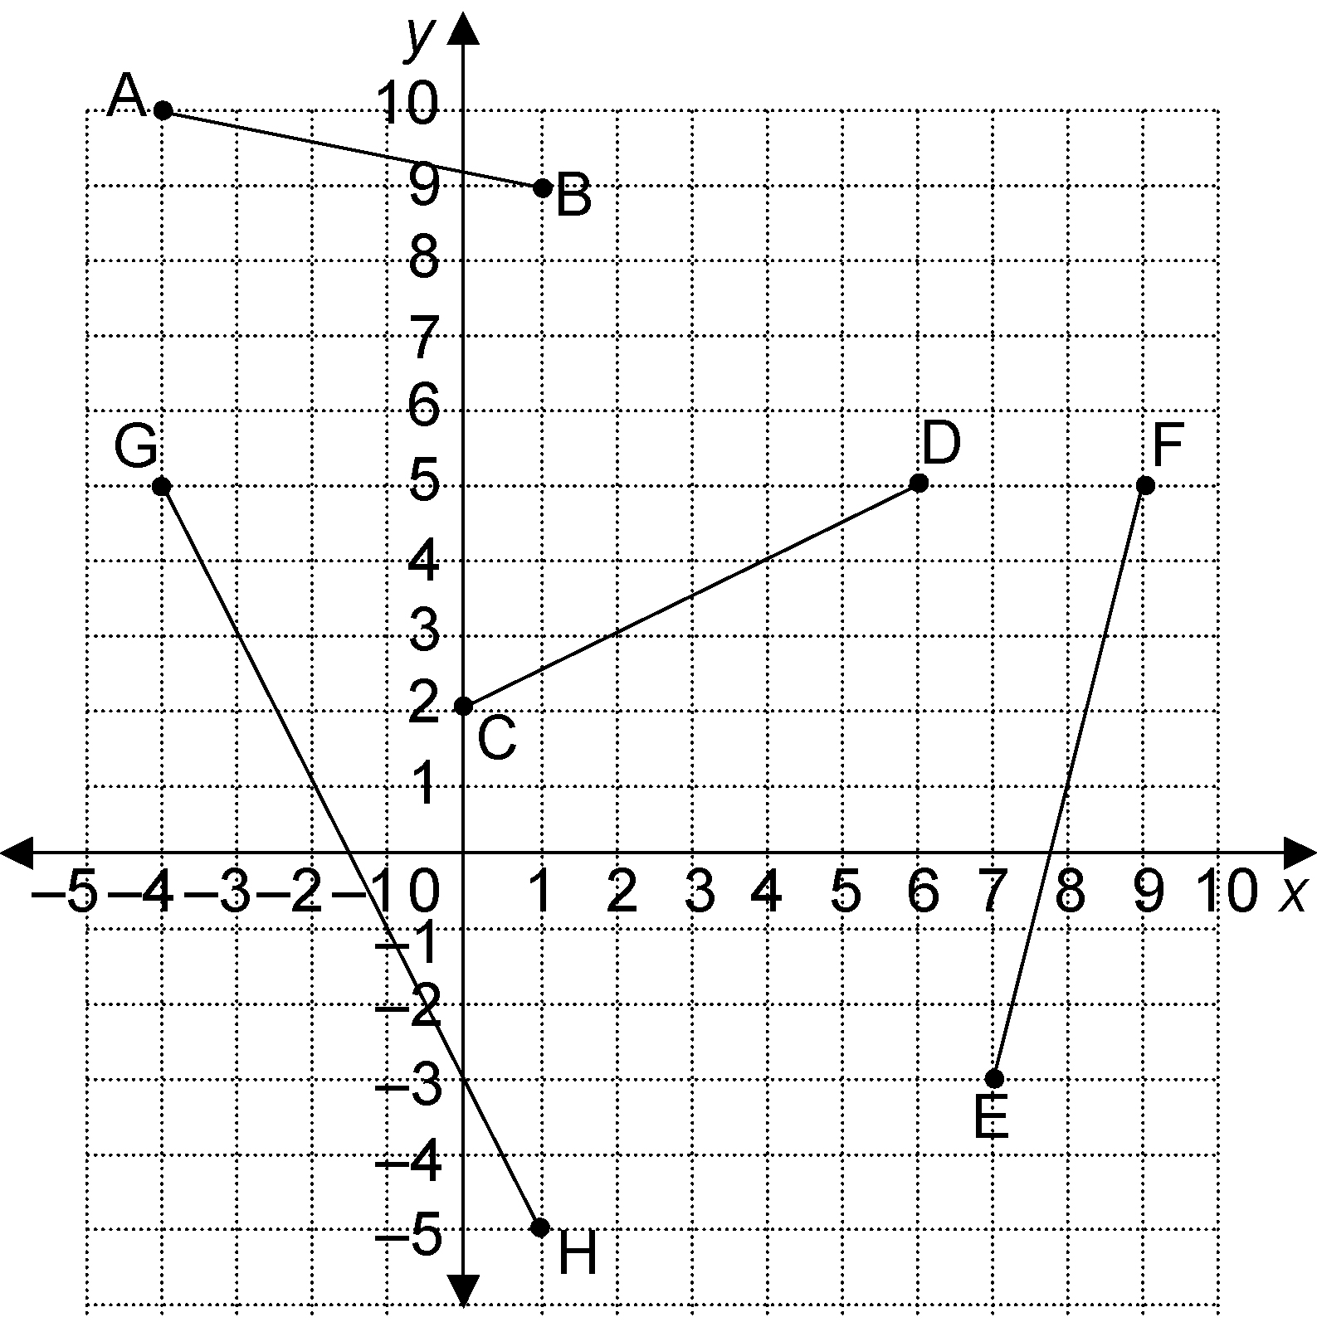

**3.** Find the slope of each line segment.

**a)** AB

**b)** CD

**c)** EF

**d)** GH

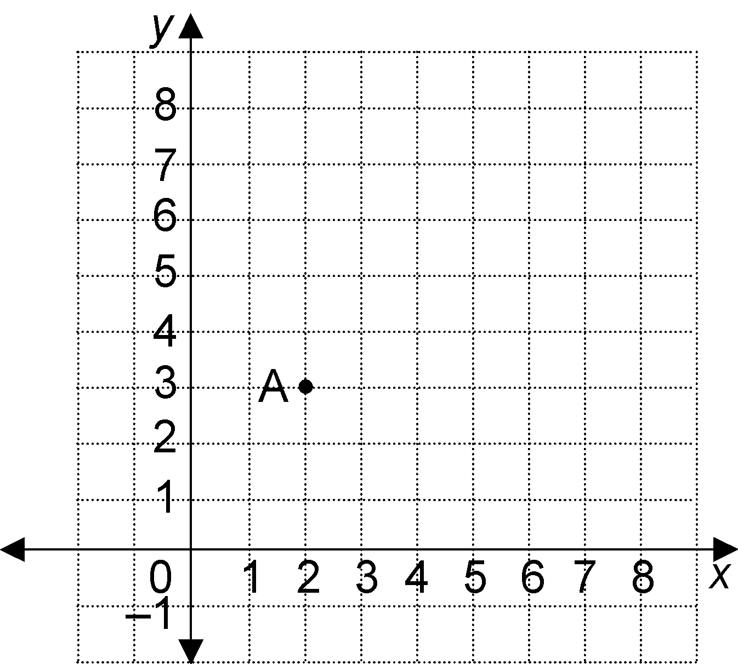

**4.** Point A (2, 3) is plotted on the grid. Draw a line segment AB with slope . What are possible coordinates of B?

 9**.** Find the slope of the line joining the points

a) K $(-3, -3)$ and L $(-4,-6)$ b) M $(-3, -3)$ and N $(-3,-6)$) c) X $(-3, -5)$ and Y $(-4,-5)$

**10.** Decide if the lines in each pair are parallel, perpendicular, or neither, and justify your answers. The slopes of the lines are given.

a)  and  b)  and 

**Answers**

**3. a)**  **b)**  **c)** 4 **d)** −2

**4.** Answer may vary. Possible answer:B(6, 1) C(4,2)

**9.** a)3 b) undefined c) 0

**10.** a) parallel, since simplified slopes are equal b) perpendicular, since simplified slopes are negative reciprocals