**MPM1D – Test #3 Review**

***Part 1: Solving Equations***

1. Find a simplified algebraic expression for the perimeter of each shape. Diagrams not to scale.  
   a) b) c)   
   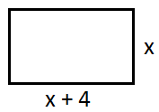 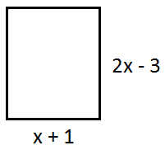 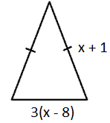
2. The perimeter of each shape in question 1 above is 32 cm. Find the value of x in each case, and determine the side lengths of each shape.
3. Solve for the variable. Show your work.a) 5m – 3 = 22 b) 5 + 4*x* = 2*x* + 9 c) 4*a* + 9 = 44 – a   
   d) (*h* + 2) + 6 = 5(*h* – 1) e)  f) 8 – 2(*x* – 3) = 6 – (*x* + 3)
4. Mr John solves a couple equations in his head. Do a formal check to see whether his answers are correct. Show your work.

|  |  |
| --- | --- |
| Original Equation | Mr John’s answer for you to check |
|  |  |
|  |  |

|  |  |
| --- | --- |
| 1. 9B_4-2-4A square and a rectangle have the same perimeter. Find the side lengths of each figure. | 1. What is the perimeter of the square ABCD? Show your work. |

***Part 2: Cube Toss Questions***

1. Draw a line of good fit and determine the ***key features*** (y-intercept, x-intercept, rate of change). Show how you determined your rate of change, and mark the x-intercept and y-intercepts on the graph.

|  |  |
| --- | --- |
| a) |  |

1. Explain the meaning of the key features in question 7 in the context of this activity. Use words like “cubes” and “stations”.
2. Determine the rate of change of the following cube toss graphs. Show your work.

|  |  |
| --- | --- |
| a) | b) |

1. The cube toss activity is done twice (Trial A and Trial B). Complete the table below.

|  |  |  |
| --- | --- | --- |
| **Representation #1 (don’t need to write anything)** | **Representation #2  (add for Trial B)** | **Explanation: why is Trial B like this?** |
|  |  |  |

|  |  |  |
| --- | --- | --- |
|  | TRIAL A: $$y=-8.5x+100$$ TRIAL B: |  |

|  |  |  |
| --- | --- | --- |
| TRIAL A: $$y=-6x+70$$ TRIAL B: $$y=8x+10$$ |  |  |

***Part 3: Distance-Time Graphs***

11. Describe the motion of the person that produces each of the following distance time graphs. You do not need to provide numbers for the distance/time/speed; use descriptions like “walking towards”, “walking slowly”, etc.  
  
a) b) c)   
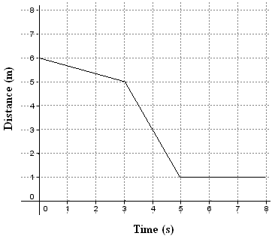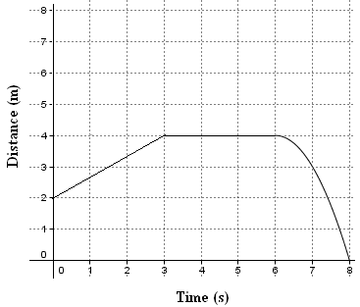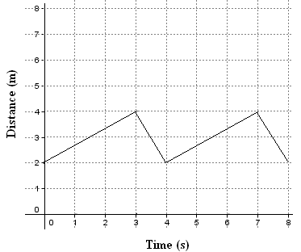

12. For graph a) in question 4, describe the motion in more detail. Include details about direction, time, speed and distance for each section of the journey**.**

13. a) You begin 8 m from the CBR. You walk towards the CBR at a constant speed for 3 seconds and travel 6 m. You stop for 4 seconds. You then walk away from CBR for 2 seconds at 1.5 m/s. Draw and label a distance time graph for your walk on the grid provided.

b) If someone had started 1 m away from the CBR and started walking at the same time as you, at what speed would they need to walk to arrive at your final location 1 second before you did? Justify your answer.

***ANSWERS (I think…)***

PART 1

1. a) $4x+8$ b) $6x-4$ c) $5x-22$
2. a) $x=6$ so sides are 6 cm, 10 cm b) $x=6$ so sides are 7 cm, 9 cm   
   c) $x=10.8$ so sides are 11.8 cm, 8.4 cm
3. a) $m=5$ b) $x=2$ c) $a=7$ d) $h=\frac{13}{4}=3.25$ e) $x=-6$ f) $x=11$
4. NOTE: DON’T SOLVE THE EQUATION. CHECK MINE USING LEFT SIDE/RIGHT SIDE   
   a) LS not equal to RS, so answer not correct b) LS equals RS, so answer is correct
5. $x=6$; square is 7 x 7, rectangle is 9 x 5
6. $x=8$; $P=96 units$

PART 2

1. $y-$ intercept: 96 cubes (approx. x-intercept: ~station 9   
   rate of change = –11.4 cubes per station (approx.)
2. $y-$ intercept: how many cubes we would score from imaginary station 0  
   x–intercept: from what station number we would expect to score 0 cubes  
   rate of change: how many cubes we decrease with every station we move back
3. a) $-$ 11 cubes per station b) –8.6 cubes per station (approx.)
4. a) Stations should start at same place (station 0). Trial B has stations that are spaced further apart  
   b) y = –8.5x + 70 Various answers possible: 70 could be 60, 80, 75, etc  
   c) you need to think deeply about this one. Note that there is no negative sign on the rate of change.

PART 3

11. a) walk slowly towards CBR, walk quickly towards CBR, stop

b) walk away from CBR, stop, walk towards CBR speeding up along the way

c) walk away slowly, walk towards quickly, walk away slowly, walk towards quickly

12. a) start 6 m form CBR, walk slowly towards CBR at 0.33 m/s for 3 s, walk quickly towards CBR at 2 m/s for 2 s, stop for 3 s

b) start 2 m away from CBR, walk away from CBR at 0.67 m/s, stop for 3 s, walk all the way towards the CBR speeding up along the way

c) start 2 m away from CBR, walk away at 0.67 m/s for 3 s, walk towards at 2 m/s for 1 s, walk away at 0.67 m/s for 3 s, walk towards at 2 m/s for 1 s

13. a) Draw a straight line from (0,8) to (3,2). Draw another line from (3,2) to (7,2). Draw another line from (7,2) to (9,5)

b) 4 m per 8 s, or approx. 0.5 m/s