MPM1D - Spiral 5 Test Review
Angle Relationships
- What is the sum of the interior angles of 20 sided figure? | - What is the measure of each angle of a regular polygon with 18 sides?
- If the sum of the interior angles of a polygon is 3060º, how many sides does it have? | - The interior angles of a regular polygon measure 144º. How many sides does the polygon have?
- Find the value of x in the pentagon shown below. | - a) Find the measure of .  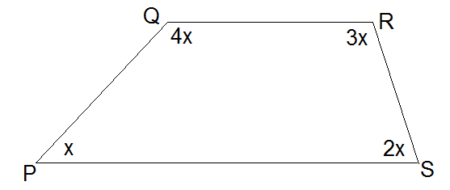
- Solve for x | - Find the value of y
- What is the value of z? Show your work. | Answers to geometry  1. 3240° 2. 160° 3. 19 4. 10  5. 110° 6. 72° 7. 21.25 ° 8. 65°  9. 54°
Playdoh-Water-Paper Problems
- You make a paper cube with side lengths 5 cm. If you double the side lengths, how many times bigger is the surface area? What about the volume?
- A cylinder has a circumference of 50 cm, and is filled with water to a height of 12 cm. If you drop 3 golf balls into the water, to what height will the water level rise? Golf balls have a diameter of 4.4 cm.
- A cylinder with a height of 5 cm and a radius of 3 cm is made out of playdoh. If you break the playdoh in half and form two new cylinders with a height of 5 cm, what will the new radius be?
- One playdoh cube has a volume that is 50% more than a smaller playdoh cube. If the side lengths of the large playdoh cube are 4 cm, what are the side lengths of the smaller cube?
- You make a cube out of playdoh, and calculate its surface area to be 900 cm2. If you turn that cube into a sphere, what will the surface are of the sphere be?
ANSWERS: 1. SA 4x V 8x 2. Increase: 0.7 cm, height of 12.7 cm 3. r = 2.1 cm 4. l = 3.5 cm 5. R = 7.6 cm, SA = 725 cm²

