***MPM1D – Review for Test #4 Name: _____________***

***ANALYTIC GEOMETRY***

1. Determine equation of the following lines in the form 

|  |  |
| --- | --- |
|  |  |
|  |  |
| 1. has a slope of  passes through (-4, -3) | 1. has a slope of -2, passes through (-2, 5) |

2. Find the slope between the following pairs of points, and an equation that passes through them. Do this on a separate piece of paper!!! You can use: 

a) (2, 5) and (4, 9) b) (0, –5) and (3, –8) c) (-3, 8) and (3, 0)

3. Give the equation of a line that….

1. has a slope of  ____________________
2. has a y-intercept of 3 ____________________
3. is increasing ____________________
4. is a horizontal line ____________________
5. is steeper than *y* = –1 + 4*x* ____________________
6. is less steep than  ____________________
7. goes in the opposite direction to , but has the same   
   steepness ____________________
8. is steeper than  but less steep than  ____________________
9. crosses the y axis between and  ____________________
10. is not steep, is decreasing, and has a small   
    y-intercept ____________________
11. is really steep, and goes in the opposite direction of *y* = 5 – 2*x* ____________________
12. is a vertical line that passes through the point (2, 3) ____________________
13. is steeper than and passes through the origin ____________________
14. is perpendicular to  ____________________
15. is parallel to , with the same y-intercept as y = 4 ____________________

4. Draw a graph of the following lines. Label them.

a) 

b) 

c) 

d) 

e) 

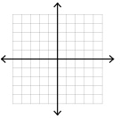

5. Line 1 passes through the points (6, 19) and (18, 11). Line 2 is perpendicular to Line 1, and has a y-intercept of –5. Does line 2 pass through the point (10, 10)? Show your work.

ANSWERS

|  |  |
| --- | --- |
| 1. a)  b)  c)  d)  e)  f) | 1. a)  b)  c) |

1. Various answers are acceptable
2. 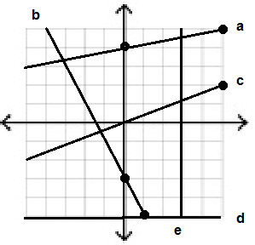
3. Yes it does – the equation is $y=\frac{3}{2}x-5$