***MPM1D – Review for Test #4 Name: _____________***

***ANALYTIC GEOMETRY***

1. Determine equation of the following lines in the form 

|  |  |
| --- | --- |
|  |  |
|  |  |
| 1. has a slope of and passes through the point (-4, -3) | 1. has a slope of -2, and passes through the point (2, 5) |

2. Find the slope between the following pairs of points, and an equation that passes through them. You can use: 

a) (2, 5) and (4, 9) b) (0, –5) and (3, –8) c) (-3, 8) and (3, 0)

3. Draw a graph of the following lines. Label them.

a) 

b) 

c) 

d) 

e) 

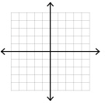

4. Give the equation of a line that….

1. has a slope of  ____________________
2. has a y-intercept of 3 ____________________
3. goes up and to the right ____________________
4. is a horizontal line ____________________
5. is steeper than *y* = –1 + 4*x* ____________________
6. is less steep than  ____________________
7. goes in the opposite direction to , but has the same   
   steepness ____________________
8. is steeper than  but less steep than  ____________________
9. crosses the y axis between and  ____________________
10. is not steep, goes down and to the right, and has a small   
    y-intercept ____________________
11. is really steep, and goes in the opposite direction of *y* = 5 – 2*x* ____________________
12. is a vertical line that passes through the point (2, 3) ____________________
13. is steeper than and passes through the origin ____________________
14. is perpendicular to  ____________________
15. is parallel to , with the same y-intercept as y = 4 ____________________

ANSWERS

1. a) $y=\frac{1}{3}x-2$  
   b) $y=-x+3$  
   c) $x=-2$  
   d) $y=4x+8$  
   e) $y=\frac{3}{4}x$  
   f) $y=2x+1$
2. a) $y=2x-3$  
   b) $y=-x-5$  
   c) $y=-\frac{4}{3}x-4$
3. 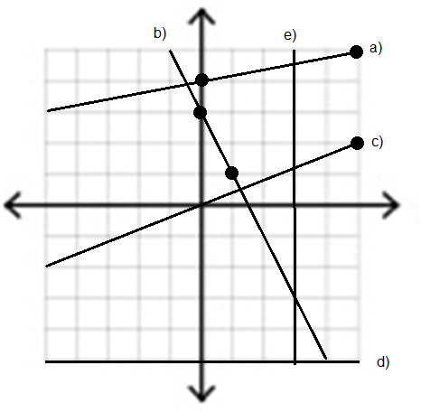
4. Various answers are acceptable