MPM1D – Finding Points

A grid is provided to help you answer the questions below. Looking for a challenge? Try to answer them without use of the grid. INTEGER COORDINATES ONLY PLEASE!!

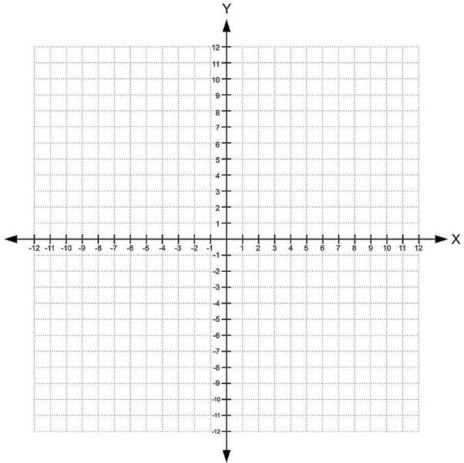

- A line passes through the points (2,3) and (11,10). Find another point on the line
  - In quadrant 1
  - In quadrant 3
- A line passes through the points (–7,11) and
(–3,3). Find another point on the line
  - In quadrant 4
  - In quadrant 3
- Line segment A connects (2, –3) to (–2, 7). Line segment B passes through (–3, –9) and is parallel to segment A
  - If segment B is the same length as segment A, what is segment B’s other endpoint?
  - If segment B is shorter than as segment A, what is segment B’s other endpoint?
  - If segment B is longer than segment A, what could segment B’s other endpoint be?
- Line A passes through (–2, –4) and (4, –1). Line B is parallel to Line A, and passes through (–6,1).
  - Find another point on Line B
  - Line B passes through the point (2, y). What is the value of y?
  - Line B passes through (x, -1). What is the value of x?
- Line A passes through (–4, –3) and (–2, 3). Line B passes through (–1, 5) and is perpendicular to Line A. Find another point on Line B
  - In quadrant 1 b. In quadrant 2 c. In quadrant 4
- Line A passes through (4, 5) and (8, –1). Line B also passes through (4, 5), but it is perpendicular to Line A. Find a point on Line B that is in quadrant 2.
ANSWERS (I think!). Note – other correct answers are possible.
- a) (12, 7) b) (–3, 1) c) (–8, –1) 2. a) (1, –5) b) (–1, –1) 3. a) (–7, 1) b) (–5, –4) c) (–9, 6)
4. a) (–4, 2) or (–2, 3) or (0 ,4) b) (2, 5) c) (–10, –1) 5. a) (2, 4) b) (–4, 6) c) (17, –1) 6. (–2, 1)

