Rearrange the equation to be in the form y = mx + b. Then graph.  $$5x-2y-10=0$$ | Name: _______________________  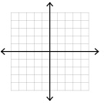
Rearrange the equation to be in the form y = mx + b. Then graph.  $$5x-2y-10=0$$ | Name: __________________________
Graph the following by finding the intercepts. Show your work.
$$-3x+5y+15=0$$

Graph the following by finding the intercepts. Show your work.
$$-3x+5y+15=0$$

