MPM1D: y = mx + b Learning Check Name: ______________________________
Determine the equation of each line shown below.  a) _____________________________________  b) _____________________________________  c) _____________________________________ | Graph and label the following lines on the grid.  a) $y=\frac{2}{3}x-5$ b) $y=-\frac{1}{2}x+4$  c) $y=3x-1$ d) $y=6$  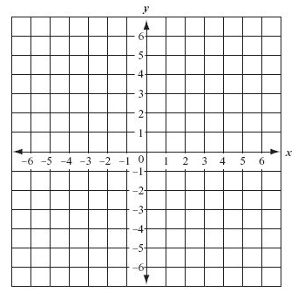
MPM1D: y = mx + b Learning Check Name: ______________________________
Determine the equation of each line shown below.  a) _____________________________________  b) _____________________________________  c) _____________________________________ | Graph and label the following lines on the grid.  a) $y=\frac{2}{3}x-5$ b) $y=-\frac{1}{2}x+4$  c) $y=3x-1$ d) $y=6$

