MPM 1D – Shapes and Slopes Name: _____________________________
EXAMPLE 1  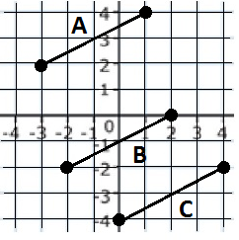 |  |  | EXAMPLE 2  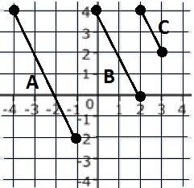 |  |  | EXAMPLE 3  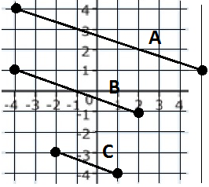
Slope of A | Slope of B | Slope of C | Slope of A | Slope of B | Slope of C | Slope of A | Slope of B | Slope of C
How can we tell if lines are parallel?
EXAMPLE 4  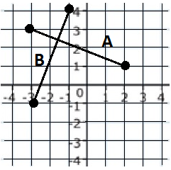 |  |  | EXAMPLE 5  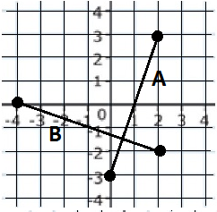 |  |  | EXAMPLE 6  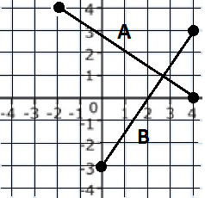
Slope of A | Slope of B |  | Slope of A | Slope of B |  | Slope of A | Slope of B
How can we tell if two lines are perpendicular?

