MPM1D – My Parabola Polygraph Name: _____________________
A | 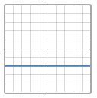 | B | 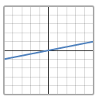 | C | 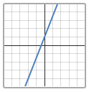 | D | 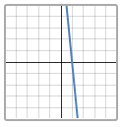
E | 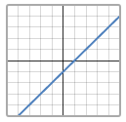 | F | 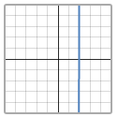 | G | 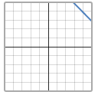 | H | 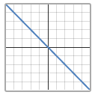

For each question and answer, identify the lines that could be eliminated. Use the lines above.
# | Question | Answer | Eliminated
1. | Is the line increasing? | Yes
2. | Does the line pass through the origin? | No
3. | Is the line steep? | No
4. | Is the line decreasing? | Yes
5. | Is the line either horizontal or vertical? | Yes
6. | Is the line increasing and steep? | Yes
7. | Does the line have a positive y-intercept? | No
8. | Can you see the x-intercept in the picture? | Yes

In each case, I will give you two lines that remain. Write a question that would let you win the game.
Line 1 | Line 2 | Question
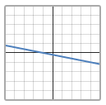 | 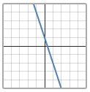
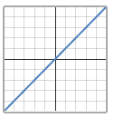 | 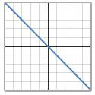
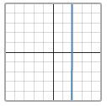 | 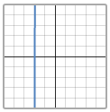
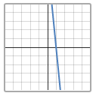 | 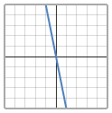
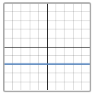 | 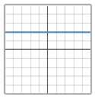

For each question, draw three lines (one for yes, two for no). Use a ruler.
Line 1 (Yes!) | Line 2 (No!) | Line 3 (No!) | Question
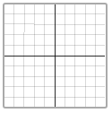 |  |  | Is the line steep and decreasing?
 |  |  | Does the line have a positive x-intercept and a positive y-intercept?
 |  |  | Does the line pass through 3 quadrants?

Steep | Not steep | Increasing | Decreasing
Vertical | Horizontal | x-intercept | y-intercept
Positive | Negative | Origin | Quadrant (1/2/3/4)
x-axis | y-axis

