a. is increasing  b. is steep and decreasing  c. passes through the point (3,1)  d. passes through the origin and is not steep  e. has a positive x-intercept  f. has a negative y-intercept and passes through (2,–5)  g. passes through three quadrants  h. is vertical, with a negative x-intercept  i. is horizontal, with a positive y-intercept  j. is not steep, is decreasing, and has a negative y-intercept  k. passes through 2 quadrants and has no y-intercept  l. has a positive x-intercept and a positive y-intercept  m. is horizontal, and passes through (–2, 4)  n. passes through  (–4,–1) with a slope of $\frac{2}{3}$  o. has a negative x-intercept, a positive y-intercept, and is decreasing (this one is more than a little tricky) | a.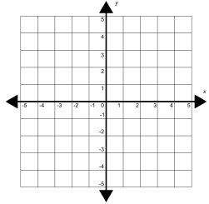 | b. | c.
 | d. | e. | f.
 | g. | h. | i.
 | j. | k. | l.
 | m. | n. | o.
MPM1D – Draw A Line That… Name: _________________________

