Making Shapes Name: __________________________________
ON THIS PAGE, ONLY IDENTIFY POINTS FOR WHICH THE COORDINATES ARE INTEGERS, AND ONLY IDENTIFY POINTS THAT ARE ON THE GRID (THERE ARE MANY OTHERS OFF THE GRID)
1. a) What are the coordinates of the points?
b) Identify all possible locations for a 4th point that would result in a parallelogram

c) How many points will result in a trapezoid (not including the 3 points from part b)?

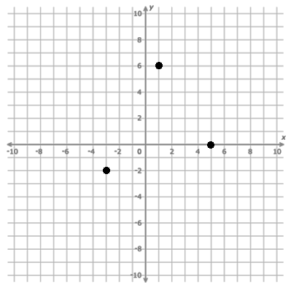

2. a) Determine the slope between the two points.
b) Identify all possible locations (on the grid) for a third point that would result in a straight line.

c) Identify all possible locations for a third point that would result in a right angle triangle (there are 5 that are on the grid).

ANSWERS (I think!)
- a) (5, 0), (1,6), (–3, –2) b) (–7,4), (9,8), (1, –8) c) 12 points (not including 3 from b)
- a) m= $\frac{3}{5}$ b) (–2,2) or (8, –4) c) (6,4), (9,9), (0, –6), (–4,10), (–10, 0)
