Coordinates/Ordered Pairs - Introduction Name: __________________________________

The imaginary lines we call the x-axis (which is horizontal) and y-axis (which is vertical), chop the Cartesian plane into 4 quadrants. We use ordered pairs to locate points on the plane
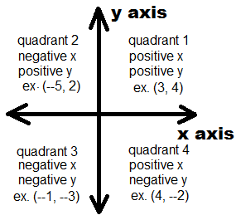

- Mark the following points on the Cartesian plane.
- (1, 3)
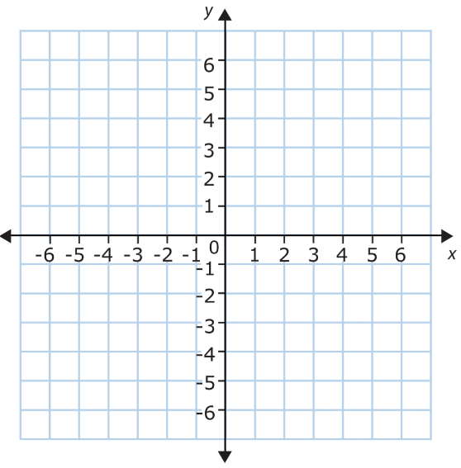
- (4, 5)
Join the following points using straight lines: b), c), d), e), b)

Now join: g), h), i)
Surprise!
- (4, –3)
- (–6, –3)
- (–6, 5)
- (–3, 3)
- (–4, 0)
- (–1, –2)
- (2, 0)

- State the coordinates of the points on the Cartesian plane.
