MPM1D - Practice Graphing Standard Form by Rearranging
In each case, rearrange the equation to be in the form y = mx + b. Then graph.
- $2x+5y+10=0$  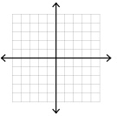 | - $3x+2y=-8$
- $10x-5y=20$ | - $x+3y+3=0$
- $4y-16=0$ | - $24x-18y-38=-2$

